Adding and Modifying Spans and Supports
Introduction
Using Cut, Copy, Paste and Delete
Spans and Supports as Pairs
To Add a Span/Support
Properties
Segment Descriptions
General Information
Adding Segments
To Create a New Segment by Inserting
To Create a New Segment by Copying
Clearing and Deleting Segments
To Clear all Segments
To Delete a Segment
Sorting Segments
Boundary Conditions
Avoiding Unreasonable Models
Interior Span/Supports
Exterior Span/Supports
Hinges
To Add In Span Hinges
Limit State Factors
Support
Simple Support
Columnar Support
Support Data
Boundary conditions
Insertion Point
Editing Spans and Supports
To Edit a Span
To Edit a Support
Make and Support Cantilever
To Make a Cantilever
To Support a Cantilever
Section Properties Calculator
Running the Calculator
From the Bridge Contractor
From the Span Editing Dialog
Step 1 - Supporting Components
Step 2 - Deck Types
Step 3 - Beam/Girder Description
Type 1 - Steel Beam
Type 2 - Concrete Beam
Type 3 - Wood Beams
Step 4 - Concrete Slab Description
Type 1 - Concrete Slab
Type 2 - Steel Grid Deck Description
Type 3 - Wood
Step 5 - Skew Corrections
Step 6 - Properties and Distribution Factors
Adding Your Own I-Beam/Bulb-Tee and Wide Flange Sections

Introduction
Once you have a bridge model, you can add, modify and delete the spans and supports. You can fully customize your models made with the Bridge Contractor. For example, you might want to modify your prismatic model to approximate a non-prismatic model or add a sloped-leg column.

If you are building your model from scratch, the “blank sheet” technique, use the information in this chapter to add spans and supports to your model.

The first part of the chapter describes adding spans and supports. Since the editing dialog boxes are subsets of the adding dialog boxes, the last section tells you how to edit spans and supports with references back to the previous sections for details.

Using Cut, Copy, Paste and Delete
This chapter describes the methods for adding and modifying spans and supports that have properties different from the existing spans/supports. QConBridge also offers a variety of ways to modify spans and supports when you don’t need to change the properties. You can choose the commands cut, copy and paste from the toolbar, main menu and context menus. Please refer to Chapter 3, Editing Techniques and Features for details.

Briefly, if you want to add a span or support that has the same properties as one already in the model, use the copy and paste commands. To remove a span or support, use the delete or cut commands. To move a span or support, use the cut and paste commands.

Spans and Supports as Pairs
QConBridge works with spans and supports as pairs to maintain a valid bridge model. When you add a span, you also add a support. When editing , a span and one of its supports must be selected together. This is known as a span/support pair. QConBridge automatically selects a support when a span is selected or a span when a support is selected, as defined by the Selection Mode.

Please refer to Chapter 3, Editing Techniques and Features, for more information on selecting and inserting supports and spans.

To Add a Span/Support
 8 From the Span/Support menu, choose Add Span/Support (Alt, S, A).
The Add Span/Support dialog box appears.

Note - Once you enter the Add Span/Support dialog, you cannot change the options set for Selection and Insertion Modes. The defaults are Select Right and Insert After, which is working from left to right. If that is contrary to how you normally work, you may want to check the Options menu before entering the Add Span/Support dialog.

Properties
All your routine work is done on the Properties tab. Use the Section Properties Calculator to generate properties or enter them manually. Adding rows to the grid provides a method for modeling non-prismatic spans.

The minimum input is a reasonable Span Length.

Segment Descriptions
The grid provides a method for modeling non-prismatic spans with a stepwise approximation. A non-prismatic span is divided into several prismatic segments. The more segments you use, the more accurate the results are going to be, however the analysis will take more time. A coarse approximation is usually good enough. See Figure 4-7 for a sample non-prismatic model.

General Information
- Properties are constant within the segment.
- Location is always measured from the left end of the span.
- Every span must have at least one segment located at the left end of the span.
- Segment 1 starts at location zero. Segment 2 starts at the next length (measured from left end of the span) and so on.
- Each segment has eight properties. Cross sectional area, moment of inertia, modular elasticity, density (unit weight in US units), and four live load distribution factors.

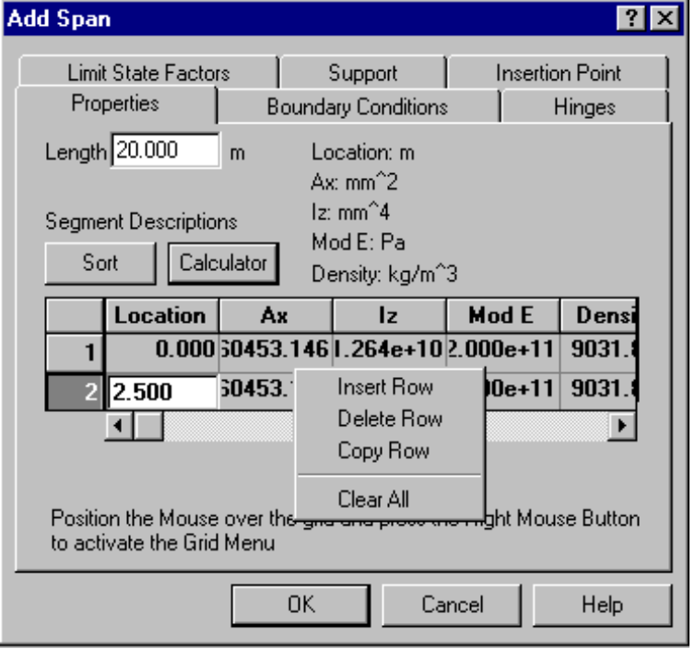
Figure 4-1 - Properties Tab

Adding Segments
There are two ways to add segments. You can insert a new row in the grid entering a new location and section properties. If you have a segment that is symmetrical or very similar to an existing one, you can copy the existing segment, enter the new location, and make any necessary properties changes.

To Create a New Segment by Inserting
- Position the mouse over any cell (numerical portion) in the grid and press the right mouse button to activate the context menu.
- Choose Insert from the context menu.
3. Enter location relative to beginning of span.
4. To insert values, either:
- Enter them manually by using the Tab key or the mouse to move from one cell to cell
OR
- For any row, highlight a cell in that row and click Calculator 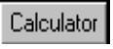 to run the Section Properties Calculator. The Calculator runs against the selected row. See Section Properties Calculator description at the end of this chapter.

To Create a New Segment by Copying
- Position the mouse over any cell (numerical portion) in the row you want to copy and press the right mouse button to activate the context menu.
- Choose Copy from the context menu.
A new row is added with properties identical to the one you copied.
- Modify the location. Change any of the properties if necessary.

Note - CTRL+C, CTRL+X, and CTRL+V work for cutting, copying and pasting cell values.

Clearing and Deleting Segments

To Clear all Segments
- Position the mouse over any cell (numerical portion) in the grid and press the right mouse button to activate the context menu.
- Choose Clear All from the context menu.
Resets to the default segment properties.

To Delete a Segment
- Position the mouse over the row in the grid you want to delete and press the right mouse button to activate the context menu.
- Choose Delete Row from the context menu.

Sorting Segments
Clicking Sort  , sorts the segments by location from left to right. You don’t have to add segments in correct order.

Note - Under Options on the main menu, you can choose Display and check segment ticks. You get a visual representation of where segments are along the span. They appear on the model in the Editor window (see Figure 4-7) and the printed hardcopy.

Boundary Conditions
The Boundary Condition Tab is used to modify the span’s connection with adjacent spans. When checked, the left or right end of span is made continuous with the adjacent span and column. If unchecked, the span is not continuous with the adjacent span and column.

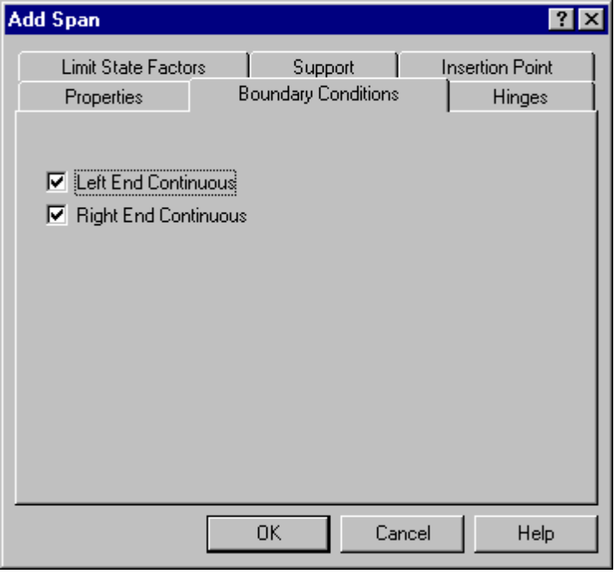
Figure 4-2 - Boundary Conditions Tab

Avoiding Unreasonable Models
A few words need to be said about what conditions to avoid when using this tab to add spans and supports to your model. QConBridge will fail to function properly if you make your model so that it is unstable. There are several cases in which this happens.

Interior Span/Supports
- When the right end of one span and the left end of an adjacent span are not continuous AND there is a hinge at the top of the column
- If an Interior support is a pin or roller AND the ends of both adjacent spans are not continuous .
The only way you can have two ends be not continuous at an interior support, is if you have a column and the top of the column is not hinged.

Exterior Span/Supports
- If the Exterior support is a pin or roller and the adjacent span has a discontinuous end at that support.

Hinges
The Hinges Tab is used to describe in-span hinge locations . They are similar to hinges at end of a span and use the same symbol (¡). The Location of the hinge is measured from the left hand side of the span. Hinge 1 must be closer to the left end of span than hinge 2. See Figure 4-7 for an example of a model with in-span hinges.

Note - It is not recommended to use in span hinges to release the start or end of a span (make a span dis-continuous). You should do that by boundary conditions, otherwise the program may fail to function properly.

To Add In Span Hinges
- Determine how many hinges you have in your span (You’ll know it by the problem you’re solving.) You can have 0-2.
- Check 1 or 2 and the boxes light up.
- Enter location of the hinge.

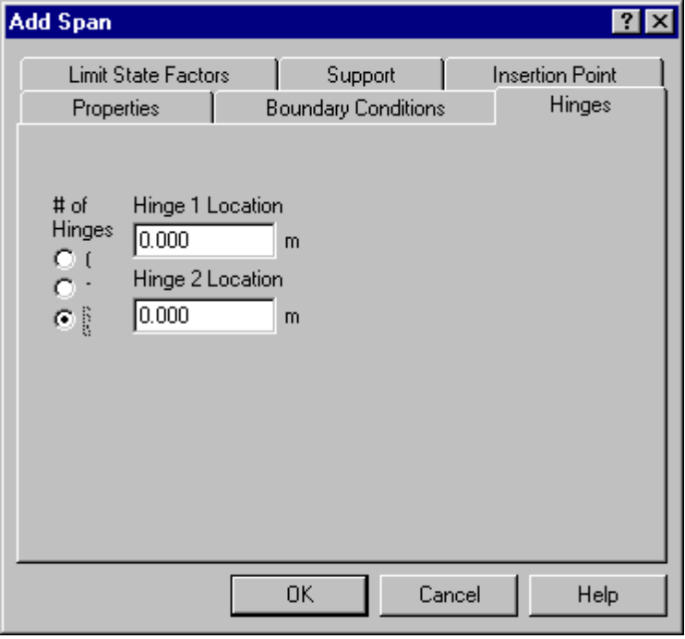
Figure 4-3 - Hinges Tab

Limit State Factors
The Limit State Factors Tab is for entering the Limit State Factors for a Span/Support pair. They are used for Limit State Load Combinations. Please reference Article 1.3.2 of the AASHTO LRFD Bridge Design Specifications for more information regarding the Limit State Factors.

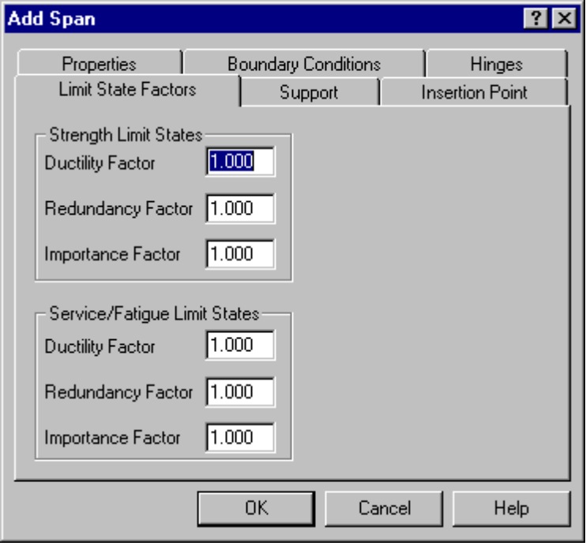
Figure 4-4 - Limit State Factors Tab

Support
When you are adding a span, you must add a support as well. Remember--they always come in pairs. For more information on working with the pairs, see Chapter 2. There are two categories of supports, simple and columnar. The support type is controlled by a check box at the top of the tab.

Note - To edit a support, highlight a span and choose Edit Support from the Span/Support menu. This tab does not appear in the Edit Span dialog.

Simple Support
If you want a simple support, check the box. Designate under Boundary Conditions whether it is Pinned or Roller.

Columnar Support
If you want to model the supports as columns, remove the check from the Simple Support box, and the Support data boxes are activated.

Support Data
The Support Data consists of the height of the support and its cross-sectional properties. The Offset allows for sloped columns in the bridge model. An offset less than zero will move the base of the column to the left and an offset greater than zero will move the base of the column to the right. Height must be greater than 0. Sloped columns are shown in Figure 4-7.
Remember! - Work in the context of the problem you are trying to solve. If you are modeling a Line of Girders and you have a multi-column support, you need to enter section properties that are consistent with this type of model. If you are doing a Full Width Bridge model, then your properties need to be consistent with that type of model.

Boundary conditions
The boundary conditions describe the fixity at the base of the column: Pinned, Roller or Fixed, and whether there is a top of column hinge or not. Fill in the properties appropriate for your model.

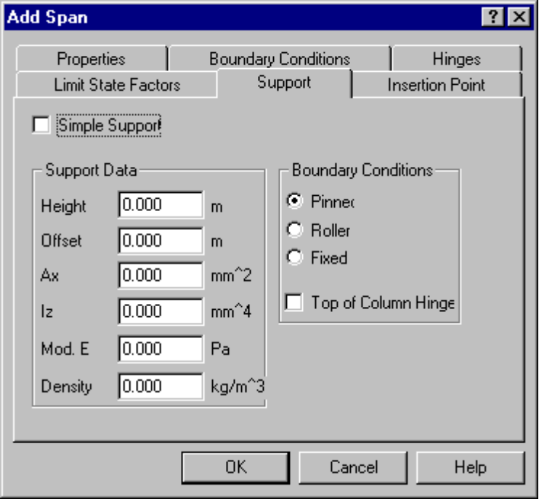
Figure 4-5 - Support Tab

Insertion Point
You can insert a span/support pair at several places in the bridge model:.
- Start of Bridge - Span/support pair go to the left-end of the bridge
- End of Bridge - Span/support pair go to the right-end of the bridge.
- Insert at Current Location - Inserts the span/support pair adjacent to the currently selected span/support pair in accordance with the insertion mode.

The default Insertion Mode is Insert After. The span/support pair is inserted after (to the right of) the currently selected span/support pair. The support is attached to the span in accordance with the Selection Mode. The default Select Mode is Right Support. The support is attached to the right end of the span. For more information on the Selection Mode and Insertion Mode, refer to Chapter 3.

Note - You need to adjust Selection and Insertion Modes before you enter the Add Span/Support dialog. You cannot change it now.

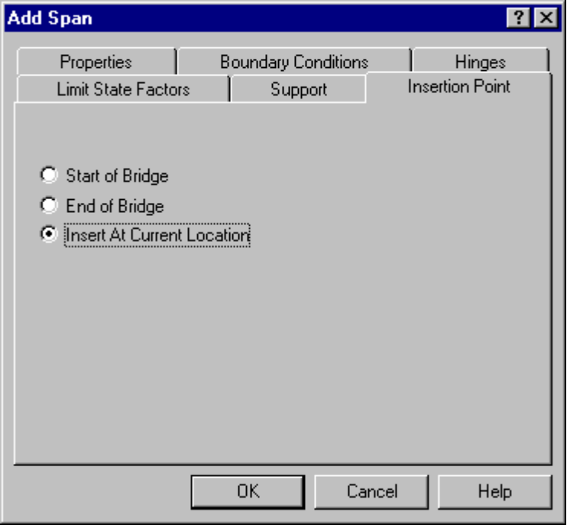
Figure 4-6 - Insertion Point Tab

The sample model below in Figure 4-7, shows a non-prismatic model with various types of supports and loads.
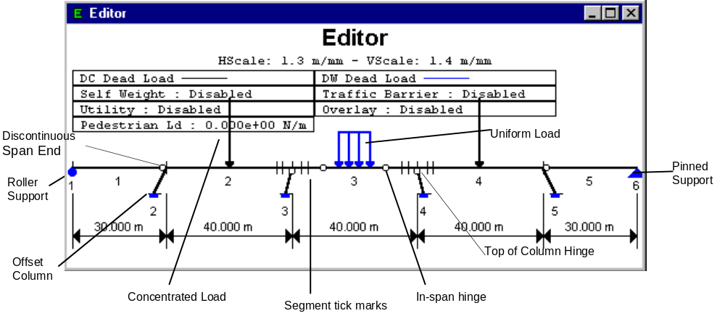
Figure 4-7 - Non-prismatic model showing supports and loads

Editing Spans and Supports
Editing Spans and Supports is done similarly to Adding Spans and Supports.

To Edit a Span
Select the span you want to edit.
8 From the Span/Support menu, choose Edit Span (Alt, S, S).
The Edit Span dialog box appears.

OR

Double-click the span you want to edit.
The Edit Span dialog box appears.

Note - An additional keyboard alternative for editing a span is: Select the span by using the right and left arrow keys, press ENTER. The Edit Span dialog box appears.

Use the Properties, Boundary Conditions, Hinges, and Limit State Factors tabs to edit information about the span. For information about any of these tabs, see the sections earlier in this chapter.

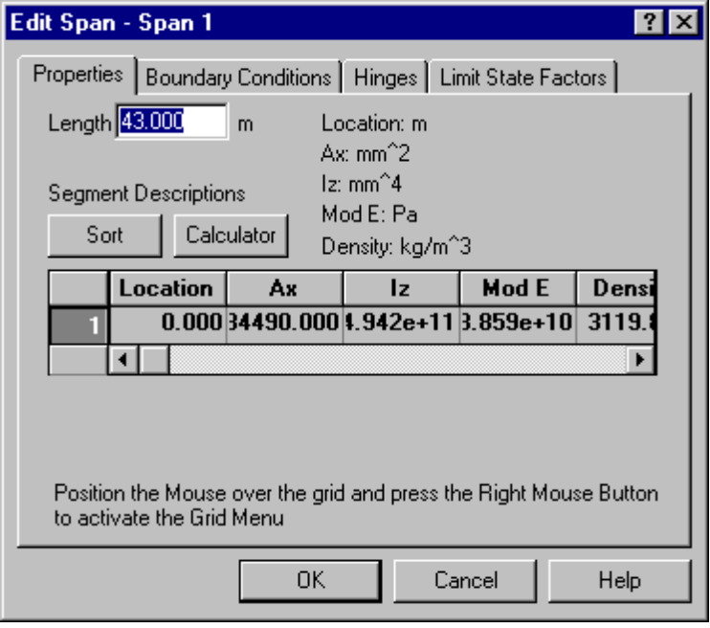

To Edit a Support
Select the support you want to edit.
8 From the Span/Support menu, choose Edit Support (Alt, S, P).
The Edit Support dialog box appears.

OR

Double-click the support you want to edit.
The Edit Support dialog box appears.

Note - An additional keyboard alternative for editing a support is: Select the support by using the right and left arrow keys, press Ctrl+ENTER. The Edit Support dialog box appears.

The Edit Support dialog box contains the Support tab. See the Support section in this chapter for details.

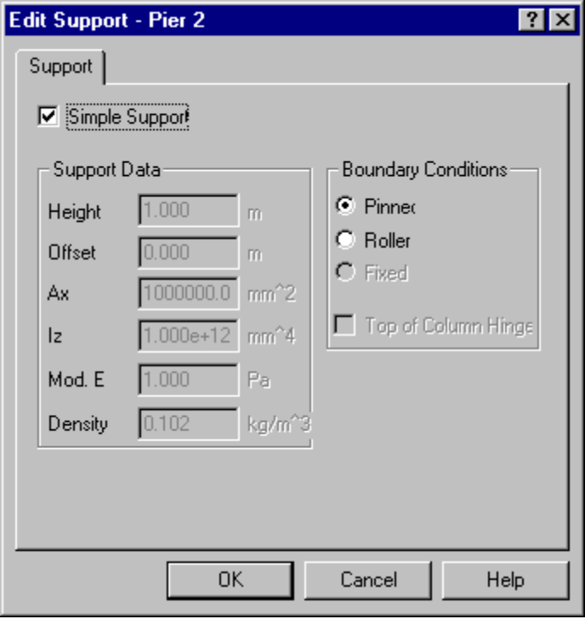
Figure 4-8 - Edit Support Dialog Box

Make and Support Cantilever
You can make a span a cantilever or add a support to a cantilever on either end of your bridge model. Making a cantilever takes away the support from the exterior end of the selected outside span. Supporting the cantilever puts back a hinge support on the exterior end of the outside selected span.

To Make a Cantilever
1. Select the outside span for which you want to cantilever.
- From the Add Span/Support menu, choose Make Cantilever.
The support is removed from the exterior end of the span.

To Support a Cantilever
- Select the outside span you want to support cantilever.
- From the Add Span/Support menu, choose Support Cantilever.
A hinge support is added to the exterior end of the span.

Section Properties Calculator
The Section Properties Calculator is used to calculate section properties and live load distribution factors for a variety of typical bridge cross sections. It currently supports types A, K and L from Table 4.6.2.2.2.1-1 in the AASHTO LRFD Bridge Design Specification. Please reference that section of the code for details. The Section Properties Calculator computes properties for steel plate girders, steel wide flange beams, precast prestressed I-Beams/Bulb-Tees, and wood beams. The section properties and live load distribution factors it computes are consistent with a line of girders analysis.

Running the Calculator
The Calculator is available when you are creating a new model using the Bridge Contractor, or adding or editing a span. It guides you through several steps collecting information about your bridge cross section as it goes. When complete, section properties and live load distribution factors are reported. A printed report may be created. The results of the calculations are automatically copied into QConBridge’s span segment description fields, however QConBridge does not remember where these values came from..

From the Bridge Contractor
- From the File menu, choose New (Alt, F, N) to run the Bridge Contractor to build a new bridge model. See Chapter 2 for details pertaining to the Bridge Contractor.
In the Cross Section Description step, click to activate the Section Properties Calculator.

From the Span Editing Dialog
1. From the Span/Support menu, choose either Add Span/Support (Alt, S, A) or Edit Span (Alt, S, S).
The Add Span or Edit Span dialog box appears
Click to activate the Section Properties Calculator.

In each of the Calculator windows, click Next to move to the next window, Back to return to the previous window and Cancel to leave Bridge Contractor.

Step 1 - Supporting Components
The supporting components dialog box maps into the first column of the LRFD table. Choose the component appropriate for your model.

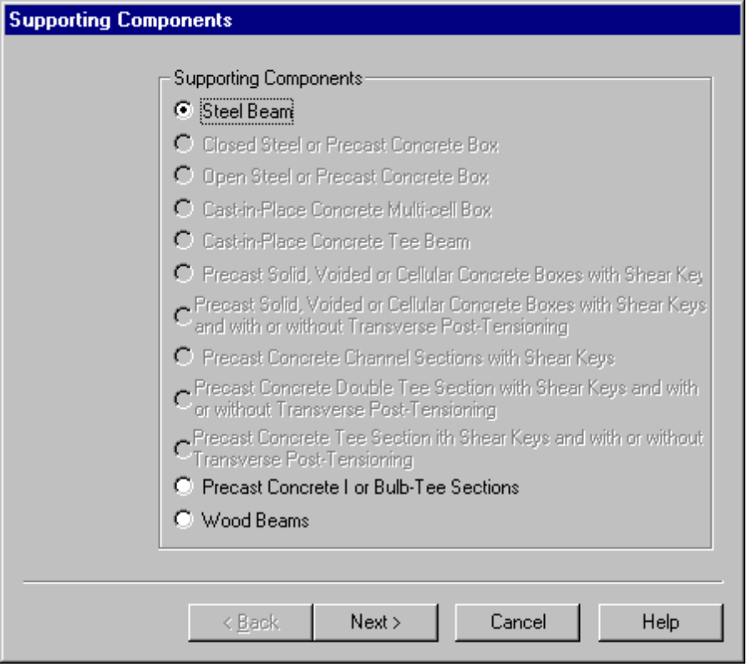
Figure 4-9 - Supporting Components
The following table shows the component types and which sections they corresponds to in the LRFD table.

Supporting Component Type | Section from LRFD Table
Steel beam (Plate girder and wide flange sections | Type A
Precast concrete I or Bulb T sections | Type K
Wood Beams | Type L

Step 2 - Deck Types
The Deck Types maps into the second column of the table. Your choice of deck types is dependent on the supporting component chosen in Step 1.

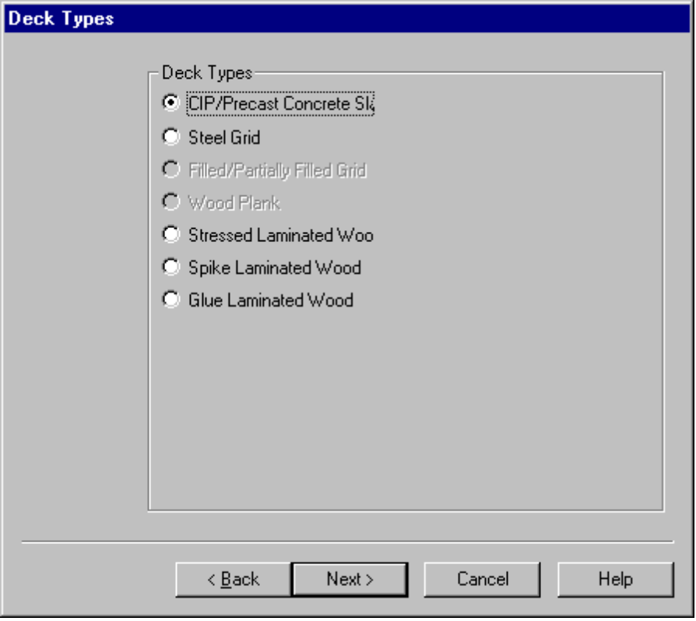
Figure 4-10 - Deck Types

Step 3 - Beam/Girder Description
The beam/girder description dialog box that appears is dependent on the type of component you chose in step 1. The three types, Steel Beam, Precast Concrete I or Bulb Tee Sections, and Concrete Wood Beam are described below.

Type 1 - Steel Beam

Beam/Girder description
Rolled Shape - When checked, select a wide flange section from the associated list. You may add your own rolled shapes to the list. See the last section of this chapter for instructions. When not checked, define the girder dimensions.
Top Flange
t Thickness of the top flange
w Width of the top flange
Web
t Thickness of the web
h Height of the web
Bottom Flange
t Thickness of the bottom flange
w Width of the bottom flange

Material Properties
Unit Weight/Density - Unit weight or density of the beam material.
Mod. E - Modulus of Elasticity of the beam material.

Girder Location
Select the appropriate girder location for your analysis. Girders are classified as interior or exterior. Section properties, effective flange width, and live load distribution factors are all functions of the girder location.

Beam/Girder layout
Cross Frames Check Box - When checked, the section is assumed to be sufficiently stiffened with cross frames to invoke the special provisions in Article 4.6.2.2.2d Paragraph 3 (distribution by the Statically Method).
Span Length - Span length used for computing live load distribution factors.
Girder Spacing - Average spacing of adjacent girders.
Num. Beams - Number of beams in the cross section.
Num. Lanes - Number of design lanes.

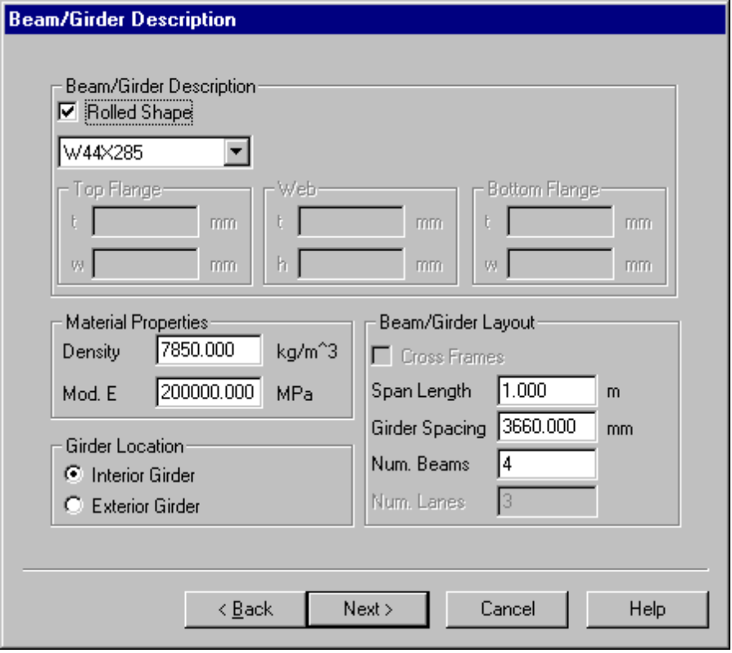
Figure 4-11 - Beam Girder Description

Type 2 - Concrete Beam
The Concrete/Beam Girder Description is very similar to the Steel beam.

Girder Properties
Standard Shape Check Box - When checked, select a predefined girder shape from the associated list. When not checked, describe the girder with its noncomposite section properties. You may add your own girder shapes by this list by modifying the file GIRDER.TBL. See the last section in this chapter.

Non-composite Properties
Ax - Cross sectional area
Iz - Moment of inertia about the horizontal centroidal axis
Yb - Distance from the bottom of the section to the cg of the section
H - Overall height of the section
Top Flg Width - Top flange width. Used for effective slab width calculations.
Web Width - Web width. Used for effective slab width calculations.

Material Properties
Unit Weight/Density - Unit weight or density of the beam material.
f’c - Compressive strength of the beam concrete.

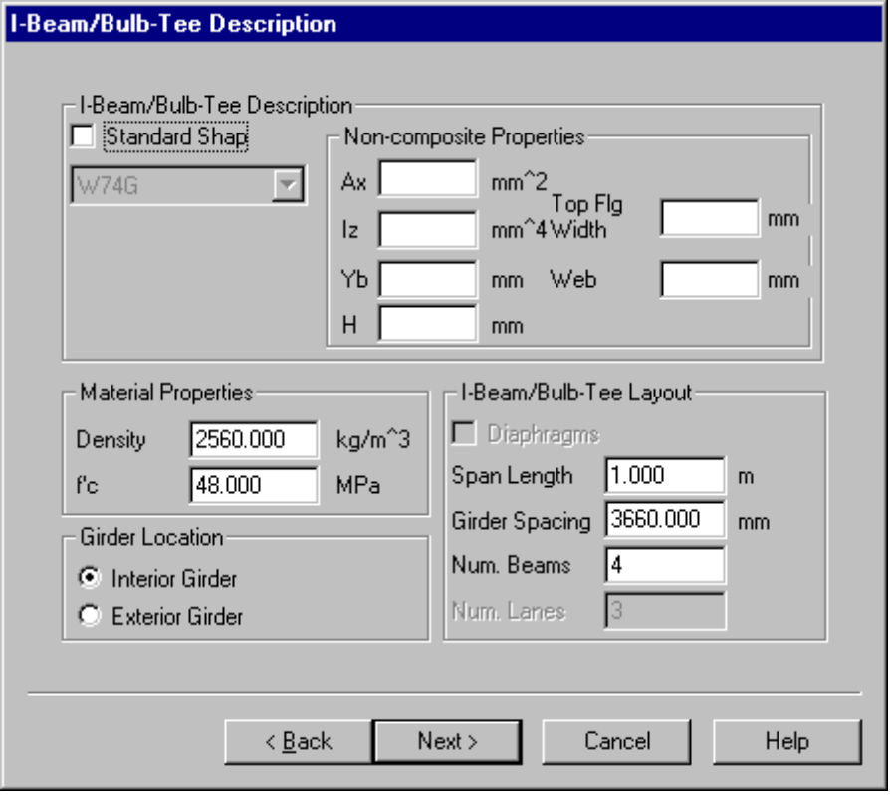
Figure 4-12 - I Beam/Bulb Tee Description

Girder Location
Select the appropriate girder location for your analysis. Girders are classified as interior or exterior. Section properties, effective flange width, and live load distribution factors are all functions of the girder location.

I-Beam/Bulb-Tee Layout
Diaphragms - When checked, the section is assumed to be sufficiently stiffened with diaphragms to invoke the special provisions in Article 4.6.2.2.2d Paragraph 3 (distribution by the Statical Method).
Span Length - Span length used for computing live load distribution factors.
Girder Spacing - Average spacing of adjacent girders.
Num. Beams - Number of beams in the cross section.
Num. Lanes - Number of design lanes.

Type 3 - Wood Beams
For Wood Beams, only layout information is required.

Wood Beam Description
Depth - Depth of the beam.
Width - Width of the beam.

Material Properties
Unit Weight/Density - Unit weight or density of the beam material.
Mod. E - Modulus of Elasticity of the beam material.

Girder Location
Select the appropriate girder location for your analysis. Girders are classified as interior or exterior. Live load distribution factors are a function of the girder location.

Beam/Girder Layout
Girder Spacing - Average spacing of adjacent girders.

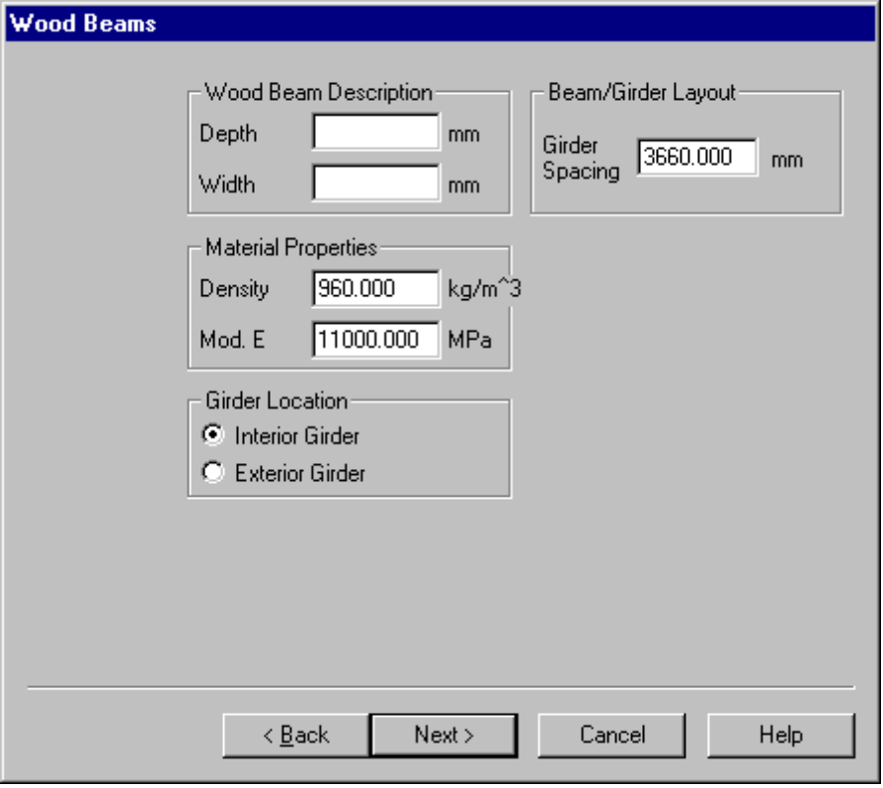
Figure 4-13 - Wood Beams

Step 4 - Concrete Slab Description
The Slab description dialog box depends on what type slab you chose in step 2. There are Concrete Slab, Steel Grid, and Wood Slabs.

Type 1 - Concrete Slab

Concrete Slab Description
Slab Depth - Slab depth, excluding the slab pad.
Pad Depth - Depth of slab pad. The slab pad is the portion of the slab from the top of girder to the bottom of the main slab.
Sacrificial Depth - That portion of the slab depth that will be sacrificed for deterioration due to traffic and wheel friction. The sacrificial depth is considered as non-structural, and as such is not included in the section properties calculations. The sacrificial depth is used for computing the effective unit weight (effective density) of the section.
Slab Overhang - Distance from the centerline of an exterior girder to the edge of the slab.
de - Distance between the center of exterior beam and the interior edge of the curb or traffic barrier.

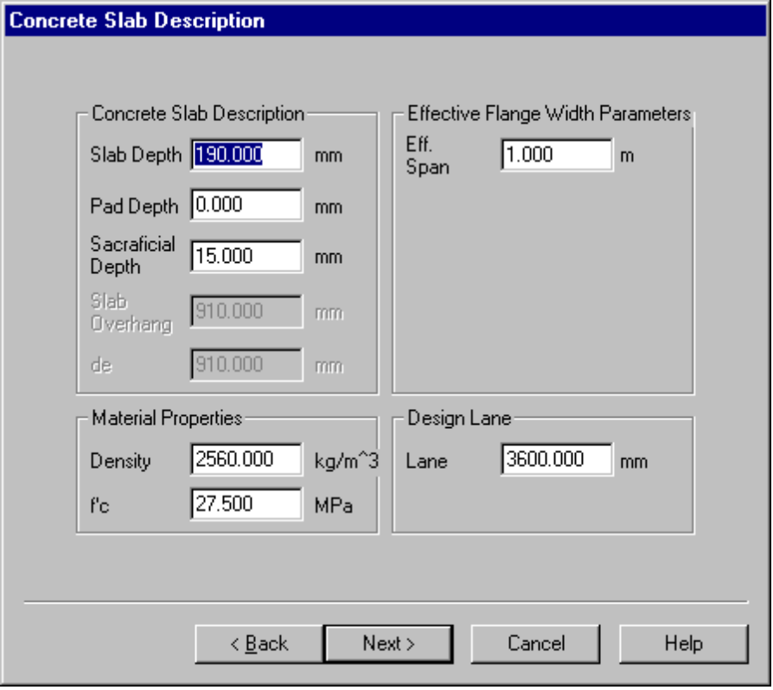
Figure 4-14 - Concrete Slab

Material Properties
Unit Weight/Density - Unit weight or density of the slab material.
f’c - Compressive strength of the slab.

Effective Flange Width Parameters
Eff. Span Length - Effective span length. This parameter is used in the computing the effective flange width of the slab.

Note - The Effective Slab Width is that width of slab that is participating in resisting the applied forces. The LRFD code (Article 4.6.2.6.1) gives three methods for computing the Effective Slab Width, the least of the three is used. Two of the methods are easy to compute. The third, requires the Effective Span Length. The Effective Span Length is the distance between points of dead load contraflexure. These points depend upon the section properties of the bridge and the section properties depend upon these points. As you can guess this gets into an iterative solution, which QConBridge and the Section Properties Calculator does not support. For this reason, you must supply the Effective Span Length. Fortunately, this third method of calculations rarely controls. If however, it does control the calculation, you must go back and adjust the effective span length and ultimately the section properties and live load distribution factors and re-do the entire analysis.

Design Lane
Lane Width - Width of the design lane. Used in Lever Rule and Statical Method calculations.

Type 2 - Steel Grid Deck Description

Steel Grid Deck Description
tg - Thickness of the decking
de - Distance between the center of exterior beam and the interior edge of the curb or traffic barrier.

Material Properties
Weight - Weight of the decking material.

Design Lane
Lane Width - Width of the design lane. Used in Lever Rule calculations.

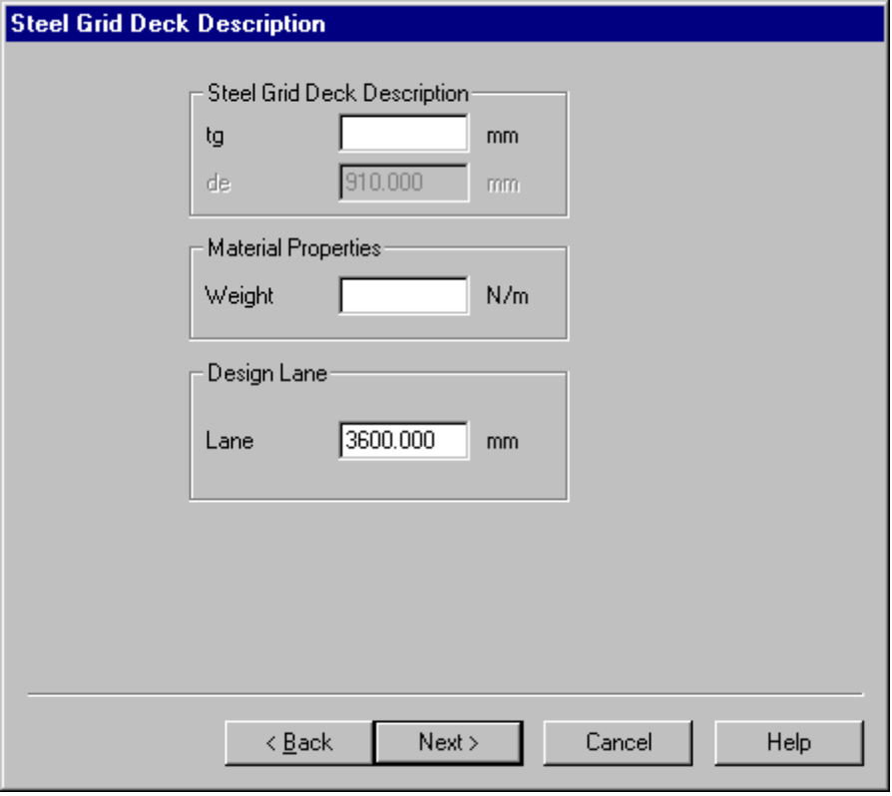
Figure 4-15 - Steel Grid Deck Description

Type 3 - Wood

Deck Description
Tributary Width - Width of deck contributing to the self-weight of the beam/deck system.
Depth - Depth of the deck.
De - Distance between the center of exterior beam and the interior edge of the curb or traffic barrier.

Material Properties
Unit Wgt/Density - Unit Weight/Density of the deck material.

Design Lane
Lane Width - Width of the design lane. Used in Lever Rule calculations.

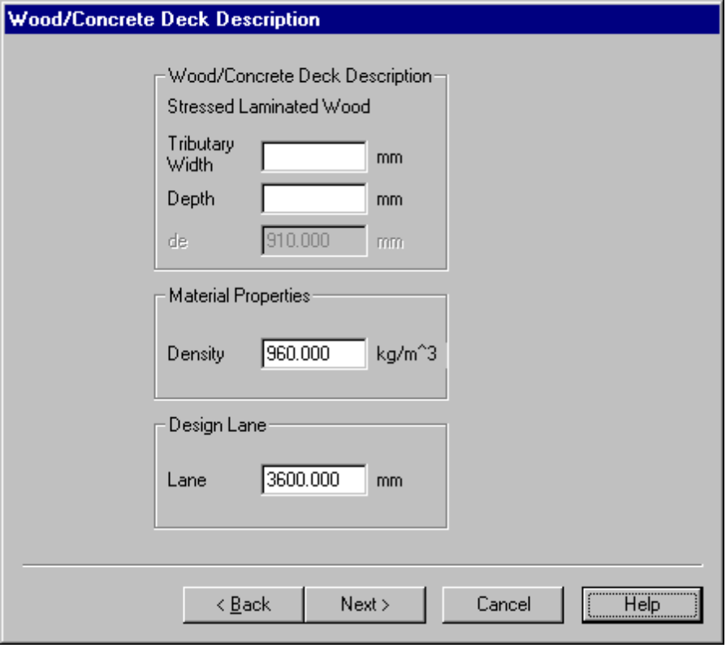
Figure 4-16 - Wood/Concrete Deck Description

Step 5 - Skew Corrections
QConBridge allows you to enter a correction factor if the bridge has skewed ends. Check the boxes if you need to apply the skew corrections and enter the skew angle.

Correct Moment of Skew Effects Check Box - When checked, live load distribution factors for moment are corrected for skew effects.
Correct Shear for Skew Effects Check Box - When checked, live load distribution factors for shear are corrected for skew effects.
Skew Angle - The skew angle.

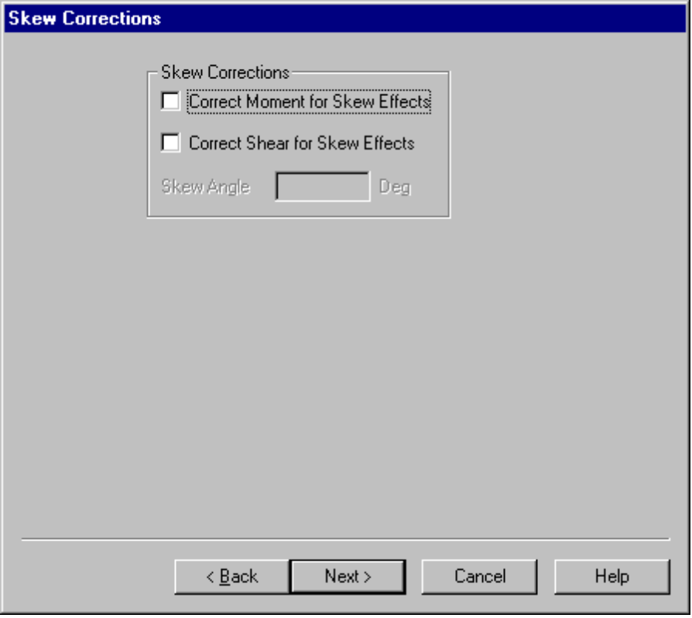
Figure 4-17 - Skew Corrections

Step 6 - Properties and Distribution Factors
QConBridge displays the results of the calculation. Click Print to get a hardcopy. The results of the calculations are automatically copied into QConBridge’s span segment description fields

Girder Properties
Ax - Cross sectional area
Iz - Moment of inertia about the horizontal centroidal axis
CG - Center of gravity measured from the bottom of the girder

Slab Properties
Eff. Flange Width - Effective flange width of the slab
Mod. E - Modulus of elasticity of the slab

Composite Properties
Ax - Cross sectional area of the composite section
Iz - Moment of inertia of composite section about the horizontal centroidal axis
CG - Center of gravity of the composite section measured from the bottom of the girder
Eff. Unit Weight/Eff. Density - Effective unit weight or density of the composite section. The effective unit weight or density of the section gives the same selfweight of the transformed composite section as the selfweight of the nontransformed gross section.
Mod. E - Modulus of elasticity of the composite section
n - Modular ratio of the composite section

Distribution Factors
eg - Distance between the centers of gravity of the basic beam and deck.
Kg - Kg is a parameter relating to the longitudinal stiffness of the section

Strength/Service Limit States
Moment - 1 Loaded Lane - Live load distribution factor for moment for one loaded lane
Moment - 2+ Loaded Lanes - Live load distribution factor for moment for two or more loaded lanes
Shear - 1 Loaded Lane - Live load distribution factor for shear for one loaded lane
Shear - 2+ Loaded Lanes - Live load distribution factor for shear for two or more loaded lanes

Fatigue Limit State
gMoment - Live load distribution factor for moment
gShear - Live load distribution factor for shear

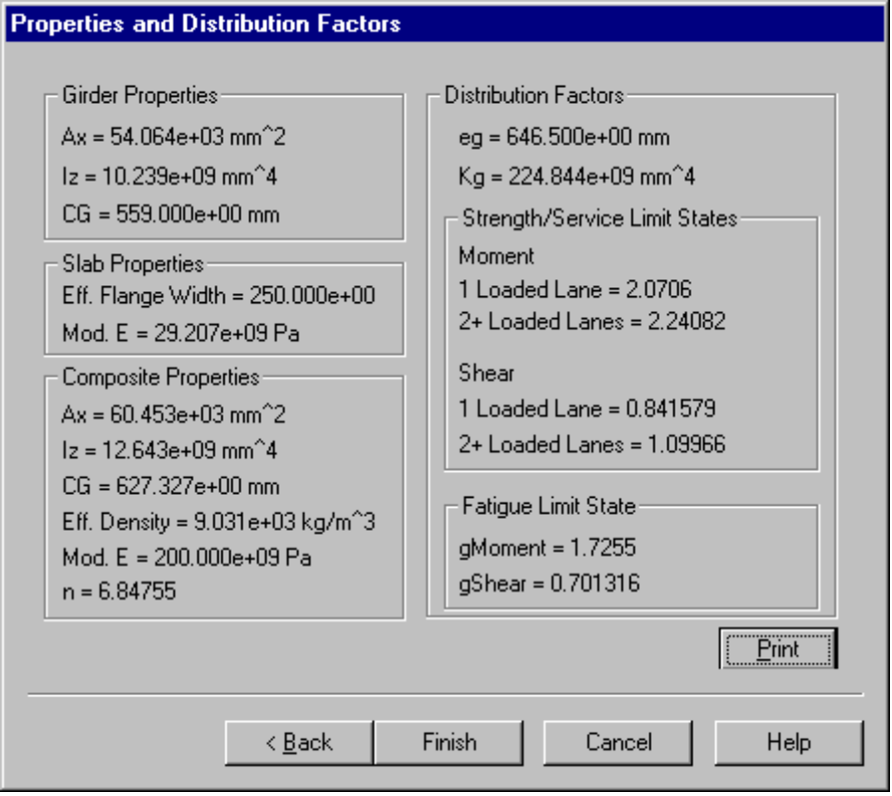
Figure 4-18 - Results

Adding Your Own I-Beam/Bulb-Tee and Wide Flange Sections
You may add to the types of predefined I-Beam/Bulb-Tee and Wide Flanges sections available in the Section Properties Calculator by simply editing a couple of ASCII text files.

For I-Beam/Bulb-Tee sections, use a plain text editor to edit GIRDER.TBL. Fill in the dimensions for I-Beam and Bulb-Tee girders as shown below.

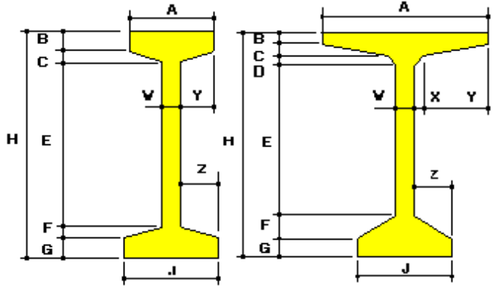
Figure 4-19 - I-Beam/Bulb Tee girder dimensions for girder.tbl file
For Wide Flange sections use a plain text editor to edit WFLANGE.TBL. Fill in the dimensions shown in the file.

