Adding and Modifying Loads
Introduction
Standard Loads
To Add/Edit a Standard Load
DC Loads
Generating self-weight
Traffic Barrier
DW Loads
Utilities
Overlay
Concentrated Load
To Add a Concentrated Load
Load Parameters
Load Case
To Edit a Concentrated Load
Uniform Load
To Add a Uniform Load
Load Parameters
Load Case
To Edit a Uniform Load
Live Load Generation Parameters
To Edit the Live Load Generation Parameters
Design Tandem
Design Truck
Dual Truck Train
Variable Headway Spacing Parameters
Dual Tandem Train
Variable Headway Spacing Parameters
Fatigue Truck
Dynamic Load Allowance
To Edit the Dynamic Load Allowance Factors
Pedestrian Live Load
To Edit the Pedestrian Live Load Value
Load Factors
To View/Edit the Load Factors

Introduction
Once you have a bridge model, you can add and modify loads. QConBridge supports dead load, HL93 live load (including the optional dual tandem truck train), fatigue truck, and pedestrian live load cases. Load combinations are performed for the Strength I, Service I, Service II, Service III, and Fatigue limit states.
For more information on the LRFD load requirements, see Section 3 of the AASHTO LRFD Bridge Design Specification.

This chapter covers adding and modifying Standard Loads, Concentrated Loads, Uniform Loads and the Pedestrian Live Load. It describes the Live Load Generation Parameters, the Dynamic Load Allowance Factors and the Load Factors for each Limit State.

For information on copying, moving and deleting Concentrated and Uniform loads, see the last sections of Chapter 3, Editing Techniques.

Standard Loads
Standard loads are loads that are commonly found on most all bridges. QConBridge allows you to include these loads in the analysis without having to go through the extra work of calculating and adding loads. These loads include the weight of all components of the structure, appurtenances, attached utilities and overlays. QConBridge models these loads as uniform loads applied over the entire length of the bridge. The standard loads are shown as enabled or disabled in the general information at the top of the bridge model in the Editor View.

To Add/Edit a Standard Load
8 1. From the Loads menu, choose Standard Dead Loads (Alt, L, S).
The Standard Dead Loads dialog box appears.
2. Select the desired tab and make your changes.
3. Click OK to save.

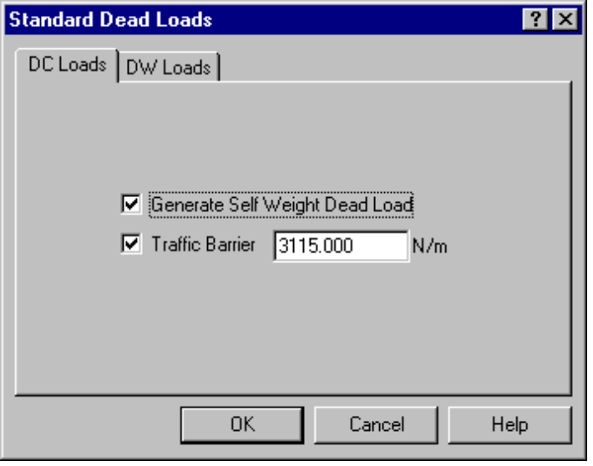
Figure 5-1- DC Loads tab

DC Loads
DC loads are dead loads of structural components and nonstructural attachments. These loads are applied to the DC load case.

- To include either one of these loads, simply check the appropriate box on the DC Loads tab.
- For Traffic Barrier, enter a value. The weight of the barrier must be consistent with the type of model you have constructed.

Generating self-weight
When checked, the self weight of the structure is included in the DC load case. The program calculates the weight as cross-sectional area times unit weight for each segment in the model.

Traffic Barrier
If your bridge has a traffic barrier on it and you think it is significant, provide a value to include it in the model. Traffic Barrier loads are modeled as a uniform weight across the entire bridge.

DW Loads
DW loads are dead loads of wearing surfaces and utilities. These loads are applied to the DW load case

- To enter DW loads, select the DW Loads tab from the Standard Dead Loads dialog box, click the appropriate box and enter a value.

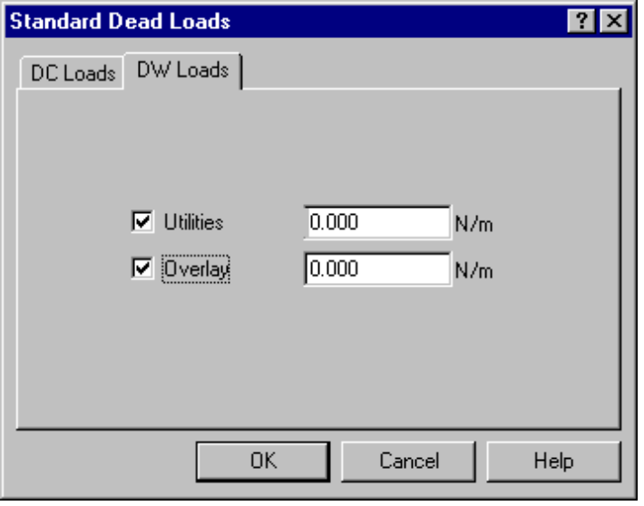
Figure 5-2 - DW Loads tab

Utilities
Utilities are modeled with a uniform load over the entire length of the bridge. Some types of utilities found on bridges are water lines and power lines.

Overlay
Overlay is additional material, for example, an asphalt overlay on top of bridge. It is not part of the slab. It’s applied on top of the slab. The weight of the overlay is modeled as a uniform load over the entire length of the bridge.

Note - If you have used the Section Properties Calculator and your slab has a sacrificial depth, then that weight is accounted for in the self weight and you probably wouldn’t want to use Overlay. Don’t include this weight twice.
Shown below, in Figure 5-3, is a bridge model with standard loads added to it. Notice that the Utility and Overlay loads are Disabled. This indicates that these loads are not applied to the model.

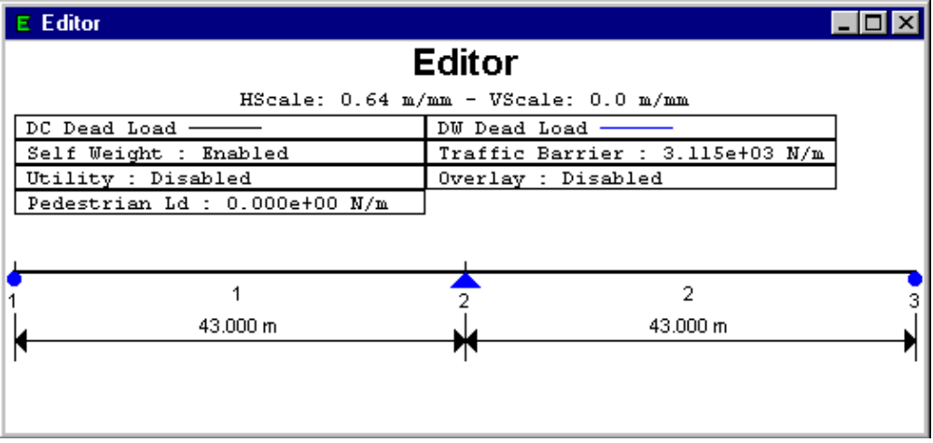
Figure 5-3- Standard Loads information shown in top of model

Concentrated Load
Concentrated Loads can be added to your bridge model. A load is applied at some location measured from the left-hand side of a span. The load can be easily applied to one or all spans. Concentrated loads are shown as arrows on the bridge model (See Figure 5-5).

To Add a Concentrated Load
1. Select the span onto which you want to add the concentrated load.
 8 2. From the Loads menu, choose Add Concentrated Load(Alt, L, C).
The Concentrated Load dialog box appears.
3. Describe the load.
4. Click OK to save.

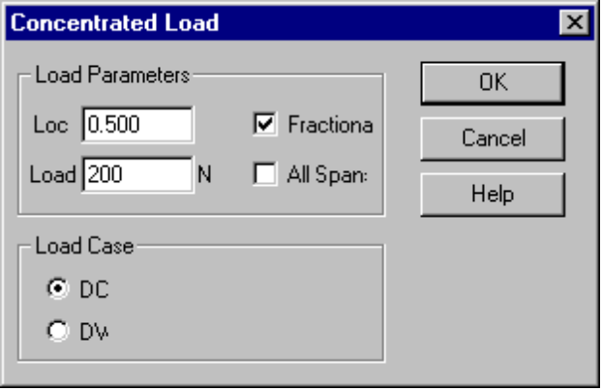
Figure 5-4 - Concentrated Load dialog box

Load Parameters
Location - Enter either an absolute distance or a fractional distance (a number between 0 and 1), from the left-hand side of the span.
Fractional - Check this box if you want the load to be a fractional distance on the span.
Load - Enter the magnitude of the load. Loads with magnitudes greater than zero are applied in a downward direction, likewise, loads with magnitudes greater than zero are applied in an upwards direction.
All Spans - Check this box to apply the load to all spans in the model at the distance and value indicated.

Note -Applying the load to all spans works best if the location of the load is described with a fractional measure. When describing the load with an absolute distance, you must make certain that the load is not positioned beyond the end of any of the spans.

Load Case
Select either the DC or DW load case.

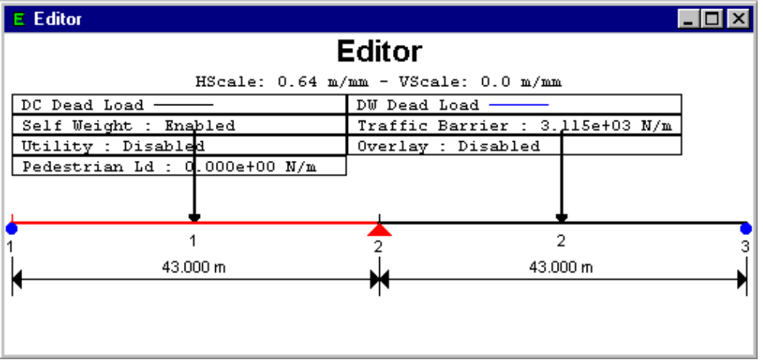
Figure 5-5 - Model with Concentrated Load on all Spans

To Edit a Concentrated Load
1. Double-click the load you want to edit.
The Concentrated Load dialog box appears (without the All Spans box).
2. Make your changes and click OK to save.
OR
1. Select the load you want to edit.
8 2. From the Loads menu, choose Edit Load (Alt, L, C).
The Concentrated Load dialog box appears (without the All Spans box).
3. Make your changes and click OK to save.

Uniform Load
Modeling uniform Loads is the same as for concentrated loads except they are located with a starting and ending location instead of a single location. Uniform loads are shown as a series of arrows on the bridge model (see Figure 5-7).

To Add a Uniform Load
1. Select the span onto which you want to add the load.
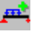 8 2. From the Loads menu, choose Add Uniform Load (Alt, L, U).
The Uniform Load dialog box appears.
3. Describe the load.
4. Click OK to save.

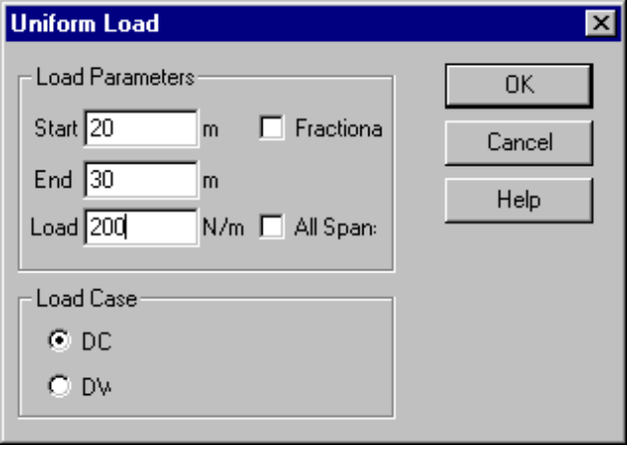
Figure 5-6 - Uniform Load dialog box

Load Parameters
Start - Starting location of the load measured from the left-hand side of the span in absolute or fractional distance.
End - Ending location of the load measured from the left-hand side of the span in absolute or fractional distance.
Fractional - When checked, Start and End are a fractional measurement.
Load - The magnitude of the load. Positive values indicate a downward load.
All Spans - When checked, this load applies to all spans.

Load Case
Select either DC or DW to apply for this load.

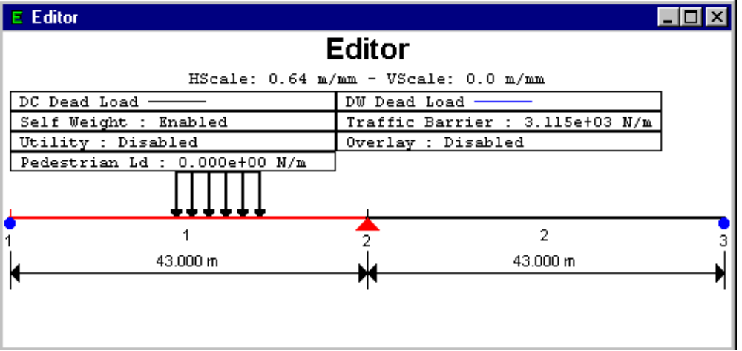
Figure 5-7-Example of Uniform Load on Bridge Model

To Edit a Uniform Load
1. Double-click the load you want to edit.
The Uniform Load dialog box appears.
OR
1. Select the load you want to edit.
8 2. From the Loads menu, choose Edit Load (Alt, L, E).
The Uniform Load dialog box appears. (All Spans box not included.)
3. Make your changes and click OK to save.

Live Load Generation Parameters
The Live Load Generation Parameters dialog box is used to edit the live load generation parameters. These parameters control the how the HL93 Live Load model is applied to the structure. QConBridge is capable of analyzing your model for five of the six parts of the HL93 live load model (the optional live load for deflection is not supported at this time). You have the ability to analyze your structure for any or all of the five components of the live load model.

To Edit the Live Load Generation Parameters
- From the Loads menu, choose Live Load Gen Parameters (Alt, L, L).
The Live Load Generation Parameters dialog box appears.
- Select the desired tab and make your changes.
- Click OK to save.

Each tab controls the parameters for an element of the model. If you don’t want to consider that element of the live load model, check the disable box. The more elements you use, the longer the analysis time. The elements are discussed in the following sections.

Design Tandem
The Design Tandem is a fixed axle truck so there is nothing to configure. You either consider this element in the live load model, or not.
- Check Disable Load Generation to disable.

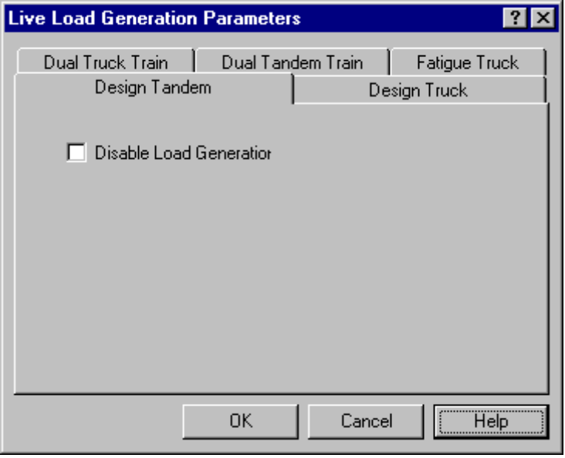
Figure 5-8 - Design Tandem tab

Design Truck
The Design Truck is a 3 axle truck. The rear axle spacing varies between 4.300 and 9.000 m. This parameter defines the number of times to divide this spacing. If the number of spacings is 1, 4.300 m is used. If the number of spacings is 2, 4.300 and 9.000 m are used. If the number of spacings is 3 or more, 4.300 and 9.000 m are used as well as (n-2) spaces at 4.300 + (9.000 - 4.300) / (n - 1) m.

- Check Disable Load Generation to NOT use this loading
OR
- Enter the number of rear axle spacings to be used for live load generation.

Note - The more spacings you use, the more refined the analysis and the longer it takes. Usually one axle spacing of 4.300 m is the controlling case.

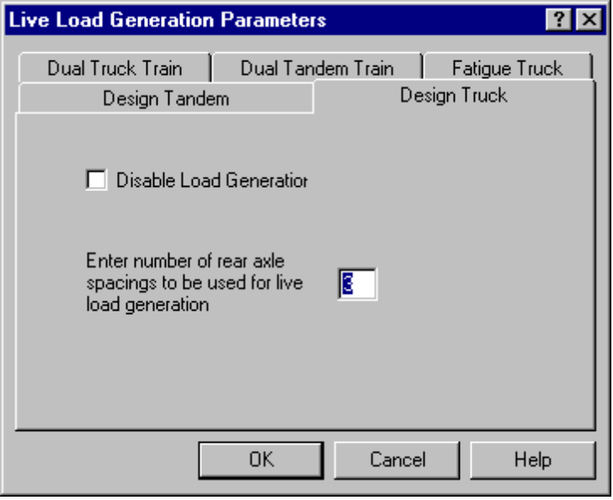
Figure 5-9 - Design Truck tab

Dual Truck Train
The Dual Truck Train and Dual Tandem Train are used to calculate the negative moment between the points of contraflecture under a uniform load on all spans.

In some instances it may be expedient to neglect the Dual Truck Train loading. Simple span bridges is such a case.

- Check the Disable Load Generation to NOT consider the Dual Truck Train.

Variable Headway Spacing Parameters
The headway spacing between the last axle of the leading truck and the first axle of the trailing truck must be a minimum of 15m. The code does not provide an upper bound on the maximum headway spacing. The ranges are divided into increments using similar rules to that of the Design Truck. The more increments you use, the more refined the analysis and the longer it takes.

You may use up to three ranges. Each range has a minimum and maximum spacing and the number of increments into which the range is divided. The primary reason to have three ranges is to model trucks in adjacent spans, the same span and alternating spans as shown in Figure 5-10 below.
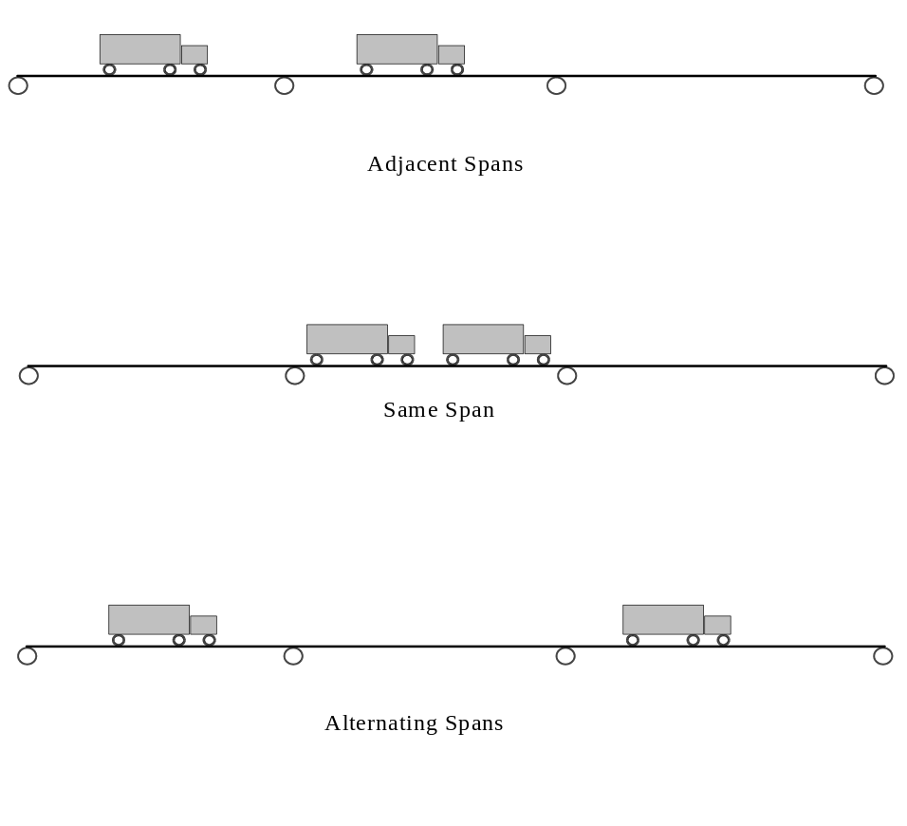
Figure 5-10 - Three range possibilities to model variable headway spacing
- Enter a lower and upper bound, and number of increments.
- Check the box next to the 2nd and 3rd ranges to activate. Enter a lower and upper bound, and number of increments for each range checked.

Note - You can change the low range default of 15.000 m. The program will not give you an error. Remember -The more increments, the longer the calculations will take. You can set up to 3 ranges. For example, you can use 15.000 m to 100.000 m at 5 increments which is rather coarse grained and a second range of 15.000 m to 20.000m at 30 increments for really fine grained.

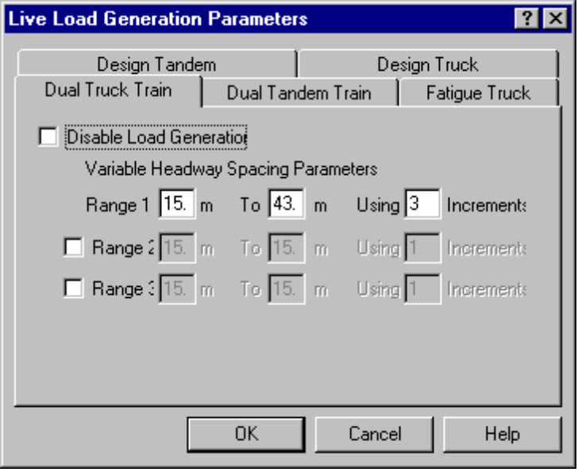
Figure 5-11 - Dual Truck Train tab

Dual Tandem Train
The Dual Tandem Train works similarly to the Dual Truck Train. It is an optional loading as described by commentary article C3.6.1.3.1 and is disabled by default. In some instances, such as simple span bridges, it may be expedient to neglect the dual tandem train loading. When checked, the dual tandem train loading is not used.

- Check Disable Load Generation to NOT use the Dual Tandem Train loading.

Variable Headway Spacing Parameters
The headway spacing between the last axle of the leading truck and the first axle of the trailing truck must be a minimum of 8.000m and a maximum of 12.000m. You may use up to three ranges for headway spacing. Each range has a minimum and maximum spacing and the number of spaces into which the range is divided. The ranges are divided using similar rules to that of the Design Truck.

- Enter a lower and upper bound, and number of increments.
- Check the box next to the 2nd and 3rd ranges to activate. Enter a lower and upper bound, and number of increments for each range checked.
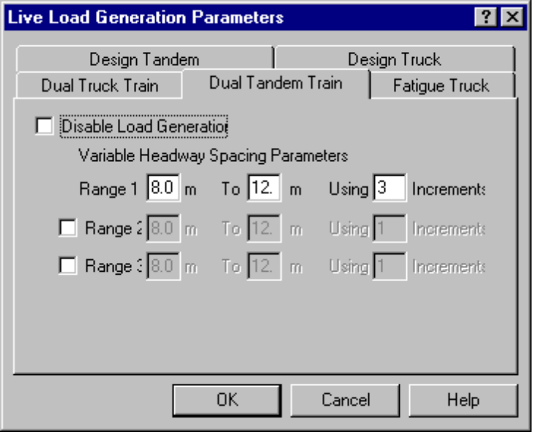
Figure 5-12 - Dual Tandem Train tab

Fatigue Truck
For certain types of bridges, Fatigue Trucks are not considerations. But, for example, in steel bridges, Fatigue is a real consideration Refer to Article 3.6 of the code.

- Check Disable Load Generation to NOT use the Fatigue Truck loading.

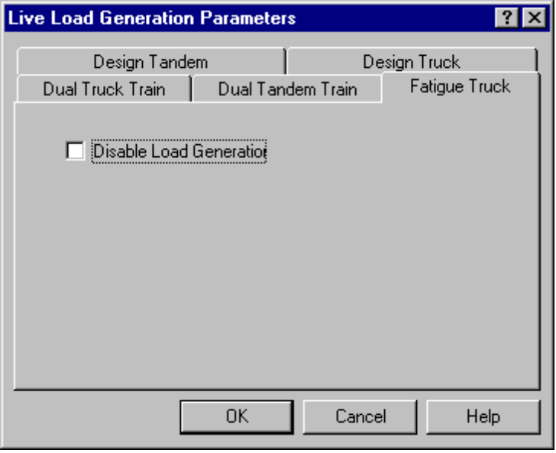
Figure 5-13 - Fatigue Truck tab

Dynamic Load Allowance
The Dynamic Load Allowance factors are applied to force effects from the design truck, design tandem, design lane load and fatigue truck. Use the Dynamic Load Allowance factors dialog box to edit the values. The default values are consistent with the LRFD code, so you rarely need to change them.

Code References: 3.6.1.2.2, 3.6.1.2.3, 3.6.1.2.4, 3.6.2

To Edit the Dynamic Load Allowance Factors
1. From the Loads menu, choose Dynamic Load Allowance (Alt, L, D).
The Dynamic Load Allowance dialog box appears containing the code values.
2. Make your changes and click OK to save.

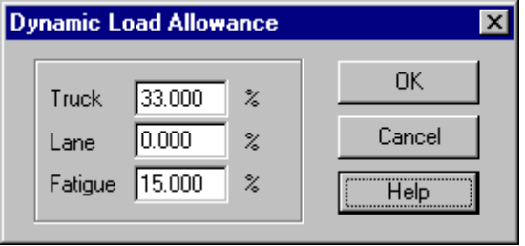
Figure 5-14 - Dynamic Load Allowance dialog box
Note - If for some reason you need to scale a component of the live load model, it can be done indirectly through the Dynamic Load Allowance dialog. For example, if you needed to increase the weight of the Design Truck and Design Tandem by 25%, the Dynamic Load Allowance Factor would become 1.33 * 1.25 = 1.6625 or 66.25%. Note that in this example both the Design Tandem and Design Truck are scaled up by 25%. This increased weight is used for the Design Tandem, Design Truck, Dual Truck Train and Dual Tandem Train loadings.

Pedestrian Live Load
The Pedestrian Live Load is applied across the entire bridge as a uniform load. It is considered simultaneous with truck traffic and is included in the Live Load Calculations. The case of pedestrian only bridges is not considered.

The Pedestrian Load Dialog is used to define a pedestrian live load. The Code Reference for calculating the values is Article 3.6.1.6.

To Edit the Pedestrian Live Load Value
- From the Loads menu, choose Pedestrian Live Load (Alt, L, P).
The Pedestrian Live Load dialog box appears.
2. Make your changes and click OK to save.

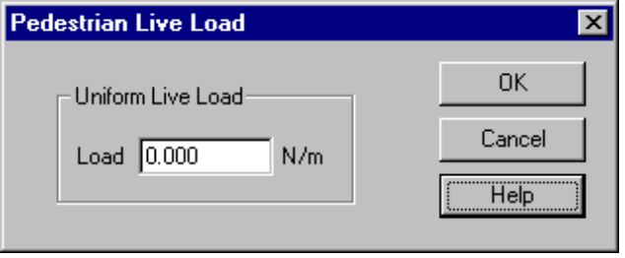
Figure 5-15 - Pedestrian Live Load dialog box

Load Factors
As a last step before analysis, you may want to look at the Load Factors for each limit state. They default to the code values so there is usually no reason to change them. The code reference is Article 3.4.

To View/Edit the Load Factors
- From the Bridge Menu, choose Load Factors (Alt, B, L).
The Load Factors dialog box appears.
- Select the desired tab, make any changes.
- Click OK to save.

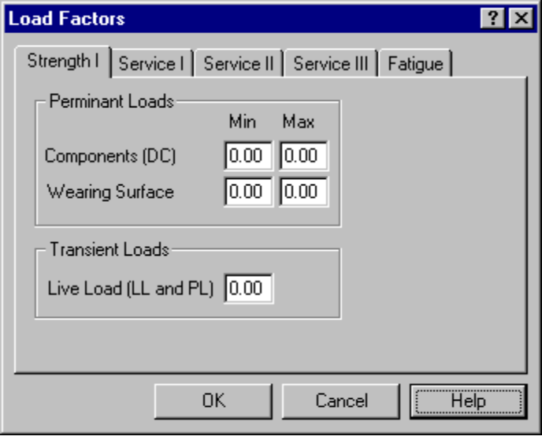
Figure 5-16 - Load Factors, Strength I tab
Permanent Loads
Permanent loads belong to either the DC (dead load of components) or DW (dead load of wearing surface) load cases. The Strength I limit state requires minimum and maximum values. The remaining limit states do not.

Transient Loads
Truck and pedestrian live load belong to the LL and PL load cases, respectively. The same load factor is used for both cases.

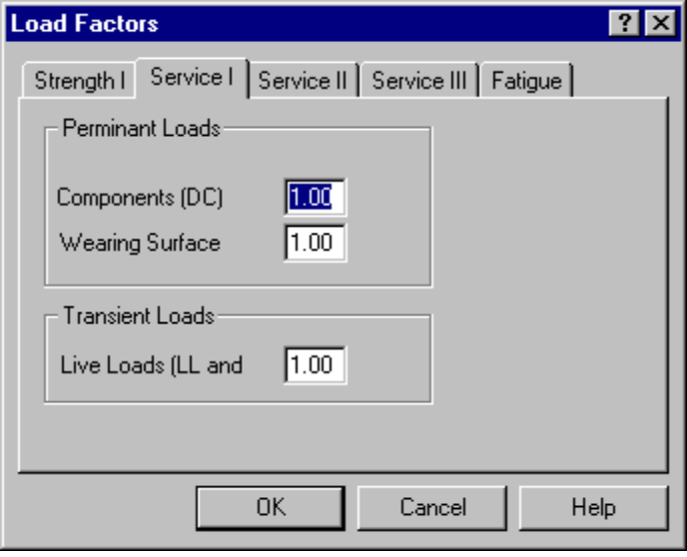
Figure 5-17 - Load Factors, Service I tab

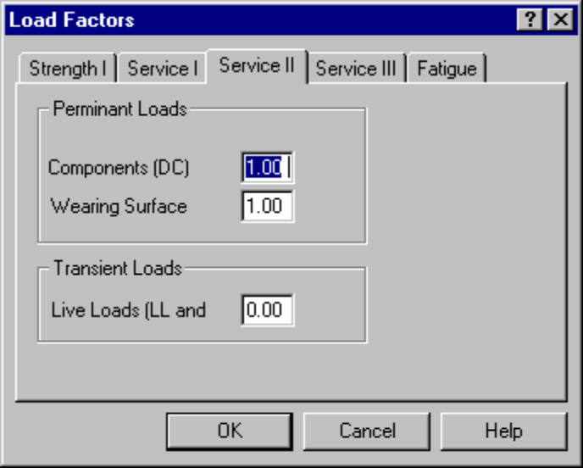
Figure 5-18 - Load Factors, Service II tab
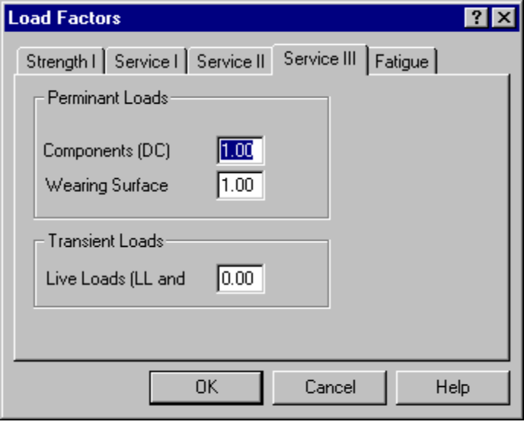
Figure 5-19 - Load Factors, Service III tab

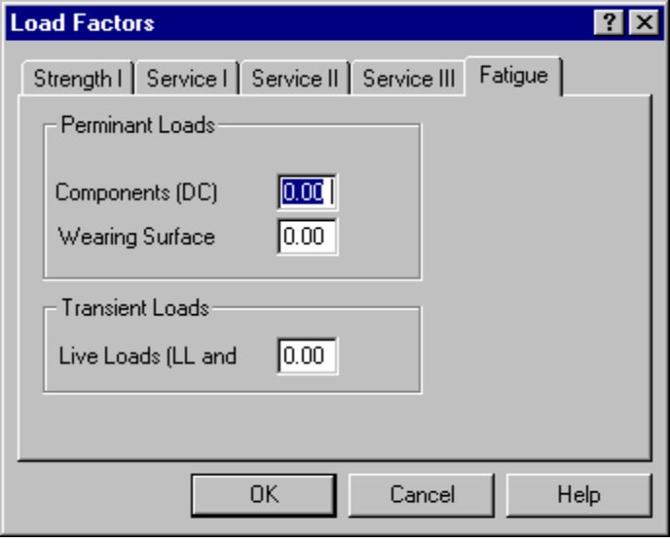
Figure 5-20 - Load Factors, Fatigue tab
Now you are ready to do the analysis and view the results.

In SI units, the unit weight is equal to density times a gravitational acceleration of 9.81 m/s²

