Analyzing the Model
Introduction
Analyzing the Model
To Run the Analysis

Introduction
Once you build your bridge model, adding spans, supports and loads; you want to do the analysis so you can view the results. This is accomplished easily in QConBridge by either clicking the Analysis icon on the toolbar or choosing Analysis from the Bridge menu.

This chapter describes how to run the analysis for your bridge model.

Analyzing the Model
QConBridge analyzes the bridge model to give you results. Usually you do the analysis after adding loads and including the Live Load Generation Parameters you want for your model.

There are two ways to start the analysis. Click the Analysis icon on the toolbar to start the analysis immediately using the default 10 points per span. If you want to change the points, choose the Analysis command from the Bridge menu.

To Run the Analysis
- Click Analyze  on the Toolbar.

OR

- From the Bridge menu, choose Analysis (Alt, B, A).
The Analysis Parameter window appears.
Change the Minimum Number of Analysis Points value and click OK.

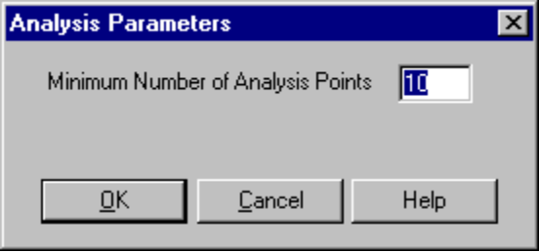
Figure 6-1 - Analysis Parameters window
QConBridge starts the analysis showing you the progress of the Live Load Generation elements you included. The Processing Design Truck Progress window is shown below.

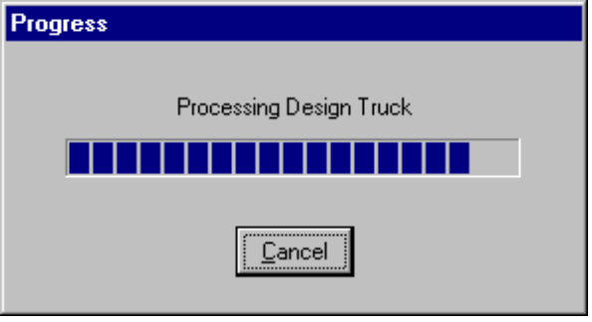
Figure 6-2 -A Progress window
- Click Cancel at anytime to cancel the Analysis.
- When the analysis is complete, the Analysis Completed Successfully window appears.
- Click OK.

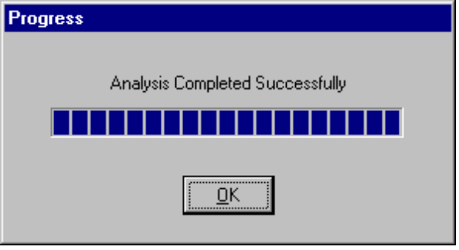
Figure 6-3 - Progress window - Analysis Complete message.
Now you are ready to view the results of the analysis.

