Reviewing Results
Introduction
Diagram Views
To View a Shear Diagram
To View a Moment Diagram
Interpreting the Diagrams
Anatomy of the Diagram
Title
Scale
Legend
Per Lane Basis note
Interpreting the Results
Dead Loads
Individual (Basic) Live Loads
Combination Loadings
Tabular Results
To View a Table
Changing the Points
Report
To View a Report
Changing Options
To Edit Options
Decorations
Screen Plot and Printer Plot Styles

Introduction
QConBridge offers several ways for you to view the results of your analysis. You can see the results in Moment and Shear diagrams, in tabular format and a comprehensive report. You may print a hardcopy of all the formats and export the table and report information to a text file.

This chapter describes the different ways you can view the results and how to interpret them. See Chapter 8 for information on printing, sending and exporting.

Note - You must run the analysis before viewing results. If you do not, you get the message “Results not available” when choosing a view from the View menu.

Diagram Views
The Moment and Shear diagram views work similarly. View as many loadings as you want on one diagram or spread them between several diagram windows.

To View a Shear Diagram
 1. From the View menu, choose Shear Diagram (Alt, V, S).
The Shear Diagram window is displayed. You need to select the loading you want to diagram.

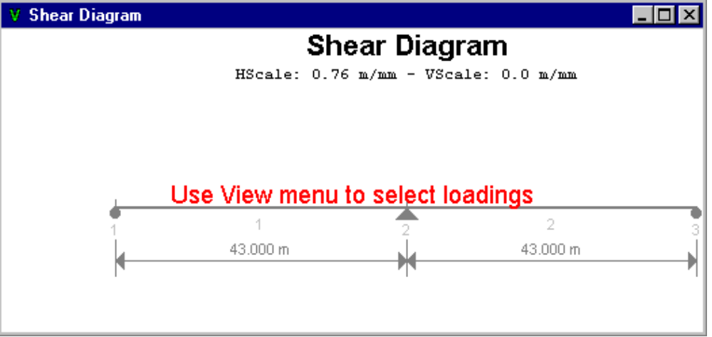
Figure 7-1- Shear Diagram window
8 2. From the View menu, choose Select Loading (Alt, S, L).
The Select Loadings dialog box appears.

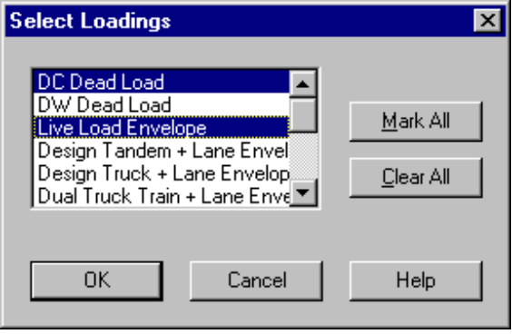
Figure 7-2 - Select Loading dialog box
3. Select any loading or group of loadings to diagram. Click Mark All to select all 14 loadings. Click Clear All to clear all loadings you marked.
4. Click OK to save.
The Shear Diagram window appears with the results for the loadings you selected.

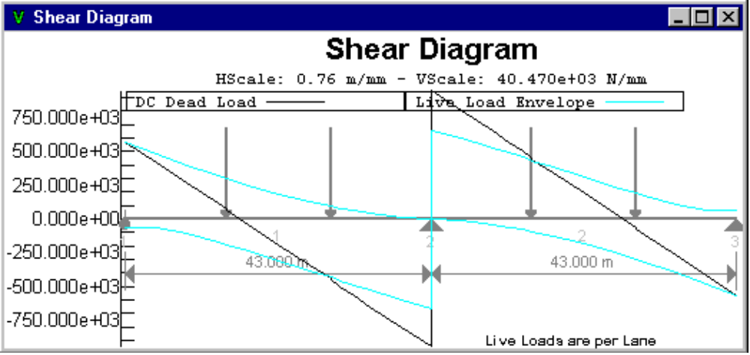
Figure 7-3 - Shear Diagram

To View a Moment Diagram
 1. From the View menu, choose Moment Diagram (Alt, V, M).
The Moment Diagram window is displayed.

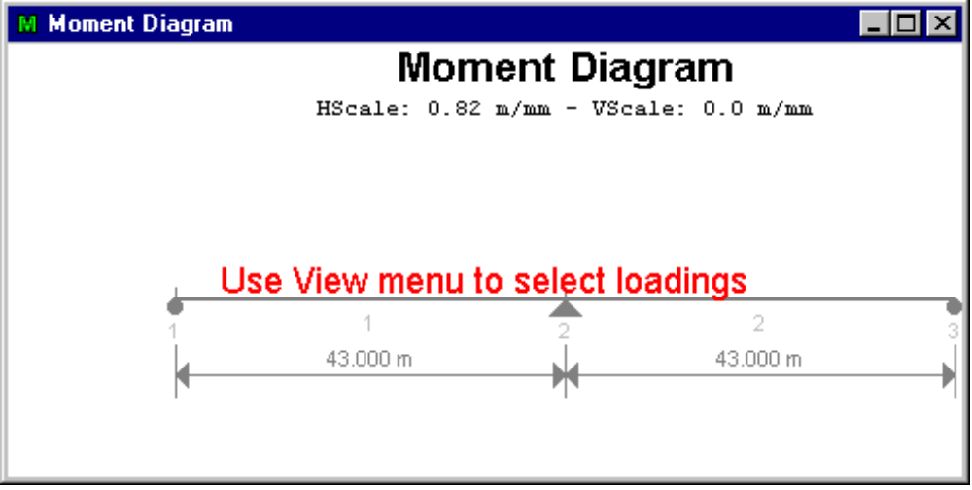
Figure 7-4 - Moment Diagram window
Now select the loadings you want to diagram by following steps 3 and 4 in the instructions above for viewing the Shear diagram.

Once you select your loadings in the Select Loadings dialog box and click OK, QConBridge diagrams the results as shown in Figure 7-5.

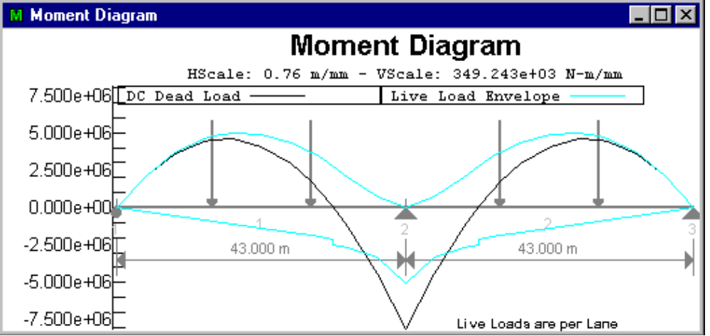
Figure 7-5 - Moment Diagram
Remember - You can size the Diagram window (like any other window) to increase or decrease the size. Since you may have several Diagram windows open at the same time, you can arrange them on your screen by using the commands under Window on the main menu (See Appendix).

Interpreting the Diagrams
The Moment and Shear diagrams are represented in essentially the same way. The following sections describe in detail the different parts of the diagrams and how to interpret them.

Anatomy of the Diagram
This section describes the parts of a diagram window.

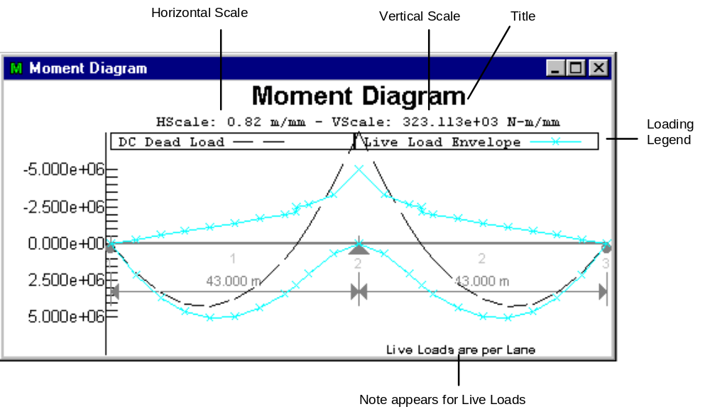
Figure 7-6 - Parts of a Diagram view

Title
The title, Moment or Shear Diagram, appears at the top.

Scale
HScale is the Horizontal scale and VScale is the Vertical scale.

QConBridge has an intelligent scale selector. Different scales are selected for the screen and for the printer. Diagrams drawn on the screen use whatever scale is necessary to maximize the usage of the window. As you increase or decrease the size of the window, the scale changes.

Diagrams drawn on the printer use the best engineering scale for the size of paper selected. The engineering scales are chosen from the ones listed in the following table, figure 7-7.

You can pick whatever size paper your printer supports. See Chapter 8, Printing.
SI Units | Traditional US Units
1:500 | 1:10
1:1000 | 1:20
1:1250 | 1:30
1:1500 | 1:40
1:2000 | 1:50
1:2500 | 1:60
Figure 7-7 - Print scale choices

Legend
The legend at the top of the diagram shows the color and/or symbol that represents each loading. Each selected loading is shown. There can be up to 14 loadings in one diagram. Use the Display command from the Options menu to choose the loading representations. See “Changing Options” later in this chapter.

Per Lane Basis note
The note in the bottom right hand corner, “Live Loads are on a per lane basis” appears when you are viewing the results for an individual live load. This is a reminder that the results are on a per lane basis. The Live Load distribution factors are not applied to the individual live load cases.

Note - The note only appears for basic live load cases. Dead Loads and Combination (Strength I, Service I-III) loadings are in the context of however you built the bridge model. These points are discussed in more detail in the following section..

Interpreting the Results
In order to properly interpret the results, you must know which factors are applied to which results.
How you interpret the loadings is based on the type of loading. They are divided into three categories: Dead Loads, Individual or Basic Live Loads, and Combination Loads.

Dead Loads
The results for both the DC and DW Dead Load cases are on the basis of however you built the model. If you are doing a per girder analysis then it is per girder. If you are doing a full bridge width analysis then the results are on a full bridge width basis.

Individual (Basic) Live Loads
The force effects for the Individual live loads are computed on a per lane basis.

- Live Load + Impact = (Truck * IMtruck + Lane * IMlane)

The Dynamic Load Allowance Factors (a.k.a. Impact Factors) have been applied to the truck and the lane loads and added together. Live Load Distribution factors are NOT included in these numbers.

Live Load Envelope
This is the envelope of Design Tandem + Lane, Design Truck + Lane, Dual Truck Train + Lane and Dual Tandem Train + Lane. This envelope is used in the limit state load combinations, except for Fatigue.

Design Tandem plus Lane Envelope
Design Tandem + Lane force effects are computed as (IMtruck)(Design Tandem) + (IMlane)(Lane Load).

Design Truck and Lane Envelope
Design Truck + Lane force effects are computed as (IMtruck)(Design Truck) + (IMlane)(Lane Load).

Dual Truck Train plus Lane Envelope
Dual Truck + Lane force effects are computed as 0.90[(IMtruck)(Design Truck) + (IMlane)(Lane Load)].

Dual Tandem Train plus Lane Envelope
Dual Tandem + Lane force effects are computed as (IMtruck)(Design Tandem) + (IMlane)(Lane Load).

Pedestrian
These force effects are on a per component basis.

Fatigue Truck
The Fatigue Truck is handled separately from the basic live loads and the pedestrian load. The force effects from the Fatigue Truck Envelope are on a per lane basis, and used in the Fatigue Limit State Combination.
Fatigue Truck force effects are computed as (IMfatigue)(Fatigue Truck)

Combination Loadings
The Combination Loadings are: Strength I, Service I-III, and the Fatigue Envelope. Their results are in the context of how the model was built (per girder, per full bridge width, etc.)

The Live Load Distribution Factors ARE applied to the Limit State Combinations. These limit state load combinations are consistent with Article 3.4.1 and Tables 3.4.1-1 and 3.4.1-2 of the LRFD specification.

Tabular Results
Tabular results are viewed similarly to the diagrams except only one loading can be selected at a time. The Title and Headings change to reflect the loading you have selected.

To View a Table
 1. From the View menu, choose Tabular Results (Alt, V, T).
The Tabular Results window appears telling you to use the View menu to choose a table.
2. From the View menu, choose Select Table (Alt, V, A).
The Select Loading dialog box appears. It is the same dialog box you use to select the loading for a diagram. Use it the same way, except choose one table at a time.

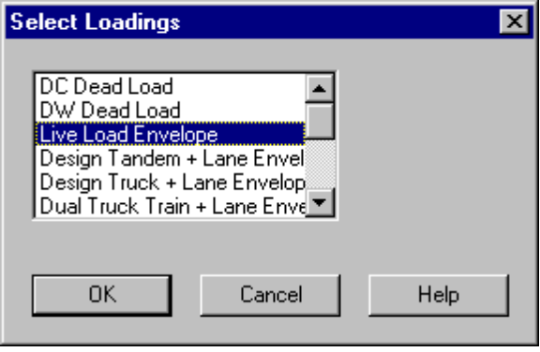
Figure 7-8 - Selecting the Live Load Envelope loading for tabular results
The Tabular Results window appears with the Table information for the loading indicated in the Select Loadings dialog box.

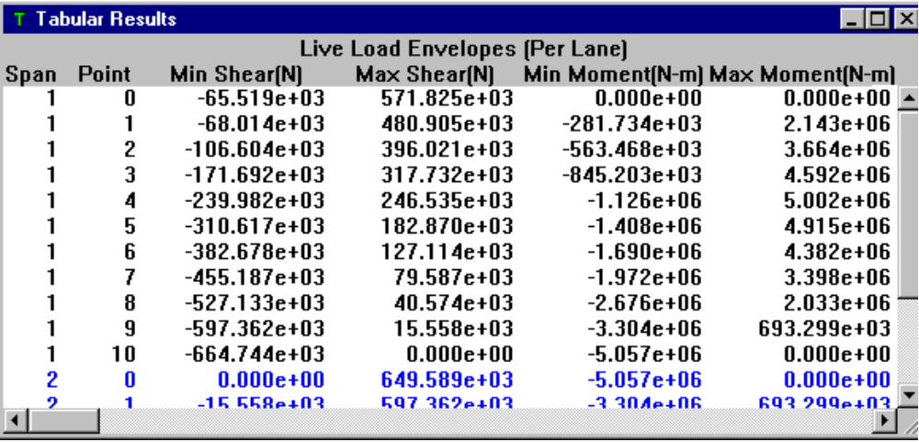Figure 7-9 - Tabular Results window - Live Load Envelope
The first two columns represent a location in the bridge. The next two columns in the table are the values of the Shear diagram and the last two are the values for the Moment diagram for the selected loading. The values in Figure 7-9 represent the Live Load Envelope.

Changing the Points
The default number of points for the table results is 10. If you want something different, you must change the number of points before analysis. Use the Analysis command from the Bridge menu to change the number of points. See the Analysis chapter for more information.

Report
The Report contains your input, information the program used and the results of the analysis. You can print the report and export to an ASCII text file.

To View a Report
 From the View menu, choose Report (Alt, V, R).
The Report window appears with the full report information for the bridge model.

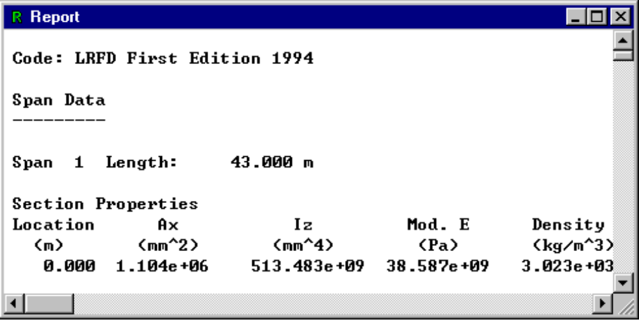
Figure 7-10 - Full Report

Changing Options
QConBridge offers several options to customize the look of your diagrams. Use the Display Options dialog to control the elements and style of the Editor, Shear and Moment Diagram view.

To Edit Options
8 1. From the Options menu, choose Display (Alt, O, D).
The Options menu appears.
2. Select the desired tab and make your changes.
3. Click Save.

Decorations
The first three options on the Decorations tab apply to the presentation of the bridge model in the Editor window and the Diagram windows, whereas the last two are options for the Diagram windows.

- To edit Decorations, select the Decorations tab from the Display Options dialog box, check (or uncheck) the appropriate box. Click OK to save.

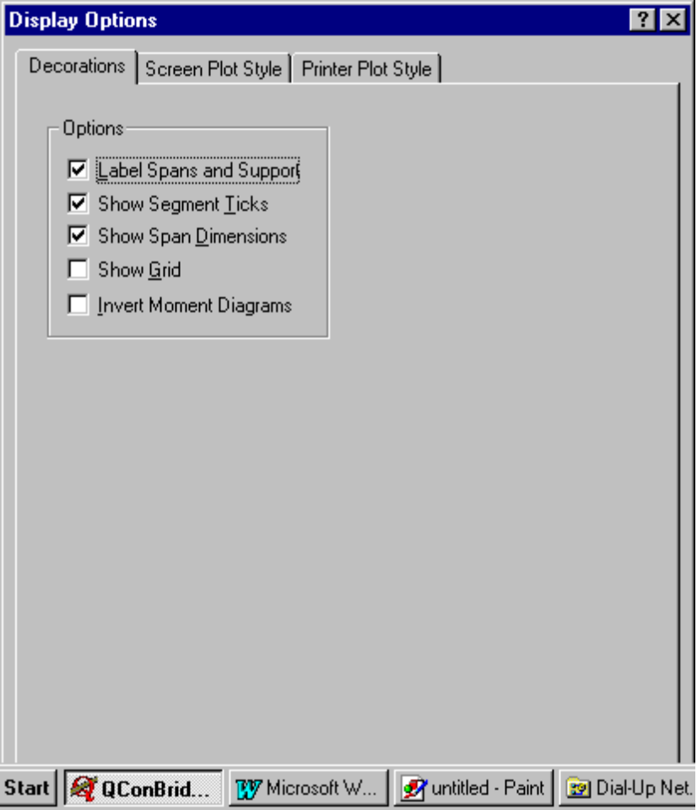
Figure 7-11 - Display Options - Decorations tab

Editor and Diagram window options
Label Spans and Supports - Check to label span and support index numbers.
Show Segment Ticks - Check to show tick marks on the span and support segments.
Show Span Dimensions - Check to show dimensions for the spans.

Diagram window options
Show Grid - Check to show horizontal grid lines in the Shear and Moment Diagram views.
Invert Moment Diagrams - Check to invert the Moment diagrams. This is useful for reinforcing steel layouts in negative moment regions. Negative moments are drawn on the top of the structure. An inverted moment diagram is shown in Figure 7-11.

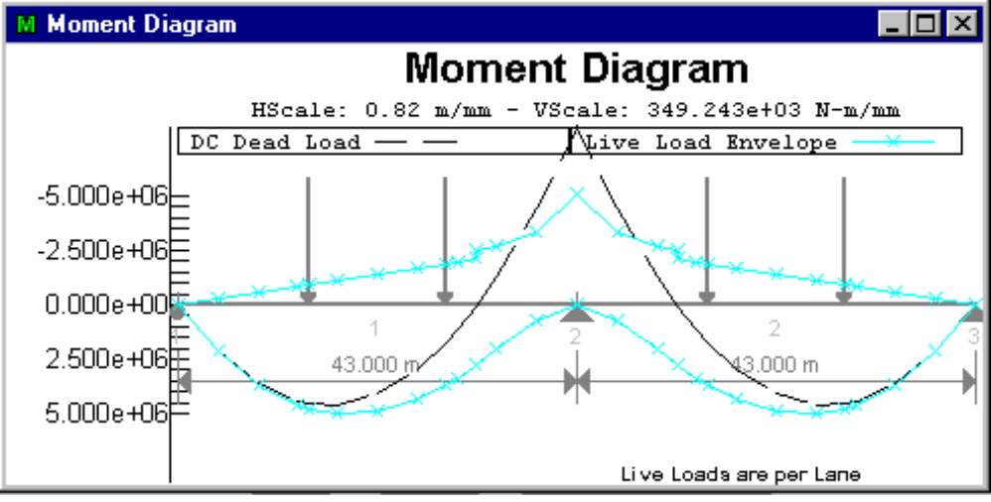
Figure 7-12 - Inverted Moment Diagram

Screen Plot and Printer Plot Styles
Plot styles are defined for both the screen and printer. The plot style controls the color, pen style, and symbols used when drawing shear and moment diagrams. A color, pen style, and symbol must be defined for each load case and limit state.

You may use any combination of pen, line and symbol designations. The legend at the top of the Diagram window shows the scheme you have chosen.

Why two plot styles? It is rare to find a computer with a black and white monitor these days, but black and white printers are still in abundance. Some black and white printers have trouble dealing with color and as a result, the quality of the printed information is compromised. To combat this problem, two plot styles have been incorporated into QConBridge, one for the monitor and one for the printer. If your black and white printer does not handle color very well, simply reconfigure the Printer Plot Style to use black lines adorned with symbols. This has no effect on the screen display.

- To edit Screen and Printer Plot Styles, select the Screen Plot Style or Printer Plot Style tab from the Display Options dialog box, and use the drop-down lists to make your choices. Click OK to save.

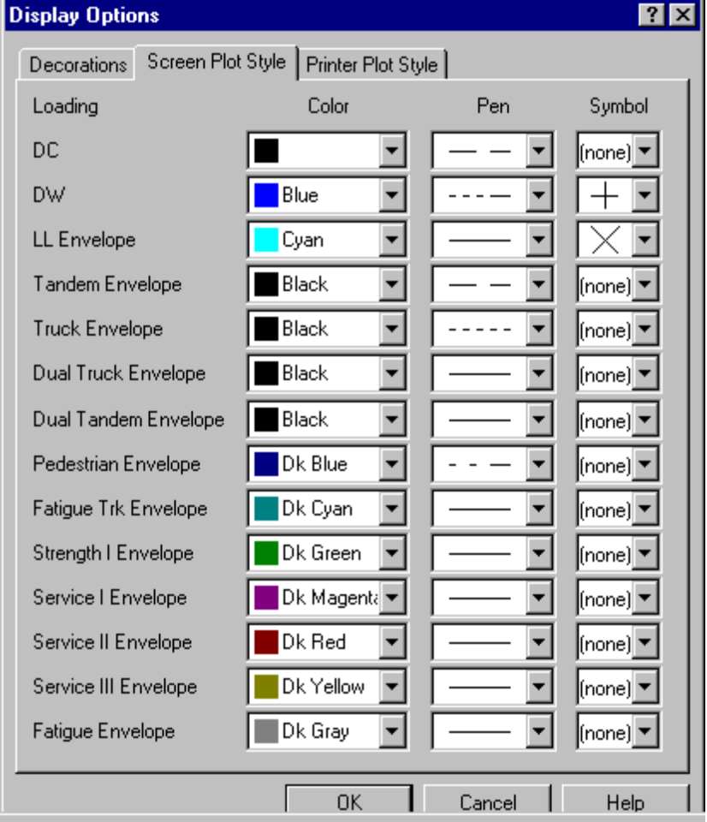
Figure 7-13 - Display Options - Screen Plot Style

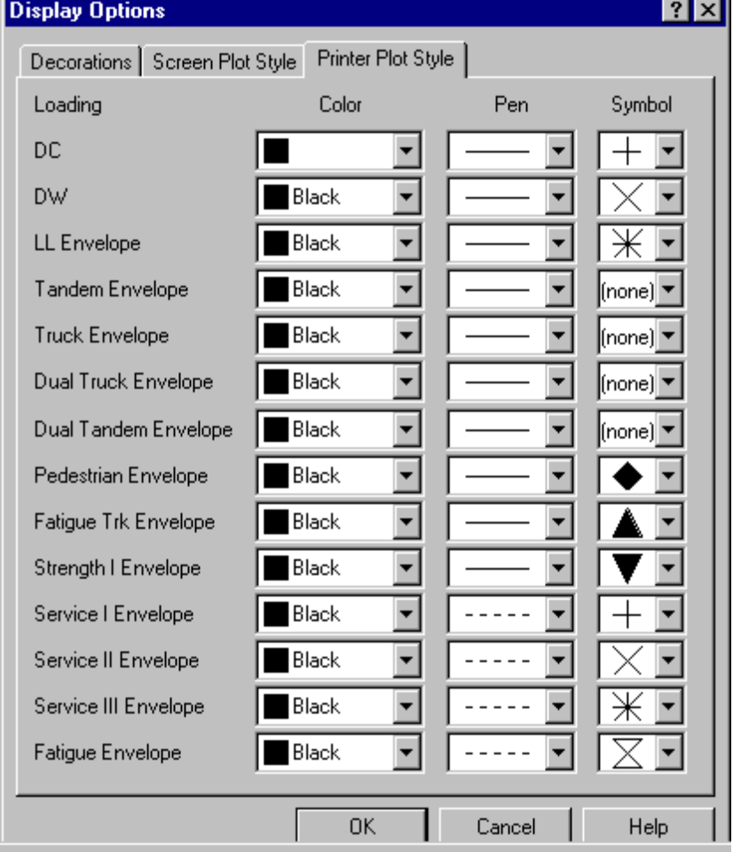
Figure 7-14 - Display Options - Printer Plot Style

Refer to Chapter 8 for information on printing, sending, and exporting your bridge model and analysis results.

