Printing, Sending, and Exporting
Introduction
Printing
To Print using Default Settings
To Print changing Printing Settings
Changing Printer Defaults
Sending Your Bridge Through the Mail
Exporting Tabular Results and the Report
To Export Tabular Results or the Report

Introduction
At some point you probably want to print your model and results, send them to a coworker or export the results to another application. QConBridge supports these tasks using the file commands Print, Export and Send. This chapter describes how to use these commands. For additional information, consult your Windows documentation.

Printing
You can print a bridge model and all four types of analysis results using the Print command.

There are two methods to print a model, diagram, table or full report depending on whether you want to use your printer default values or not. For either method, you must have the model or results you want to print in the active window

To Print using Default Settings
1. Display the model or results you want to print in the active window.
2. Click  on the toolbar.
The results are printed on your default printer using the default settings.

To Print changing Printing Settings
1. From the File menu, choose Print (Alt, F, P).
The Print dialog box appears.
2. Select the options you want and click OK to print.
The results are printed.

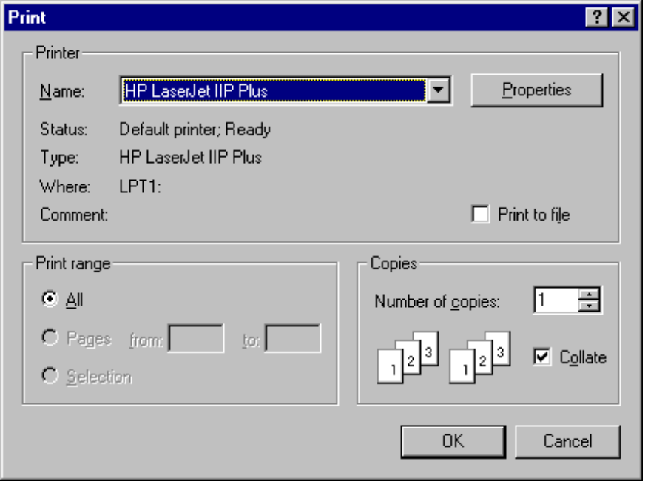
Figure 8-1 - Print dialog box

Remember - Change printing options for diagrams by editing Display options. (See Chapter 7, section on “Changing Options”).

Changing Printer Defaults
Use the Print Setup command to change printers, page size, orientation, and margins.
- From the Print menu, choose Printer Setup (Alt, F, R).
The Page Setup dialog box appears. Make your changes and click OK.

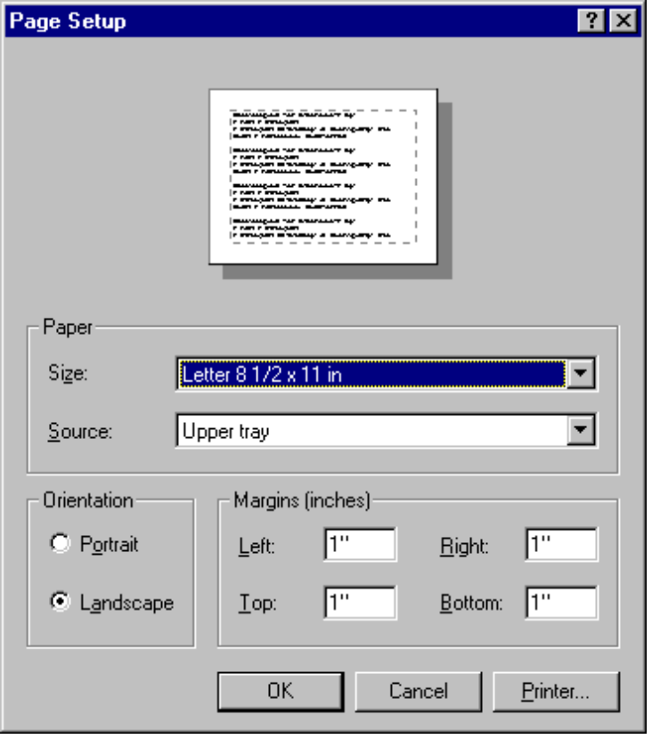
Figure 8-2 - Page Setup dialog box

Sending Your Bridge Through the Mail
QConBridge supports the Windows Send command to send your model as an attachment to a mail message.
- From the File menu, choose Send (Alt, F, D).
Your mail program, if MAPI compliant, is activated.

Exporting Tabular Results and the Report
You can export each individual table and the report as an ASCII text file. For example, you could save the contents of a table in a file and then use Microsoft® Excel® to manipulate the values.

To Export Tabular Results or the Report
- From the File menu, choose Export (Alt, F, E).
The Windows Save As dialog box appears. Save the file to use in another application.

