Window Management
Cascade
Tile Vertical
Tile Horizontal
Arrange Icons
Close All
Choosing the Active Window
On-line Help
Using On-line Help
Commands
Dialog Boxes
Notes
Engineering Notation
Deviations from AASHTO LRFD Bridge Design Specifications
Article 1.3.2
Articles 1.3.3, 1.3.4, 1.3.5
Article 3.6.1.3.1
Article 4.6.2.2.1
Article 4.6.2.2.2a
Articles 4.6.2.2.2e and 4.6.2.2.3c
Article 5.4.2.4
Article 5.7.1
References

Window Management
QConBridge offers the same capability to arrange your windows as you have on your desktop. You can look at open windows simultaneously as well as close all windows at once. The options are described in this section of the Appendix.

Cascade
- From the Windows menu, choose Cascade (Alt, W, C).
The windows are resized and positioned in an overlapping pattern with the active window on top.

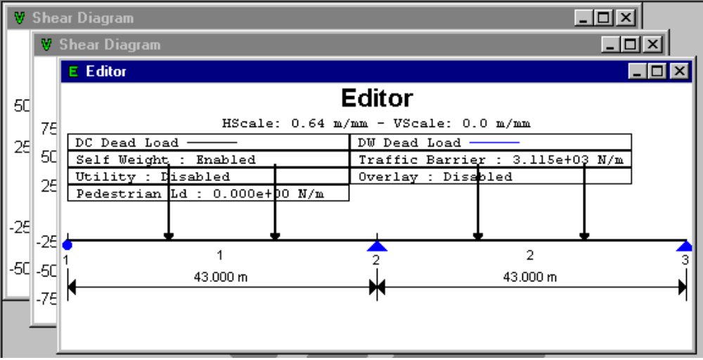

Tile Vertical
- From the Windows menu, choose Tile (Alt, W, T).
The windows are resized and positioned in a vertical non-overlapping pattern.

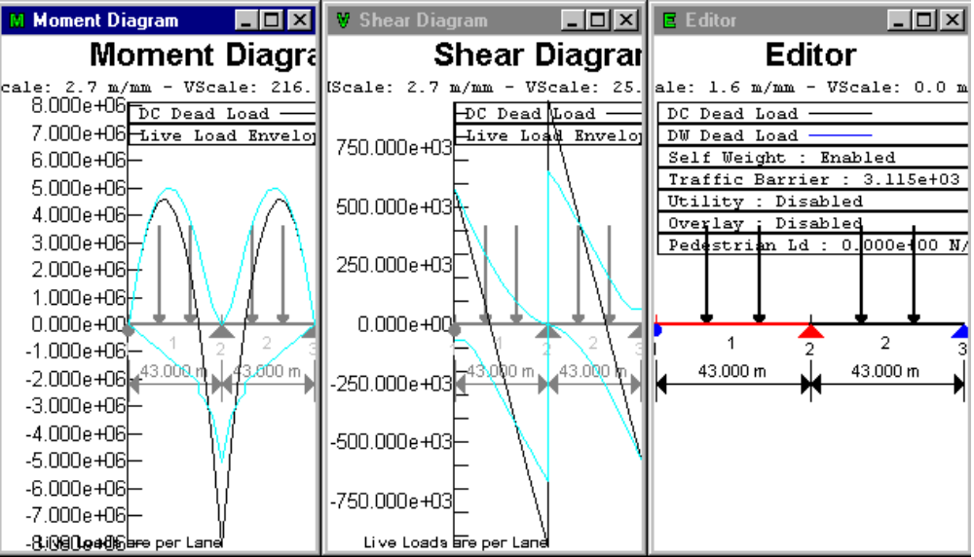

Tile Horizontal
- From the Windows menu, choose Horizontal (Alt, W, H).
The windows are resized and arranged in a horizontal non-overlapping pattern.

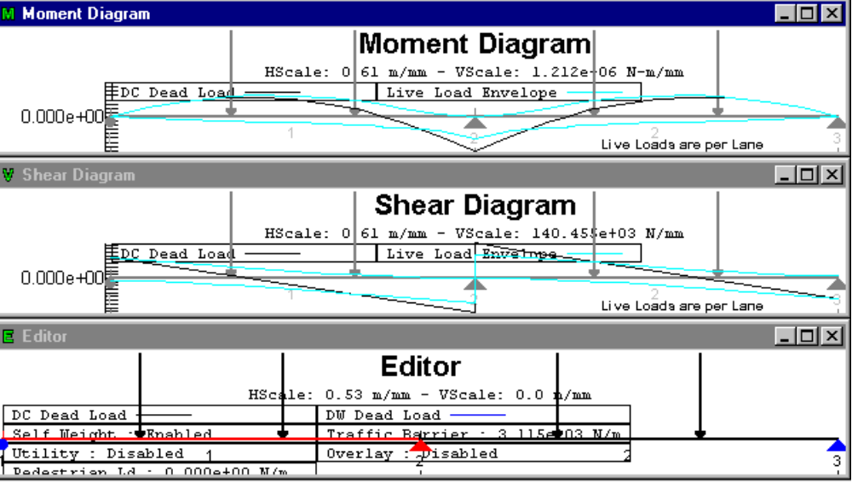

Arrange Icons
Arranges icons along a grid.

Close All
- From the Windows menu, choose Close All (Alt, W, L).
Closes all open windows in QConBridge.

Choosing the Active Window
The open windows are listed in the bottom portion of the Windows menu. A check mark is placed next to the active window.
- To change the active window, check the desired window by clicking with the mouse.
The Moment Diagram is the active window in the menu below.

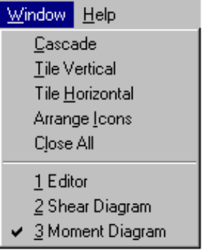

On-line Help
QConBridge comes with context-sensitive on-line help in Windows® 95 format. It contains some overview information, and is designed to give concise information concerning the command, dialog box, or topic you have designated. It is meant to give you a quick information for screens and commands, and does not contain all the overview and background information given in the reference manual.

QConBridge offers several avenues for accessing on-line Help topics. You can get help quickly on a command or for a particular dialog box as well as selecting topics through the Help searching options. Once you enter the Help system you may jump to any other topic.

Using On-line Help
Help is available anytime the program is running. You can look for information through the Table of Contents, using keywords, or searching with the Find command.

To access Help:
-  From the Help menu, choose Help Topics (Shift+F1).
QConBridge Help appears. Select Table of Contents, Index for keyword search, or Find for text searches.

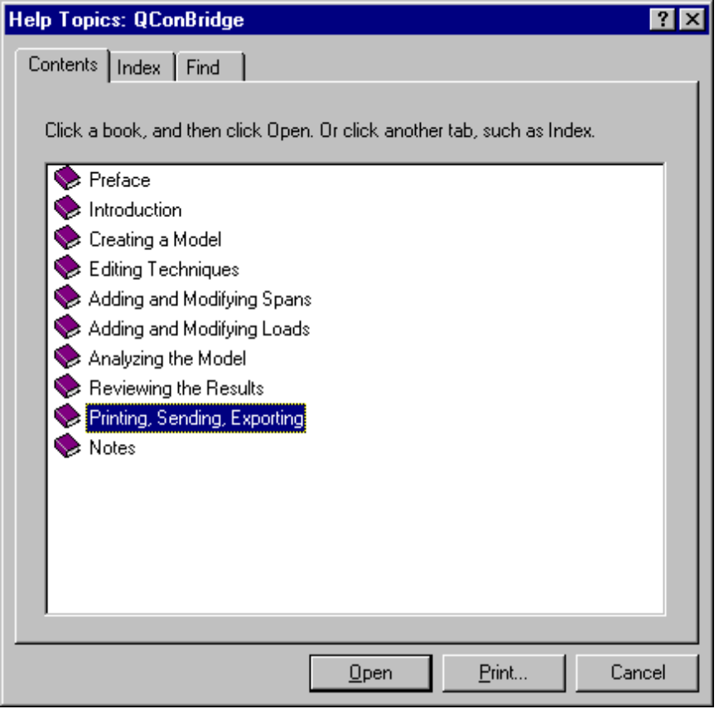

Commands
You can jump directly to information for any of the main menu commands.
- Press Shift+F1.
A large question mark appears with the cursor.
- Click on any Main Menu command either on the toolbar or the main menus.
The Help system appears with information about that command in front of you.

Dialog Boxes
There is quick access to help for a particular dialog box.
- From the dialog box, click Help .
The Help system appears with the topic about that tab in the dialog box.

Notes

Engineering Notation

The numerical values for moments and shears are displayed in something known as engineering notation. Engineering notation displays a number as a mantissa followed by an exponent that is a multiple of 3. For example 123456789.0 would be displayed as 1.234567890E+08 in scientific notation and 123.4567890E+06 in engineering notation.

Engineering notation and SI units go hand in hand. By examining the exponent, you can quickly determine the unit prefix modifier. For example 12.345E+03 N is 12.345 kN. 10³ is 1000, which represents a kilo.

Common SI units prefix modifiers and their associated exponents

Prefix Symbol Exponent (10^x)
milli m -3
kilo k 3
mega M 6
giga G 9
tera T 12

Deviations from AASHTO LRFD Bridge Design Specifications

During the development of QConBridge several anomalies were discovered in the AASHTO LFRD Bridge Design Specification, First Edition 1994. The following information details how QConBridge resolves these inconsistencies in the code.

Article 1.3.2
Equation 1.3.2.1-1 is given as η = η_{d} * η_{r} * η_{i} > 0.95. QConBridge implements this equation as η = η_{d} * η_{r} * η_{I} >= 0.95. When the limit state factor, η, is less than 0.95 it is taken as 0.95.

Articles 1.3.3, 1.3.4, 1.3.5
The code specifies the limits state factors relating to ductility (η_{d}), redundancy (η_{r}), and importance (η_{i}) are either 1.05 or 0.95 for the strength limit states. QConBridge uses 1.00 for the default values for these parameters.

Article 3.6.1.3.1
The dual truck train and dual tandem train are only to be used for negative moment between the points of dead load contraflexure and reactions at interior supports. The dead load that is to be used to located the points of dead load contraflexure is not defined (DC and/or DW). QConBridge applies a unit uniform load to all spans and located the points of contraflexure for this loading. This method is consistent with the proposed 1996 Interim Specification.

Article 4.6.2.2.1
This article states “For beam spacing exceeding the range of applicability as specified in Tables 4.6.2.2.2a-1 through 4.6.2.2.2g-1, the live load on each beam shall be the reaction of the loaded lanes based on the lever rule unless specified otherwise herein.”. The first item of concern is Table 4.6.2.2.2g-1 does not exist. The other item of concern is that the specified tables cover distribution factors for moment and skew corrections for moments. The provisions for shear are excluded. For a consistent approach to applying this specification, QConBridge uses the lever rule to compute live load distribution factors for shear when the beam spacing exceeds the range of applicability.

Article 4.6.2.2.2a
Table 4.6.2.2.1-1, Steel Beams, states Type Of Deck “...glued/spiked panels, stressed wood”. Planks are not applicable for this type of supporting component. The entry in Table 4.6.2.2.2a-1 for Plank Deck/Applicable Cross-Section is taken as only cross-sections of type L, not sections of type A and L.

In row 4 of Table 4.6.2.2.2a-1 the type of deck is Glued Laminated Panels on Glued Laminated Stringers. The Applicable Cross-Section is taken as only cross-sections of type L, not sections of type A and L

In row 5 of Table 4.6.2.2.2a-1 the type of deck is Glued Laminated Panels on Steel Stringers. The Applicable Cross-Section is taken as only cross-sections of type A, not sections of type A and L.

Articles 4.6.2.2.2e and 4.6.2.2.3c
Table 4.6.2.2.2e-1 specifies a range of applicability of 30 to 60 degrees for skew angle. This requirement is contradicted in the “Any Number of Design Lanes Loaded” column. QConBridge does not limit the range of applicability on skew angle. If the skew angle is less than 30 degrees, c1 is taken as 0.0. If the skew angle exceeds 60 degrees, it is taken as 60 degrees.

Table 4.6.2.2.3c-1 specifies a range of applicability of 0 to 60 degrees for skew angle. The code does not provided guidance for skew angles greater than 60 degrees. To be consistent with the application of Table 4.6.2.2.2e-1, QConBridge uses a skew angle of 60 degrees if the actual skew angle exceeds 60 degrees.

Article 5.4.2.4
This article specifies a range of applicability of concrete densities of 1440 to 2500 kg/m³ for computing the modulus of elasticity of concrete. QConBridge does not limit concrete densities to this range.

Article 5.7.1
The specification requires the modular ratio, n, to be rounded to the nearest integer number. For concrete beams with composite concrete slabs, this does not make sense. For example if a girder has f’c=48MPa, and the slab has f’c=27.5MPa, n will be the square root of the ratio f’cGirder/f’cSlab, which is approximately 1.3. In addition, the specification requires that the modular ratio not be less than 6. It would not make sense to round 1.3 to 6. QConBridge does not implement these requirements.

References

AASHTO LRFD Bridge Design Specifications, First Edition, 1994

Load and Resistance Factor Design for Highway Bridges, Vol. 1 and 2 (Version 2.03), National Highway Institute, 1995

