# $ K + Creating a Bridge Model
QConBridge builds bridge models that support the AASHTO LRFD Bridge Design Specification, First Edition 1994. The program models simple and continuous bridge structures of virtually any cross section. They can be full width or line of girders models. QConBridge does both Live and Dead Load analysis.

QConBridge offers two ways to create a new bridge model. You can build a bridge model automatically with the Bridge Contractor or you can build the model from scratch. The purpose of the Bridge Contractor is to quickly generate the framework of a bridge model with a minimal amount of input. Once you have a basic model, use QConBridge’s editing features to make modifications. QConBridge also gives you the option of building the bridge model from scratch using the “Blank Sheet” method. Using this method, you are not constrained by the limitations of the Bridge Contractor, which builds symmetrical, prismatic bridges.

Using the Bridge Contractor
Using a "Blank Sheet"

# $ K + Using the Bridge Contractor
Using the Bridge Contractor is a quick and simple way of creating a bridge model. The Bridge Contractor leads you through an interview process to gather information about your bridge. Once the specifications for your bridge are complete, the Bridge Contractor builds the bridge for you.

In order to keep the amount of information required to build the bridge to a minimum, the Bridge Contractor only builds symmetrical structures with prismatic spans.

Guidelines for building a model with the Bridge Contractor
To Use the Bridge Contractor

Bridge Contractor
General Properties
Bridge Geometry
Cross Section Descriptions
Interior Support Description

# $ + k Guidelines for building a model with the Bridge Contractor
- The minimal input recommended to build a reasonable bridge model is:
- Number of Spans (General Properties window)
- Span Length (Bridge Geometry window)
- Column Height (If you have columns - Interior Support Description window)
- If you are modeling a line of girders for a steel, prestressed concrete, or wood beam and slab bridge, use the Section Properties Calculator to quickly obtain the section properties, material properties, and live load distribution factors.
- Enter any values you know and accept the defaults for all others. You can edit them later.

Tip - If your bridge is not symmetrical, the Bridge Contractor is still of great importance to you. Use the Bridge Contractor to build a framework for your bridge, and then edit it accordingly. This technique has proven to be much faster than building the entire model manually. This is also true if your bridge has non-prismatic spans. Bridge Contractor builds a prismatic bridge but QConBridge has editing features that offer a method for modeling non-prismatic bridges as well.

See
To Use the Bridge Contractor

# $ K + To Use the Bridge Contractor
- From the File menu, choose New (Alt,F,N).
The General Properties window appears.

Caution - Do not press the New button on the toolbar. This creates a "blank sheet" for a new bridge model rather than using the Bridge Contractor.

- In each of the Bridge Contractor windows, click Next to move to the next window, Back to return to the previous window and Cancel to leave Bridge Contractor.

Note - Clicking Cancel while running the Bridge Contractor returns you to the Editor with a blank screen where you can build a bridge model from scratch.

- Once you click Finish in the final window, Bridge Contractor builds the model.
The bridge model appears in the Editor window.

# $ K + Bridge Model in the Editor Window
Once you click Finish in the Done window, Bridge Contractor builds the model and draws it in the Editor window.

For example, the model shows a 5 span bridge with hinged column supports.

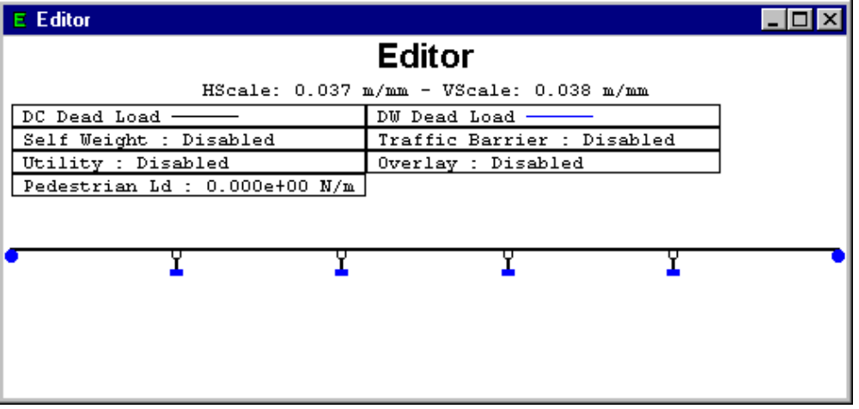

If the Bridge Contractor was able to build the model you wanted, you are ready to add some loads, if not now is the time to make any necessary modifications.

# $ K + Creating a Bridge Model with a "Blank Sheet"
You can create a bridge model completely from scratch using the “Blank Sheet” method in QConBridge. Rather than running the Bridge Contractor and ending up with a basic model built in the Editor window, you start out with a blank Editor window and add spans, supports and loads to create what ever kind of model you need.

To Create a new bridge model with a "Blank Sheet"
- Click {bmc BMP00067.BMP} on the toolbar. A blank Editor window appears.
- Use the editing features to add spans , supports and loads .

# $ K + Saving a Model
Save your bridge model by using either the Save command or the Save As command. The Save command allows you to quickly save an existing model. The Save As command saves the model under a new name.

To Save an Existing Model
- From the File menu, choose Save (Alt, F, S) {bmc BMP00068.BMP}
The model is saved under its same name.

To Save a New, Unnamed Model
- From the File menu, choose Save As (Alt, F, A).
The Save As dialog box appears. Enter a name and click OK.

# $ K + Opening an Existing Model

To Open an existing model
1. From the File menu, choose Open (Alt, F, O) {bmc BMP00069.BMP}
The Open dialog box appears.
2. Choose the model you want to edit and click OK.
QConBridge displays the model.

OR
1. Drag the file from Explorer and Drop it on QConBridge’s main menu.
QConBridge displays the model.

# HCreate_Creating_a_Bridge_Model
$ Creating a Bridge Model
K Creating a Bridge Model;Creating a Bridge Model,overview
+ HCREATE:0
# HCreate_Using_the_Bridge_Contractor
$ Using the Bridge Contractor
K Bridge Contractor;Creating a Bridge Model;Creating a Bridge Model,using the bridge contractor
+ HCREATE:0
# HCreate_Guidelines_for_building_a_model_with_the_Bridge_Contractor
$ Guidelines for building a model with the Bridge Contractor
+ HCREATE:0
k Bridge Contractor
# HCreate_To_Use_the_Bridge_Contractor
$ To Use the Bridge Contractor
K Bridge Contractor
+ HCREATE:0
# HCreate_Bridge_Model_in_the_Editor_Window
$ Bridge Model in the Editor Window
K Bridge Model in the Editor Window
+ HCREATE:0
# HCreate_Creating_a_Bridge_Model_with_a_Blank_Sheet
$ Creating a Bridge Model with a "Blank Sheet"
K Creating a Bridge Model;Creating a Bridge Model,with a "Blank Sheet"
+ HCREATE:0
# HCreate_Saving_a_Model
$ Saving a Model
K Saving a Model
+ HCREATE:0
# HCreate_Opening_an_Existing_Model
$ Opening an Existing Model
K Opening an Existing Model
+ HCREATE:0

