# $ K + Welcome to QConBridge
QConBridge is a live load analysis program designed to implement the AASHTO-LRFD Bridge Design Specification. QConBridge models simple and continuous bridge structures of virtually any cross section. Dead load, HL93 live load (including the optional dual tandem truck train), fatigue truck, and pedestrian live load cases are supported. Load combinations are performed for the Strength I, Service I, Service II, Service III, and Fatigue limit states.

QConBridge provides a Bridge-centric approach to structural engineering software. Traditional engineering software forces the engineer to focus his/her attention on cryptic data files or verbose problem oriented languages. The Bridge-centric approach employs the principles of visualization and direction manipulation resulting in software that enables the engineer to concentrate on the bridge and its behavior.

See Also
A Bit of History

# $ K + A Bit of History
QConBridge is the third generation of live load analysis programs produced by the Washington State Department of Transportation, Bridge and Structures Office. The first program was known as ConBridge. This program generated dead loads, live loads, and load combinations for working stress design. When ultimate strength design came onto the scene, ConBridge was upgraded to UConBridge to handle the ultimate load combinations. The U was added to the name to reflect the ultimate strength load equation, 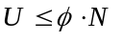. Now that LRFD design is upon us, it is time for yet another version of ConBridge, QConBridge. A Q was added to the ConBridge name for similar reasons the U was added for ultimate strength design. The total factored load equation in LRFD is 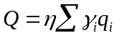.

# $ K + Choosing Commands
There are several ways of choosing commands in QConBridge. All commands are available on the pull-down menus from the Main Menu. Frequently-used commands are buttons on the Toolbar that you click with your mouse. All commands have keyboard alternatives , some of them also have keyboard shortcuts .

You can also use your right mouse button to choose commands from context (also know as speed) menus .
Toolbar
Main Menu

# $ K + The Toolbar
The toolbar is located across the top of your window. You can use a button when it is highlighted. The following two diagrams of the toolbar explain the icons in different ways. The first diagram gives the commands names and the second groups them into task categories.

{bmc Toolbar Titles.BMP}

{bmc Toolbar Tasking.BMP}

See Also
Choosing Commands

# $ K + Menus
All commands are available on pull-down menus from the Main Menu commands. All the menus are shown in this section with a brief explanation and the associated icon from the toolbar.

File Menu
Edit Menu
Span/Support Menu
Loads Menu
Bridge Menu
Options Menu
View Menu
Window Menu

# $ K + File Menu

 | Command | Description
{bmc BMP00041.BMP} | New | Create a new, untitled, document (model).  There is a difference between clicking the New button and choosing New from the menu.
{bmc BMP00042.BMP} | Open | Open an existing document
 | Close | Close the current document.
{bmc BMP00043.BMP} | Save | Save the current document if its contents have changed.
 | Save As | Save the current document under a new name.
 | Send | Sends a mail message with the current document as an attachment.
 | Export | Export a table or report to an external file.
{bmc BMP00044.BMP} | Print | Print the contents of current view.
 | Printer Setup | Select and setup a printer.
 | Exit | Exit QConBridge.

# $ K + Edit Menu

 | Command | Description
{bmc BMP00046.BMP} | Cut | Removes the selected span/support pair or load and places it onto the clipboard.
{bmc BMP00047.BMP} | Copy | Copies selected span/support pair or load to the clipboard.
{bmc BMP00048.BMP} | Paste Insert | Inserts the contents of the clipboard into the bridge model.
{bmc BMP00049.BMP} | Paste Replace | Replaces the current selection with the contents of the clipboard.
{bmc BMP00050.BMP} | Paste Special | Performs custom paste operations with the contents of the clipboard.
 | Clear All | Deletes the entire bridge model.
 | Delete | Deletes selected span/support pair or load.

# $ K + Span/Support Menu

 | Command | Description
{bmc BMP00051.BMP} | Add Span/Support | Adds a span/support pair to the bridge model.
 | Edit Span | Edits the selected span
 | Edit Support | Edits the selected support
 | Make Cantilever | Removes a support to cantilever a span
 | Support Cantilever | Adds a support to a cantilevered span

# $ K + Loads Menu

 | Command | Description
 | Standard Dead Loads | Edit the standard dead loads.
{bmc BMP00052.BMP} | Add Concentrated Load | Add a concentrated load.
{bmc BMP00053.BMP} | Add Uniform Load | Add Uniform Load
 | Edit Load | Edit the selected load.
 | Live Load Gen Parameters | Edit the live load generation parameters.
 | Dynamic Load Allowance | Edit the dynamic load allowance factors.
 | Pedestrian Live Load | Edit the pedestrian live load.

# $ K + Bridge Menu

 | Command | Description
 | Load Factors | Edit Load Factors.
{bmc BMP00054.BMP} | Analyze | Analyze the bridge model.  There is a difference between clicking the Analyze icon and choosing Analyze from the Bridge menu.
 | Reset to Defaults | Reset to default values.  - Dynamic Load Allowance Factors (impact)  - Live Load Generation Factors  - Load Factors

# $ K + Options Menu

 | Command | Description
 | Units | Change the system of units.
 | Display | Edit screen and print display options.
{bmc BMP00056.BMP} | Select Left Support | Switches the selection mode to Left Support.
{bmc BMP00057.BMP} | Select Right Support | Switches the selection mode to Right Support.
{bmc BMP00058.BMP} | Insert Before | Switches the insertion mode to Insert Before.
{bmc BMP00059.BMP} | Insert After | Switches the insertion mode to Insert After.

# $ K + View Menu
You can have multiple views open at a time, except for the Editor (You may have only one Editor view open at a time). For example, several moment and shear diagrams depicting different loads can be open at the same time for comparison.

 | Command | Description
 | Editor | Open the editor window.
{bmc BMP00060.BMP} | Shear Diagram | Open a shear diagram window.
{bmc BMP00061.BMP} | Moment Diagram | Open a moment diagram window.
 | Tabular Results | Open a tabular results window.
{bmc BMP00062.BMP} | Report | Open a report window.
 | Select Loading | Select a loading for which results will be displayed.
 | Select Table | Select a results table.
 | Tool Bar | Toggle displays or removes toolbar from screen.
 | Status Bar | Toggle displays or removes Status Bar from the screen.

# $ K + Window Menu

 | Command | Description
 | Cascade | Resize and position all windows in an overlapping pattern.
 | Tile Vertical | Resize and position all windows in a vertical non overlapping pattern.
 | Tile Horizontal | Resize and position all windows in a horizontal non overlapping pattern.
 | Arrange Icons | Align all iconized windows along a grid.
 | Close All | Close all windows.
 | n View | Brings an open view to the front

# $ K + Help Menu

 | Command | Description
{bmc BMP00063.BMP} | Help Topics | Help topic contents.
 | About | Information about QConBridge.

# $ K + Keyboard Alternatives and Shortcuts
All commands have keyboard alternatives. Some have shortcuts. They are all shown on the pull-down menus.

Alternatives
- Alt, _ Alt followed by one other key opens the menu that has the letter of the second key underlined. For example, you open the File menu with (ALT,F).
- Alt,_,_ ALT followed by two other key strokes opens a menu and executes a command on that menu—this sequence is an extension of the one above. For example, to execute the New command in the File menu, use (Alt, F, N).

Shortcuts
Some commands on the File and Edit menu have keyboard shortcuts. They are shown on the menus next to the command. For example, you can execute Exit the program by pressing Alt+F4.

# $ K + Context Menus
Context menus (also known as Speed menus) provide quick access to commonly used commands within the context of a certain task. They group commands together that otherwise you might have to choose off several pull-down menus from the main menu commands.

- Activate the context menus by pressing the right (secondary) mouse button and selecting the desired command.

For example, in the Editor view when you highlight a span and press the right mouse button, you get a context menu with commands from the Edit, Span/Support and Load menus. This context menu includes all commands necessary to do operations with a span at the touch of the mouse button.

Context Menus are available for the following parts of QConBridge:
Editor View
Add Span/Support and Edit Span/Support Dialog Boxes
Shear and Moment Diagram Views
Tabular Report View
Report View

# $ K + Editor View
This context menu is available when your are working in the Editor window. Highlight a span/support pair or load by positioning the mouse on the item and press the left (primary) mouse button. Click the right mouse button and the following context menu appears.

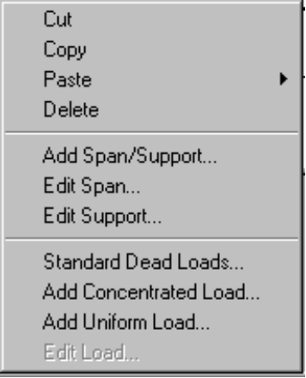

# $ K + Add Span/Support and Edit Span/Support Dialog Boxes
There is a context menu for adding segments to a span in the Properties Tab of the Edit and Add Span/Support dialog boxes. Point the mouse to any value cell in the grid and click the right mouse button. The following context menu appears.

{bmc BMP00064.BMP}

# $ K + Shear and Moment Diagram Views
Click the right mouse button anywhere in the Moment or Shear Diagram window and the following context menu appears.

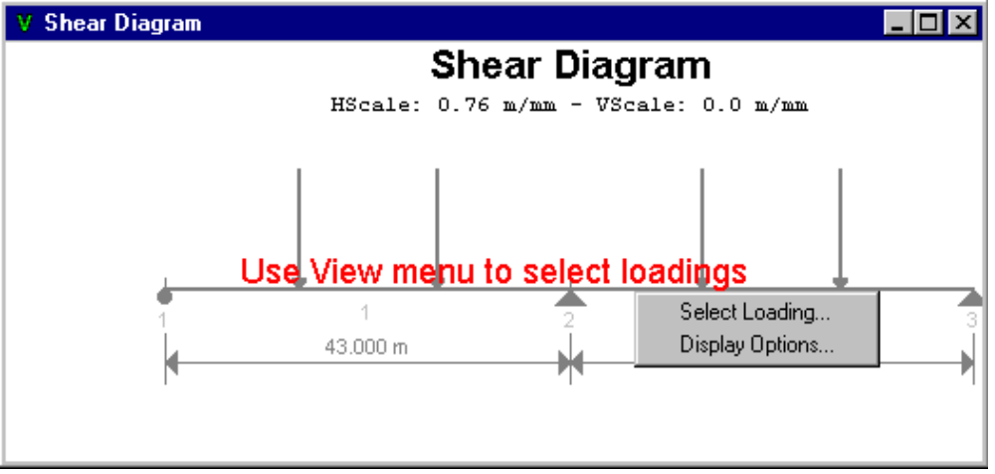

# $ K + Tabular Report View
The context menu is available in the Tabular Report view.

{bmc BMP00065.BMP}

# $ K + Report View
In the Report window, you may click the right mouse button and choose the Export command.

{bmc BMP00066.BMP}

# $ K + Symbols
QConBridge uses special symbols to represent elements of the bridge model. They appear in the Editor, Shear Diagram and Moment Diagram Views. The symbols and what they represent are shown in the following table.

Symbol | Description
 | Roller Support
 | Pinned Support
 | Fixed Support
 | Hinge. A point in the structure where the moment continuity has been removed. Hinges can appear at the top of a column, at the left and right ends of a span, or within a span.
 | Concentrated Load
 | Uniform Load

# $ Context Menus
Hold down right mouse button to see context menu and choose desired command.

# $ Toolbar Commands
Click this button on the toolbar to activate command.

# $ Unit Weight, SI units
In SI units, the unit weight is equal to density times a gravitational acceleration of 9.81 m/s2

# $ Code Reference
AASHTO LRFD Bridge Design Specifications, First Edition, 1994

# HIntroduction_Welcome_to_QConBridge
$ Welcome to QConBridge
K Welcome to QConBridge; QConBridge;QConBridge,overview
+ HINTRODUCTION:0
# HIntroduction_A_Bit_of_History
$ A Bit of History
K History of QConBridge;QConBridge;QConBridge,history
+ HINTRODUCTION:0
# HIntroduction_Choosing_Commands
$ Choosing Commands
K Choosing Commands;Commands;Commands,choosing
+ HINTRODUCTION:0
# HIntroduction_The_Toolbar
$ The Toolbar
K Toolbar;Commands;Commands,toolbar
+ HINTRODUCTION:0
# HIntroduction_Menus
$ Menus
K Menus;Commands;Commands,menu
+ HINTRODUCTION:0
# HIntroduction_File_Menu
$ File Menu
K File Menu
+ HINTRODUCTION:0
# HIntroduction_Edit_Menu
$ Edit Menu
K Edit Menu
+ HINTRODUCTION:0
# HIntroduction_Span_Support_Menu
$ Span/Support Menu
K Span/Support Menu
+ HINTRODUCTION:0
# HIntroduction_Loads_Menu
$ Loads Menu
K Loads;Loads,menu
+ HINTRODUCTION:0
# HIntroduction_Bridge_Menu
$ Bridge Menu
K Bridge Menu
+ HINTRODUCTION:0
# HIntroduction_Options_Menu
$ Options Menu
K Options Menu
+ HINTRODUCTION:0
# HIntroduction_View_Menu
$ View Menu
K View Menu
+ HINTRODUCTION:0
# HIntroduction_Window_Menu
$ Window Menu
K Window Menu
+ HINTRODUCTION:0
# HIntroduction_Help_Menu
$ Help Menu
K Help Menu
+ HINTRODUCTION:0
# HIntroduction_Keyboard_Alternatives_and_Shortcuts
$ Keyboard Alternatives and Shortcuts
K Keyboard Alternatives and Shortcuts;Shortcuts
+ HINTRODUCTION:0
# HIntroduction_Context_Menus_Overview
$ Context Menus - Overview
K Context Menus;Commands;Commands,context menus
+ HINTRODUCTION:0
# HIntroduction_Editor_View
$ Editor View
K Context Menus
+ HINTRODUCTION:0
# HIntroduction_Add_Span_Support_and_Edit_Span_Support_Dialog_Boxes
$ Add Span/Support and Edit Span/Support Dialog Boxes
K Context Menus
+ HINTRODUCTION:0
# HIntroduction_Shear_and_Moment_Diagram_Views
$ Shear and Moment Diagram Views
K Context Menus
+ HINTRODUCTION:0
# HIntroduction_Tabular_Report_View
$ Tabular Report View
K Context Menus
+ HINTRODUCTION:0
# HIntroduction_Report_View
$ Report View
K Context Menus
+ HINTRODUCTION:0
# HIntroduction_Symbols
$ Symbols
K Symbols
+ HINTRODUCTION:0
# HIntroduction_Context_Menus
$ Context Menus
# HIntroduction_Toolbar_Commands
$ Toolbar Commands
# HIntroduction_Unit_Weight_SI_units
$ Unit Weight, SI units
# HIntroduction_Code_Reference
$ Code Reference

