# $ K +Overview of Loads
Once you have a bridge model, you can add and modify loads. QConBridge supports dead load, HL93 live load (including the optional dual tandem truck train), fatigue truck, and pedestrian live load cases. Load combinations are performed for the Strength I, Service I, Service II, Service III, and Fatigue limit states.

Standard Loads
Concentrated Load
Uniform Load
Live Load Generation Parameters
Dynamic Load Allowance
Pedestrian Live Load
Load Factors

Code Reference
Section 3

# $ K + Standard Loads
To Add and Edit a Standard Load

Standard loads are loads that are commonly found on most bridges. QConBridge allows you to include these loads in the analysis without having to go through the extra work of calculating and adding loads.
These loads include:
- the weight of all components of the structure
- appurtenances
- attached utilities
- overlays

QConBridge models these loads as uniform loads applied over the entire length of the bridge.

The standard loads are shown as enabled or disabled in the general information at the top of the bridge model in the Editor View.

DC Loads
DW Loads

See Also
Overview of Loads

# $ K + > To Add/Edit a Standard Load
1. From the Loads menu, choose Standard Dead Loads (Alt, L, S) {bmct mouse.bmp}.
The Standard Dead Loads dialog box appears.
2. Select the desired tab and make your changes.
3. Click OK to save.

# $ K + > To Add a Concentrated Load
1. Select the span onto which you want to add the concentrated load.
2. From the Loads menu, choose Add Concentrated Load(Alt, L, C). {bmc BMP00002.BMP} {bmct mouse.bmp}.
The Concentrated Load dialog box appears.
3. Describe the load.
4. Click OK to save.

# $ K + > To Edit a Concentrated Load
1. Double-click the load you want to edit.
The Concentrated Load dialog box appears (without the All Spans box).
2. Make your changes and click OK to save.
OR
1. Select the load you want to edit.
2. From the Loads menu, choose Edit Load (Alt, L, C) {bmct mouse.bmp}.
The Concentrated Load dialog box appears (without the All Spans box).
3. Make your changes and click OK to save.

# $ K + > To Add a Uniform Load
1. Select the span onto which you want to add the load.
2. From the Loads menu, choose Add Uniform Load (Alt, L, U) {bmc BMP00004.BMP} {bmct mouse.bmp}.
The Uniform Load dialog box appears.
3. Describe the load.
4. Click OK to save.

# $ K + > To Edit a Uniform Load
1. Double-click the load you want to edit.
The Uniform Load dialog box appears.
OR
1. Select the load you want to edit.
2. From the Loads menu, choose Edit Load (Alt, L, E) {bmct mouse.bmp}.
The Uniform Load dialog box appears. (All Spans box not included.)
3. Make your changes and click OK to save.

# $ K + > To Edit the Live Load Generation Parameters
1. From the Loads menu, choose Live Load Gen Parameters (Alt, L, L).
The Live Load Generation Parameters dialog box appears.
2. Select the desired tab and make your changes.
3. Click OK to save.

Each tab controls the parameters for an element of the model. If you don’t want to consider that element of the live load model, check the disable box. The more elements you use, the longer the analysis time.

# $ Elements
Design Tandem, Design Truck, Dual Truck Train, Dual Tandem Train, Fatigue Truck

# $ K + > To Edit the Dynamic Load Allowance Factors
1. From the Loads menu, choose Dynamic Load Allowance (Alt, L, D).
The Dynamic Load Allowance dialog box appears containing the code values.
2. Make your changes and click OK to save.

# $ K + > To Edit the Pedestrian Live Load Value
- From the Loads menu, choose Pedestrian Live Load (Alt, L, P).
The Pedestrian Live Load dialog box appears.
2. Make your changes and click OK to save.

# $ K + > To View/Edit the Load Factors
- From the Bridge Menu, choose Load Factors (Alt, B, L).
The Load Factors dialog box appears.
- Select the desired tab, make any changes.
- Click OK to save.

# $ K + Live Load Generation Parameters
The Live Load Generation Parameters dialog box is used to edit the live load generation parameters. These parameters control the how the HL93 Live Load model is applied to the structure. QConBridge is capable of analyzing your model for five of the six parts of the HL93 live load model (the optional live load for deflection is not supported at this time). You have the ability to analyze your structure for any or all of the five components of the live load model.

To Edit the Live Load Generation Parameters

Live Loads
Design Tandem
Design Truck
Dual Truck Train
Dual Tandem Train
Fatigue Truck

# $ K + Variable Headway Spacing Parameters
The headway spacing between the last axle of the leading truck and the first axle of the trailing truck is designated by these parameters. You may use up to three ranges. Each range has a minimum and maximum spacing and the number of increments into which the range is divided. The more increments you use, the more refined the analysis and the longer it takes.

The primary reason to have three ranges is to model trucks in adjacent spans, the same span and alternating spans. Click here to see diagram.

Dual Truck Train
The headway spacing between the last axle of the leading truck and the first axle of the trailing truck must be a minimum of 15m. The code does not provide an upper bound on the maximum headway spacing.
Dual Tandem Train
The headway spacing between the last axle of the leading truck and the first axle of the trailing truck must be a minimum of 8.000m and a maximum of 12.000m.

- Enter a lower and upper bound, and number of increments.
- Check the box next to the 2nd and 3rd ranges to activate. Enter a lower and upper bound, and number of increments for each range checked.

Notes
- You can change the low range default of 15.000 m. The program will not give you an error.
- The more increments, the longer the calculations will take. You can set up to 3 ranges. For example, you can use 15.000 m to 100.000 m at 5 increments which is rather coarse grained and a second range of 15.000 m to 20.000m at 30 increments for really fine grained.

# $ + Variable Headspace Ranges Diagram
The primary reason to have three ranges for variable headway spacing parameters is to model trucks in adjacent spans, the same span and alternating spans as shown in this diagram.

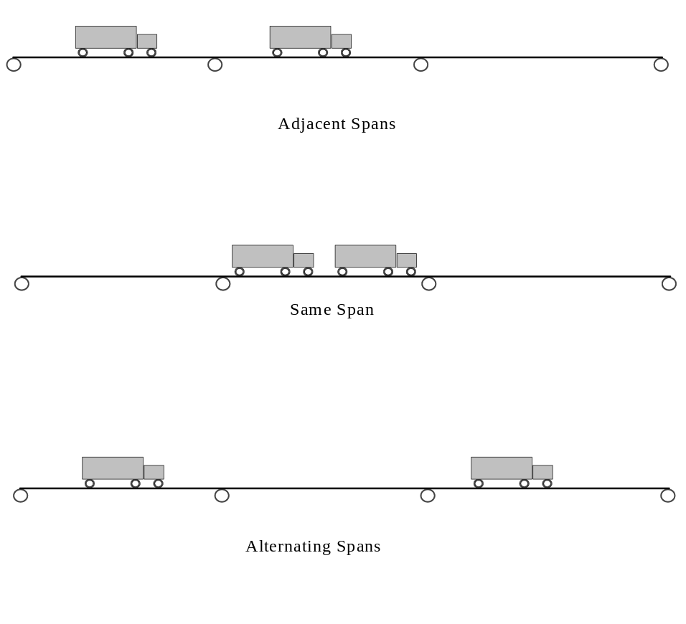

# $ K + Scaling a Component of the Live Load Model
If for some reason you need to scale a component of the live load model, it can be done indirectly through the Dynamic Load Allowance dialog . For example, if you needed to increase the weight of the Design Truck and Design Tandem by 25%, the Dynamic Load Allowance Factor would become 1.33 * 1.25 = 1.6625 or 66.25%. Note that in this example both the Design Tandem and Design Truck are scaled up by 25%. This increased weight is used for the Design Tandem, Design Truck, Dual Truck Train and Dual Tandem Train loadings.

# HLoads_Introduction
$ Overview of Loads
K Loads;Loads,overview
+ HLOADS:0
# HLoads_Standard_Loads
$ Standard Loads
K Standard Loads
+ HLOADS:0
# HLoads_To_Add_Edit_a_Standard_Load
$ To Add/Edit a Standard Load
K Adding a Standard Load;Editing a Standard Load
+ HLOADS:0
> (w95sec)
# HLoads_To_Add_a_Concentrated_Load
$ To Add a Concentrated Load
K Adding a Concentrated Load;Concentrated Load
+ HLOADS:0
> (w95sec)
# HLoads_To_Edit_a_Concentrated_Load
$ To Edit a Concentrated Load
K Editing a Concentrated Load;Concentrated Load
+ HLOADS:0
> (w95sec)
# HLoads_To_Add_a_Uniform_Load
$ To Add a Uniform Load
K Adding a Uniform Load;Uniform Load
+ HLOADS:0
> (w95sec)
# HLoads_To_Edit_a_Uniform_Load
$ To Edit a Uniform Load
K Editing a Uniform Load;Uniform Load
+ HLOADS:0
> (w95sec)
# HLoads_To_Edit_the_Live_Load_Generation_Parameters
$ To Edit the Live Load Generation Parameters
K Live load generation parameters
+ HLOADS:0
> (w95sec)
# HLoads_Elements
$ Elements
# HLoads_To_Edit_the_Dynamic_Load_Allowance_Factors
$ To Edit the Dynamic Load Allowance Factors
K Editing the Dynamic Load Allowance Factors;Dynamic Load Allowance
+ HLOADS:0
> (w95sec)
# HLoads_To_Edit_the_Pedestrian_Live_Load_Value
$ To Edit the Pedestrian Live Load Value
K Editing the Pedestrian Live Load Value;Pedestrian Live Load
+ HLOADS:0
> (w95sec)
# HLoads_To_View_Edit_the_Load_Factors
$ To View/Edit the Load Factors
K Editing the Load Factors;Load Factors
+ HLOADS:0
> (w95sec)
# HLoads_Live_Load_Generation_Parameters
$ Live Load Generation Parameters
K Live Load Generation Parameters
+ HLOADS:0
# HLoads_Variable_Headway_Spacing_Parameters
$ Variable Headway Spacing Parameters
K Variable Headway Spacing Parameters
+ HLOADS:0
# HLoads_Variable_Headspace_Ranges_Diagram
$ Variable Headspace Ranges Diagram
+ HLOADS:0
# HLoads_Scaling_a_Component_of_the_Live_Load_Model
$ Scaling a Component of the Live Load Model
K Scaling a Component of the Live Load Model;Dynamic Load Allowance
+ HLOADS:0

