# $ K + Reviewing Results
QConBridge offers several ways for you to view the results of your analysis . You can see the results in Moment and Shear diagrams , in tabular format and a comprehensive report . You may print a hardcopy of all the formats and export the table and report information to a text file.

See Also
Interpreting the Diagrams
Changing Options

Note
You must run the analysis before viewing results. If you do not, you get the message “Results not available” when choosing a view from the View menu.

# $ K + Diagram Views
The Moment and Shear diagram views work similarly. View as many loadings as you want on one diagram or spread them between several diagram windows.

To View a Shear Diagram
To View a Moment Diagram
Interpreting the Diagrams

Remember - You can size the Diagram window (like any other window) to increase or decrease the size. Since you may have several Diagram windows open at the same time, you can arrange them on your screen by using the commands under Window on the main menu.

# $ K + To View a Shear Diagram
1. From the View menu, choose Shear Diagram (Alt, V, S) {bmc BMP00073.BMP}
The Shear Diagram window is displayed. You need to select the loading you want to diagram.
2. From the View menu, choose Select Loading (Alt, S, L) {bmct mouse.bmp}.
The Select Loadings dialog box appears.
3. Select any loading or group of loadings to diagram. Click Mark All to select all 14 loadings. Click Clear All to clear all loadings you marked.
4. Click OK to save.
The Shear Diagram window appears with the results for the loadings you selected.

# $ K + To View a Moment Diagram
1. From the View menu, choose Moment Diagram (Alt, V, M) {bmc BMP00074.BMP}
The Moment Diagram window is displayed. You need to select the loadings you want to diagram.
2. From the View menu, choose Select Loading (Alt, S, L) {bmct mouse.bmp}.
The Select Loadings dialog box appears.
3. Select any loading or group of loadings to diagram. Click Mark All to select all 14 loadings. Click Clear All to clear all loadings you marked.
4. Click OK to save.
The Moment Diagram window appears with the results for the loadings you selected.

# $ K + Interpreting the Diagrams
The Moment and Shear diagrams are represented in the Diagram essentially the same way. The diagrams are overlayed onto the bridge model.

Opening a diagram window:
To View a Moment Diagram
To View a Shear Diagram

Anatomy of the Diagram
Interpreting the Results

# $ K + Anatomy of the Diagram

(enlarge window to see entire diagram)
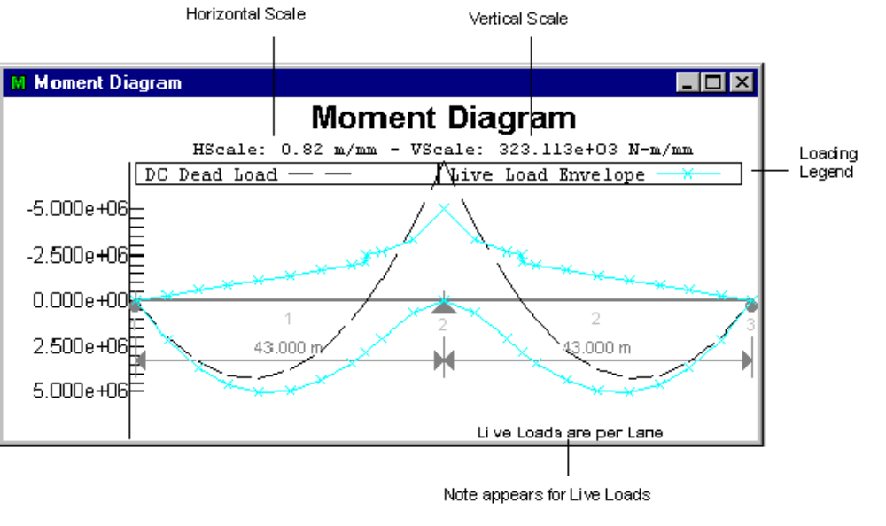
See
Legend
Scale
Per Lane Basis note
Interpreting the Results
Engineering Notation

# $ Diagram Title
The title, Moment or Shear Diagram, appears at the top.

# $ K + Scale
HScale is the Horizontal scale and VScale is the Vertical scale.

QConBridge has an intelligent scale selector. Different scales are selected for the screen and for the printer. Diagrams drawn on the screen use whatever scale is necessary to maximize the usage of the window. As you increase or decrease the size of the window, the scale changes.

Diagrams drawn on the printer use the best engineering scale for the size of paper selected. The engineering scales are chosen from the ones listed in the following table.

SI Units | Traditional  US Units
1:500 | 1:10
1:1000 | 1:20
1:1250 | 1:30
1:1500 | 1:40
1:2000 | 1:50
1:2500 | 1:60
Pick whatever size paper your printer supports.

# $ + Legend
The legend at the top of the diagram shows the color and/or symbol that represents each loading. Each selected loading is shown. There can be up to 14 loadings in one diagram. Use the Display command from the Options menu to choose the loading representations.

# $ + Per Lane Basis note
The note in the bottom right hand corner, “Live Loads are on a per lane basis” appears when you are viewing the results for an individual live load. This is a reminder that the results are on a per lane basis. The Live Load distribution factors are not applied to the individual live load cases.

Note - The note only appears for basic live load cases. Dead Loads and Combination (Strength I, Service I-III) loadings are in the context of however you built the bridge model. These points are discussed in more detail in the following section..

# $ K + Interpreting the Results
In order to properly interpret the results, you must know which factors are applied to which results.
How you interpret the loadings is based on the type of loading. They are divided into three categories: Dead Loads, Individual or Basic Live Loads, and Combination Loads.

1. Dead Loads
The results for both the DC and DW Dead Load cases are on the basis of however you built the model. If you are doing a per girder analysis then it is per girder. If you are doing a full bridge width analysis then the results are on a full bridge width basis.

2. Individual (Basic) Live Loads
The force effects for the Individual live loads are computed on a per lane basis.

- Live Load + Impact = (Truck * IMtruck + Lane * IMlane)

The Dynamic Load Allowance Factors (a.k.a. Impact Factors) have been applied to the truck and the lane loads and added together. Live Load Distribution factors are NOT included in these numbers.

Live Load Envelope
This is the envelope of Design Tandem + Lane, Design Truck + Lane, Dual Truck Train + Lane and Dual Tandem Train + Lane. This envelope is used in the limit state load combinations, except for Fatigue.
Design Tandem plus Lane Envelope
Design Tandem + Lane force effects are computed as (IMtruck)(Design Tandem) + (IMlane)(Lane Load).
Design Truck and Lane Envelope
Design Truck + Lane force effects are computed as (IMtruck)(Design Truck) + (IMlane)(Lane Load).
Dual Truck Train plus Lane Envelope
Dual Truck + Lane force effects are computed as 0.90[(IMtruck)(Design Truck) + (IMlane)(Lane Load)].
Dual Tandem Train plus Lane Envelope
Dual Tandem + Lane force effects are computed as (IMtruck)(Design Tandem) + (IMlane)(Lane Load).
Pedestrian
These force effects are on a per component basis.
Fatigue Truck
The Fatigue Truck is handled separately from the basic live loads and the pedestrian load. The force effects from the Fatigue Truck Envelope are on a per lane basis, and used in the Fatigue Limit State Combination.
Fatigue Truck force effects are computed as (IMfatigue)(Fatigue Truck)

3. Combination Loadings
The Combination Loadings are: Strength I, Service I-III, and the Fatigue Envelope. Their results are in the context of how the model was built (per girder, per full bridge width, etc.)

The Live Load Distribution Factors ARE applied to the Limit State Combinations. These limit state load combinations are consistent with Article 3.4.1 and Tables 3.4.1-1 and 3.4.1-2 of the LRFD specification.

# $ K + Tabular Results
Tabular results are viewed similarly to the diagrams except only one loading can be selected at a time. The Title and Headings change to reflect the loading you have selected.

The first two columns represent a location in the bridge. The next two columns in the table are the values of the Shear diagram and the last two are the values for the Moment diagram for the selected loading.

To View a Table

See Also
Changing the Points
Exporting Tabular Results and the Report
Printing
Reviewing Results-Overview

# $ K + To View a Table
1. From the View menu, choose Tabular Results (Alt, V, T) {bmc BMP00075.BMP}
The Tabular Results window appears telling you to use the View menu to choose a table.
2. From the View menu, choose Select Table (Alt, V, A).
The Select Loading dialog box appears. It is the same dialog box you use to select the loading for a diagram. Use it the same way, except choose one table at a time.

The Tabular Results window appears with the Table information for the loading indicated in the Select Loadings dialog box.

# $ K + Changing the Points
The default number of points for the table results is 10. If you want something different, you must change the number of points before analysis. Use the Analyze command from the Bridge menu to change the number of points.

# $ K + Report
This view is used to display a summary report of the bridge geometry, loads, and analysis results. There can be several Report Views open simultaneously. You can print the report and export to an ASCII text file.

To View a Report
From the View menu, choose Report (Alt, V, R) {bmc BMP00076.BMP}
The Report window appears with the full report information for the bridge model.

See Also
Reviewing Results-Overview

# $ K + Changing Options
QConBridge offers several options to customize the look of your diagrams. Use the Display Options dialog to control the elements and style of the Editor, Shear and Moment Diagram view.

To Edit Options

Display Options Dialog
Decorations
Screen Plot Style
Printer Plot Style

# $ K + To Edit Options
1. From the Options menu, choose Display (Alt, O, D) {bmct mouse.bmp}.
The Options menu appears.
2. Select the desired tab and make your changes.
- Click Save.

# HReview_Introduction
$ Introduction
K Results;
+ HREVIEW:0
# HReview_Diagram_Views
$ Diagram Views
K Diagrams;Diagrams,viewing
+ HREVIEW:0
# HReview_To_View_a_Shear_Diagram
$ To View a Shear Diagram
K Shear Diagram
+ HREVIEW:0
# HReview_To_View_a_Moment_Diagram
$ To View a Moment Diagram
K Moment Diagram
+ HREVIEW:0
# HReview_Interpreting_the_Diagrams
$ Interpreting the Diagrams
K Interpreting the Diagrams;Diagrams;Diagrams,interpreting
+ HREVIEW:0
# HReview_Anatomy_of_the_Diagram
$ Anatomy of the Diagram
K Anatomy of the Diagram;Scale
+ HREVIEW:0
# HReview_Diagram_Title
$ Diagram Title
# HReview_Scale
$ Scale
K Scale
+ HREVIEW:0
# HReview_Legend
$ Legend
+ HREVIEW:0
# HReview_Per_Lane_Basis_note
$ Per Lane Basis note
+ HREVIEW:0
# HReview_Interpreting_the_Results
$ Interpreting the Results
K Interpreting the Results;Loads;Loads,interpreting results
+ HREVIEW:0
# HReview_Tabular_Results
$ Tabular Results
K Tabular Results
+ HREVIEW:0
# HReview_To_View_a_Table
$ To View a Table
K View a Table
+ HREVIEW:0
# HReview_Changing_the_Points
$ Changing the Points
K Changing the Points;Points,changing
+ HREVIEW:0
# HReview_Report
$ Report
K Reports
+ HREVIEW:0
# HReview_Changing_Options
$ Changing Options
K Options
+ HREVIEW:0
# HReview_To_Edit_Options
$ To Edit Options
K Edit Options;Options
+ HREVIEW:0

