Getting Started Manual
This document outline is based on the IEEE Standard 1058.1-1987 for Software Project Management Plans.
This is the controlling document for managing a software project, and it defines the technical and managerial processes necessary to deliver the project requirements.
The paragraphs written in the “Comment” style are for the benefit of the person writing the document and should be removed before the document is finalized.
For The
Longitudinal Bridge Analysis System (LBAM) Component
A Member of the Alternate Route Project
Version 1
November 1, 2002
Richard Pickings, PE
BridgeSight Software

Richard Brice, PE
WSDOT
Revision Chart
This chart contains a history of this document’s revisions. The entries below are provided solely for purposes of illustration. Entries should be deleted until the revision they refer to has actually been created.
The document itself should be stored in revision control, and a brief description of each version should be entered in the revision control system. That brief description can be repeated in this section. Revisions do not need to be described elsewhere in the document except inasmuch as they explain the development plan itself.

Version | Primary Author(s) | Description of Version | Date Completed
1.0 - Draft 1 | RDP | Initial draft created for distribution and review comments | 11/1/2002

Contents
New paragraphs formatted as Heading 1, Heading 2, and Heading 3 will be added to the table automatically. To update this table of contents in Microsoft Word, put the cursor anywhere in the table and press F9. If you want the table to be easy to maintain, do not change it manually.
1. Introduction 4
1.1 Key System Packages 4
1.2 Why So Many Packages? 5
1.3 Keys to Extensibility – Context Objects 5
2. OK, Enough Architecture - What About Ease Of Use? 6
2.1 LBAM Utility Components 6
2.1.1 A Very Simple Example 6
2.2 On-Demand Computation 8
3. Building Complex Models 9

List of Figures
New figures that are given captions using the Caption paragraph style will be added to the table automatically. To update this table of contents in Microsoft Word, put the cursor anywhere in the table and press F9. If you want the table to be easy to maintain, do not change it manually.
This section can be deleted if the document contains no figures or if otherwise desired.
Figure 1 Key System Packages 4
Figure 2 On Demand Computation 8

Introduction
This section should describe the purpose and background of the project and the organization of this document. No text is necessary between the heading above and the heading below unless otherwise desired.
The Longitudinal Bridge Analysis Modeling (LBAM) components are a COM-based software solution designed to automate the analysis of highway bridge superstructures using the simplified approach. Longitudinal Bridge Analysis Models are an idealized, single girderline description of the bridge superstructure.
In this section, describe the overall system concept, expected operational environment (hardware, peripherals, etc.), high level diagrams of the system showing the external interfaces and data flow, and an overview of high level requirements.
No text is necessary between the heading above and the heading below unless otherwise desired.

Key System Packages
The complete LBAM Analysis system consists of seven interdependent packages as shown by the package diagram below. The Fem2d package is a dependency of the LBAM system, but is a stand-alone unit unto itself and is documented elsewhere.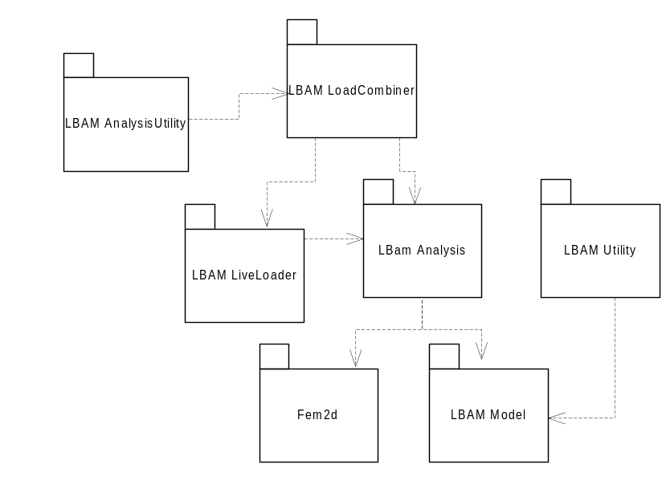
Figure 1 Key System Packages
The following table gives a brief description of each package in the LBAM System:
Package | Description
LBAM Model  (LBAM.dll) | Main purpose is to provide a description of the LBAM Model itself. Describes model geometry and stiffness properties of elements, loads, load combinations, and live loads. Supports model persistence and fires events whenever the model is changed. Has a few computational methods that help to deal with model geometry.
LBAM Analysis  (LBAMAnalysis.dll) | Basic analysis of static loadings (LoadGroups only), influence lines, and contraflexure response. Also provides components/interfaces to aid in finding model information located at POI’s.
LBAM LiveLoader (LBAMLiveLoader.dll) | Computes live load responses for all live loads defined in the LBAM model.
LBAM LoadCombiner (LBAMLoadCombiner.dll) | Computes combined LoadCase and LoadCombination responses.
LBAM Utility (LBAMUtility.dll) | Basic utility functions to facilitate working with the LBAM Model. Contains a factory component for creating entire models and model elements; a POI utility component for Autogeneration and sorting of POIs; and a general utility component to aid in working with model stages and elements.
LBAM AnalysisUtility (LBAMAnalysisUtility.dll) | Contains a utility component that simplifies the composition of a default analysis system. Most users of the LBAM system will use this component to initialize the system to perform their analysis.

Why So Many Packages?
At this point, you might be asking: “Why so many packages? Does the system need to be this complicated?”
These are valid questions. The LBAM analysis system was designed with ease of use in mind, but other design factors also predominated. Among these were:
- Minimal, and well-defined coupling between packages.
- Extensibility via composition
These concerns may not seem important to a typical user of the LBAM system, but they allow flexibility that would not be available with a monolithic system. Examples of ways that the packages might be reused or extended are:
- Use of the live loader and/or load combiner to compute results for models other than the LBAM Model.
- Ability to plug in a different live load positioning algorithm than the default algorithm provided with the LBAM system.

Keys to Extensibility – Context Objects
Context objects are used to completely define (and implement) the set of interfaces that the components in an analysis package are dependent on. For instance, if a programmer wants to use the LBAM LiveLoader with his own system (i.e., components other than the default LBAM Model and LBAM Analysis components), he would create a new context object that supports the set of interfaces defined by the VehicularAnalysisContext component and then use the IDependOnVehicularAnalysisContext interface on the analysis components to initialize them.
Detailed specifications for the interfaces that must be implemented by each context object in the system are defined in the LBAM Programmer’s Guide.

OK, Enough Architecture - What About Ease Of Use?
After all, the main purpose of the LBAM Analysis system is to provide a foundation for building bridge design software applications. The system is designed to be easy to use by a wide range of clients for building simple bridge models. Of course, more detailed bridge models will require more detailed input (no free lunch).

LBAM Utility Components
The LBAM system has three components designed to help build and analyze simple models both quickly and easily. These are the LBAMFactory, LBAMPOIUtility and LBAMAnalysisEngine components.
The LBAMFactory and LBAMPOIUtility components are contained in the LBAMUtility package. LBAMFactory implements the ILBAMFactory interface, which contains methods that simplify creating LBAM elements. The most interesting method for our current discussion is CreateSimpleLBAM, which allows you to create a complete multi-span prismatic model of a superstructure on simple supports. A call to this method is often a good way to quickly build a model to get started.
The LBAMPOIUtility supports the ILBAMPOIUtility interface, which contains methods for creating and sorting POI’s. For our discussion, we are interested in GeneratePOIsOnSuperstructure, which will create POI’s at a fixed increment along all Spans in the structure.
The LBAMAnalysisEngine component is used to quickly build a set of default analysis components that can be used to compute force responses on the LBAM Model. This component is adequate for most users, except those who wish to analyze models other than LBAM’s or use custom versions of their own analysis engines. The ILBAMAnalysisEngine interface has an Initialize method that must be called once before performing the response analysis. Initialize does all of the hard work of creating the necessary context objects, and marrying the various engines together as mentioned in the previous section.

A Very Simple Example
The following code in VBA demonstrates how to use the utility components to build a simple three-span model, apply a uniform load to it, and compute mid-span moments.

Option Explicit
Option Base 0

Private Sub CommandButton1_Click()

' Create our model factory
Dim factory As New LBAMFactory

' Set up span lengths of 50, 100, 50
Dim span_lengths(2) As Double
span_lengths(0) = 50
span_lengths(1) = 100
span_lengths(2) = 50

' Use factory to create model with E=1.0, I=1.0, A=1.0 and depth=1.0
Dim mdl As LBAMModel
Set mdl = factory.CreateSimpleLBAM(span_lengths, 1, 1, 1, 1)

' We need a load group to put our load in
Dim self_weight_lg As New LoadGroup
self_weight_lg.Name = "Self Weight"
mdl.LoadGroups.Add self_weight_lg

' Create a vertical distributed load with value of -1.0 across the
' entire superstructure
Dim dl As New DistributedLoad
dl.Direction = ldFy
dl.MemberType = mtSuperstructureMember
dl.MemberID = 0
dl.StartLocation = 0
dl.EndLocation = -1
dl.WStart = -1
dl.WEnd = -1

mdl.DistributedLoads.Add "Stage 1", "Self Weight", dl

' Place POIs half-points along spans (1 through 9)
Dim i As Long
Dim poi_util As New LBAMPOIUtility
i = poi_util.GeneratePOIsOnSuperstructure(mdl, 1, 2)

' Set up our engine to perform analysis
Dim engine As New LBAMAnalysisEngine
engine.Initialize mdl, atForce

' Request results at POIs at middle of each span
Dim poi_ids(2) As Long
poi_ids(0) = 2
poi_ids(1) = 5
poi_ids(2) = 8

' Compute results
Dim results As ISectionResult3Ds
Set results = engine.LoadGroupResponse.ComputeForces("Self Weight", poi_ids,
"Stage 1", roMember, rsIncremental)

' Print results out to "Immediate" window
Debug.Print " Mid-Span Moments"
Debug.Print " Span 1 = "; results(0).ZLeft
Debug.Print " Span 2 = "; results(1).ZLeft
Debug.Print " Span 3 = "; results(2).ZLeft

End Sub

This example shows the basic three-step approach to using the LBAM analysis system. First build a model, next define and apply loads, then request results. The steps are the same for more complex models, however, the amount of code to build the model and define loads increases as complexity increases.

On-Demand Computation
If you have browsed the Properties and Methods for the LBAM Model and analysis packages, you may have noticed that there is no Method called "AnalyzeModel" or "ComputeNow". This is because the engines only perform analyses on an as-needed basis. A basic flow chart for client programs is shown below:
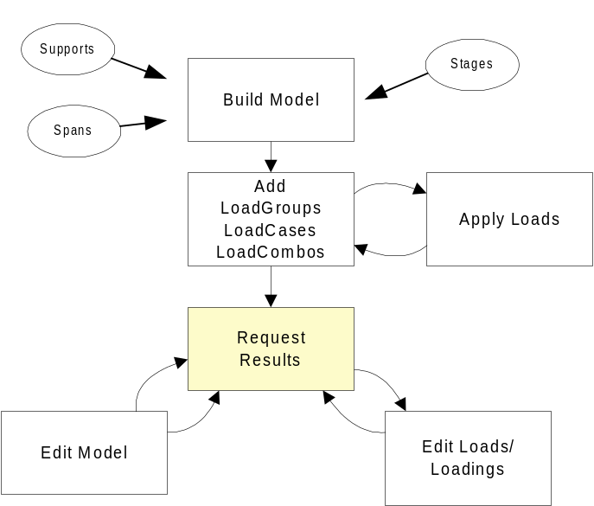
Figure 2 On Demand Computation

The basic idea here is that you can change the model and request results at any time, and the analysis engines will automatically update themselves. Of course, models must be valid in order to perform a successful analysis.

Building Complex Models
The LBAMFactory object provides a fast and easy way to build simple superstructure models. However, it quickly loses its usefulness for models with full-length supports, multiple stages, or varying cross sections. For these types of models, it is probably best to forgo using the factory and build models from scratch.

The best way to show how to build a model from scratch is by example. The SDCL.xls spreadsheet demonstrates how to build a multi-stage model for analyzing a simple for dead load, continuous for live load structure. SDCL.xls is installed in the Samples folder.

Refer to the help file for the LBAM Model package for detailed information about building LBAM models.

