|  |
| --- |
|  |
|  |
|  |
|  |
| E-Shopping System |

Software design

Kun Wang 542115502

Lin Li 542115503

|  |
| --- |
|  |

Yiyun Wang 542115510

**URS**

URS 1: The user can register as a customer.

URS 2: The user can login to the system as customer.

URS 3: The customer can update personal information.

URS 4: The customer can browse the product categories.

URS 5: The customer can search for the product name.

URS 6: The customer can add products to shopping cart.

URS 7: The customer can select multi product.  
  
URS 8: The customer can check out to summary.

 URS 8.1: The customer can view what products she/he selected.

URS 8.2: The customer can view the total price of products he/she has to pay.

  URS 8.3: The customer can select a payment option.

URS 8.3.1: The customer can select the way of money transfer to pay.

URS 8.3.2: The customer can select the way of credit card to pay.

URS8.3.3: The customer can select the way of PayPal to pay.

URS 8.4: The customer can delete, update products from the shopping cart.

URS 9: The customer can click confirm button to finish buying process.

URS 10: The customer can save shopping cart.

URS 11: The customer can browse shopping history.

URS 12: The administrator can edit name, description, and pictures of the product.

URS 13: The administrator can add products to products list.

URS 14: The administrator can delete products from products list.

URS 15: The administrator can browse the shopping history of all customers.

**SRS**

SRS 1: The system provides the UI which receive the username, password, re-enter password, address and picture that the customer registered.

SRS 2: The system shall check the username format and the username format should be email format.

SRS 3: The system provides the UI which the customer can update personal information later.

SRS 4: The system shall check the password format. The password format must be 4-20 characters. The password must contain the small letter, capital letter, and number.

SRS 5: The system shall check re-enter password format and consistency with password format.

SRS 6: The system shall verify the customer’s address.

SRS 7: The system shall verify the customer’s picture.

SRS 8: The system shall display an error message “the username must be an e-mail”.

SRS 9: The system shall display an error message “the password length should be 4-20 characters”.

SRS 10: The system shall display an error message “the re-enter password must be consistency with password format”.

SRS 11: The system shall display an error message “The customer address should fill in”.

SRS 12: The system shall display an error message “The customer picture must upload”.

SRS 13: The system shall send a successful registration email to customer.

SRS 14: The system shall display successful register message on the registration page.

SRS 15: The system provides the log in the interface for user.

SRS 16: The system shall check whether username and password are match or not .

SRS 17: The system shall display an error message “the username is not correct”

SRS 18: The system shall display an error message “the password is not correct”

SRS 19: The system shall list the product with name, short description and picture.

SRS 20: The system provides search option for product name.

SRS 21: The system provides product choose option when customer wants add the product to shopping carts.

SRS 22: The system provides multi product option to customer.

SRS 23: The system shall show the summary of product in the shopping cart what customer selected when check out.

SRS 24: The system shall list all products name that customer selected.

SRS 25: The system shall list price of each product and total price.

SRS 26: The system provides payment options, e- bank transfer, credit card and PayPal.

SRS 27: The system provides confirm options for the customer to confirm buying process.

SRS 28: The system provides delete option for the customer to delete products where in the shopping cart.

SRS 29: The system shall show buying transaction history what customer has bought.

SRS 30: The system shall list all products what customer selected and saved in the shopping cart.

SRS 31: The system provides edit product details option for administrator.

SRS 32: The system provides add product option for administrator.

SRS 33: The system provides delete product option for administrator.

SRS 34: The system allowed administrator to view customers shopping history.

**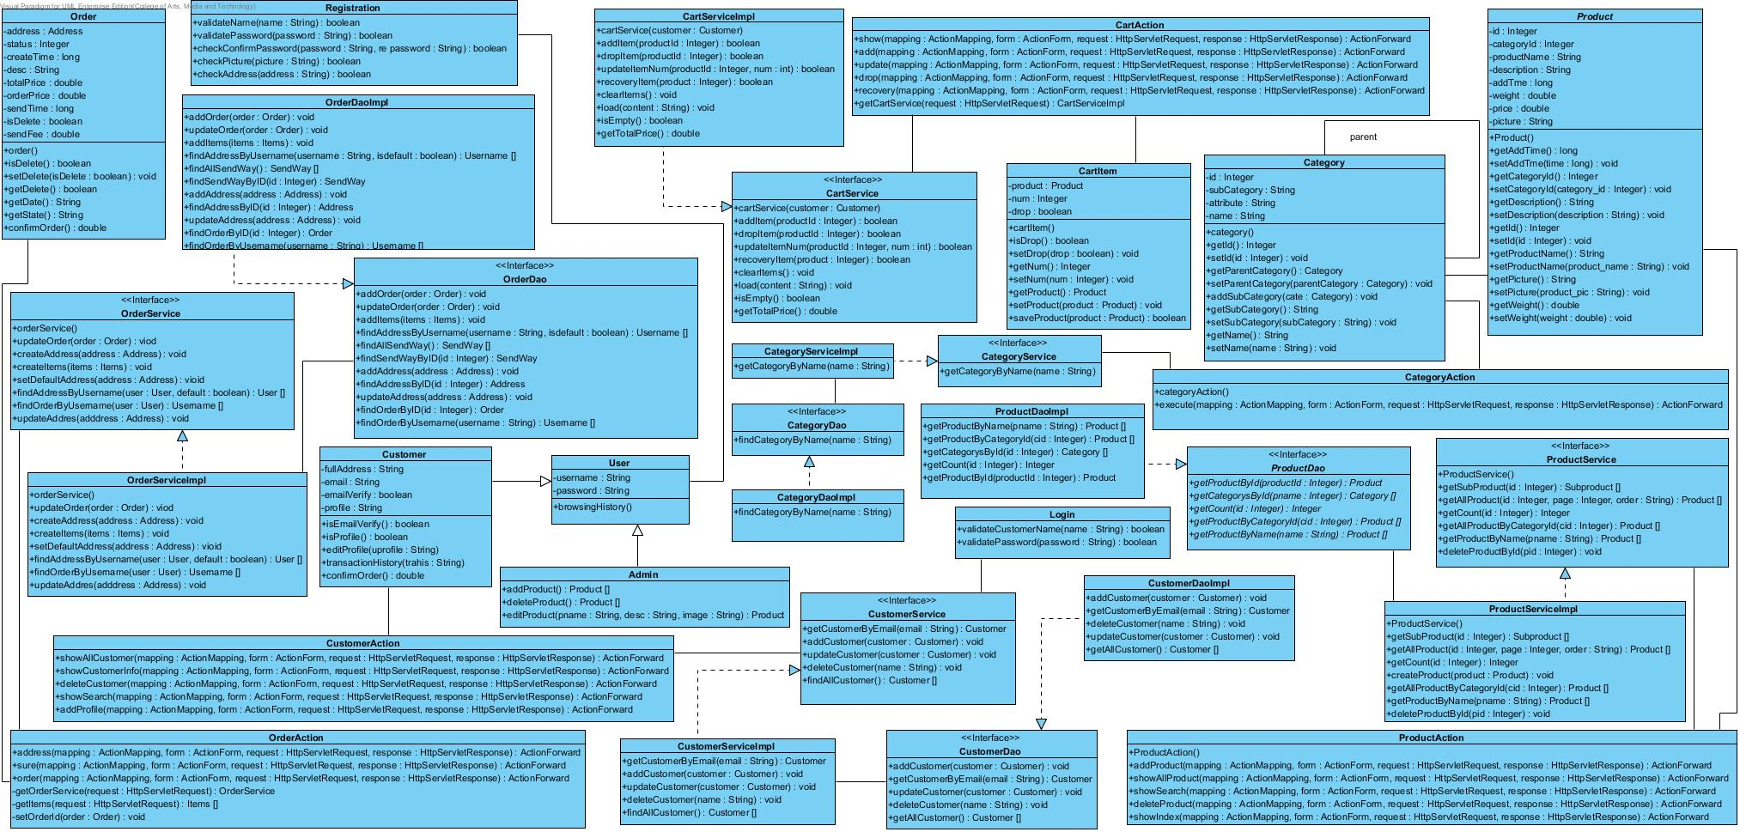**

**Class Diagram**

**Sequence Diagram**

Register UI

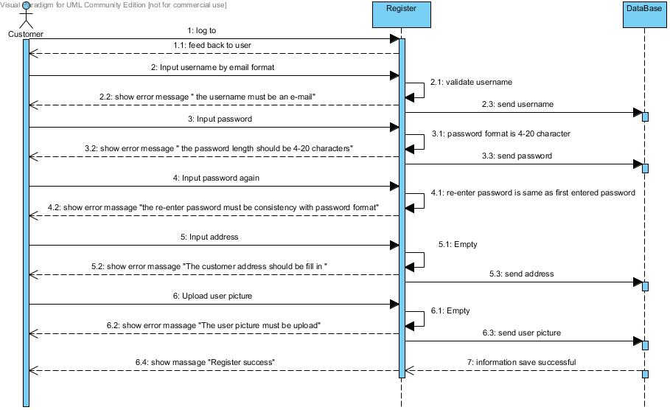

Login  
  
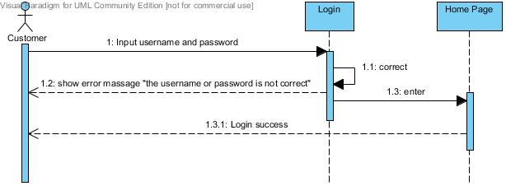

Personal Information Edit

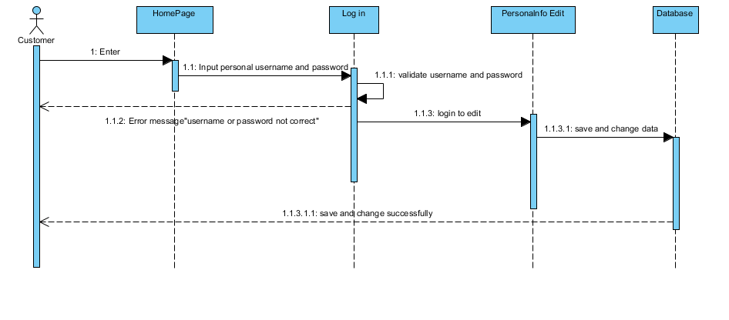

Order Product

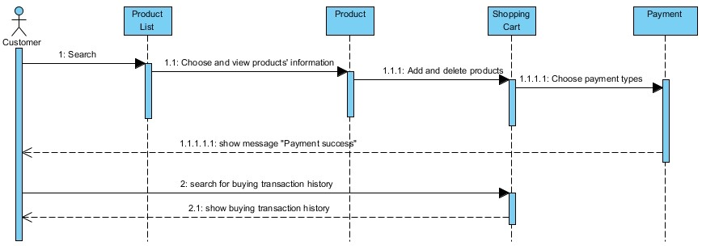

Add Product

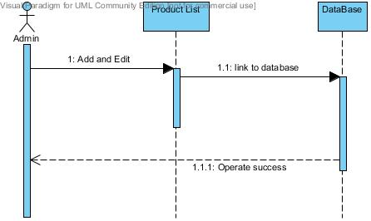

Delete Product

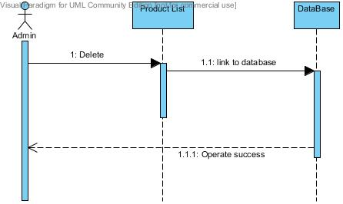

**Method Design**

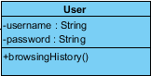

|  |  |  |
| --- | --- | --- |
| **Method** | **parameter** | **Description** |
| +browsingHistory() | - | This method let customer and admin can brow shopping history. |

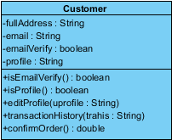

|  |  |  |
| --- | --- | --- |
| **Method** | **parameter** | **Description** |
| +isEmailVerify() | - | This method validate that the username is an email format. |
| +isProfile() | - | This method validate that the user picture is a correct format. |
| +editProfile() | uprofile:String | This method let customer edit personal information after register. |
| +transactionHistory() | trahis:String | This method allow customer view transaction history. |
| +confirmOrder() | - | This method let customer confirm order before payment. |

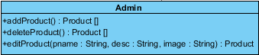

|  |  |  |
| --- | --- | --- |
| **Method** | **Parameter** | **Description** |
| +addProduct() | Product[] | This method let admin add product to product list. |
| +deleteProduct() | Product[] | This method let admin delete product from product list. |
| +editProduct() | pname:String, desc:String, image:String | This method let admin edits product where name, description and image. |



|  |  |  |
| --- | --- | --- |
| **Method** | **parameter** | **Description** |
| +validateCustomerName() | name:String | This method validate customer name whether or not is a registered name. |
| +validatePassword() | password:String | This method validate customer password whether or not is right. |

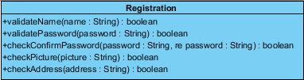

|  |  |  |
| --- | --- | --- |
| **Method** | **parameter** | **Description** |
| +validatePassword() | password : String | This method validate whether or not customer’s password is a right format |
| +checkConfirmPassword() | password : String, repassword : String | This method checks customer confirm password whether or not is the same as an inputted password. |
| +validateName() | name : String | This method validate whether or not a right name format. |
| +checkPicture() | picture:String | This method checks customer picture whether or not is picture format. |
| +checkAddress() | address:String | This method is checks whether or not customer address is valid. |

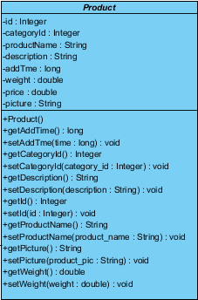

|  |  |  |
| --- | --- | --- |
| **Method** | **parameter** | **Description** |
| +product() | - | This method provides product project. |

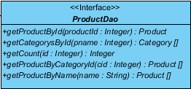

|  |  |  |
| --- | --- | --- |
| **Method** | **parameter** | **Description** |
| +getProductById() | productId: Integer | - |
| +getCategorysById() | Pname: Integer | - |
| +getCount() | id: Integer | - |
| +getProductByCategoryId() | cid:Integer | - |
| +getProductByName() | name: String | - |

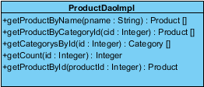

|  |  |  |
| --- | --- | --- |
| **Method** | **parameter** | **Description** |
| +getProductById() | productId: Integer | - |
| +getCategorysById() | Pname: Integer | - |
| +getCount() | id: Integer | - |
| +getProductByCategoryId() | cid:Integer | - |
| +getProductByName() | name: String | - |

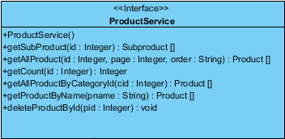

|  |  |  |
| --- | --- | --- |
| **Method** | **parameter** | **Description** |
| +productService() | - | Calling the method of product service where from product DAO implement class. |
| +deleteProductById() | pid: Integer | Calling the method of delete product by ID where from product DAO implement class. |

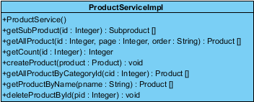

|  |  |  |
| --- | --- | --- |
| **Method** | **parameter** | **Description** |
| +productService() | - | Implement the method of product service where from product service interface. |
| +deleteProductById() | pid: Integer | Implement the method of delete product by ID where from product service interface. |

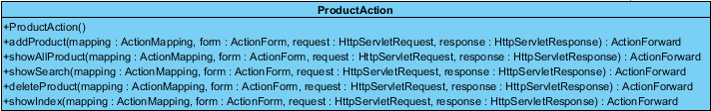

|  |  |  |
| --- | --- | --- |
| **Method** | **parameter** | **Description** |
| +productAction() | - | Calling the method of product action where from product service interface. |
| +addProduct() | mapping : ActionMapping, form : ActionForm,  request : HttpServletRequest, response : HttpServletResponse | Calling the method of add product where from product service interface. |
| +showAllProduct() | mapping : ActionMapping, form : ActionForm,  request : HttpServletRequest, response : HttpServletResponse | Calling the method of show all products where from product service interface. |
| +showSearch() | mapping : ActionMapping, form : ActionForm,  request : HttpServletRequest, response : HttpServletResponse | Calling the method of show search where from product service interface. |
| +deleteProduct() | mapping : ActionMapping, form : ActionForm,  request : HttpServletRequest, response : HttpServletResponse | Calling the method of delete product where from product service interface. |
| +showIndex() | mapping : ActionMapping, form : ActionForm,  request : HttpServletRequest, response : HttpServletResponse | Calling the method of show index page where from product service interface. |

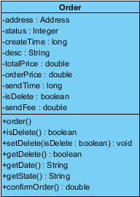

|  |  |  |
| --- | --- | --- |
| **Method** | **parameter** | **Description** |
| +order() | - | This method let customer order items. |
| +isDelete() | - | This method let customer can delete items that he ordered. |
| +confirmOrder() | - | This method let customer confirm order before payment. |

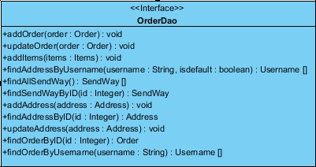

|  |  |  |
| --- | --- | --- |
| **Method** | **parameter** | **Description** |
| +addOrder() | order:Order | Calling the method of add order which from order DAO implement class. |
| +updateOrder() | order : Order | Calling the method of update order which from order DAO implement class. |
| +addItems() | items:Items | Calling the method of add items which from order DAO implement class. |
| +findAddressByUsername() | userid : Integer, isdefault : boolean | Calling the method of find address by username which from order DAO implement class. |
| +findAllSendWayByUsername() | username: String,  isDefault:boolean | Calling the method of find all send way by username which from order DAO implement class. |
| +findAllSendWay() | SendWay[] | Calling the method of find all send way which from order DAO implement class. |
| +addAddress() | address:Address | Calling the method of add address which from order DAO implement class. |
| +findAddressByID() | id:intdger | Calling the method of find address by ID where from order DAO implement class. |
| +updateAddress() | address : .Address | Calling the method of update address where from order DAO implement class. |
| +findOrderById() : | id:integer | Calling the method of find order by Id where from order DAO implement class. |
| +findOrderByUsername() | Username:String | Calling the method of find order by username where from order DAO implement class. |

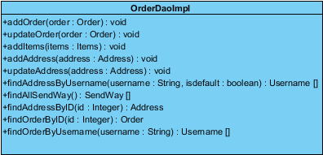

|  |  |  |
| --- | --- | --- |
| **Method** | **parameter** | **Description** |
| +addOrder() | order:Order | Implement the method of add order which from order DAO interface. |
| +updateOrder() | order : Order | Implement the method of update order which from order DAO interface. |
| +addItems() | items:Items | Implement the method of add item which from order DAO interface. |
| +findAddressByUsername() | userid : Integer, isdefault : boolean | Implement the method of find address by username which from order DAO interface. |
| +findAllSendWayByUsername() | username: String,  isDefault:boolean | Implement the method of find all send way by username which from order DAO interface. |
| +findAllSendWay() | SendWay[] | Implement the method of find all wend which from order DAO interface. |
| +addAddress() | address:Address | Implement the method of add address which from order DAO interface. |
| +findAddressByID() | id:intdger | Implement the method of find address by ID which from order DAO interface. |
| +updateAddress() | address : .Address | Implement the method of update address which from order DAO interface. |
| +findOrderById() : | id:integer | Implement the method of find order by id which from order DAO interface. |
| +findOrderByUsername() | Username:String | Implement the method of find order by username where from order DAO interface. |

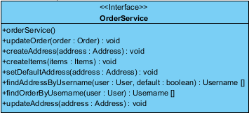

|  |  |  |
| --- | --- | --- |
| **Method** | **parameter** | **Description** |
| +orderService() | - | Calling the method of order service where from order DAO implement class. |
| +updateOrder() | order:Order | Calling the method of update order which from order DAO implement class. |
| +createAddress() | address : Address | Calling the method of create address which from order DAO implement class. |
| +createItems() | items : Items | Calling the method of create items which from order DAO implement class. |
| +findAddressByUsername() | user : User, default : boolean | Calling the method of find address by username which from order DAO implement class. |
| +findOrderByUsername() | user :User | Calling the method of find order by username which from order DAO implement class. |
| +updateaAddress() | address:Address | Calling the method of update address which from order DAO implement class. |

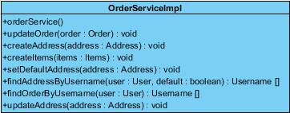

|  |  |  |
| --- | --- | --- |
| **Method** | **parameter** | **description** |
| +orderService() | - | Implement the method of order service where from order service interface. |
| +updateOrder() | order:Order | Implement the method of update order which from order service interface. |
| +createAddress() | address : Address | Implement the method of create address which from order service interface. |
| +createItems() | items : Items | Implement the method of create items which from order service interface. |
| +findAddressByUsername() | user : User, default : boolean | Implement the method of find address by username which from order service interface. |
| +findOrderByUsername() | user :User | Implement the method of find order by username which from order service interface. |
| +updateaAddress() | address:Address | Implement the method of update address which from order service interface. |

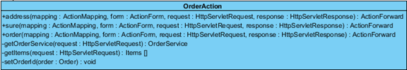

|  |  |  |
| --- | --- | --- |
| **Method** | **parameter** | **Description** |
| +address() | mapping : ActionMapping, form : ActionForm,  request : HttpServletRequest, response : HttpServletResponse | Calling the method of address where from order service interface. |
| +sure() | mapping : ActionMapping, form : ActionForm,  request : HttpServletRequest, response : HttpServletResponse | Calling the method of sure which from order service interface. |
| +order() | mapping : ActionMapping, form : ActionForm,  request : HttpServletRequest, response : HttpServletResponse | Callng the method of order which from order service interface. |

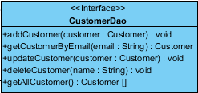

|  |  |  |
| --- | --- | --- |
| **Method** | **parameter** | **Description** |
| +addCustomer() | customer : Customer | Calling the method of add customer which from customer DAO implement class. |
| +updateCustomer() | customer :Customer | Calling the method of update customer where from customer DAO implement class. |
| +deleteCustomer() | name : String | Calling the method of delete customer where from customer DAO implement class. |

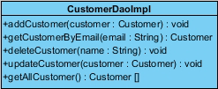

|  |  |  |
| --- | --- | --- |
| **Method** | **parameter** | **Description** |
| +addCustomer() | customer : Customer | Implement the method of add customer which from customer DAO interface. |
| +updateCustomer() | customer :Customer | Implement the method of update customer where from customer DAO interface. |
| +deleteCustomer() | name : String | Implement the method of delete customer where from customer DAO interface. |

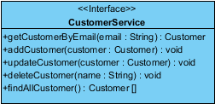

|  |  |  |
| --- | --- | --- |
| **Method** | **parameter** | **Description** |
| +addCustomer() | customer : Customer | Calling the method of add customer which from customer DAO implement class. |
| +updateCustomer() | customer :Customer | Calling the method of update customer which from customer DAO implement class. |
| +deleteCustomer() | name : String | Calling the method of delete customer where from customer DAO implement class. |
| +findAllCustomer() | - | Calling the method of find all customers which from customer DAO implement class. |

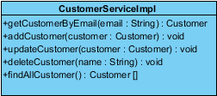

|  |  |  |
| --- | --- | --- |
| **Method** | **parameter** | **Description** |
| +addCustomer() | customer : Customer | Implement the method of add customer which from customer service interface. |
| +updateCustomer() | customer :Customer | Implement the method of update customer where from customer service interface. |
| +deleteCustomer() | name : String | Implement the method of delete customer where from customer service interface. |
| +findAllCustomer() | - | Implement the method of find customer where from customer service interface. |

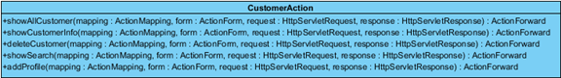

|  |  |  |
| --- | --- | --- |
| **Method** | **parameter** | **Description** |
| +showAllCustomer() | mapping : ActionMapping, form : ActionForm,  request : HttpServletRequest, response : HttpServletResponse | Calling the method of show all customers which from customer service interface. |
| +showCustomerInfo() | mapping : ActionMapping, form : ActionForm,  request : HttpServletRequest, response : HttpServletResponse | Calling the method of show customer information where from customer service interface. |

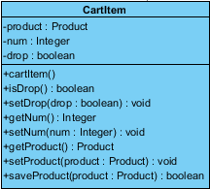

|  |  |  |
| --- | --- | --- |
| **Method** | **parameter** | **Description** |
| +cartItem() | - | This method provides cart item object. |
| +isDrop() | - | This method check cart item whether or not is drop. |
| +saveProduct() | product:Product |  |

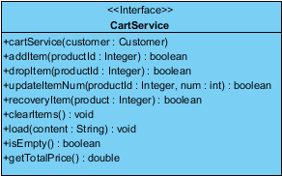

|  |  |  |
| --- | --- | --- |
| **Method** | **parameter** | **Description** |
| +cartService() | customer : Customer | Calling the method of cart service where from cart DAO implement class. |
| +addItem() | productId : Integer | Calling the method of add item which from cart DAO implement class. |
| +dropItem() | productId : Integer | Calling the method of drop item which from cart DAO implement class. |
| +updateItemNum() | productId : Integer, num : int | Calling the method of update item number where from cart DAO implement class. |
| +recoveryItem() | product : Integer | Calling the method of recovery item which from cart DAO implement class. |
| +clearItems() | - | Calling the method of clear item which from cart DAO implement class. |
| +load() | content : String | Calling the method of load where from cart DAO implement class. |
| +isEmpty() | - | Calling the method of is empty which from cart DAO implement class. |

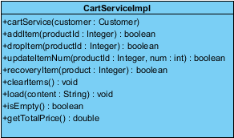

|  |  |  |
| --- | --- | --- |
| **Method** | **parameter** | **Description** |
| +cartService() | customer : Customer | Implement the method of cart service where from cart service interface. |
| +addItem() | productId : Integer | Implement the method of add item which from cart service interface. |
| +dropItem() | productId : Integer | Implement the method of drop item which from cart service interface. |
| +updateItemNum() | productId : Integer, num : int | Implement the method of update item number which from cart service interface. |
| +recoveryItem() | product : Integer | Implement the method of recovery item which from cart service interface. |
| +clearItems() | - | Implement the method of clear items which from cart service interface. |
| +load() | content : String | Implement the method of load where from cart service interface. |
| +isEmpty() | - | Implement the method of is empty which from cart service interface. |

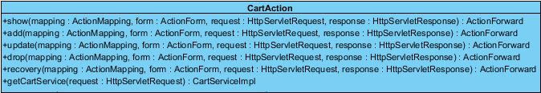

|  |  |  |
| --- | --- | --- |
| **Method** | **parameter** | **Description** |
| +show() | mapping : ActionMapping, form : ActionForm,  request : HttpServletRequest, response :  HttpServletResponse | Calling the method of show where from cart service interface. |
| +add() | mapping : ActionMapping, form : ActionForm,  request : HttpServletRequest, response : HttpServletResponse | Calling the method of add which from cart service interface. |
| +update() | mapping : ActionMapping, form : ActionForm,  request : HttpServletRequest, response : HttpServletResponse | Calling the method of update which from cart service interface. |
| +drop() | mapping : ActionMapping, form : ActionForm,  request : HttpServletRequest, response : HttpServletResponse | Calling the method of drop wherefrom cart service interface. |
| +recovery() | mapping : ActionMapping, form : ActionForm,  request : HttpServletRequest, response : HttpServletResponse | Calling the method of recovery where from cart service interface. |

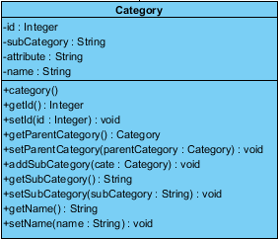

|  |  |  |
| --- | --- | --- |
| **Method** | **parameter** | **Description** |
| +category() | name : String | This method provides category object. |

C:\Users\ADMINI~1\AppData\Local\Temp\ksohtml\wps_clip_image-8448.png

|  |  |  |
| --- | --- | --- |
| **Method** | **parameter** | **Description** |
| +findCategoryByName() | name : String | Calling the method of find category by name which from category DAO implement class. |

C:\Users\ADMINI~1\AppData\Local\Temp\ksohtml\wps_clip_image-20890.png

|  |  |  |
| --- | --- | --- |
| **Method** | **parameter** | **Description** |
| +findCategoryByName() | name : String | Implement the method of find category by name where from category DAO interface. |



|  |  |  |
| --- | --- | --- |
| **Method** | **parameter** | **Description** |
| +getCategoryByName() | name: String | - |



|  |  |  |
| --- | --- | --- |
| **Method** | **parameter** | **Description** |
| +getCategoryByName() | name: String | - |

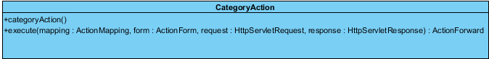

|  |  |  |
| --- | --- | --- |
| **Method** | **parameter** | **Description** |
| +categoryAction() | - | Calling the method of category action where from cart service interface. |
| +execute() | mapping :ActionMapping, form :ActionForm, request :HttpServletRequest, response :http.HttpServletResponse | Calling the method of execute where from cart service interface. |

**Traceability Matrix**

Traceability Matrix between URS / SRS

**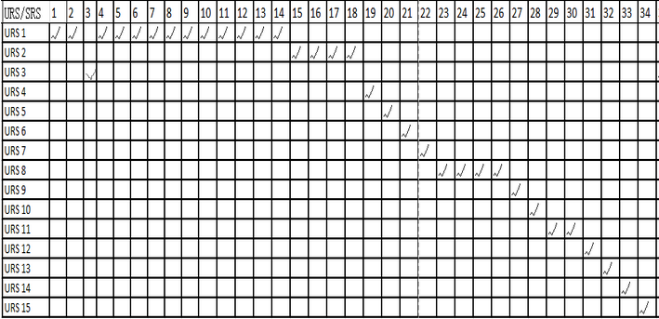**

Traceability Matrix between Sequence / URS

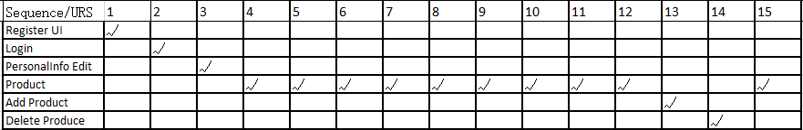

Traceability Matrix between Sequence / SRS

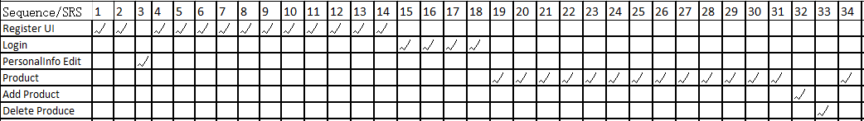

|  |  |  |  |  |  |  |  |  |  |  |  |  |  |  |  |  |  |  |  |  |  |  |  |  |  |  |  |  |  |  |  |  |  |
| --- | --- | --- | --- | --- | --- | --- | --- | --- | --- | --- | --- | --- | --- | --- | --- | --- | --- | --- | --- | --- | --- | --- | --- | --- | --- | --- | --- | --- | --- | --- | --- | --- | --- |
| class / SRS | 01 | 02 | 03 | 04 | 05 | 06 | 07 | 08 | 09 | 10 | 11 | 12 | 13 | 14 | 15 | 16 | 17 | 18 | 19 | 20 | 21 | 22 | 23 | 24 | 25 | 26 | 27 | 28 | 29 | 30 | 31 | 32 | 34 |
| User |  |  |  |  |  |  |  |  |  |  |  |  |  |  |  |  |  |  |  |  |  |  |  |  |  |  |  |  |  |  |  |  | √ |
| Customer |  | √ | √ |  |  |  |  |  |  |  |  |  | √ |  |  |  |  |  |  |  |  |  |  |  |  |  | √ |  | √ |  |  |  | √ |
| Admin |  |  |  |  |  |  |  |  |  |  |  |  |  |  |  |  |  |  |  |  |  |  |  |  |  |  |  |  |  |  | √ | √ |  |
| Login |  | √ |  | √ |  |  |  |  |  |  |  |  |  |  | √ | √ | √ | √ |  |  |  |  |  |  |  |  |  |  |  |  |  |  |  |
| Registration |  | √ |  | √ | √ | √ | √ | √ | √ | √ |  | √ |  | √ |  |  |  |  |  |  |  |  |  |  |  |  |  |  |  |  |  |  |  |
| Product |  |  |  |  |  |  |  |  |  |  |  |  |  |  |  |  |  |  | √ | √ |  |  |  |  |  |  |  | √ |  | √ | √ | √ |  |
| ProsuctDao |  |  |  |  |  |  |  |  |  |  |  |  |  |  |  |  |  |  | √ | √ |  |  |  |  |  |  |  |  |  | √ |  |  |  |
| ProductDaoImpl |  |  |  |  |  |  |  |  |  |  |  |  |  |  |  |  |  |  | √ | √ |  |  |  |  |  |  |  |  |  | √ |  |  |  |
| ProductService |  |  |  |  |  |  |  |  |  |  |  |  |  |  |  |  |  |  | √ | √ |  |  |  |  |  |  |  | √ |  | √ | √ | √ |  |
| ProductServiceImpl |  |  |  |  |  |  |  |  |  |  |  |  |  |  |  |  |  |  | √ | √ |  |  |  |  |  |  |  | √ |  | √ | √ | √ |  |
| ProductAction |  |  |  |  |  |  |  |  |  |  |  |  |  |  |  |  |  |  |  | √ |  |  |  |  |  |  |  |  |  | √ | √ | √ |  |
| Order |  |  |  |  |  |  |  |  |  |  | √ |  |  |  |  |  |  |  |  |  | √ |  |  |  |  |  | √ | √ |  |  |  |  |  |
| OrderDao |  |  | √ |  |  |  |  |  |  |  |  |  |  |  |  |  |  |  |  |  | √ |  |  |  |  |  |  |  |  |  |  |  |  |
| OrderDaOImpl |  |  | √ |  |  |  |  |  |  |  |  |  |  |  |  |  |  |  |  |  | √ |  |  |  |  |  |  |  |  |  |  |  |  |
| OrderService |  |  | √ |  |  |  |  |  |  |  |  |  |  |  |  |  |  |  |  |  | √ |  |  |  |  |  |  |  |  |  |  |  |  |
| OrderServiceImpl |  |  | √ |  |  |  |  |  |  |  |  |  |  |  |  |  |  |  |  |  | √ |  |  |  |  |  |  |  |  |  |  |  |  |

Traceability Matrix between Class / SRS

|  |  |  |  |  |  |  |  |  |  |  |  |  |  |  |  |  |  |  |  |  |  |  |  |  |  |  |  |  |  |  |  |  |  |
| --- | --- | --- | --- | --- | --- | --- | --- | --- | --- | --- | --- | --- | --- | --- | --- | --- | --- | --- | --- | --- | --- | --- | --- | --- | --- | --- | --- | --- | --- | --- | --- | --- | --- |
| class / SRS | 01 | 02 | 03 | 04 | 05 | 06 | 07 | 08 | 09 | 10 | 11 | 12 | 13 | 14 | 15 | 16 | 17 | 18 | 19 | 20 | 21 | 22 | 23 | 24 | 25 | 26 | 27 | 28 | 29 | 30 | 31 | 32 | 34 |
| OrderAction |  |  | √ |  |  |  |  |  |  |  |  |  |  |  |  |  |  |  |  |  | √ |  |  |  |  |  |  |  |  |  |  |  |  |
| CustomerDao | √ |  |  |  |  |  |  |  |  |  |  |  |  |  |  |  |  |  |  |  |  |  |  |  |  |  |  |  |  |  |  |  |  |
| CustomerDaoImpl | √ |  |  |  |  |  |  |  |  |  |  |  |  |  |  |  |  |  |  |  |  |  |  |  |  |  |  |  |  |  |  |  |  |
| CustomerService |  |  |  |  |  |  |  |  |  |  |  |  |  |  |  |  |  |  |  |  |  |  |  |  |  |  |  |  |  |  |  |  |  |
| CustomerServiceImpl |  |  |  |  |  |  |  |  |  |  |  |  |  |  |  |  |  |  |  |  |  |  |  |  |  |  |  |  |  |  |  |  |  |
| CustomerAction |  |  |  |  |  |  |  |  |  |  |  |  |  |  |  |  |  |  |  |  |  |  | √ |  |  |  |  |  |  |  |  |  |  |
| CartItem |  |  |  |  |  |  |  |  |  |  |  |  |  |  |  |  |  |  |  |  | √ | √ |  |  |  |  |  |  |  | √ |  |  |  |
| CartService |  |  |  |  |  |  |  |  |  |  |  |  |  |  |  |  |  |  |  |  | √ | √ |  |  |  |  |  |  |  | √ |  |  |  |
| CartServiceImpl |  |  |  |  |  |  |  |  |  |  |  |  |  |  |  |  |  |  |  |  | √ | √ |  |  |  |  |  |  |  | √ |  |  |  |
| CartAction |  |  |  |  |  |  |  |  |  |  |  |  |  |  |  |  |  |  |  |  | √ | √ | √ | √ | √ |  |  |  |  | √ |  |  |  |
| Category |  |  |  |  |  |  |  |  |  |  |  |  |  |  |  |  |  |  |  |  |  |  |  |  | √ |  |  |  |  | √ |  |  |  |
| CategoryDao |  |  |  |  |  |  |  |  |  |  |  |  |  |  |  |  |  |  |  |  |  |  |  |  | √ |  |  |  |  | √ |  |  |  |
| CategoryDaoImpl |  |  |  |  |  |  |  |  |  |  |  |  |  |  |  |  |  |  |  |  |  |  |  |  | √ |  |  |  |  | √ |  |  |  |
| CategoryService |  |  |  |  |  |  |  |  |  |  |  |  |  |  |  |  |  |  |  |  |  |  |  |  | √ |  |  |  |  | √ |  |  |  |
| CategoeyServiceImpl |  |  |  |  |  |  |  |  |  |  |  |  |  |  |  |  |  |  |  |  |  |  |  |  | √ |  |  |  |  | √ |  |  |  |
| CategoryAction |  |  |  |  |  |  |  |  |  |  |  |  |  |  |  |  |  |  |  |  |  |  |  |  | √ |  |  |  |  | √ |  |  |  |

Traceability Matrix between Class / SRS (cont.)