Identifying Early Predictors of Alzheimer’s Disease Progression and MCI-to-Dementia Conversion: A Participant-Level Analysis of ADNI Data
By
Warda Saeed
Thesis Project
Submitted in partial fulfillment of the
Requirements for the degree of
MASTER OF SCIENCE IN DATA SCIENCE
July 2026
First Reader/Advisor: Syamala Srinivasan
syamala.srinivasan@northwestern.edu

ABSTRACT
Identifying Early Predictors of Alzheimer’s Disease Progression and MCI-to-Dementia Conversion: A Participant-Level Analysis of ADNI Data
Warda Saeed
Background. Machine-learning estimates of Alzheimer’s disease progression can be inflated when repeated visits from the same participant cross training and test partitions or when preprocessing is fitted before cross-validation.
Objective. This thesis uses baseline multimodal ADNI measures to identify two related but distinct predictor sets: (1) early predictors of later progression among cognitively normal participants and (2) predictors of confirmed MCI-to-dementia conversion, under participant-level validation.
Methods. Each participant contributed one intact earliest-visit baseline record. Five-fold stratified cross-validation kept participants disjoint, and iterative imputation, MRI residualization on intracranial volume, and standardization were fitted within each training fold. Conversion required a worse diagnostic stage at two consecutive visits. Six classifiers were evaluated in CN→progression, MCI→Dementia, and pooled CN+MCI→Dementia cohorts; class weighting was used where supported, and SMOTE-NC was a sensitivity analysis. Random-forest calibration was assessed with Brier scores, predictor importance with held-out permutation importance, and MCI conversion time with Kaplan–Meier and Cox models. Thirty-three candidate variables were prepared; 32 entered the estimators after ICV was used only for residualization.
Results. Random-forest ROC-AUC was 0.71 (95% CI 0.64–0.78) for CN→progression, 0.83 (0.80–0.86) for MCI→Dementia, and 0.88 (0.86–0.90) for the pooled cohort. Brier skill was negative for CN (−0.06) but positive for MCI (+0.23) and pooled (+0.25). Logistic-regression and random-forest point estimates were similar; the results did not support ensemble superiority. Important predictors shifted from residualized brain-volume and memory measures in CN to function, FDG metabolism, and amyloid measures in MCI and pooled analyses. At five years, approximately 55% of APOE4 carriers and 80% of non-carriers remained dementia-free. A seven-variable logistic model achieved cross-validated AUC 0.81; its integer points are descriptive rather than separately validated.
Conclusions. Baseline ADNI measures identified stage-specific early and conversion signals: brain-volume and memory measures were prominent in CN, whereas functional, metabolic, cognitive, and amyloid measures were prominent in MCI. CN→progression prediction was weaker and poorly calibrated; MCI→Dementia and pooled prediction showed good internal discrimination. These findings do not establish clinical utility, external validity, or an individualized deployment threshold.
Keywords: Alzheimer's disease; mild cognitive impairment; ADNI; machine learning; conversion

GLOSSARY OF ABBREVIATIONS
Aβ | Amyloid-beta
AD | Alzheimer's disease
ADAS13 | Alzheimer's Disease Assessment Scale–Cognitive Subscale (13-item)
ADNI | Alzheimer's Disease Neuroimaging Initiative
ANOVA | Analysis of variance
APOE | Apolipoprotein E
APP | Amyloid precursor protein
AUC | Area under the curve
AV45 | Florbetapir (amyloid-PET tracer)
CDR-SB | Clinical Dementia Rating–Sum of Boxes
CI | Confidence interval
CN | Cognitively normal
CSF | Cerebrospinal fluid
CV | Cross-validation
FAQ | Functional Activities Questionnaire
FDG | Fluorodeoxyglucose (PET)
HR | Hazard ratio
ICV | Intracranial volume
IQR | Interquartile range
KNN | K-nearest neighbors
LDELTOTAL | Logical Memory delayed recall (total)
MCI | Mild cognitive impairment
ML | Machine learning
MLP | Multilayer perceptron
MMSE | Mini-Mental State Examination
MoCA | Montreal Cognitive Assessment
MRI | Magnetic resonance imaging
NPV | Negative predictive value
p-tau | Phosphorylated tau
PET | Positron emission tomography
PPV | Positive predictive value
PSEN1 | Presenilin 1
PSEN2 | Presenilin 2
PTAU | CSF phosphorylated tau-181
RAVLT | Rey Auditory Verbal Learning Test
RF | Random forest
ROC | Receiver operating characteristic
SD | Standard deviation
SMOTE | Synthetic Minority Over-sampling Technique
SUVR | Standardized uptake value ratio
SVM | Support vector machine
XGBoost | Extreme Gradient Boosting
TABLE OF CONTENTS
Section | Page
Abstract | 2
Glossary of Abbreviations | 4
List of Tables | 8
List of Figures | 9
Chapter 1 — Introduction | 10
1.1 Overview of Alzheimer's Disease | 10
1.2 Statement of the Problem | 10
1.3 Research Objectives | 10
1.4 Hypotheses | 11
1.5 Justification and Significance | 12
Chapter 2 — Literature Review | 12
2.1 Genetic Factors in AD | 12
2.2 Neuropathology | 12
2.3 Brain Atrophy and Structural Change | 13
2.4 Diagnostic Methods and Biomarkers | 13
2.5 Benefits of Early Diagnosis | 13
2.6 The Role of ADNI | 14
2.7 Machine Learning in AD Prediction, and the Methodological Gap | 14
Chapter 3 — Methods | 15
3.1 Study Design and Data Source | 15
3.2 Baseline Data Preparation | 15
3.3 Missing-Data Treatment and Encoding | 16
3.4 Cohort Construction and Unit of Analysis | 16
3.5 Feature Set | 17
3.6 Classification Models | 18
3.7 Predictor Identification | 20
3.8 Survival Analysis (Time to Conversion) | 20
3.9 Reduced Seven-Variable Model | 21
3.10 Software and Reproducibility | 21
3.11 Data-Integrity Correction: CSF p-tau (PTAU) | 22
Chapter 4 — Results | 22
4.1 Participant Flow and Cohort Construction | 22
4.2 Exploratory Data Analysis | 24
4.3 Impact of Evaluation Design (Data Leakage) | 29
4.4 Conversion Labeling and Sensitivity Analysis | 29
4.5 Predictive Performance Across Cohorts and Algorithms | 30
4.6 Predictors of Conversion and Their Stage Dependence | 32
4.7 Time to Conversion (Survival Analysis) | 34
4.8 Reduced Seven-Variable Model | 36
4.9 Subgroup Analysis | 37
4.10 Detailed Classification Performance and Calibration | 38
4.11 Feature-Group Contribution | 40
Chapter 5 — Discussion | 41
5.1 Summary of Principal Findings | 41
5.2 Stage-Dependent Predictors | 42
5.3 Model Performance and the Study Hypothesis | 42
5.4 Timing of Conversion | 42
5.5 A Methodological Contribution: Evaluation Rigor and Label Quality | 43
5.6 Clinical Implications | 43
5.7 Limitations | 43
5.8 Future Directions | 45
Chapter 6 — Conclusion | 46
References | 48
Appendices | 50
LIST OF TABLES
Table | Title | Page
4.1 | Baseline characteristics by diagnostic group | 23
4.2 | Converters by outcome definition | 30
4.3 | ROC-AUC by model and cohort (pooled out-of-fold predictions) | 31
4.4 | Top early predictors by cohort (permutation-importance rank) | 33
4.5 | Kaplan–Meier: probability of remaining dementia-free | 35
4.6 | Pooled → Dementia ROC-AUC by subgroup | 37
4.7 | Detailed performance by cohort (AUC 95% CI, threshold metrics, Brier) | 38
4.8 | Feature-group ablation | 41
A1 | Classifier hyperparameters | 50
B1 | Feature dictionary (33 baseline predictors) | 51
C1 | Cox proportional-hazards results (MCI → Dementia) | 53
C2 | Top-10 predictors by cohort | 54
C3 | Reduced seven-variable model: descriptive coefficient points | 54
LIST OF FIGURES
Figure | Title | Page
EDA-1 | Cohort overview: baseline demographics and follow-up | 25
EDA-2 | Distributions of key cognitive, MRI, and biomarker features | 26
EDA-3 | Key features by baseline diagnosis (CN / MCI / Dementia) | 27
EDA-4 | Correlation matrix of baseline features | 29
1 | Receiver operating characteristic curves by cohort | 31
2 | Stage-dependent early predictors (permutation importance) | 33
3 | Kaplan–Meier estimates of remaining dementia-free, MCI cohort, by APOE4 status | 35
4 | Cox proportional-hazards model of time to MCI → Dementia conversion | 36
5 | Subgroup discrimination (Pooled → Dementia) | 37
6 | Calibration curves (Random Forest, out-of-fold) | 40
Chapter 1 — Introduction
1.1 Overview of Alzheimer's Disease
Alzheimer’s disease (AD) is a progressive neurodegenerative disorder that impairs memory, cognition, and independent functioning. It is characterized by amyloid plaques, tau tangles, neuronal loss, and brain atrophy. The World Health Organization estimated that more than 55 million people were living with dementia in 2021, with projections of 78 million by 2030 and 139 million by 2050; global costs were approximately US$1.3 trillion in 2019 (World Health Organization, 2021). Because no cure is available, earlier recognition is valuable for planning, eligibility assessment, and research, but prediction models require careful validation before clinical use.
1.2 Statement of the Problem
Despite advances in neuroimaging and fluid biomarkers, early AD diagnosis remains difficult. Current tools can miss the earliest cognitive changes, and compensatory strategies can mask deficits. In a prospective U.S. cohort of 108 incident AD cases, the mean interval from reported symptom onset to diagnosis was 2.8 years (Brookmeyer et al., 2002). Mild cognitive impairment (MCI) is therefore an important target, yet only a subset of patients progress to dementia. Data-driven methods are needed to identify baseline measures that signal impending decline while producing trustworthy, generalizable estimates.
1.3 Research Objectives
This thesis applies machine learning to multimodal ADNI data — demographics, cognitive assessments, MRI-derived regional brain volumes, FDG- and amyloid-PET summary measures (SUVR), and CSF biomarkers — all as tabular values provided in ADNIMERGE, with no image processing performed — to identify (1) early predictors of progression from cognitive normality and (2) predictors of conversion from MCI to dementia. Its specific objectives are:
- To identify baseline early predictors of later progression among cognitively normal participants and predictors of confirmed conversion among participants with MCI, using a leakage-free, participant-level evaluation framework.
- To compare the discriminative performance of multiple machine-learning algorithms (logistic regression, random forest, XGBoost, support vector machine, k-nearest neighbors, and a neural network) for predicting conversion.
- To determine whether the most informative predictors differ by baseline diagnostic stage, by modeling CN and MCI cohorts separately as well as pooled.
- To model the timing of MCI-to-dementia conversion using survival analysis and to identify predictors of conversion tempo.
- To evaluate whether a reduced seven-variable logistic model retains much of the discrimination of the full feature set, and to present a descriptive coefficient-to-points translation.
1.4 Hypotheses
Primary hypothesis. Baseline multimodal measures will discriminate participants who later progress, and the most informative predictors will differ by baseline stage — with structural and memory measures more prominent in CN and functional, metabolic, and amyloid measures more prominent in MCI.
Secondary hypothesis. Nonlinear ensemble methods will improve discrimination over logistic regression. As reported in Chapter 5, the observed results did not support this hypothesis.
1.5 Justification and Significance
By leveraging ADNI's multimodal, longitudinal design, this study aims to strengthen the evidence base for early AD detection in two ways. Substantively, it characterizes stage-specific early predictors that could inform assessment prioritization. Methodologically, it demonstrates how evaluation design (participant-level versus visit-level data splitting) and outcome definition (confirmed versus transient conversion) materially affect reported performance — an issue of direct relevance to the credibility of machine-learning claims in this field.

Chapter 2 — Literature Review
2.1 Genetic Factors in AD
Although its precise etiology remains under investigation, AD has well-established genetic contributors. Autosomal-dominant mutations in presenilin 1 (PSEN1) and presenilin 2 (PSEN2) — components of the γ-secretase complex that cleaves amyloid precursor protein (APP) — are associated with early-onset AD, typically before age 60. For the far more common late-onset form, the apolipoprotein E (APOE) ε4 allele is the strongest common genetic risk factor, acting through effects on amyloid deposition and tau phosphorylation, while the ε2 allele appears protective (Corder et al., 1993; Scheuner et al., 1996).
2.2 Neuropathology
AD pathology is defined by two hallmarks: amyloid plaques, formed by aggregation of amyloid-beta peptides derived from APP cleavage, which accumulate extracellularly and disrupt neuronal communication; and neurofibrillary tangles of hyperphosphorylated tau, which impair intracellular transport and contribute to neuronal death. The relative timing and coupling of these processes underlie contemporary biomarker-based staging of the disease (Braak & Braak, 1991; Sperling et al., 2011; Jack et al., 2018).
2.3 Brain Atrophy and Structural Change
Neurodegeneration in AD follows a characteristic spatial trajectory, beginning in the medial temporal lobe—particularly the hippocampus and entorhinal cortex—and extending through temporal and association cortices (Braak & Braak, 1991; Frisoni et al., 2010). In a cross-sectional MRI study, Du et al. (2001) reported hippocampal volume reductions of 11% in MCI and 27% in AD, and entorhinal reductions of 13% and 39%, respectively, relative to normal cognition. These cohort-specific—not universal—values support the MRI-derived features used here; longitudinal MRI also links hippocampal atrophy rates to clinical change (Jack et al., 2000).
2.4 Diagnostic Methods and Biomarkers
Contemporary AD assessment integrates three streams. Neuroimaging — structural MRI for atrophy, FDG-PET for glucose metabolism, and amyloid-PET (e.g., AV45) for plaque burden. CSF biomarkers — reduced amyloid-beta (ABETA) and elevated total and phosphorylated tau (TAU, p-tau), which change early in the disease course. Neuropsychological testing — instruments such as ADAS-Cog, MMSE, MoCA, RAVLT, the FAQ, and CDR-SB that quantify cognitive and functional status. The present study draws on all three streams. (Note: CSF phosphorylated tau was initially corrupted by a preprocessing error and was corrected against the ADNI source before analysis; see Methods §3.11.)
2.5 Benefits of Early Diagnosis
Earlier diagnosis benefits patients (access to treatment during the most effective window; time for financial and legal planning), caregivers (reduced burden; opportunity for care planning), and health systems (timely intervention; capacity management) (Porsteinsson et al., 2021; Grabher, 2018). These benefits are the practical motivation for improving predictive tools at the MCI and preclinical stages.
2.6 The Role of ADNI
The Alzheimer's Disease Neuroimaging Initiative (ADNI) began in 2004 as a public–private partnership and has been central to AD biomarker research (Alzheimer's Disease Neuroimaging Initiative, n.d.; Weiner et al., 2013). Its longitudinal, multimodal design—repeated imaging, fluid biomarkers, and cognitive assessment across the diagnostic spectrum—enables the study of disease trajectories and the validation of predictive models. Its enrollment strategy, however, preferentially recruits participants with existing cognitive concern, a feature that shapes conversion rates and is addressed as a limitation of the present work (Chapter 5).
2.7 Machine Learning in AD Prediction, and the Methodological Gap
A substantial literature applies machine learning to longitudinal dementia data, often reporting high accuracy for stage classification or conversion prediction (Venugopalan et al., 2021; Liu et al., 2015; Suk & Shen, 2013; Liu et al., 2020). Two design problems are especially relevant. Repeated visits from one participant must not cross training and test partitions, because shared person-specific information can inflate performance (Ghiasi et al., 2026). In addition, fluctuating diagnoses and unequal follow-up make a single-visit or fixed-horizon outcome difficult to interpret. This thesis therefore uses one baseline record per participant, participant-disjoint folds, a confirmed-conversion label, calibration measures, and an explicitly MCI-only survival analysis. These safeguards support credible internal estimates, while external validation remains outside the scope of this MSDS thesis.

Chapter 3 — Methods

3.1 Study Design and Data Source
This was a retrospective, longitudinal cohort study using tabular data derived from the Alzheimer's Disease Neuroimaging Initiative (ADNI) merged dataset (ADNIMERGE). Participants spanned the CN, MCI, and dementia spectrum with repeated assessments. The analysis used demographic, cognitive, MRI-derived volume, PET-SUVR, and cerebrospinal-fluid summary variables; no raw-image processing was performed. The final scripts also exclude PTIDs beginning 381_S_, in accordance with ADNI's March 2026 data advisory. The exact release identifier and download date were not retained in the supplied aggregate review package and must be recovered from the author's authorized ADNI access records for final submission.
3.2 Baseline Data Preparation
From the merged dataset, 39 variables were retained: identifiers and timing (PTID, VISCODE, Years.bl, Month.bl, visit month M), demographics (AGE, PTEDUCAT, PTGENDER, PTETHCAT, PTRACCAT, PTMARRY, APOE4), diagnosis (DX current, DX.bl baseline), and multimodal measures (ABETA, ADAS13, AV45, CDRSB, Entorhinal, FAQ, FDG, Fusiform, Hippocampus, ICV, LDELTOTAL, MidTemp, MMSE, MOCA, mPACCdigit, mPACCtrailsB, PTAU, RAVLT [forgetting, immediate, learning, percent-forgetting], TAU, TRABSCOR, Ventricles, WholeBrain). Records lacking a current diagnosis were removed, and data were sorted chronologically within participant.
Diagnostic labels were harmonized so baseline and follow-up categories were comparable: “AD” was recoded to “Dementia,” and “LMCI”/“EMCI” were collapsed to “MCI.” Assay values reported beyond detection limits were encoded at the stated boundary (ABETA: >1700→1700 and <200→200; TAU: <80→80 and >1300→1300; PTAU: <8→8 and >120→120). These boundary-coded observations should be interpreted as censored values rather than exact concentrations. The p-tau correction is described in Section 3.11.
3.3 Missing-Data Treatment and Encoding
For each variable with missing values, the source pipeline retained a binary null flag. The re-analysis used those flags to reconstruct the observed baseline by returning previously filled entries to missing. Within every cross-validation split, an IterativeImputer with a Bayesian-ridge estimator was fitted on the training fold and then applied to the held-out fold. The participant’s intact earliest row was selected before reconstruction; values were not assembled column-by-column from later non-null visits. Later visits therefore could not enter baseline imputation. Null flags themselves were excluded as predictors. Complete-case and observed-only checks are reported in Section 4.10.
Categorical variables were encoded numerically: sex as binary (Male = 1), marital status as four indicator variables (Married, Widowed, Divorced, Never-married), and diagnosis ordinally (CN = 0, MCI = 1, Dementia = 2). Continuous predictors were standardized (zero mean, unit variance) at model-fitting time within each cross-validation fold (Section 3.6), rather than being standardized in the stored dataset.
3.4 Cohort Construction and Unit of Analysis
To respect the repeated-measures structure and prevent information leakage, all predictive modeling was conducted at the participant level. Each participant was represented by a single record — their baseline (earliest) visit — and models predicted that participant's future diagnostic outcome. This guaranteed that every train/test partition separated distinct individuals.
Exclusions. Of 2,131 participants, 453 with only a single visit (no observable follow-up) and 28 with a clinically implausible improvement in diagnosis (Dementia → a less-severe stage, treated as diagnostic error) were excluded, leaving 1,650 analyzable participants (2,131 − 453 − 28).
Outcome definition (confirmed conversion). Because diagnostic status fluctuates in ADNI, a participant was labeled a converter only if a more severe stage was sustained on at least two consecutive visits. Single-visit fluctuations were not counted as conversion. This "confirmed" definition was pre-specified as the primary outcome. Its effect was quantified in a sensitivity analysis comparing five definitions (last-visit, ever-reached, confirmed, and confirmed within 24 and 36 months; Results Table 4.2).
Analytic cohorts.
- Cohort A — CN → progression: baseline CN, outcome = confirmed progression to MCI or dementia (n = 519; 74 events, 14%).
- Cohort B — MCI → Dementia: baseline MCI, outcome = confirmed progression to dementia (n = 819; 228 events, 28%).
- Cohort C — Pooled → Dementia: baseline CN or MCI combined, outcome = confirmed progression to dementia (n = 1,338; 244 events, 18%). Baseline diagnosis was deliberately excluded from this feature set, which makes the pooled task a heterogeneous any-time conversion problem rather than a stage-adjusted clinical model.
3.5 Feature Set
Thirty-three candidate baseline variables were prepared: AGE, PTEDUCAT, PTGENDER, APOE4, ABETA, ADAS13, AV45, CDRSB, Entorhinal, FAQ, FDG, Fusiform, Hippocampus, ICV, LDELTOTAL, MidTemp, MMSE, MOCA, mPACCdigit, mPACCtrailsB, PTAU, four RAVLT measures, TAU, TRABSCOR, Ventricles, WholeBrain, and four marital-status indicators. ICV was used only to residualize six MRI volumes within each training fold and was then dropped; 32 predictors entered each estimator. Identifiers, timing variables, diagnosis fields, and null flags were excluded. PTAU handling is described in Section 3.11.
3.6 Classification Models
Six algorithms named in the study design were evaluated under an identical protocol:
- Logistic Regression — L2-regularized, max_iter=2000, class_weight='balanced'.
- Random Forest — 400 trees, max_depth=10, class_weight='balanced'.
- XGBoost — 300 estimators, max_depth=4, learning_rate=0.05, subsample=0.8, log-loss objective.
- Support Vector Machine — RBF kernel, C=1, class_weight='balanced', with training-only Platt probability scaling.
- K-Nearest Neighbors — k=7.
- Neural Network (Multilayer Perceptron) — two hidden layers (32, 16 units), max_iter=400.
Each model used a pipeline fitted within every training fold: iterative imputation, linear residualization of six MRI volumes on ICV, removal of raw ICV, and standardization. The primary analysis used class weights in estimators that support them and did not oversample. SMOTE-NC was evaluated only as a sensitivity analysis and was applied to training data before scaling, with encoded categorical variables restored to valid levels. Performance was estimated from pooled out-of-fold predictions under five-fold stratified cross-validation (shuffle=True, random_state=42). ROC-AUC was primary; threshold measures used a prespecified 0.5 cut-point, and random-forest probability quality was summarized by Brier score and Brier skill relative to a prevalence-only prediction.
Evaluation metrics. Discrimination was summarized by the area under the ROC curve (ROC-AUC) — the probability that a randomly chosen converter receives a higher predicted risk than a randomly chosen non-converter (0.5 = chance, 1.0 = perfect ranking). At a 0.5 probability threshold, four count-based measures were derived from the confusion matrix: sensitivity (recall; true positives ÷ all true converters), specificity (true negatives ÷ all true non-converters), positive predictive value (PPV; true positives ÷ all predicted converters), and negative predictive value (NPV; true negatives ÷ all predicted non-converters). The F1 score (harmonic mean of PPV and sensitivity) summarized the balance between them, and balanced accuracy (mean of sensitivity and specificity) provided an imbalance-robust accuracy. Probability calibration — whether predicted risks match observed frequencies — was quantified with the Brier score, the mean squared difference between predicted probability and outcome (lower is better). ROC-AUC was the primary metric because it is threshold-independent and insensitive to class prevalence, both important given the low conversion base rates. For the survival models, the concordance index (C-index) — the survival analogue of ROC-AUC — and hazard ratios (the multiplicative change in instantaneous conversion risk per one-standard- deviation increase in a covariate; >1 faster, <1 slower) were reported.
Interval estimation. Ninety-five-percent confidence intervals for ROC-AUC were obtained from 2,000 participant-level bootstrap resamples of the pooled out-of-fold predictions (2.5th–97.5th percentiles). The reported point estimates are pooled out-of-fold AUCs, not means of the five fold-specific AUCs.
Subgroup analysis. Pooled-model out-of-fold AUC was recomputed descriptively within strata defined by sex, APOE4 carriage, education (<16 vs ≥16 years), and age (<75 vs ≥75 years). These point estimates assess heterogeneity in discrimination; without uncertainty intervals, calibration-by-group, or external validation, they do not establish fairness or explain the source of differences.
Feature-group ablation. To attribute predictive value to data modalities, the pooled model was refit (i) using each predefined feature group in isolation and (ii) with each group removed, comparing the resulting cross-validated AUC to the full-model AUC. Groups were cognitive/functional, MRI-volumetric, PET, CSF, and demographic/genetic. A large decrease when a group is removed indicates non-redundant signal; a negligible decrease indicates the group's information is largely captured by the remaining features.
Rationale for the modeling protocol. The participant, rather than the visit, was the unit of resampling. All learned preprocessing was fitted on training folds, and class weighting preserved the observed cases without generating synthetic primary-analysis records. These choices target the most consequential sources of optimistic bias while keeping the workflow appropriate for an internally validated MSDS thesis.
3.7 Predictor Identification
Held-out permutation importance was the prespecified predictor-identification method.
- Permutation importance — the mean decrease in ROC-AUC when one feature was permuted in a held-out fold (three repeats per fold), averaged across the five folds. Because correlated features can substitute for one another, these rankings are descriptive rather than causal.
3.8 Survival Analysis (Time to Conversion)
For the MCI cohort, event time was the first dementia visit in the first pair of consecutive dementia diagnoses; participants without such a pair were right-censored at their last recorded visit (n = 819; 228 events; 591 censored in the supplied aggregate output). Kaplan–Meier estimates were computed overall and by observed APOE4 carrier status, excluding the one genotype flagged as imputed. A Cox proportional-hazards model used 14 standardized baseline covariates after a single baseline imputation and ICV residualization. The Cox model is an explanatory secondary analysis, not a cross-validated individual-risk model.
3.9 Reduced Seven-Variable Model
A reduced logistic-regression model used AGE, APOE4, MMSE, FAQ, CDRSB, hippocampal volume, and ADAS13. Its discrimination was estimated with the same five-fold, training-fold-only preprocessing. Separately, coefficients fitted to the full MCI analysis set were scaled to integer points for interpretation. The cross-validated AUC applies to the seven-variable logistic model; the integer point translation was not separately validated and should not be presented as a clinical score.
3.10 Software and Reproducibility
The analysis uses Python with NumPy, pandas, scikit-learn, imbalanced-learn, XGBoost, statsmodels, SciPy, and Matplotlib. Exact package versions for the supplied pre-advisory aggregate run were not retained reliably, so unverified patch numbers are not reported. The final package includes scripts 10–14, aggregate JSON outputs, and generated figures. A fixed random seed of 42 is used where supported. Because the participant-level ADNI file is access-restricted and was not included in this review package, final submission requires one clean rerun in the author’s authorized environment and retention of a generated environment lock file (for example, output from python -m pip freeze).
The reproducibility sequence is: 10_leakage_free_reanalysis.py, 11_reanalysis_extended.py, 12_survival_riskscore.py, 13_subgroup_ablation.py, and 14_figures.py. Scripts 10–13 reconstruct observed baseline values from null flags, enforce participant-level folds, and apply the March 2026 ADNI advisory exclusion before generating aggregate outputs. Script 14 reads those outputs to produce the thesis figures. Participant-level data are intentionally not included in the distributable package.

3.11 Data-Integrity Correction: CSF p-tau (PTAU)
The CSF phosphorylated-tau field (PTAU, p-tau181) had previously been processed with total-tau detection limits and imputed on the total-tau scale. Observed source values were restored on the p-tau181 8–120 pg/mL scale by participant and visit. For the final predictive analyses, entries flagged as imputed were returned to missing and imputed anew within each training fold; no full-dataset random-forest p-tau imputation was used. The observed-only all-visit correlation between PTAU and TAU was 0.978 (n = 2,103), showing a strong biological/assay relationship, but this all-visit statistic is not a baseline independence check. Threshold-coded values remain censored at assay limits, and PTAU should not be interpreted as an independent causal predictor.
Chapter 4 — Results

4.1 Participant Flow and Cohort Construction
Of the 2,131 participants in the processed ADNI baseline dataset, 453 were excluded for having only a single visit (no follow-up over which an outcome could be observed), and 28 were excluded for containing a clinically implausible improvement in diagnosis (Dementia → a less severe stage), which was treated as diagnostic error. This left 1,650 analyzable participants (2,131 − 453 − 28) with at least two visits.
Because the Alzheimer's Disease Neuroimaging Initiative preferentially enrolls participants who already show cognitive concern, the baseline diagnostic distribution was weighted toward impairment. Among the full processed sample of 2,131 participants, 792 were cognitively normal (CN), 969 had mild cognitive impairment (MCI), and 370 had dementia at baseline (the ~1,650 analyzable participants noted above are the subset of this sample with at least two visits). This enrollment pattern is discussed as a limitation (Section 5.7), as it inflates the apparent prevalence of conversion relative to a community-based sample.
To respect the longitudinal structure of the data, all predictive models were built at the patient level: each participant contributed a single record consisting of their baseline (earliest) visit, and the model predicted that participant's future diagnostic outcome. Consequently, every train/test partition separated distinct individuals, making it impossible for a given patient to appear in both training and testing folds.
Table 4.1 summarizes baseline characteristics by diagnostic group. Cognitive, functional, structural, and molecular measures show expected cross-sectional gradients across CN, MCI, and dementia. These current-status contrasts are descriptive and are not evidence of future-prediction performance. The distributions and correlation structure are shown in Section 4.2; the p-tau source correction is described in Methods Section 3.11.
Table 4.1 — Baseline characteristics by diagnostic group, mean (SD).
Characteristic | CN (n = 792) | MCI (n = 969) | Dementia (n = 370)
Age, years | 73.0 (6.2) | 72.9 (7.6) | 74.9 (7.9)
Education, years | 16.6 (2.6) | 15.9 (2.8) | 15.3 (3.0)
Sex, male / female | 354 / 438 | 571 / 398 | 207 / 163
APOE4 alleles, mean | 0.32 | 0.59 | 0.84
MMSE | 29.1 (1.1) | 27.6 (1.8) | 23.1 (2.1)
MoCA | 25.7 (2.4) | 22.5 (3.1) | 16.7 (3.8)
ADAS-13 | 10.3 (4.5) | 16.8 (6.7) | 30.2 (8.1)
CDR-SB | 0.0 (0.1) | 1.5 (0.9) | 4.4 (1.7)
FAQ | 0.2 (0.9) | 3.2 (4.1) | 13.2 (7.0)
Delayed memory (LDELTOTAL) | 13.2 (3.3) | 5.7 (3.4) | 1.4 (1.9)
Hippocampal volume (mm³) | 7,407 (824) | 6,724 (1,104) | 5,725 (975)
CSF Aβ (ABETA, pg/mL) | 1,248 (369) | 956 (397) | 674 (269)
CSF total tau (pg/mL) | 237 (69) | 289 (117) | 368 (123)
CSF p-tau181 (pg/mL) | 21.4 (7.0) | 27.9 (13.1) | 36.5 (13.3)
Amyloid-PET (AV45 SUVR) | 1.1 (0.2) | 1.2 (0.2) | 1.4 (0.2)
FDG-PET (SUVR) | 1.3 (0.1) | 1.2 (0.1) | 1.1 (0.1)
4.2 Exploratory Data Analysis
Before modeling, the baseline cohort (each participant’s first visit, N = 2,131 in the supplied extract) was characterized descriptively to document composition, inspect feature ranges and skew, and check cross-sectional biological plausibility (Tukey, 1977). Four figures summarize cohort composition, univariate distributions, diagnostic-group contrasts, and correlations. These plots describe the prepared baseline table and do not substitute for held-out predictive evaluation.
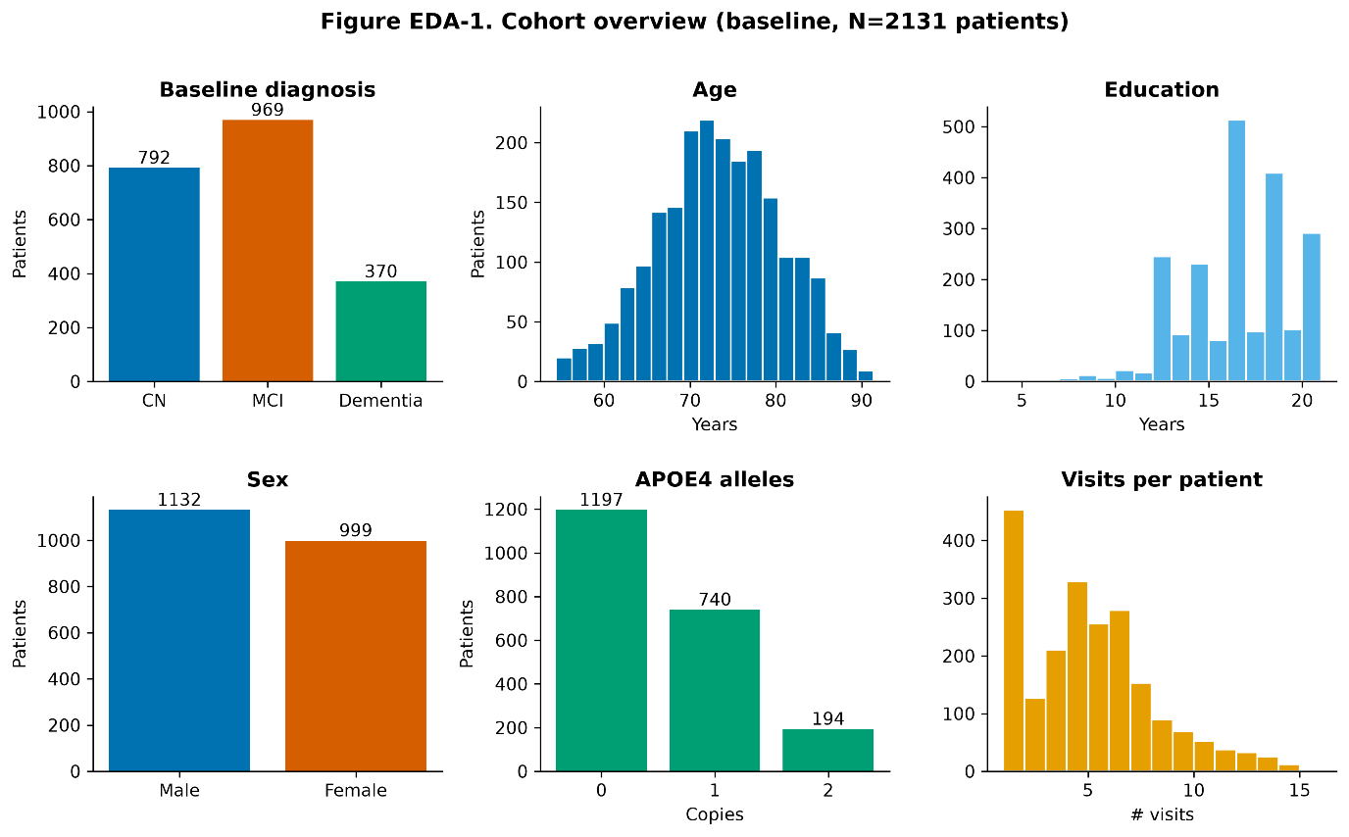
Figure EDA-1 — Cohort composition and follow-up. Six panels summarize the baseline sample: distribution of baseline diagnosis, age, education, sex, APOE ε4 allele count, and number of longitudinal visits per participant. The cohort is weighted toward the impaired end of the spectrum: 969 participants (45.5%) were MCI at baseline, 792 (37.2%) CN, and 370 (17.4%) dementia. Participants were older adults (median age 73.4 years, IQR 68.3–78.4) and highly educated (median 16 years, IQR 14–18), with a slight male majority (1,132 men, 999 women). APOE ε4 showed the expected dose gradient (1,197 non-carriers, 740 with one allele, 194 with two). Follow-up was right-skewed: most participants contributed a few visits, with a long tail up to ~15. The over-representation of MCI is a design feature of ADNI, a convenience cohort that preferentially enrolls individuals with existing cognitive concern; this, and the high educational attainment, limit generalization to the general population and are carried forward as limitations (Section 5.7). The visible ε4 dose gradient is a first internal validity check — a well-established risk factor is distributed as the literature predicts.
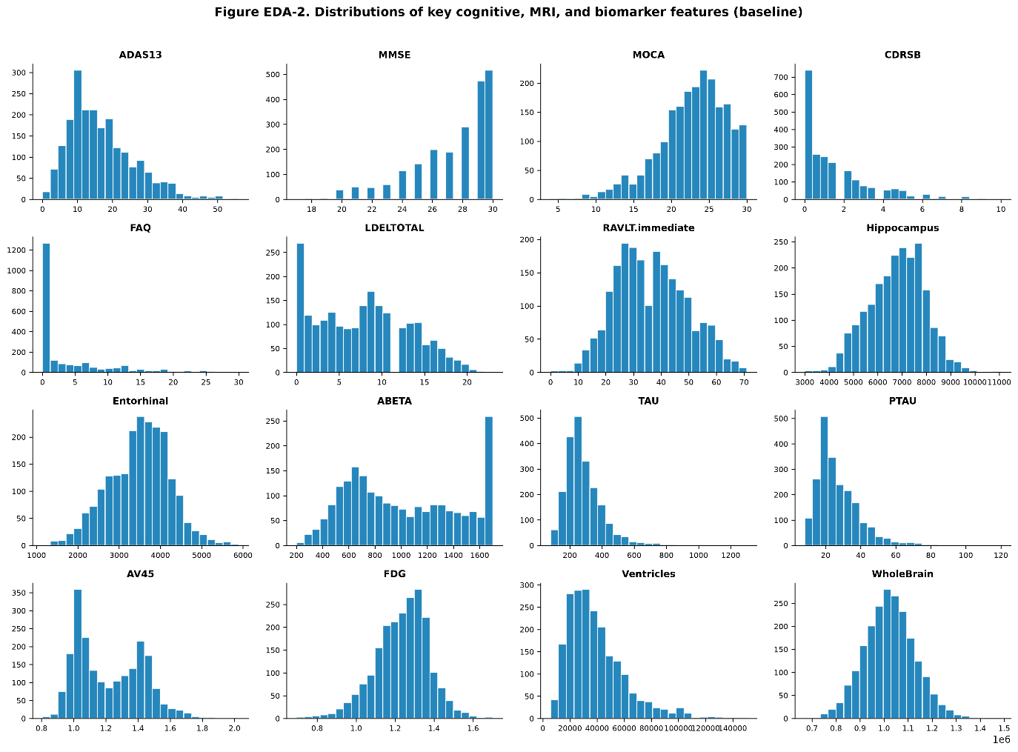
Figure EDA-2 — Univariate distributions of the modeling features. Histograms of sixteen key cognitive, MRI-volumetric, and fluid/PET biomarker features reveal three distributional patterns, each with a modeling consequence. (i) Ceiling and floor effects: MMSE piles up at its maximum of 30 (a well-known ceiling effect in a cohort with many unimpaired participants), while FAQ and CDRSB floor near zero. (ii) Right-skew in the fluid biomarkers: total tau and, after correction, phosphorylated tau (median ~24 pg/mL on the correct 8–120 pg/mL scale) are right-skewed — confirming p-tau is no longer a rescaled duplicate of total tau (Methods §3.11). (iii) Bimodality in amyloid measures: both CSF Aβ42 and amyloid-PET (AV45) show two modes, consistent with the biological split between amyloid-negative and amyloid-positive individuals; the ABETA spike at the upper bound reflects assay truncation at its ceiling. MRI volumes and FDG are approximately symmetric. These shapes justify reporting medians with IQRs for descriptive summaries and standardizing all features before any distance- or gradient-based model (KNN, SVM, MLP, logistic regression).
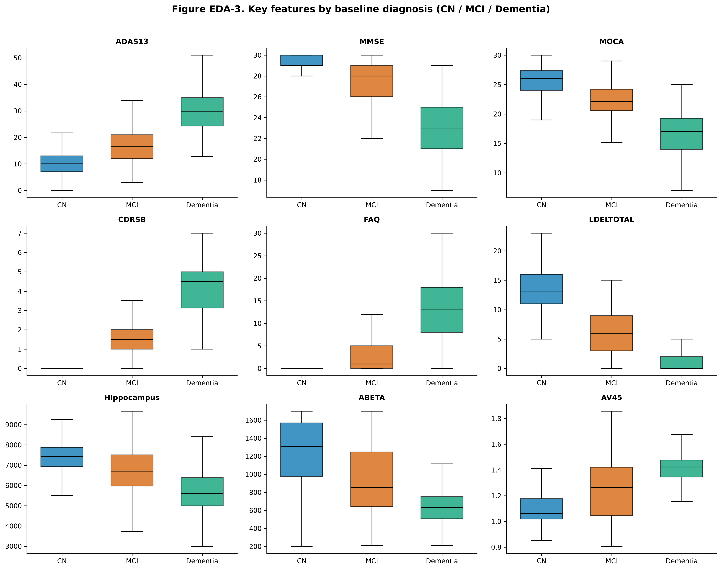
Figure EDA-3 — Feature separation by baseline diagnosis. Box plots of nine core features across CN, MCI, and Dementia give an unadjusted view of how strongly each measure tracks disease stage. Every feature displays a monotone gradient, and the magnitude of separation orders the modalities. Global cognition and function separate most sharply (ADAS13 median 10.0 [7–13] → 16.7 [12–21] → 29.7 [24–35]; CDRSB 0.0 → 1.5 → 4.5; FAQ 0.0 → 1.0 → 13.0); memory shows the same ordering (LDELTOTAL 13 → 6 → 0; RAVLT-immediate 45 → 33 → 23). Structural and metabolic imaging separate more modestly but consistently (hippocampus 7,434 → 6,706 → 5,614 mm³; FDG 1.3 → 1.2 → 1.1). Molecular pathology tracks stage in the expected directions (CSF Aβ42 falls 1,310 → 854 → 630 pg/mL; corrected p-tau rises 20.2 → 25.2 → 35.1 pg/mL), and APOE ε4 carriage climbs in parallel (29% → 48% → 64%). This uniform, biologically coherent staging confirms the features carry genuine, correctly oriented disease signal — a data-quality gate before modeling — and previews a central finding: the degree of separation is stage-dependent, which motivates modeling the cohorts separately rather than pooling them blindly (Methods §3.4; Section 4.6). Box-plot separation by current diagnosis, however, is not the same as predictive value for future conversion, which is examined next.
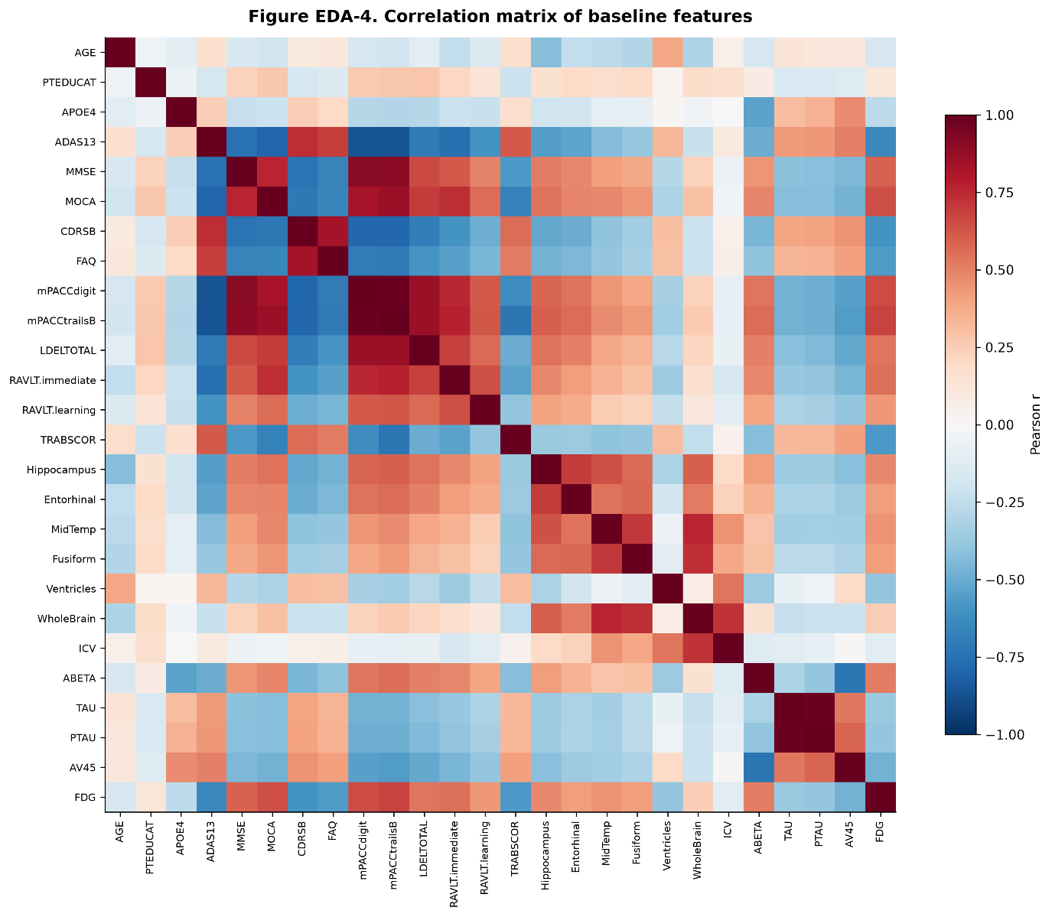
Figure EDA-4 — Correlation structure of the feature set. The heat map shows strongly correlated cognitive, structural, and biomarker blocks. MMSE and MOCA are positively related, ADAS13 is inversely related to global cognition, mPACCdigit and mPACCtrailsB are near-duplicates by construction, and whole-brain volume tracks ICV — motivating fold-wise ICV residualization. TAU and PTAU are also highly correlated in the prepared baseline table. An observed-only all-visit check produced r = 0.978 (n = 2,103); this supports a real association but does not establish independent predictor value. Correlation and permutation importance should therefore be interpreted at the level of correlated feature groups rather than as causal effects.
4.3 Impact of Evaluation Design (Data Leakage)
All final analyses use one baseline record per participant and participant-disjoint cross-validation. An earlier visit-level experiment addressed a different three-class current-status task and used a different metric, so its numeric result is not used to estimate the magnitude of leakage. It is retained only as design motivation: repeated visits from one person must not be allowed to cross training and test partitions.
4.4 Conversion Labeling and Sensitivity Analysis
Because diagnostic status fluctuates in ADNI, the definition of "converter" materially affects the analysis. Diagnostic reversion (an improvement between visits) occurred in 123 participants (5.8% of the full sample), comprising 136 reversion events — 108 MCI → CN and 28 Dementia → MCI (the difference reflects 13 participants who reverted more than once). The 28 Dementia → MCI cases are the clinically implausible improvements excluded during cohort construction (§3.4). A further 18 participants exhibited the CN → (MCI/Dementia) → CN pattern.
Table 4.2 reports the number of converters under alternative definitions. Requiring a confirmed transition (worse stage sustained ≥2 consecutive visits) reduced converter counts by roughly a quarter to a third relative to a naïve last-visit definition, removing single-visit fluctuations. The confirmed definition was pre-specified as the primary outcome for all subsequent models.
Table 4.2 — Converters by outcome definition
Definition | MCI→Dementia | CN→MCI/Dementia
Last-visit only | 321 (39%) | 106 (20%)
Ever reached worse stage | 321 (39%) | 116 (22%)
Confirmed (≥2 visits) — primary | 228 (28%) | 74 (14%)
Confirmed within 36 months | 177 (22%) | 26 (5%)
Confirmed within 24 months | 138 (17%) | 17 (3%)
For the MCI cohort, last-visit and ever-reached counts coincide after dementia-to-less-severe reversions are excluded. Short fixed horizons produce substantially fewer events, especially in CN. The primary classifiers therefore use confirmed any-time conversion; because follow-up duration varies, their probabilities refer to conversion over observed follow-up rather than to a common clinical horizon. Formal time-to-event analysis was limited to the MCI cohort (Section 4.7).
4.5 Predictive Performance Across Cohorts and Algorithms
Three cohorts were modeled: (A) baseline CN → progression to MCI or dementia; (B) baseline MCI → Dementia; and (C) a pooled CN+MCI cohort predicting progression to dementia, with baseline diagnosis deliberately excluded from the feature set so that the model surfaced biological and cognitive predictors rather than the trivial CN-vs-MCI distinction.
Six algorithms were evaluated under the same five-fold, participant-level splits. Training-fold imputation, ICV residualization, and scaling were repeated independently in each fold; the primary models used class weights where supported and no synthetic oversampling. Table 4.3 reports pooled out-of-fold ROC-AUC, and Figure 1 shows random-forest ROC curves.
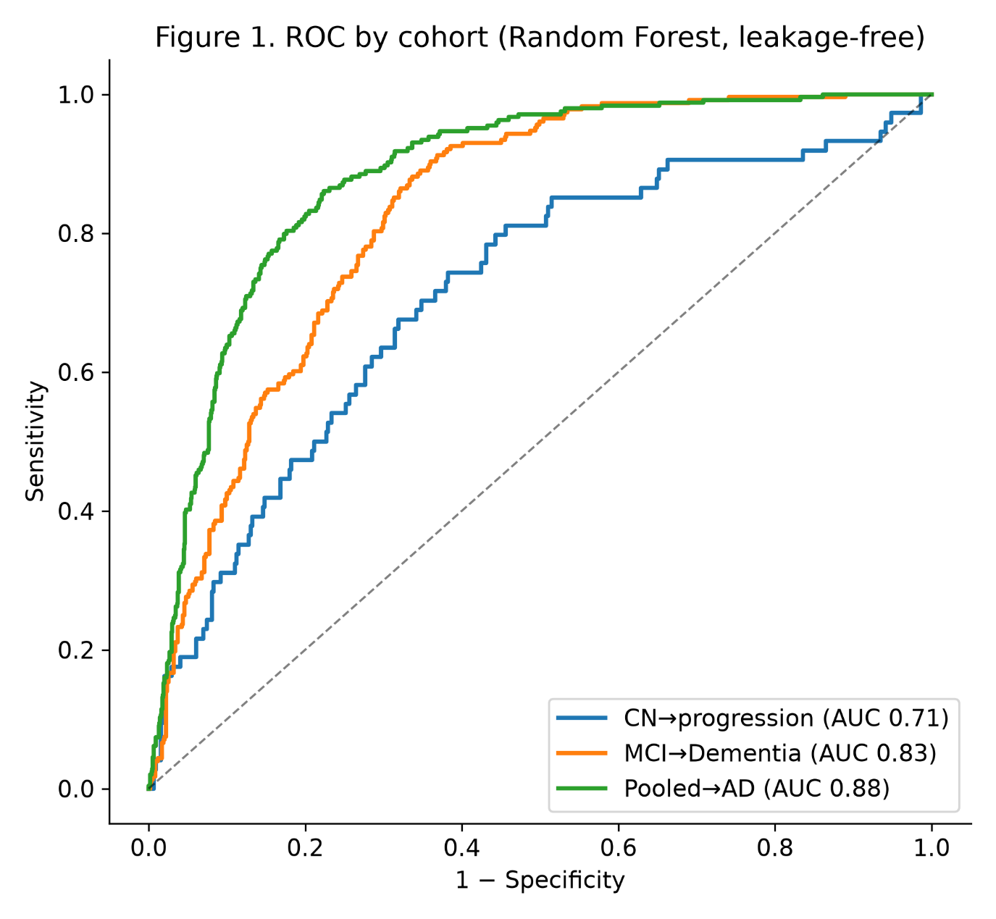
Figure 1. Random-forest receiver operating characteristic curves from pooled out-of-fold predictions: pooled CN+MCI→Dementia (n = 1,338; 244 events; AUC 0.88), MCI→Dementia (n = 819; 228 events; AUC 0.83), and CN→progression (n = 519; 74 events; AUC 0.71). No participant appears in both training and held-out folds.
Table 4.3 — ROC-AUC by model and cohort (pooled out-of-fold predictions)
Model | CN → progression | MCI → Dementia | Pooled → Dementia
Logistic Regression | 0.68 | 0.83 | 0.88
Random Forest | 0.71 | 0.83 | 0.88
XGBoost | 0.69 | 0.83 | 0.88
SVM (RBF) | 0.70 | 0.82 | 0.88
K-Nearest Neighbors | 0.58 | 0.79 | 0.83
Neural Network (MLP) | 0.63 | 0.78 | 0.84
Cohort n / events: CN→progression 519 / 74 (14%); MCI→Dementia 819 / 228 (28%); Pooled 1,338 / 244 (18%).
Two patterns are notable. First, discrimination increased with baseline impairment: the pooled and MCI cohorts achieved strong performance (AUC 0.83–0.88), whereas prediction from full cognitive normality was substantially harder and under-powered (AUC 0.58–0.71 across models; Random Forest 0.71, 74 events). Second, no model significantly outperformed logistic regression. In a paired bootstrap comparison of out-of-fold AUCs, logistic regression was the top or tied-top model in the MCI and pooled cohorts, and in the CN cohort the Random-Forest–versus–logistic-regression difference had a 95% confidence interval spanning zero ([−0.03, +0.09]). The evaluated models therefore had similar cross-validated discrimination; the data provide no evidence of ensemble superiority (Section 5.3).
4.6 Predictors of Conversion and Their Stage Dependence
Permutation importance (mean decrease in held-out ROC-AUC) ranked predictors within each cohort (Figure 2 and Table 4.4). Importance values were averaged across folds after three repeats per held-out fold. Correlated predictors can divide or substitute for one another, so the rank order is a descriptive summary of model reliance, not a causal hierarchy.
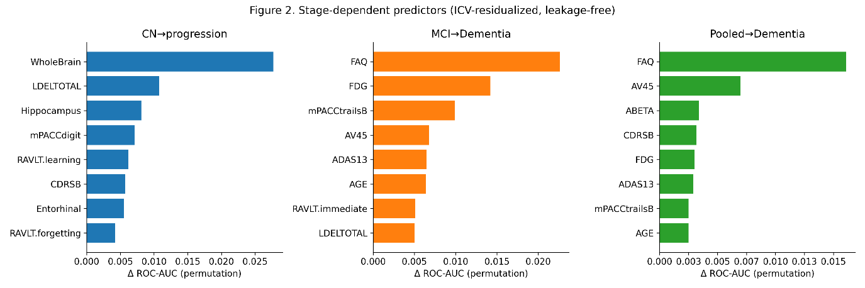
Figure 2. Held-out permutation importance for the three cohorts after fold-wise imputation and ICV residualization. Residualized whole-brain, hippocampal, entorhinal, and memory measures lead the CN model; FAQ, FDG, amyloid, and cognitive measures are more prominent in MCI and pooled models. Raw ICV is not a model predictor.
Table 4.4 — Top early predictors by cohort (permutation importance rank)
Rank | CN → progression | MCI → Dementia | Pooled → Dementia
1 | WholeBrain | FAQ | FAQ
2 | LDELTOTAL | FDG | AV45
3 | Hippocampus | mPACCtrailsB | ABETA
4 | mPACCdigit | AV45 | CDRSB
5 | RAVLT-learning | ADAS13 | FDG
6 | CDRSB | Age | ADAS13
7 | Entorhinal | RAVLT-immediate | mPACCtrailsB
8 | RAVLT-forgetting | LDELTOTAL | Age
The dominant predictors shifted with disease stage. In CN, residualized WholeBrain, Hippocampus, Entorhinal, delayed memory, and learning measures were prominent. In MCI, FAQ, FDG, mPACCtrailsB, AV45, ADAS13, age, and memory measures led. In the pooled cohort, FAQ and AV45 were followed by ABETA, CDRSB, FDG, ADAS13, mPACCtrailsB, and age. These rankings support stage dependence, but high within-modality correlation limits claims about any single feature.
4.7 Time to Conversion (Survival Analysis)
For the MCI cohort (819 participants; 228 confirmed conversions; 591 right-censored in the supplied aggregate output), time from baseline to the first dementia visit in a confirming pair was modeled. The APOE4-stratified estimate excludes the one genotype flagged as imputed, leaving 818 participants for that comparison. Kaplan–Meier estimates showed faster conversion among carriers (Figure 3 and Table 4.5).
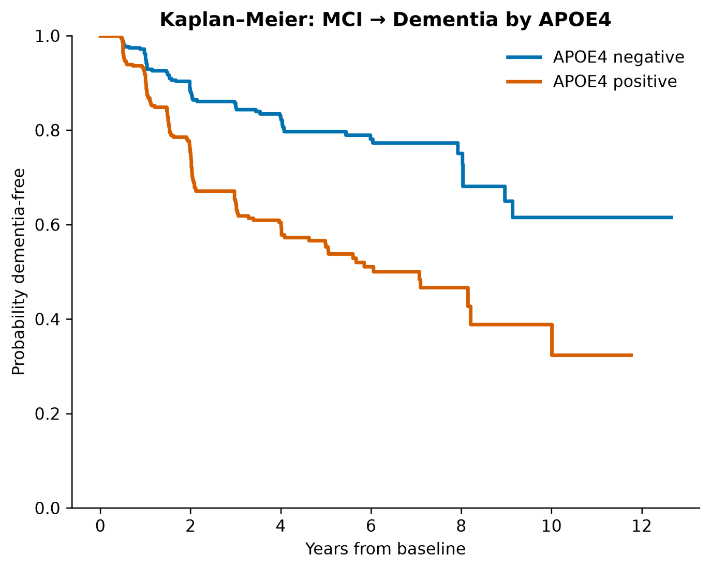
Figure 3. Kaplan–Meier estimates of remaining dementia-free in the MCI cohort, stratified by observed APOE4 carrier status. One genotype flagged as imputed was excluded. Rounded five-year estimates were approximately 55% for carriers and 80% for non-carriers (log-rank p < 0.001).
Table 4.5 — Kaplan–Meier: probability of remaining dementia-free
Group | 2 years | 3 years | 5 years
APOE4 negative | 88% | 85% | 80%
APOE4 positive | 75% | 65% | 55%
All observed-genotype MCI | 81% | 75% | 68%
A Cox proportional-hazards model using standardized covariates identified higher AV45 (HR 1.43), FAQ (1.38), and ADAS13 (1.25) with faster conversion. Higher FDG (0.73), hippocampal volume (0.75), and RAVLT-immediate performance (0.75) were associated with slower conversion (p ≤ 0.042 in the supplied output). LDELTOTAL was borderline (HR 0.83, p = 0.051). These are multivariable associations after single baseline imputation, not cross-validated causal effects.
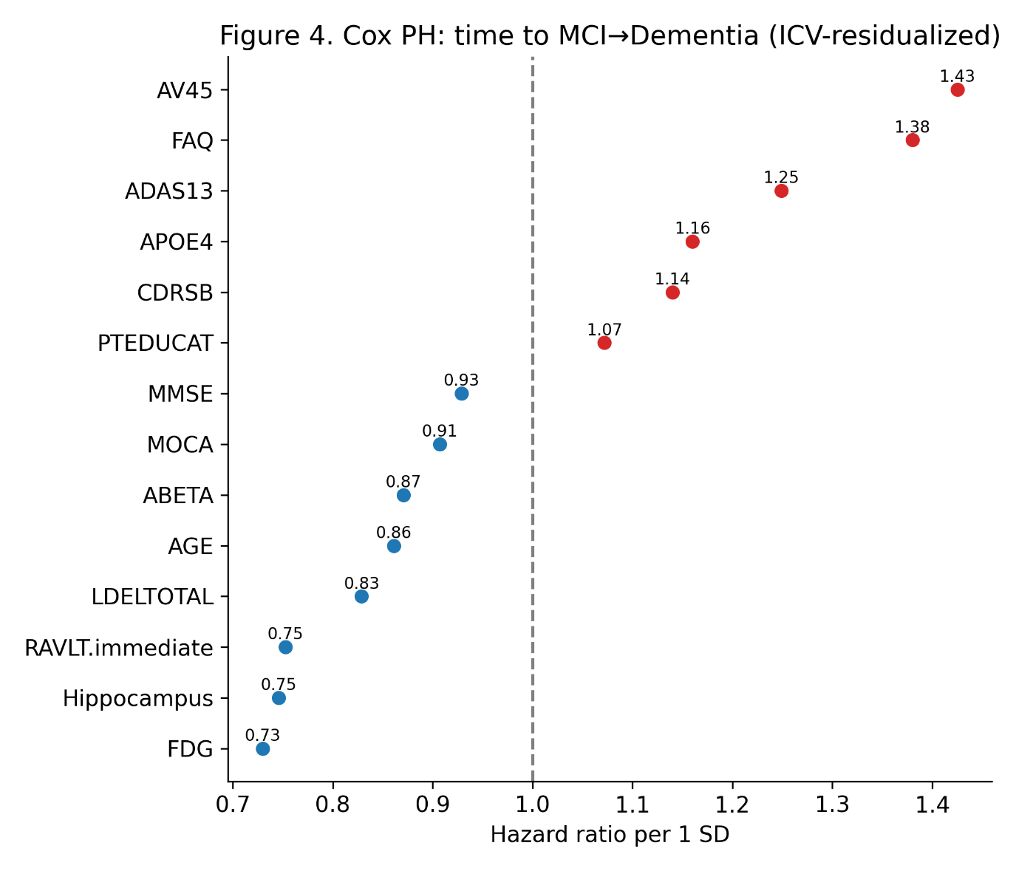
Figure 4. Cox proportional-hazards point estimates for time to confirmed MCI→Dementia conversion (n = 819; 228 events). Hazard ratios are per one-standard-deviation increase. The plot is descriptive; exact Wald intervals are generated by the corrected survival script and should accompany final inferential reporting after the current-data rerun.
4.8 Reduced Seven-Variable Model
A seven-variable logistic model using age, APOE4, MMSE, FAQ, CDRSB, hippocampal volume, and ADAS13 achieved cross-validated ROC-AUC 0.814. This result applies to the continuous logistic model. The full-sample coefficients were also translated into integer points for interpretability (Appendix C3), but that point system was not separately cross-validated, calibrated, or assigned clinical thresholds.
4.9 Subgroup Analysis
Pooled-model discrimination was recomputed descriptively within sex, APOE4, education, and age strata (Table 4.6 and Figure 5).
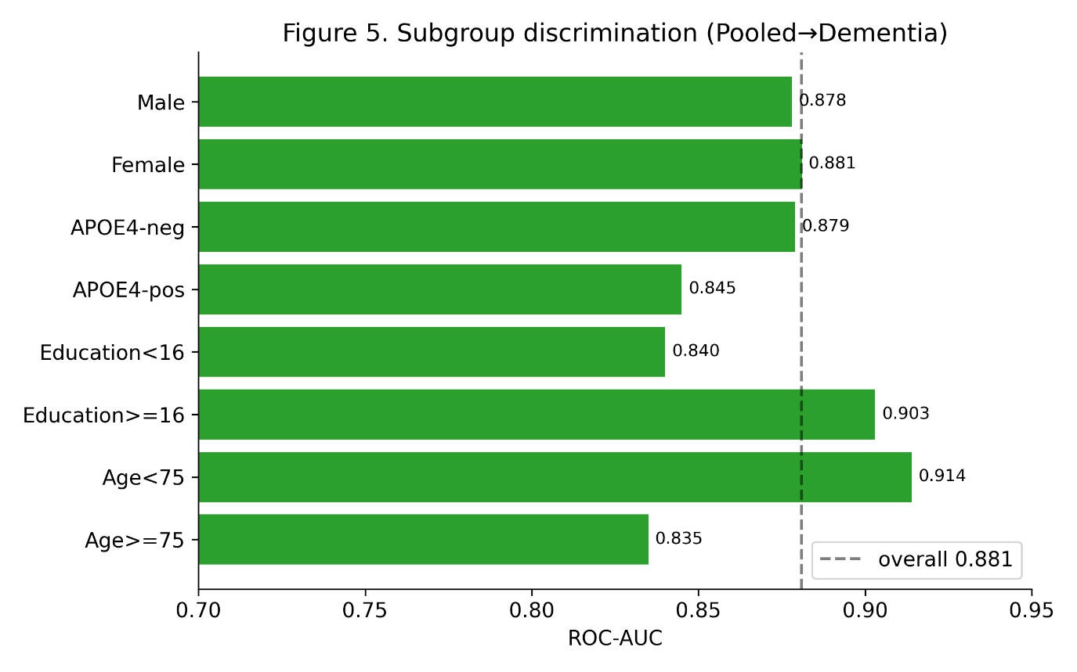
Figure 5. Pooled→Dementia random-forest ROC-AUC by subgroup. Point estimates were 0.878 for men, 0.881 for women, 0.879 for APOE4 non-carriers, 0.845 for carriers, 0.840 for education <16 years, 0.903 for education ≥16 years, 0.914 for age <75 years, and 0.835 for age ≥75 years. These descriptive differences do not establish fairness without uncertainty and group-specific calibration.
Table 4.6 — Pooled → Dementia ROC-AUC by subgroup.
Subgroup | n | Events | ROC-AUC
Male | 737 | 142 | 0.878
Female | 601 | 102 | 0.881
APOE4-negative | 771 | 83 | 0.879
APOE4-positive | 567 | 161 | 0.845
Education < 16 yr | 447 | 92 | 0.840
Education ≥ 16 yr | 891 | 152 | 0.903
Age < 75 yr | 767 | 134 | 0.914
Age ≥ 75 yr | 571 | 110 | 0.835
Sex-stratified point estimates were similar, whereas lower point estimates appeared among older, less-educated, and APOE4-positive participants. Because the supplied stored output did not include confidence intervals for these subgroup differences, they should be treated as signals for external validation rather than proven disparities or evidence of equitable performance.
4.10 Detailed Classification Performance and Calibration
Table 4.7 reports random-forest discrimination with bootstrap confidence intervals, operating characteristics at the prespecified 0.5 threshold, and Brier scores. Positive Brier skill for MCI and pooled cohorts indicates improvement over a prevalence-only prediction, but the calibration curves show systematic overprediction at higher predicted probabilities. The CN model has negative Brier skill and should not be used for individual probability statements.
Table 4.7 — Detailed performance by cohort (patient-level out-of-fold predictions).
Cohort | ROC-AUC (95% CI) | Sens. | Spec. | PPV | NPV | F1 | Brier
CN → progression | 0.71 (0.64–0.78) | 23% | 93% | 34% | 88% | 0.27 | 0.130 (skill −0.06)
MCI → Dementia | 0.83 (0.80–0.86) | 70% | 77% | 54% | 87% | 0.61 | 0.155 (skill +0.23)
Pooled → Dementia | 0.88 (0.86–0.90) | 73% | 86% | 54% | 94% | 0.62 | 0.113 (skill +0.25)
At the 0.5 threshold, the MCI and pooled models had specificity of 77% and 86% and NPV of 87% and 94%, respectively. These values depend on ADNI prevalence, observed follow-up, class weighting, and the selected threshold; they are not evidence that the model can rule out near-term progression in clinical practice. The CN model had low sensitivity (23%) and negative Brier skill.
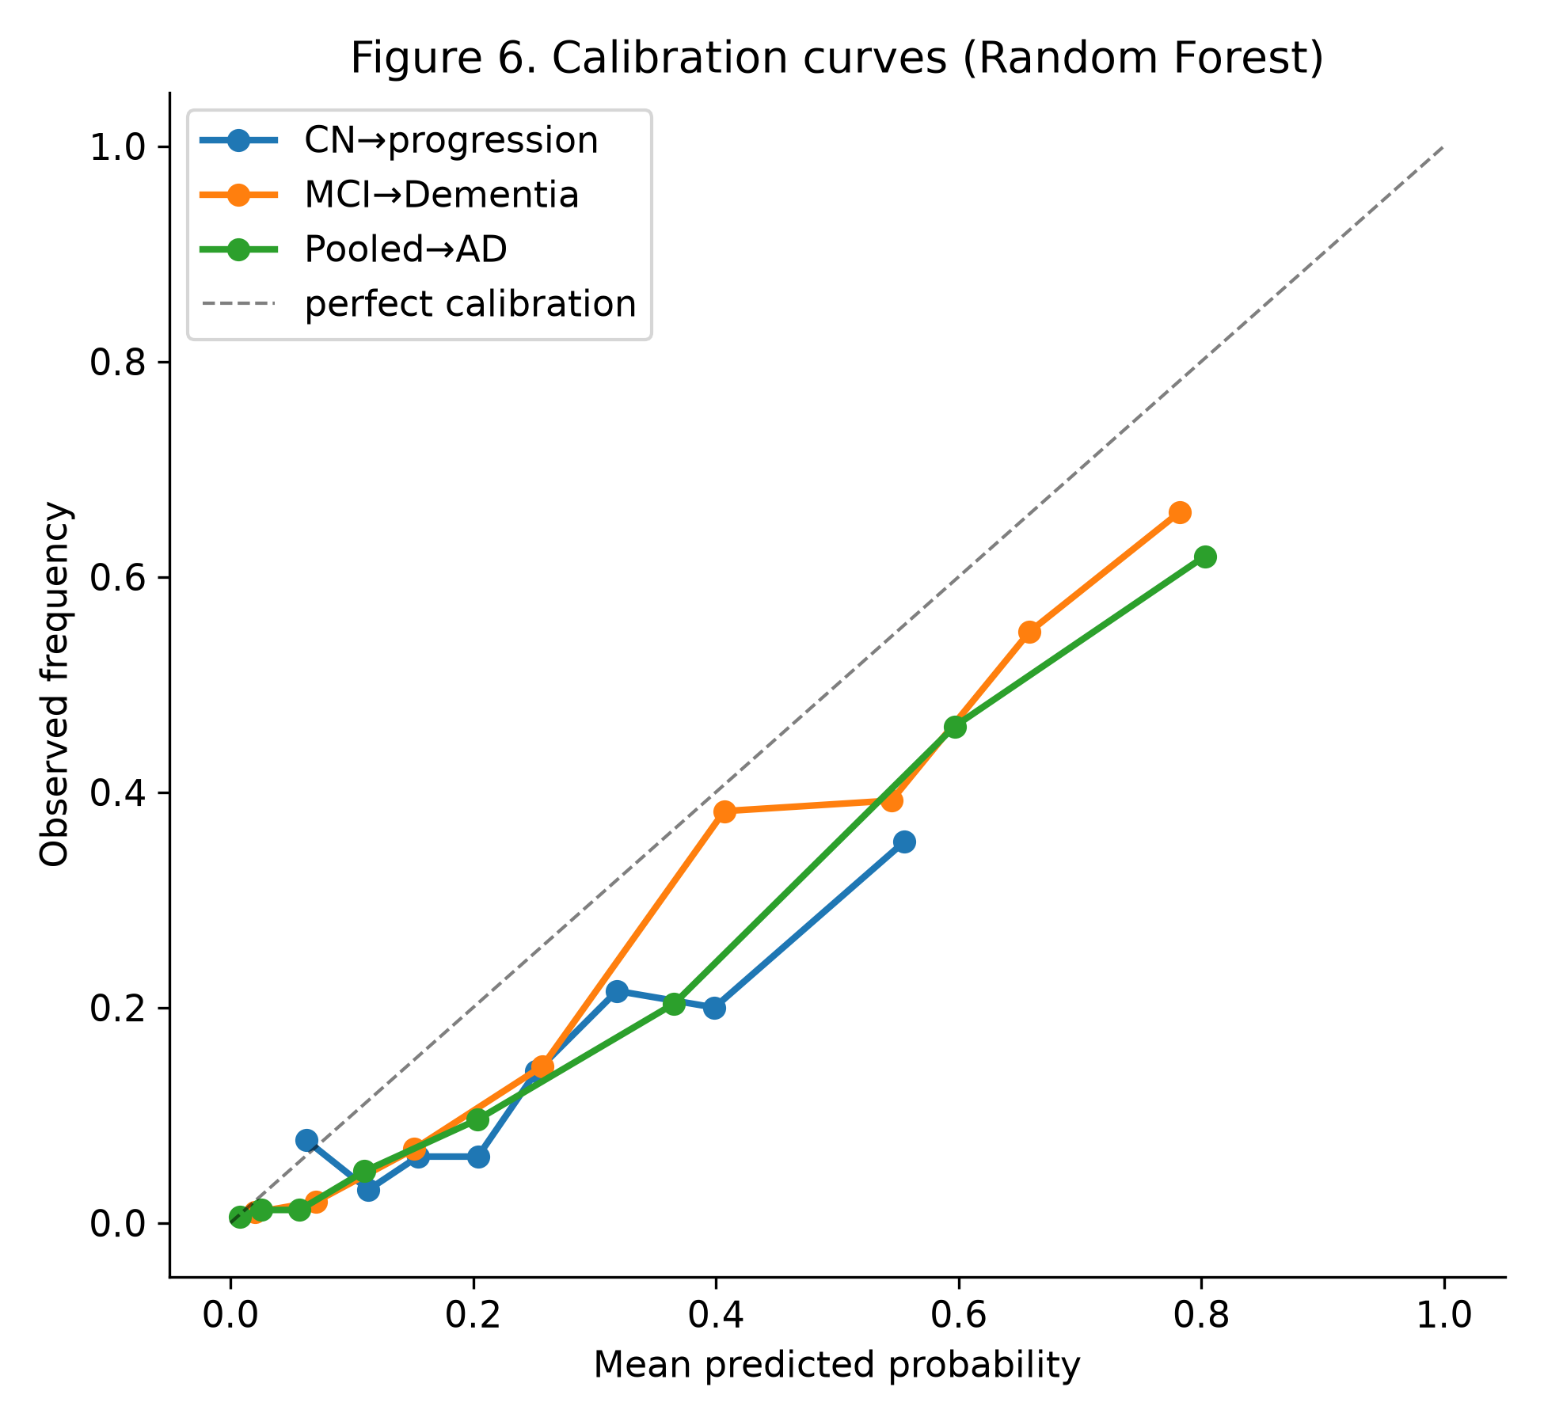
Figure 6. Random-forest calibration curves from out-of-fold predictions. The MCI and pooled models have positive Brier skill but overpredict observed event frequencies in several higher-probability bins. The CN model departs more substantially from the diagonal and has negative Brier skill.
Sensitivity analyses. SMOTE-NC and class-weighted analyses produced similar AUCs. Complete-case analyses produced higher AUCs in smaller, biomarker-complete subsets; this supports persistence of discrimination but does not refute missing-data bias because complete cases are selected and contain fewer events. The observed-only PTAU–TAU correlation was 0.978 across 2,103 all-visit records, confirming a strong association but not validating separate baseline contributions.
4.11 Feature-Group Contribution
To quantify each data modality's contribution, the pooled model was refit using each feature group in isolation and, separately, with each group removed (Table 4.8).
Table 4.8 — Feature-group ablation (Pooled → Dementia; full-model AUC 0.882).
Feature group | AUC (group alone) | AUC (group removed) | Δ if removed
Cognitive / functional | 0.854 | 0.850 | −0.032
MRI volumetric | 0.770 | 0.875 | −0.006
PET (AV45, FDG) | 0.788 | 0.883 | +0.002
CSF (ABETA, TAU, PTAU) | 0.761 | 0.884 | +0.003
Demographic / genetic | 0.658 | 0.878 | −0.004
Cognitive and functional variables alone reached AUC 0.854, and removing them reduced the full-model AUC from 0.882 to 0.850. MRI, PET, CSF, and demographic/genetic groups each yielded lower AUCs alone; removing any one of those groups changed AUC by −0.006 to +0.003 in the supplied analysis. These ablations show redundancy for internal discrimination and do not imply that imaging or biomarkers lack diagnostic or biological value.

Chapter 5 — Discussion

5.1 Summary of Principal Findings
This study used baseline multimodal ADNI data to identify early predictors of progression from cognitive normality and predictors of MCI-to-dementia conversion under a participant-level, fold-wise evaluation framework. For the early-prediction task, random-forest AUC was 0.71 for CN→progression. For the conversion task, AUC was 0.83 for MCI→Dementia, while the supplemental pooled CN+MCI→Dementia cohort reached 0.88. Important predictors shifted from brain-volume and memory measures in CN to function, FDG metabolism, cognition, and amyloid in MCI; MCI survival analyses also linked APOE4 and these baseline domains with conversion timing. Calibration and cohort definition materially limit how these estimates should be used.
5.2 Stage-Dependent Predictors
The stratified design revealed a plausible shift in model reliance. Residualized brain-volume and memory variables were prominent in CN, while FAQ, FDG, amyloid, and cognitive variables were prominent in MCI and pooled analyses. This pattern is consistent with stage-dependent signal, but permutation importance among correlated variables is unstable and should not be read as a causal sequence. Raw ICV was used only for residualization and was not a predictor. Corrected PTAU did not appear among the current top-ten pooled permutation-importance variables.
5.3 Model Performance and the Study Hypothesis
The secondary hypothesis that ensembles would outperform logistic regression was not supported. Logistic regression had the highest or tied point estimate in the MCI and pooled cohorts, while the CN random-forest advantage over logistic regression had a bootstrap interval spanning zero. This does not prove formal equivalence among all six algorithms, but it provides no evidence that added model complexity improved discrimination in these tabular data.
5.4 Timing of Conversion
Survival analysis extended the binary conversion question to when conversion occurs. Kaplan–Meier estimates showed markedly faster progression in APOE4 carriers (55% remained dementia-free at five years versus 80% in non-carriers), reinforcing APOE4's role as a determinant of both risk and tempo. The Cox model identified functional (FAQ), cognitive (ADAS13), and amyloid (AV45) measures as predictors of faster conversion, and greater hippocampal volume, memory performance, and glucose metabolism (FDG) as protective — a pattern that converges with the classification-based importance rankings and lends internal consistency to the findings.
5.5 A Methodological Contribution: Evaluation Rigor and Label Quality
The methodological contribution is the explicit use of one baseline row per participant, participant-disjoint folds, training-fold-only preprocessing, and a confirmed-conversion label. A prior visit-level current-status experiment was not directly comparable in task or metric and is therefore not used to quantify leakage inflation. The defensible conclusion is narrower: repeated visits must not cross folds, and transient diagnoses should not define conversion without confirmation.
5.6 Clinical Implications
The reduced seven-variable logistic model retained substantial internal discrimination (AUC 0.814) with fewer inputs than the full panel. That finding supports a simpler model-development direction, not a deployable bedside score. The integer points in Appendix C3 are a descriptive translation of full-sample coefficients and lack separate validation, calibration, and action thresholds. Feature-group ablation (Section 4.11) similarly indicates redundancy for discrimination within ADNI, not that PET, CSF, or MRI are clinically unnecessary.
5.7 Limitations
- Enrollment / volunteer bias. ADNI preferentially recruits participants who already have cognitive concern, over-representing prevalent MCI relative to a community sample. Absolute conversion rates therefore overstate population risk, and the well-powered results derive largely from the impaired end of the spectrum.
- Under-powered and poorly calibrated CN cohort. Only 74 confirmed CN progression events were available. Random-forest AUC was 0.71 with a wide confidence interval (0.64–0.78), and Brier skill was negative. This estimate is uncertain rather than a “lower bound,” and its probabilities should not be used for individual risk statements.
- Outcome, follow-up, and incorporation bias. Clinical diagnoses vary across visits, and dementia-to-less-severe reversions were excluded as implausible. The confirmed-any-time outcome gives participants with longer follow-up more opportunity to become cases and does not represent a common prediction horizon. In addition, FAQ, CDRSB, and ADAS13 help characterize clinical stage and later diagnosis, so their predictive importance may partly reflect baseline severity and incorporation into clinical judgment rather than independent early biology.
- Data-integrity correction and assay censoring. PTAU values were restored to the p-tau181 scale, and final models re-imputed missing baseline values within folds. The high observed-only all-visit PTAU–TAU correlation confirms strong association but not independence. Boundary-coded assay values were treated as numeric limits rather than modeled as censored measurements.
- Subgroup uncertainty. Sex-stratified AUC point estimates were similar, while age, education, and APOE4 strata differed. Confidence intervals for subgroup differences and group-specific calibration were not available in the supplied stored output; the analysis is therefore descriptive and cannot establish fairness.
- Single-cohort validation and current-data refresh. All model estimates are internal to ADNI. No independent cohort was used. ADNI also issued a March 2026 advisory removing 78 participants with 381_S_ identifiers; the corrected scripts now exclude those records, but the aggregate outputs in this draft were not rerun from participant-level data during the independent audit. A clean rerun against the author’s current authorized ADNI snapshot is required before final submission.
- Reversible transitions simplified. Conversion was treated as effectively one-directional after confirmation; a full multi-state model of reversible CN↔MCI transitions was not undertaken.
5.8 Future Directions
- Incorporate plasma biomarkers. Future work can evaluate plasma p-tau181, p-tau217, Aβ42/40, NfL, and GFAP as coverage and assay harmonization permit (Hampel et al., 2018). Any incremental-value analysis should be prespecified and evaluated in a held-out or external cohort rather than added opportunistically to the present model.
- External validation in an independent, ideally community-based cohort to test generalizability beyond ADNI's enrollment profile.
- Multi-state / competing-risks survival models to represent reversible transitions and death as a competing event.
- Image-based deep learning (e.g., a convolutional network on structural or default-mode-network imaging) as a complementary modality, deferred here as a separate line of work.
- Calibration and decision-curve analysis to move from discrimination toward clinically actionable thresholds.

Chapter 6 — Conclusion
This thesis identified two related but distinct sets of predictors under participant-level, fold-wise validation: early predictors of later progression among cognitively normal participants and predictors of confirmed MCI-to-dementia conversion. CN→progression discrimination was modest and poorly calibrated (AUC 0.71), while internal discrimination was good for MCI→Dementia (0.83) and the supplemental pooled CN+MCI→Dementia analysis (0.88). Predictor rankings differed by baseline stage, shifting from structural and memory signals in CN to functional, metabolic, cognitive, and amyloid signals in MCI. A reduced seven-variable logistic model retained substantial conversion discrimination. The methodological contribution remains one baseline record per participant, participant-disjoint folds, training-fold-only preprocessing, and confirmed outcomes. These results remain internal to ADNI and do not establish clinical utility, fairness, or external generalizability. Before final submission, the corrected scripts should be rerun against the current authorized ADNI snapshot, including the March 2026 advisory exclusion.
Data Availability, Ethics, and Disclosures
Data source. Analyses used access-restricted data from the Alzheimer’s Disease Neuroimaging Initiative (ADNI) via an ADNIMERGE-derived analytic table. The exact release identifier and download date were not retained in the supplied aggregate package and should be recovered from the author’s ADNI access history. The final scripts exclude 381_S_ records identified in ADNI’s March 2026 data advisory. ADNI access information: ADNI Data; advisory: March 2026 ADNI Data Advisory
Ethics. ADNI was approved by the institutional review boards of all participating sites, and all participants gave written informed consent. This work is a secondary analysis of de-identified data and involved no new data collection.
Data availability. Participant-level ADNI data cannot be redistributed and are available to qualified researchers through the ADNI application and Data Use Agreement. The distributable thesis package contains analysis code, aggregate JSON outputs, and figures, but no participant-level records.
Reproducibility. Scripts 10–14 implement the corrected workflow with random seed 42 and automatic exclusion of ADNI advisory identifiers. Aggregate values and confusion-matrix arithmetic were checked against the supplied JSON outputs. Participant-level rerunning was outside this audit because the restricted ADNI file was not supplied; the author must perform and archive one final authorized rerun and environment lock file.
Use of AI tools. Anthropic Claude and OpenAI ChatGPT/Codex were used for drafting, code scaffolding, code and aggregate-output audit, figure revision, and editorial support. During the final audit, participant-level ADNI data were not provided to the AI reviewer. The author retains responsibility for the analysis, citations, interpretations, and compliance with ADNI and Northwestern requirements. Disclosure does not substitute for instructor or program authorization. Northwestern SPS policy: Academic Policies
References
Alzheimer's Disease Neuroimaging Initiative. (n.d.). About ADNI. Retrieved July 18, 2026, from https://adni.loni.usc.edu/about/
Braak, H., & Braak, E. (1991). Neuropathological stageing of Alzheimer-related changes. Acta Neuropathologica, 82(4), 239–259.
Brookmeyer, R., Corrada, M. M., Curriero, F. C., & Kawas, C. (2002). Survival following a diagnosis of Alzheimer disease. Archives of Neurology, 59(11), 1764–1767. https://doi.org/10.1001/archneur.59.11.1764
Chawla, N. V., Bowyer, K. W., Hall, L. O., & Kegelmeyer, W. P. (2002). SMOTE: Synthetic minority over-sampling technique. Journal of Artificial Intelligence Research, 16, 321–357.
Chen, T., & Guestrin, C. (2016). XGBoost: A scalable tree boosting system. In Proceedings of the 22nd ACM SIGKDD International Conference on Knowledge Discovery and Data Mining (pp. 785–794). Association for Computing Machinery.
Corder, E. H., Saunders, A. M., Strittmatter, W. J., Schmechel, D. E., Gaskell, P. C., Small, G. W., Roses, A. D., Haines, J. L., & Pericak-Vance, M. A. (1993). Gene dose of apolipoprotein E type 4 allele and the risk of Alzheimer's disease in late onset families. Science, 261(5123), 921–923.
Du, A. T., Schuff, N., Amend, D., Laakso, M. P., Hsu, Y. Y., Jagust, W. J., Yaffe, K., Kramer, J. H., Reed, B., Norman, D., Chui, H. C., & Weiner, M. W. (2001). Magnetic resonance imaging of the entorhinal cortex and hippocampus in mild cognitive impairment and Alzheimer's disease. Journal of Neurology, Neurosurgery & Psychiatry, 71(4), 441–447. https://doi.org/10.1136/jnnp.71.4.441
Frisoni, G. B., Fox, N. C., Jack, C. R., Scheltens, P., & Thompson, P. M. (2010). The clinical use of structural MRI in Alzheimer disease. Nature Reviews Neurology, 6(2), 67–77.
Ghiasi, M. M., Falck, R. S., Liu-Ambrose, T., & Tam, R. C. (2026). Explainable machine learning for predicting longitudinal dementia status: Establishing a leakage-free benchmark. PLOS Digital Health, 5(5), e0001409. https://doi.org/10.1371/journal.pdig.0001409
Grabher, B. J. (2018). Effects of Alzheimer disease on patients and their family. Journal of Nuclear Medicine Technology, 46(4), 335–340.
Hampel, H., O'Bryant, S. E., Molinuevo, J. L., Zetterberg, H., Masters, C. L., Lista, S., Kiddle, S. J., Batrla, R., & Blennow, K. (2018). Blood-based biomarkers for Alzheimer disease: Mapping the road to the clinic. Nature Reviews Neurology, 14(11), 639–652.
Jack, C. R., Jr., Bennett, D. A., Blennow, K., Carrillo, M. C., Dunn, B., Haeberlein, S. B., Holtzman, D. M., Jagust, W., Jessen, F., Karlawish, J., Liu, E., Molinuevo, J. L., Montine, T., Phelps, C., Rankin, K. P., Rowe, C. C., Scheltens, P., Siemers, E., Snyder, H. M., … Sperling, R. (2018). NIA-AA Research Framework: Toward a biological definition of Alzheimer's disease. Alzheimer's & Dementia, 14(4), 535–562.
Jack, C. R., Jr., Petersen, R. C., Xu, Y., O'Brien, P. C., Smith, G. E., Ivnik, R. J., Boeve, B. F., Waring, S. C., Tangalos, E. G., & Kokmen, E. (2000). Rates of hippocampal atrophy correlate with change in clinical status in aging and AD. Neurology, 55(4), 484–490.
Liu, M., Li, F., Yan, H., Wang, K., Ma, Y., Shen, L., & Xu, M. (2020). A multi-model deep convolutional neural network for automatic hippocampus segmentation and classification in Alzheimer's disease. NeuroImage, 208, 116459.
Liu, S., Liu, S., Cai, W., Che, H., Pujol, S., Kikinis, R., Feng, D., & Fulham, M. J. (2015). Multimodal neuroimaging feature learning for multiclass diagnosis of Alzheimer's disease. IEEE Transactions on Biomedical Engineering, 62(4), 1132–1140.
Pedregosa, F., Varoquaux, G., Gramfort, A., Michel, V., Thirion, B., Grisel, O., Blondel, M., Prettenhofer, P., Weiss, R., Dubourg, V., Vanderplas, J., Passos, A., Cournapeau, D., Brucher, M., Perrot, M., & Duchesnay, É. (2011). Scikit-learn: Machine learning in Python. Journal of Machine Learning Research, 12, 2825–2830.
Porsteinsson, A. P., Isaacson, R. S., Knox, S., Sabbagh, M. N., & Rubino, I. (2021). Diagnosis of early Alzheimer's disease: Clinical practice in 2021. Journal of Prevention of Alzheimer's Disease, 8, 371–386.
Scheuner, D., Eckman, C., Jensen, M., Song, X., Citron, M., Suzuki, N., Bird, T. D., Hardy, J., Hutton, M., Kukull, W., Larson, E., Levy-Lahad, E., Viitanen, M., Peskind, E., Poorkaj, P., Schellenberg, G., Tanzi, R., Wasco, W., Lannfelt, L., … Younkin, S. (1996). Secreted amyloid beta-protein similar to that in the senile plaques of Alzheimer's disease is increased in vivo by the presenilin 1 and 2 and APP mutations linked to familial Alzheimer's disease. Nature Medicine, 2(8), 864–870.
Seabold, S., & Perktold, J. (2010). Statsmodels: Econometric and statistical modeling with Python. In Proceedings of the 9th Python in Science Conference (pp. 92–96).
Sperling, R. A., Aisen, P. S., Beckett, L. A., Bennett, D. A., Craft, S., Fagan, A. M., Iwatsubo, T., Jack, C. R., Kaye, J., Montine, T. J., Park, D. C., Reiman, E. M., Rowe, C. C., Siemers, E., Stern, Y., Yaffe, K., Carrillo, M. C., Thies, B., Morrison-Bogorad, M., … Phelps, C. H. (2011). Toward defining the preclinical stages of Alzheimer's disease: Recommendations from the National Institute on Aging–Alzheimer's Association workgroups on diagnostic guidelines for Alzheimer's disease. Alzheimer's & Dementia, 7(3), 280–292.
Suk, H.-I., & Shen, D. (2013). Deep learning-based feature representation for AD/MCI classification. In Medical Image Computing and Computer-Assisted Intervention – MICCAI 2013 (Lecture Notes in Computer Science, Vol. 8150, pp. 583–590). Springer.
Tukey, J. W. (1977). Exploratory data analysis. Addison-Wesley.
Venugopalan, J., Tong, L., Hassanzadeh, H. R., & Wang, M. D. (2021). Multimodal deep learning models for early detection of Alzheimer's disease stage. Scientific Reports, 11, 3254.
Weiner, M. W., Veitch, D. P., Aisen, P. S., Beckett, L. A., Cairns, N. J., Green, R. C., Harvey, D., Jack, C. R., Jagust, W., Liu, E., Morris, J. C., Petersen, R. C., Saykin, A. J., Schmidt, M. E., Shaw, L., Shen, L., Siuciak, J. A., Soares, H., Toga, A. W., & Trojanowski, J. Q. (2013). The Alzheimer's Disease Neuroimaging Initiative: A review of papers published since its inception. Alzheimer's & Dementia, 9(5), e111–e194.
World Health Organization. (2021). Global status report on the public health response to dementia. https://www.who.int/publications/i/item/9789240033245

Appendices
Supplementary material reports the supplied aggregate outputs and corrected executable scripts. Values should be refreshed by one authorized final run after the March 2026 ADNI advisory exclusion. Random seed 42 is used throughout.
Appendix A — Model Specifications and Hyperparameters
All six classifiers used participant-disjoint five-fold cross-validation. Within each training fold, missing values were imputed, MRI volumes were residualized on ICV, raw ICV was removed, and variables were standardized. The primary analysis used class weighting where supported and no oversampling; SMOTE-NC was a training-only sensitivity analysis. Estimator settings were:
Table A1 — Classifier hyperparameters.
Model | Library | Key hyperparameters
Logistic Regression | scikit-learn | L2 penalty; max_iter = 2000; class_weight = 'balanced'
Random Forest | scikit-learn | n_estimators = 400; max_depth = 10; class_weight = 'balanced'; random_state = 42
XGBoost | xgboost | n_estimators = 300; max_depth = 4; learning_rate = 0.05; subsample = 0.8; eval_metric = 'logloss'; random_state = 42
Support Vector Machine | scikit-learn | RBF kernel; C = 1; class_weight = 'balanced'; training-only Platt probability scaling
K-Nearest Neighbors | scikit-learn | n_neighbors = 7
Neural Network (MLP) | scikit-learn | hidden_layer_sizes = (32, 16); max_iter = 400; random_state = 42
The survival analysis used statsmodels PHReg with Efron handling of ties. Kaplan–Meier estimation and confirmed-conversion labeling were implemented directly in NumPy/pandas. The corrected survival script excludes the genotype flagged as imputed from the APOE4-stratified curve, computes Harrell’s C-index, and writes Cox confidence intervals for the final rerun.
Appendix B — Feature Dictionary (33 Baseline Predictors)
The feature dictionary lists 33 candidate baseline variables. ICV is a preprocessing covariate used for fold-wise residualization of six MRI volumes; it is removed before model fitting, leaving 32 estimator inputs. “% imputed” is the baseline fraction flagged missing in the prepared source table, not a claim that imputation was performed globally.
Table B1 — Feature dictionary.
# | Feature | Modality | Description (direction) | Units | % imp. | Baseline range
1 | AGE | Demographic | Age at baseline | years | 0% | 54.4 – 91.4
2 | PTEDUCAT | Demographic | Years of education | years | 0% | 4 – 20
3 | PTGENDER | Demographic | Sex (Male = 1, Female = 0) | binary | 0% | 0 – 1
4 | APOE4 | Genetic | Number of APOE e4 alleles | 0–2 | 4% | 0 – 2
5 | ABETA | CSF | Amyloid-beta 1-42 (lower = more pathology) | pg/mL | 43% | 200 – 1700
6 | ADAS13 | Cognitive | ADAS-Cog 13-item (higher = worse) | points | 1% | 0 – 56
7 | AV45 | PET | Florbetapir amyloid-PET (higher = more plaque) | SUVR | 52% | 0.81 – 2.03
8 | CDRSB | Clinical | CDR–Sum of Boxes (higher = worse) | points | 0% | 0 – 10
9 | Entorhinal | MRI | Entorhinal cortex volume | mm3 | 31% | 1,143 – 5,896
10 | FAQ | Functional | Functional Activities Questionnaire (higher = worse) | points | 1% | 0 – 30
11 | FDG | PET | FDG-PET glucose metabolism (lower = worse) | SUVR | 37% | 0.69 – 1.70
12 | Fusiform | MRI | Fusiform gyrus volume | mm3 | 31% | 8,991 – 29,950
13 | Hippocampus | MRI | Hippocampal volume | mm3 | 30% | 2,991 – 11,068
14 | ICV | MRI | Intracranial volume | mm3 | 19% | 1.10M – 2.11M
15 | LDELTOTAL | Cognitive (memory) | Logical Memory delayed recall (higher = better) | points | 0% | 0 – 23
16 | MidTemp | MRI | Middle temporal gyrus volume | mm3 | 31% | 9,375 – 32,189
17 | MMSE | Cognitive | Mini-Mental State Exam (higher = better) | 0–30 | 0% | 17 – 30
18 | MOCA | Cognitive | Montreal Cognitive Assessment (higher = better) | 0–30 | 40% | 4 – 30
19 | mPACCdigit | Cognitive (composite) | modified PACC, Digit-Symbol variant (higher = better) | composite | 0% | −23.4 – 6.3
20 | mPACCtrailsB | Cognitive (composite) | modified PACC, Trails-B variant (higher = better) | composite | 0% | −23.4 – 7.4
21 | PTAU | CSF | Phosphorylated tau-181 (higher = more pathology; corrected) | pg/mL | 43% | 8 – 120
22 | RAVLT.forgetting | Cognitive (memory) | RAVLT forgetting score | points | 0% | −28 – 15
23 | RAVLT.immediate | Cognitive (memory) | RAVLT immediate recall, trials 1–5 (higher = better) | points | 0% | 0 – 71
24 | RAVLT.learning | Cognitive (memory) | RAVLT learning score (higher = better) | points | 0% | −8 – 12
25 | RAVLT.perc.forgetting | Cognitive (memory) | RAVLT percent forgetting (higher = worse) | % | 1% | −400 – 100
26 | TAU | CSF | Total tau (higher = more pathology) | pg/mL | 43% | 80 – 1300
27 | TRABSCOR | Cognitive (executive) | Trail Making Test B time (higher = worse) | seconds | 2% | 0 – 300
28 | Ventricles | MRI | Ventricular volume (higher = more atrophy) | mm3 | 23% | 5,650 – 150,432
29 | WholeBrain | MRI | Whole-brain volume | mm3 | 21% | 0.67M – 1.49M
30 | Married | Demographic | Marital status = married (indicator) | binary | 0% | 0 – 1
31 | Widowed | Demographic | Marital status = widowed (indicator) | binary | 0% | 0 – 1
32 | Divorced | Demographic | Marital status = divorced (indicator) | binary | 0% | 0 – 1
33 | Never_married | Demographic | Marital status = never married (indicator) | binary | 0% | 0 – 1
RAVLT percent-forgetting has an extreme negative floor (−400) arising when the delayed-recall denominator is very small; the value was retained as recorded and standardized with the other features.
Appendix C — Supplementary Results
C1 — Full Cox Proportional-Hazards Model (MCI → Dementia)
Hazard ratios are per one-standard-deviation increase after single baseline imputation and ICV residualization (Efron ties); 819 participants, 228 confirmed conversions, and 591 right-censored observations appear in the supplied aggregate output. These are multivariable association estimates, not cross-validated causal effects.
Table C1 — Cox proportional-hazards results.
Covariate | Hazard ratio (per 1 SD) | p-value
AV45 | 1.425 | 0.004
FAQ | 1.380 | < 0.001
ADAS13 | 1.249 | 0.042
APOE4 | 1.160 | 0.053
CDRSB | 1.140 | 0.082
PTEDUCAT | 1.072 | 0.316
MMSE | 0.929 | 0.368
MOCA | 0.907 | 0.460
ABETA | 0.871 | 0.318
AGE | 0.861 | 0.065
LDELTOTAL | 0.829 | 0.051
RAVLT.immediate | 0.753 | 0.020
Hippocampus | 0.746 | 0.004
FDG | 0.730 | 0.001
Six covariates had p < 0.05 in the supplied output: higher FAQ, ADAS13, and AV45 were associated with faster conversion; higher hippocampal volume, RAVLT-immediate performance, and FDG were associated with slower conversion. LDELTOTAL was borderline (p = 0.051).
C2 — Full Permutation-Importance Rankings (Top 10 by Cohort)
Mean decrease in ROC-AUC when each feature was permuted, averaged across held-out folds (Random Forest, three repeats per fold). Section 4.6 shows the top eight; the full top ten is given here.
Table C2 — Top-10 predictors by cohort (permutation-importance rank).
Rank | CN → progression | MCI → Dementia | Pooled → Dementia
1 | WholeBrain | FAQ | FAQ
2 | LDELTOTAL | FDG | AV45
3 | Hippocampus | mPACCtrailsB | ABETA
4 | mPACCdigit | AV45 | CDRSB
5 | RAVLT.learning | ADAS13 | FDG
6 | CDRSB | AGE | ADAS13
7 | Entorhinal | RAVLT.immediate | mPACCtrailsB
8 | RAVLT.forgetting | LDELTOTAL | AGE
9 | RAVLT.perc.forgetting | ABETA | MidTemp
10 | MMSE | CDRSB | WholeBrain
PTAU did not appear among the current top-ten pooled held-out permutation-importance variables. Its strong correlation with TAU and other pathology measures limits claims about independent value.
C3 — Reduced Seven-Variable Model
The seven-variable logistic model achieved pooled out-of-fold ROC-AUC 0.814. The integer points below translate coefficients from a full-sample fit and were not separately cross-validated or calibrated; they are provided only to show coefficient direction and relative magnitude.
Table C3 — Risk-score points (per +1 SD).
Variable | Points
ADAS13 | +10
FAQ | +10
Hippocampus | −10
APOE4 | +6
CDRSB | +4
MMSE | −3
AGE | −3
Higher ADAS13 and FAQ increased the fitted log-odds, while larger hippocampal volume was protective. These full-sample points must not be interpreted as a validated clinical threshold system.

