Hafsa Hussain

Team Flipbook

Assignment 6

CSC 4111

Unit Test Pages: Profile Page (profile.php)

**Note: My group and I did not use Java, C++ or any language that uses classes and methods. We used HTML/CSS, PHP, and SQL. Instead of the original assignment, we emailed you and you gave us permission to each test out a page on our site and make sure that everything works properly and to report our results for that page. This includes testing out links, forms, functionalities, etc.**

**PROFILE ICON:**

In this unit test, I will be testing all visible buttons and features seen on the page below. Prior to entering inputs, you can see that the profile page displays the full name of the user that is logged in as well as their email and the option of a few recent listings. In the current situation, I wanted to keep the unit test automatic and uploaded no listings to show what the raw output looks like.

**SEARCH BAR:**

Prior to entering input –

Results after searching by the “history” subject keyword and hitting search –

**SEARCH BY CATEGORIES:**

Prior to entering input –

Results after choosing the “Computer Science” subject and hitting submit –

**CHECKOUT CART ICON:**

Prior to adding any results into the cart –

**POSTING A BOOK (PLUS SIGN + ):**

Prior to entering any inputs –

Results after filling out posting form –>

**RECENT LISTINGS:**

Most recent listings now display on the profile page.

**MY LISTINGS/CONFIRM TRANSACTIONS BUTTON:**

After posting a listing –

**CHANGE PASSWORD BUTTON:**

Prior to any inputs –

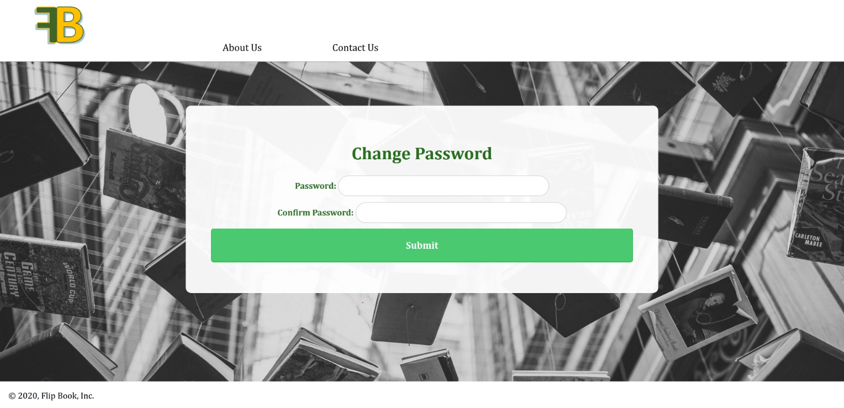

**ABOUT US PAGE (Hyperlink):**

**CONTACT US PAGE (Hyperlink):**

Prior to any inputs –

**FLIPBOOK LOGO (Hyperlink):**

Directs user to the main page –

**LOGOUT ICON:**

Prior to confirmation –

Result after hitting ‘OK’ –

