

**GOMC Capstone**

**Deployment Guide**

________________________________________________________________________________________________________

Version 0.2

December 3, 2017

**Prepared by:** Caleb Latimer

Ahmed Taher

Muamer Besic

**REVISION HISTORY**

|  |  |  |  |
| --- | --- | --- | --- |
| **Version**  **#** | **Implemented**  **By** | **Revision**  **Date** | **Scope of Change** |
| 0.1 | Ahmed T | 12/3/17 | Added screenshots |
| 0.2 | Muamer B | 12/3/17 | Created cover page, revision history, table of contents and everything else (formatting, writing, etc), also added several screenshots |
|  |  |  |  |
|  |  |  |  |
|  |  |  |  |

**Table of Contents**

**1. Overview ................................................................................................................... 4**

**2. Required Software ................................................................................................... 4**

**3. Installments .............................................................................................................. 4**

3.1 .NET .............................................................................................................. 5

3.2 MiKTeX ......................................................................................................... 8

3.3 Pandoc ....................................................................................................... 12

3.4 Python 2.7.13 .............................................................................................. 14

3.5 Pip ............................................................................................................... 18

3.6 Pygments .................................................................................................... 18

3.7 IIS 7.5 .......................................................................................................... 19

3.8 Web Deploy 3.5 .......................................................................................... 30

3.9 SQL Management Studio ............................................................................ 35

**4. Generating Salted Password Hash ...................................................................... 37**

**5. Publishing Website ................................................................................................ 39**

**1. Overview**

The GOMC Deployment Guide is designed to encompass in detail of all the different software needed to run the GOMC – Capstone web application. In the following sections of this document, you will find descriptions and screenshots of the required tasks needed to be done before running the web application.

**2. Required Software**

The following software that is required on the server end includes:

* Windows Server 2008
* IIS 7.5
* SQL Server
* .Net 4.6 or better
* Web Deploy 3.5
* MiKTex 2.9
* Pandoc 2.0 or better
* Python 2.7
* Pygments
* Pip

The following is required on the development machine:

* Visual Studio 2017
* Windows 7 or better
* SQL Server Management Studio 17
* High speed internet

**3. Installments**

This section will go over the steps of installing a number of different required software. Screenshots are included to better help explain of exactly what needs to be done.

**3.1 .NET**

To install .NET, you can simply click on the following link and it will take you to the page as shown below: <https://www.microsoft.com/net/download/windows>

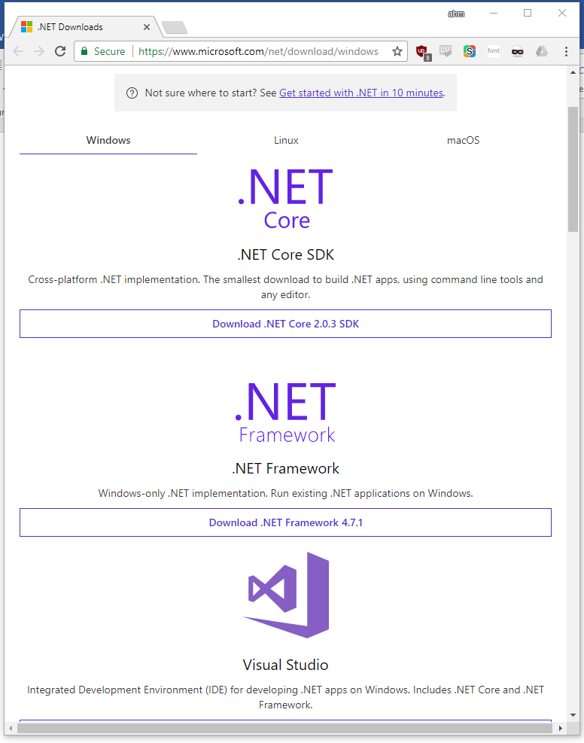

After clicking "Download .NET Framework 4.7.1", you will go through the download process as shown below:

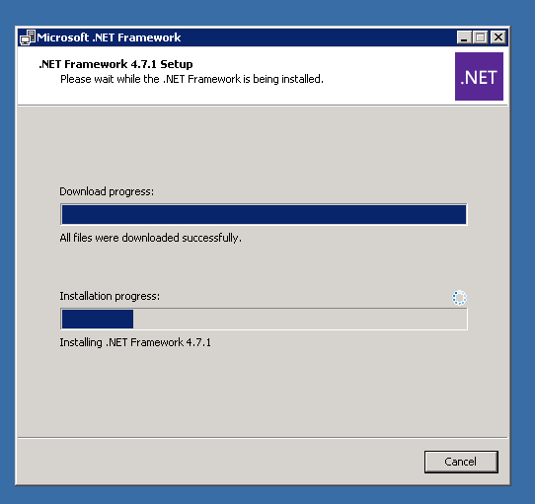

Once download is complete, figure below will be shown and you have successfully downloaded .NET Framework 4.7.1:

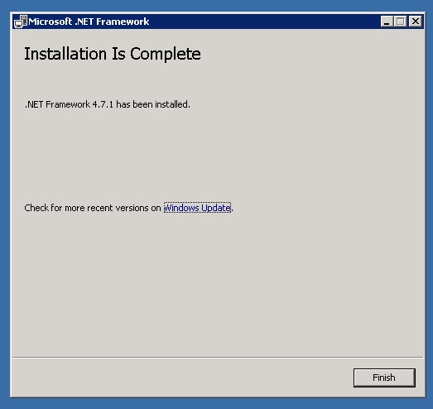

**3.2 MiKTeX**

To install MiKTeX, you can simply click on the following link and it will take you to the page as shown below: <https://miktex.org/download>

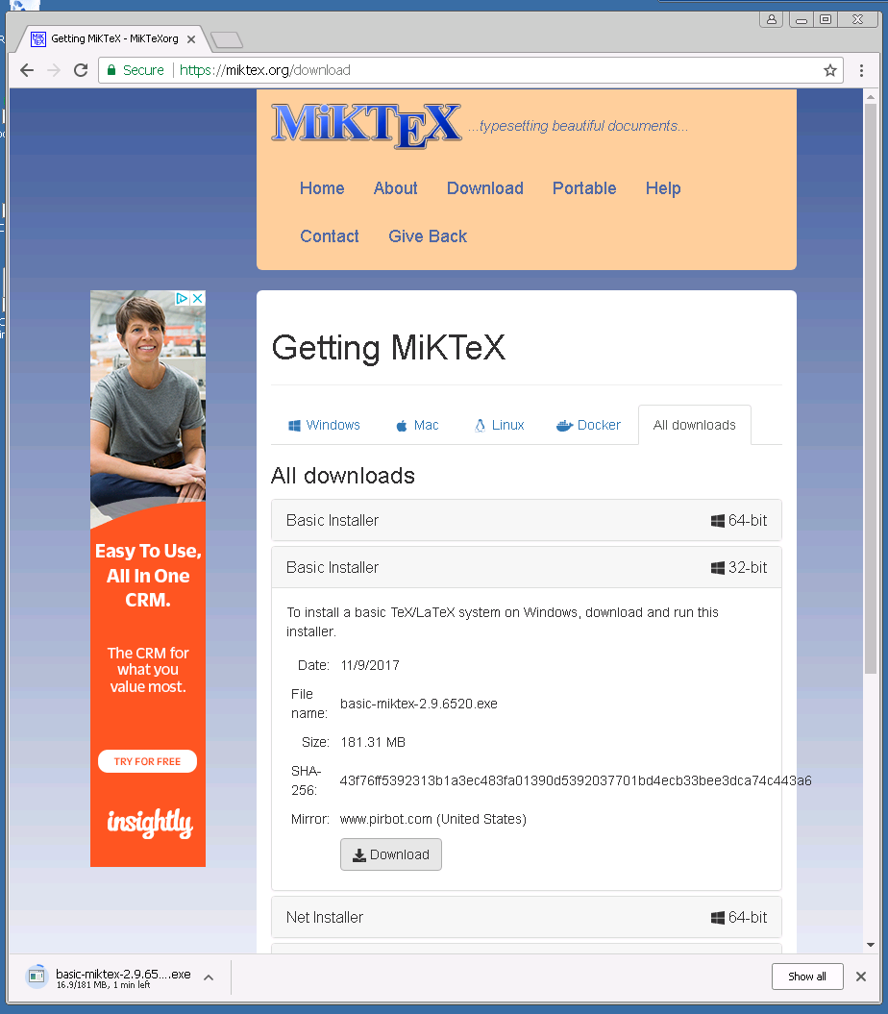

After clicking "Download", you will go through the download process as shown below. Here we simply click to accept the conditions and then click "Next":

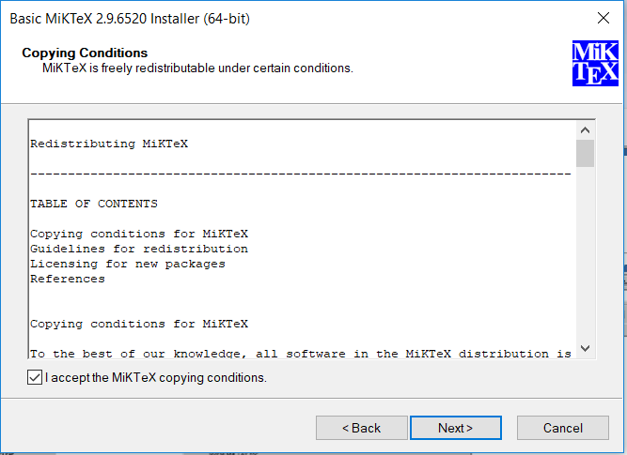

Below, select the option that applies to you and click "Next":

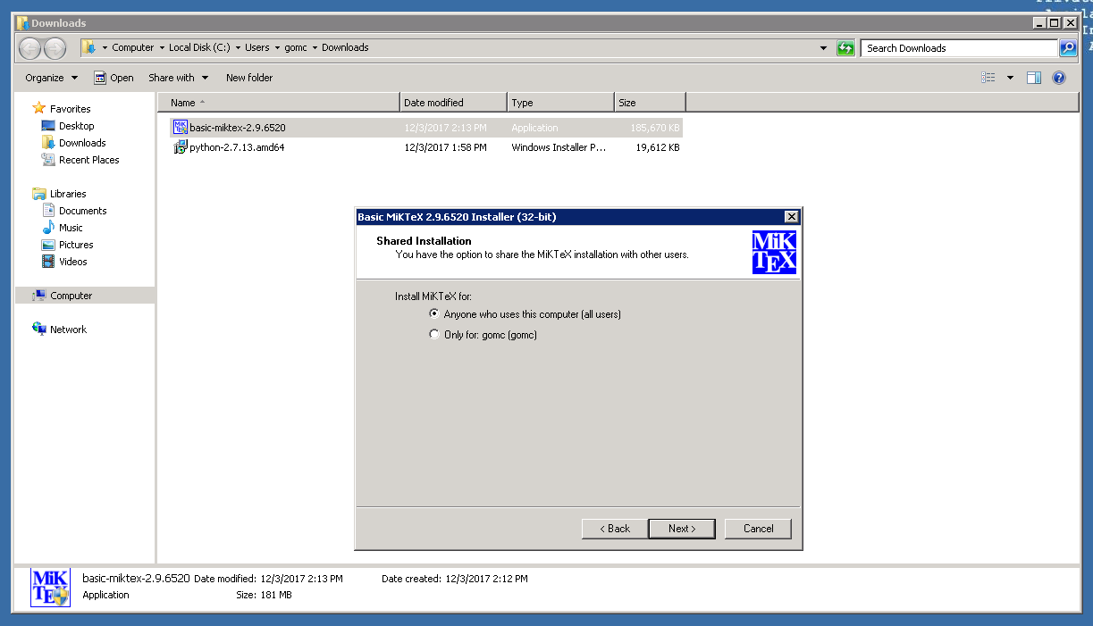

Make sure "A4" is selected in the first box and "Yes" is selected in the second box as shown below and click "Next":

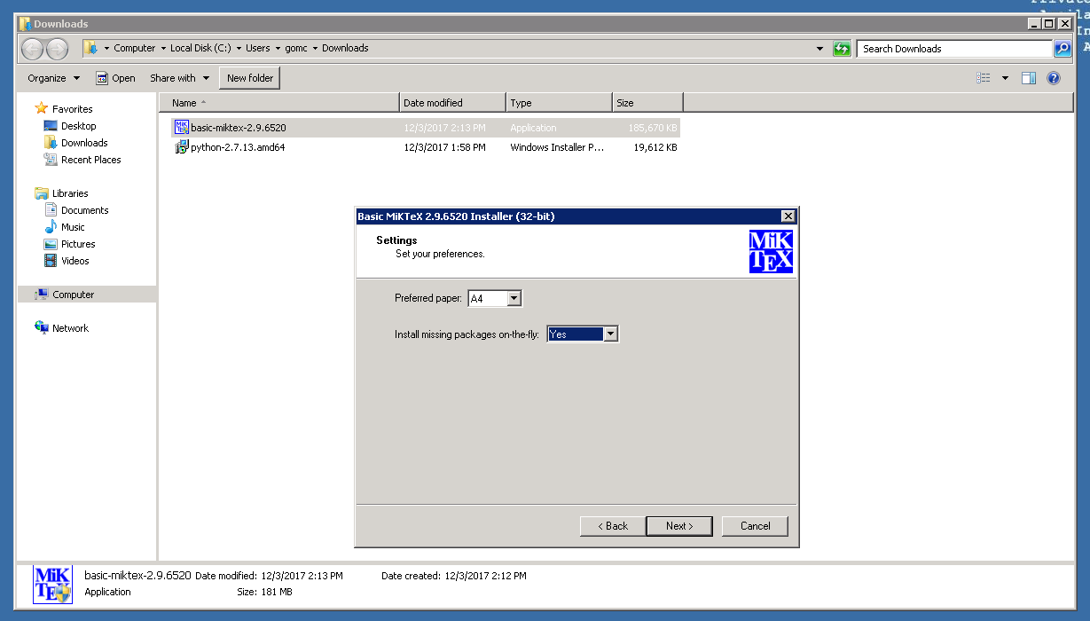

At this point, we click "Start" to start the download process as shown below:

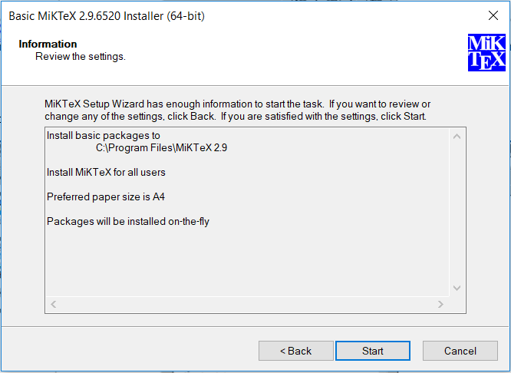

The download will start as shown below:

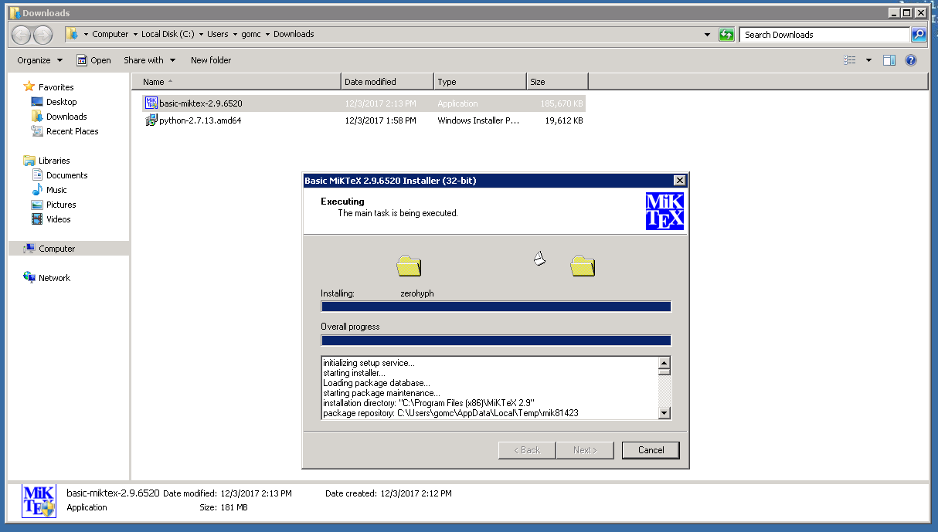

Once download is complete, figure below will be shown and you have successfully downloaded MiKTeX:

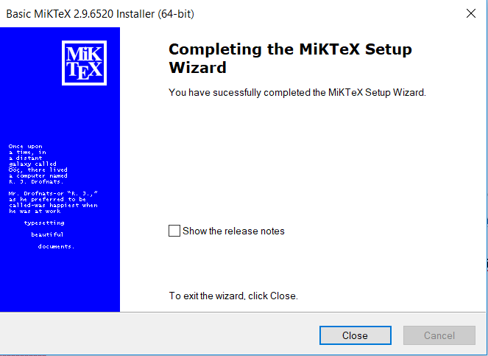

**3.3 Pandoc**

To install Pandoc, you can simply click on the following link and it will take you to the page as shown below: <https://github.com/jgm/pandoc/releases/tag/2.0.4>

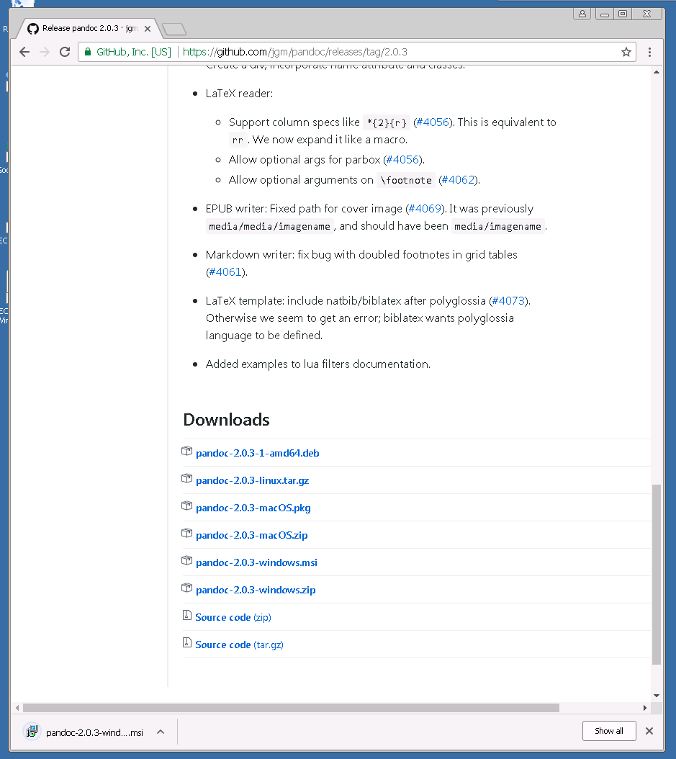

After choosing your computer operating system, you will go through the download process as shown below by making sure you accept the terms and clicking "Install":

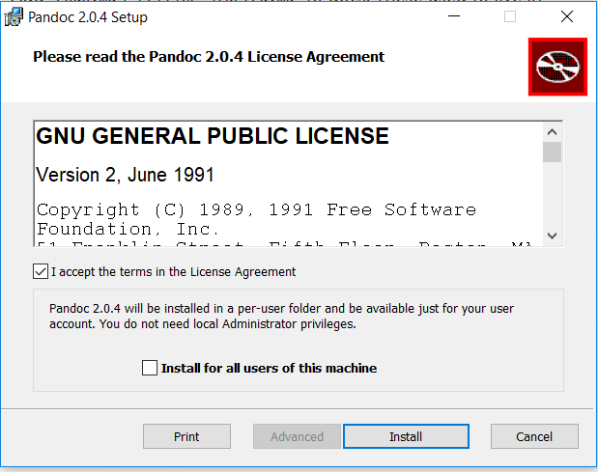

Once download is complete, figure below will be shown and you have successfully downloaded Pandoc 2.0.3.

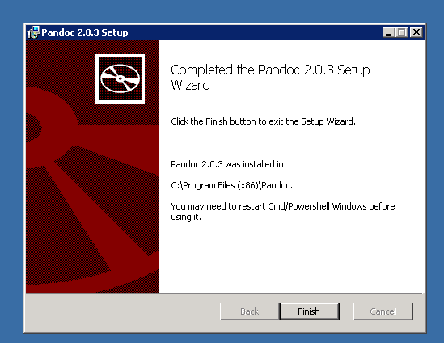

**3.4 Python 2.7.13**

To install Python 2.7.13, you can simply click on the following link and it will take you to the page as shown below: <https://www.python.org/downloads/>

Here you can choose your computer's operating system and click on it to start the download process.

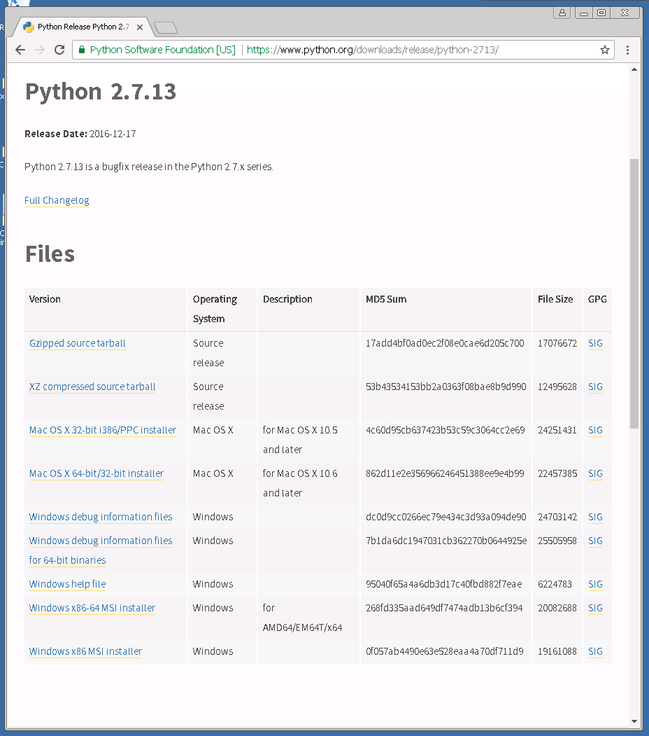

After choosing your computer operating system, you will go through the download process as shown below by selecting either of the two options and then clicking "Next":

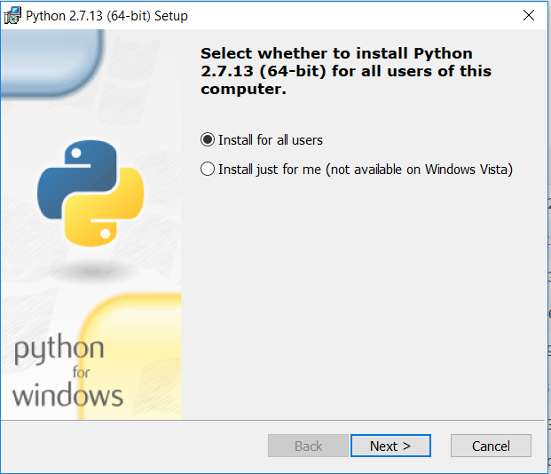

Below you are able to select a directory of your choice to store Python 2.7.13. You can just click "Next":

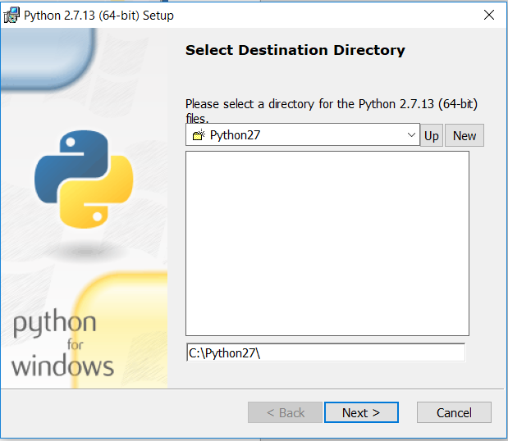

Below you are able to customize how you want features to be installed. You can simply just click "Next" once again:

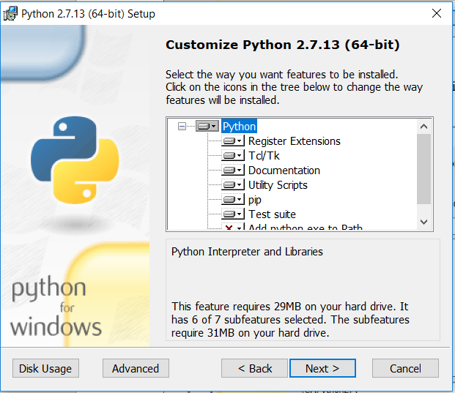

After clicking "Next", the download will start as shown below:

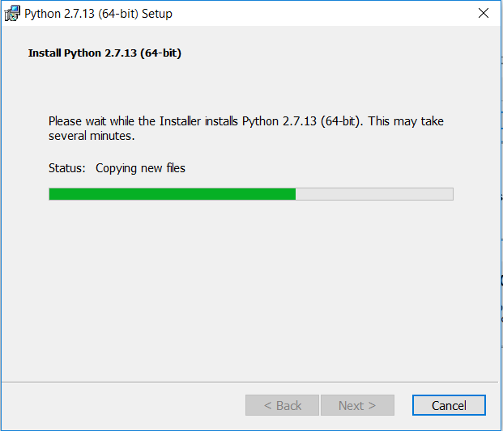

Once download is complete, figure below will be shown and you have successfully downloaded Python 2.7.13:

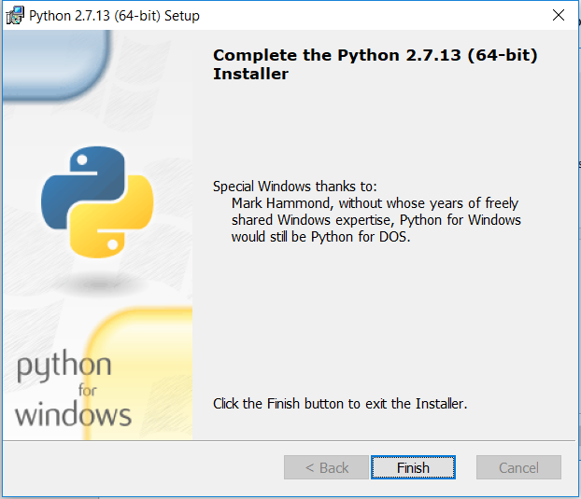

**3.5 Pip**

To install Pip, easy_install and Wheel in Python, you can simply input the following command line argument as shown below:

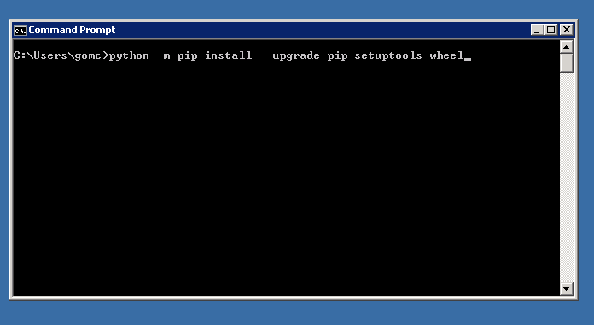

**3.6 Pygments**

To install Pygments in Python, you can simply input the following command line argument as shown below :

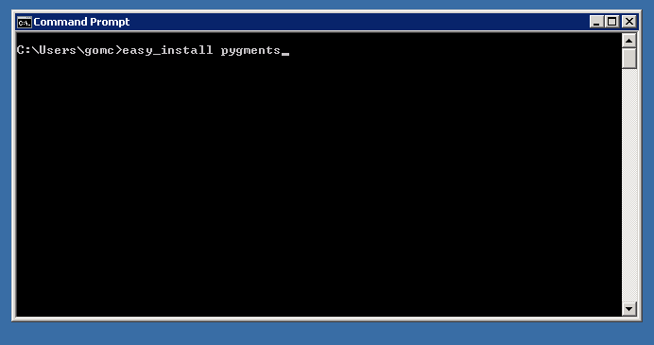

**3.7 IIS 7.5**

To install IIS 7.5, you will have to use Server Manager by adding a web server role as shown below:

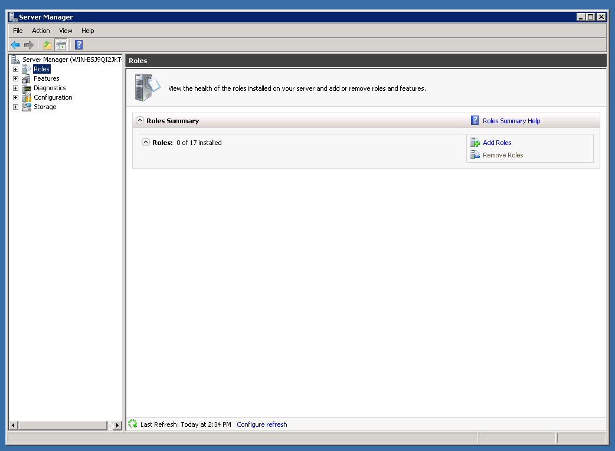

After clicking "Add Roles", you will go through the process as shown below. Click "Next":

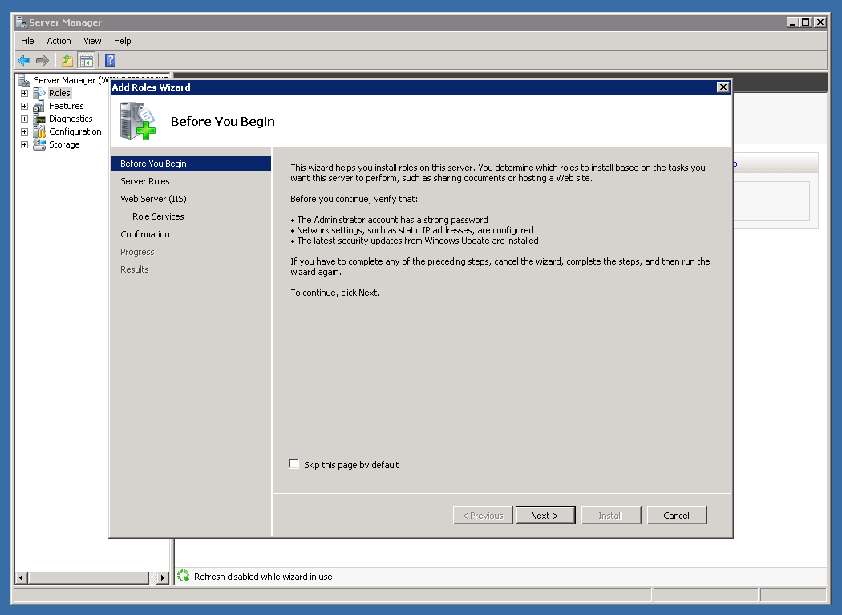

On the "Server Roles" section, make sure to check the "Web Server (IIS) check box as shown below and click "Next":

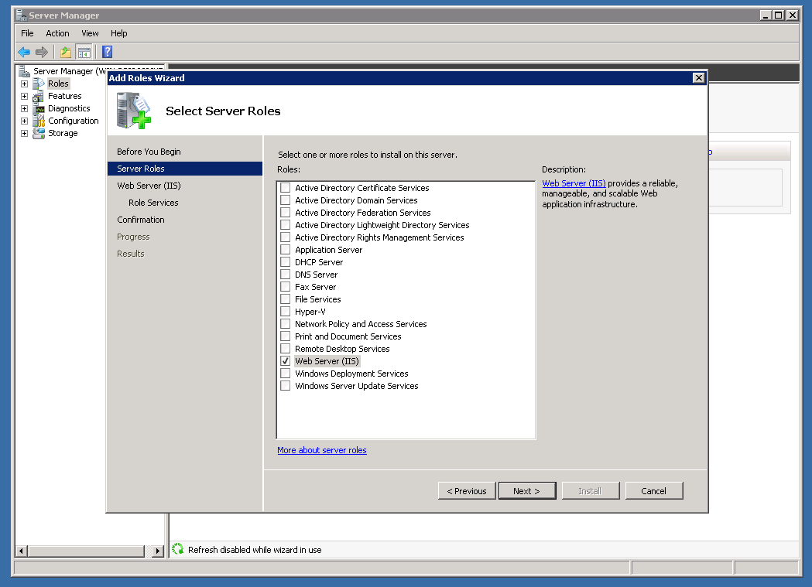

On "Web Server (IIS)" section, read through and click "Next" as shown below:

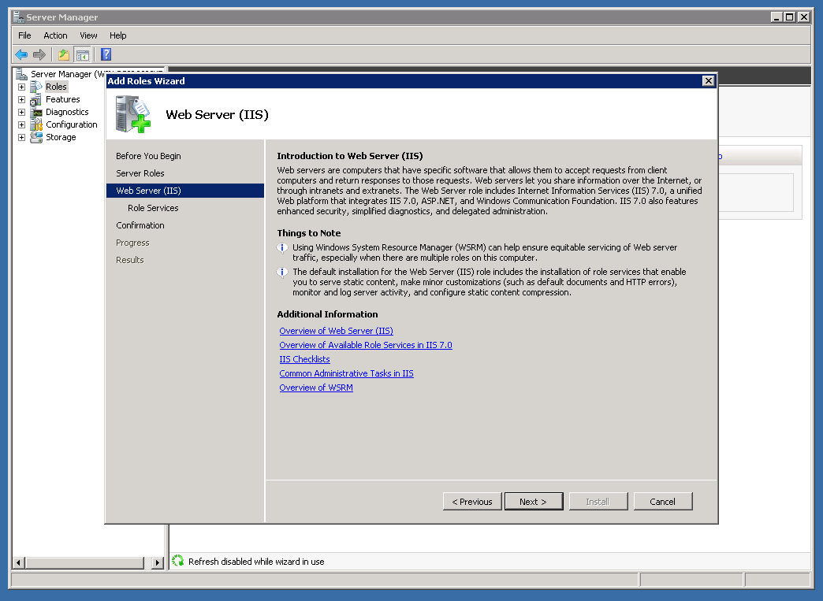

Under "Role Services" section, make sure to check all options in "Application Development" and "Common HTTP Features" as shown below and click "Next":

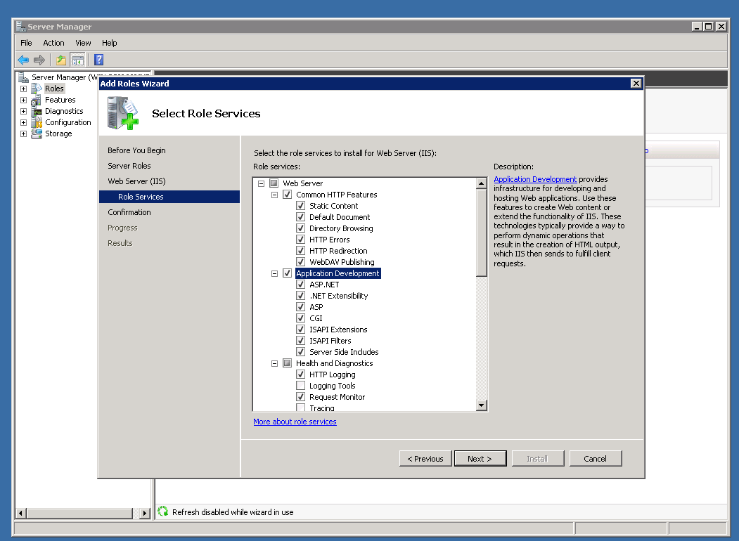

The "Confirmation" section will be shown as below. Click "Install":

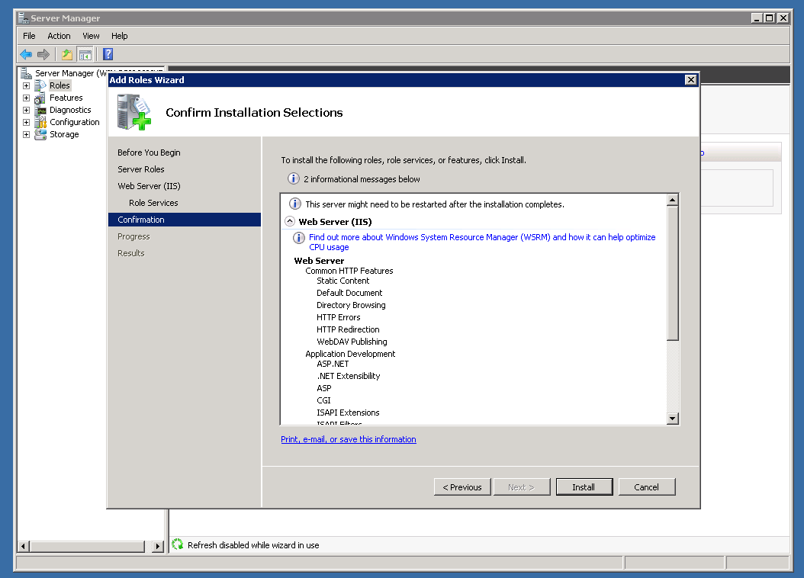

Once installation is complete, figure below will be shown and you have successfully installed a role as shown below:

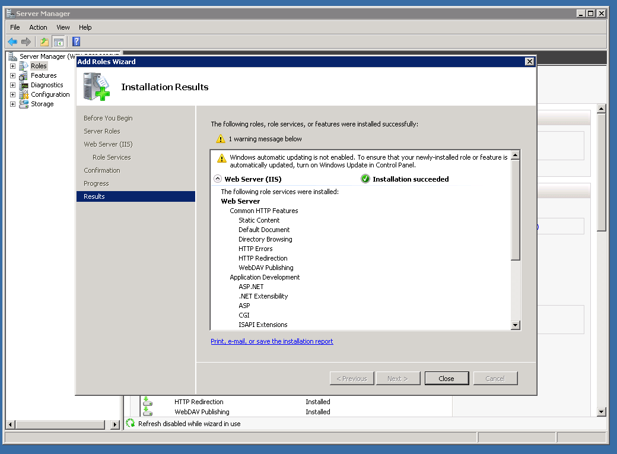

Next, open IIS console as shown below:

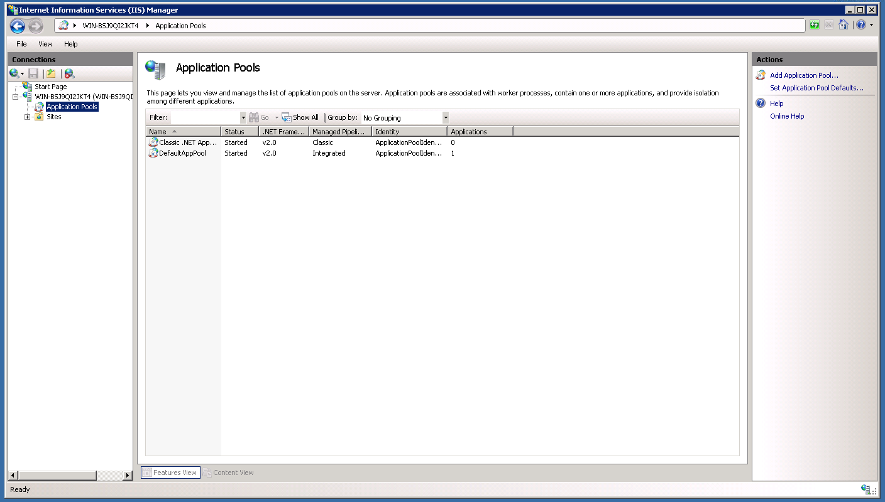

Add a new application pool with framework version set to ".NET Framework v4.0 30319" and pipeline mode set to "Integrated" as shown below:

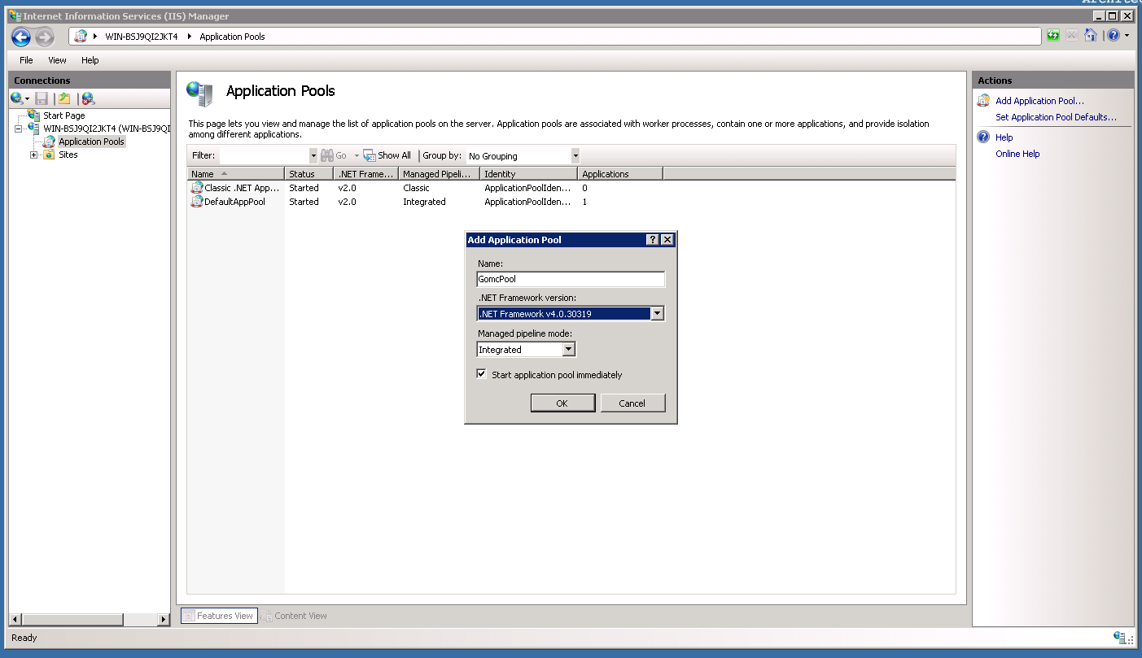

Add a web site with the pool set to the same one created above as shown below:

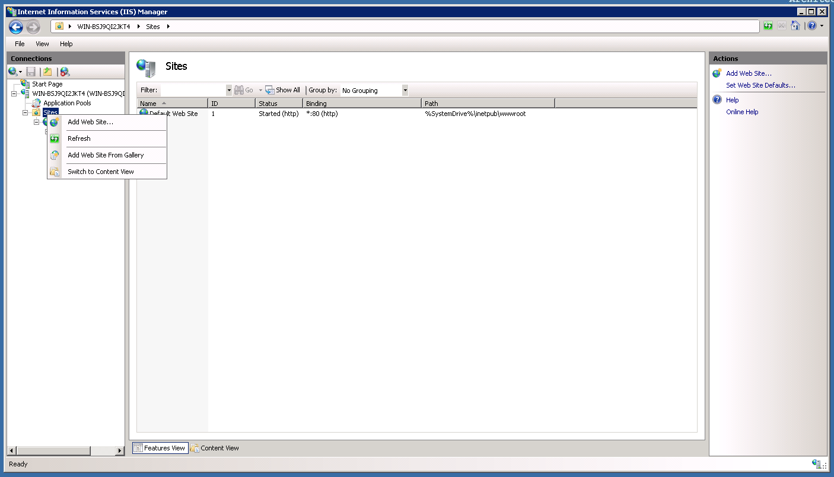

To add the new web site, you must fill in the boxes as shown below:

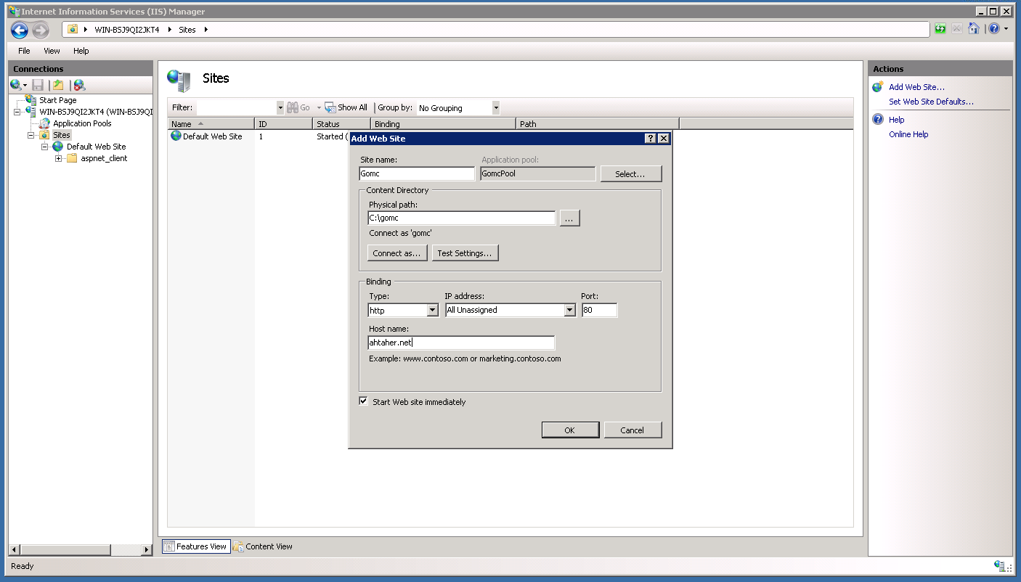

Here we connect as a user with admin permissions as shown below and click "OK":

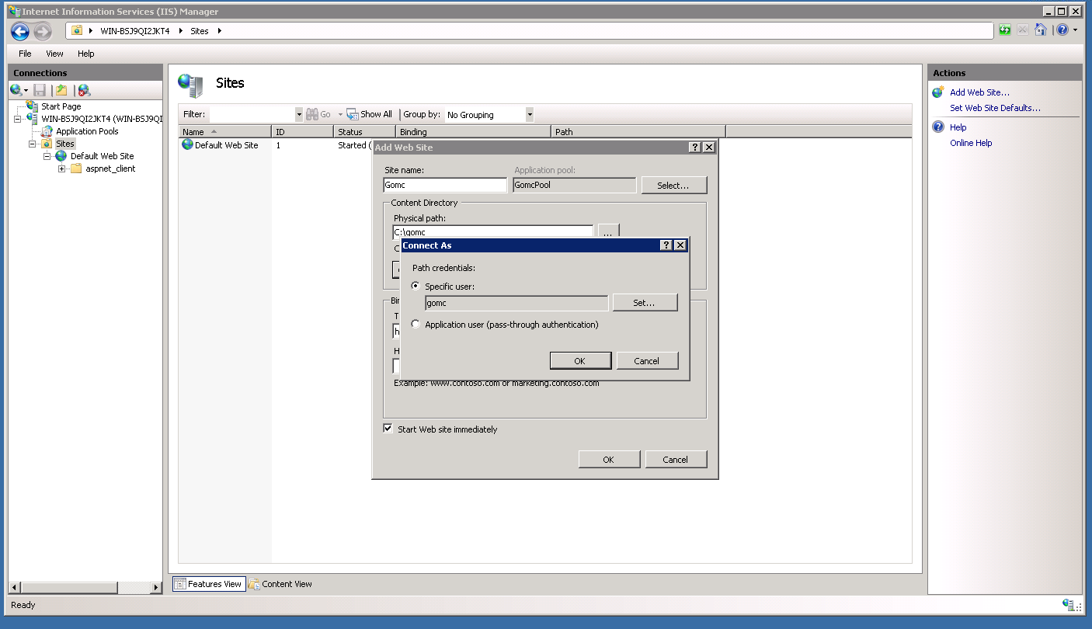

Lastly, run aspnet_regiis.exe in cmd as an admin as shown below:

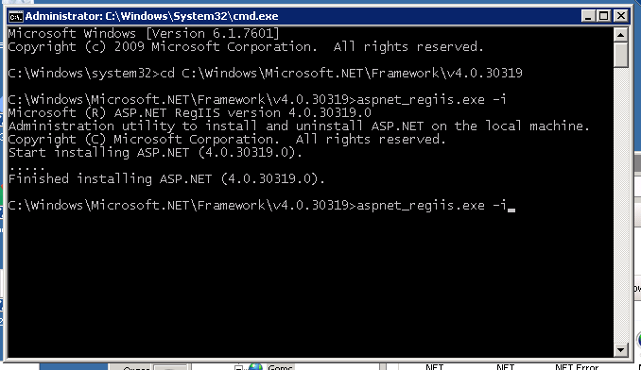

**3.8 Web Deploy 3.5**

To install Web Deploy 3.5, you can simply click on the following link and it will take you to the page as shown below: <https://www.microsoft.com/web/downloads/platform.aspx>

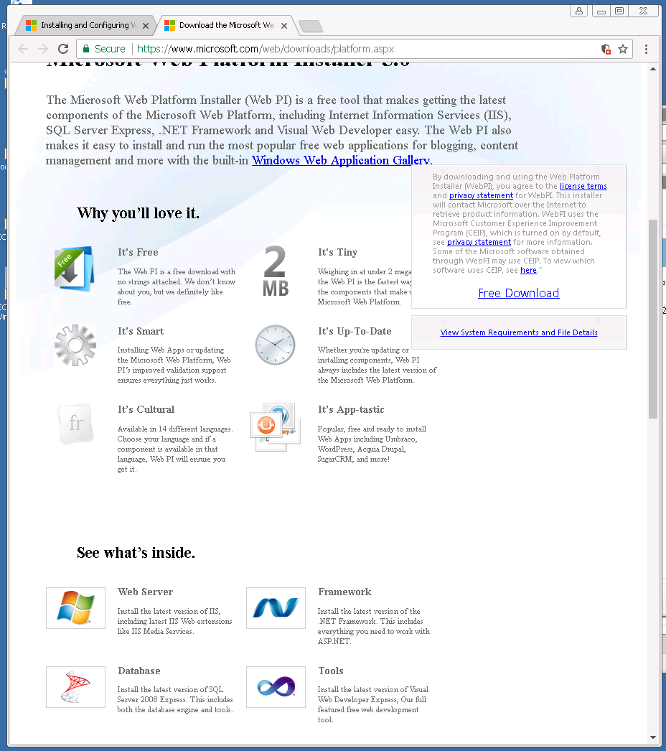

Once the web platform installer is running, search for web-deploy as shown below: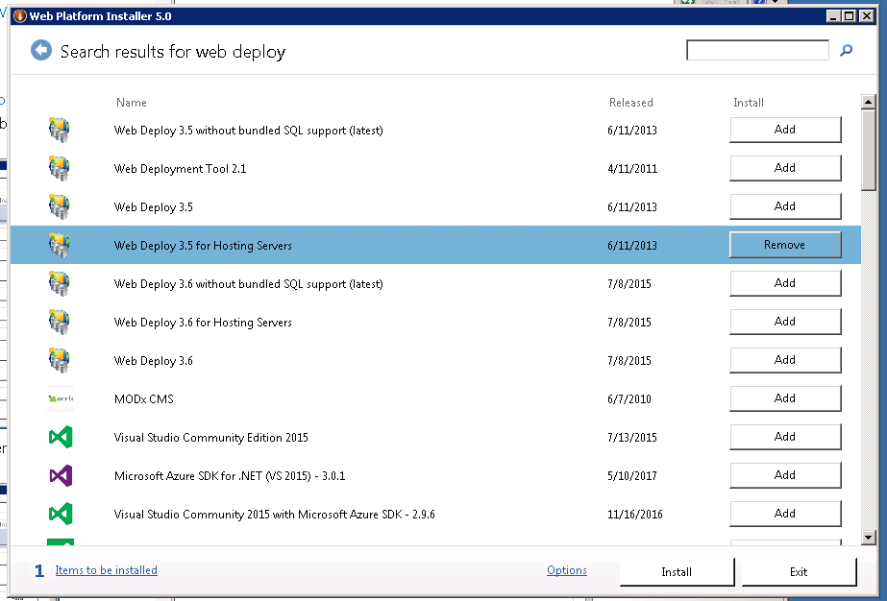

Click install and "I accept" as shown below:

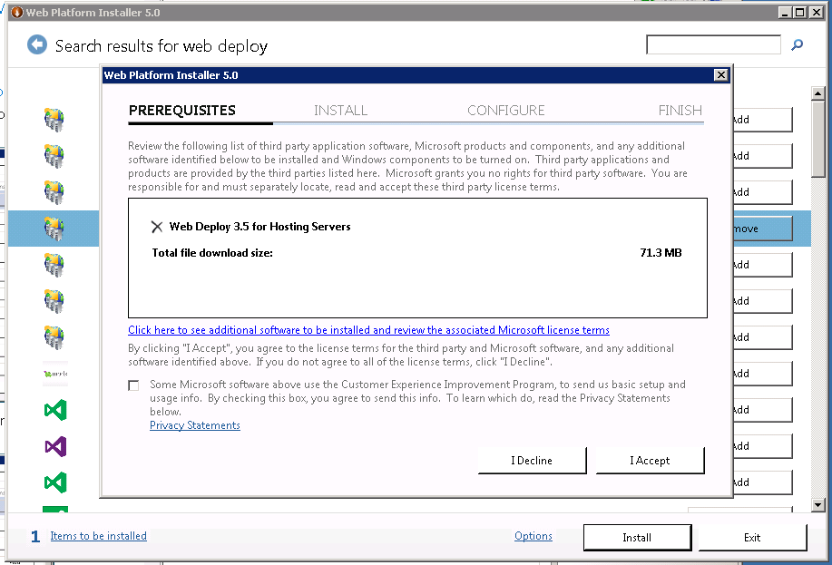

The download will begin as shown below:

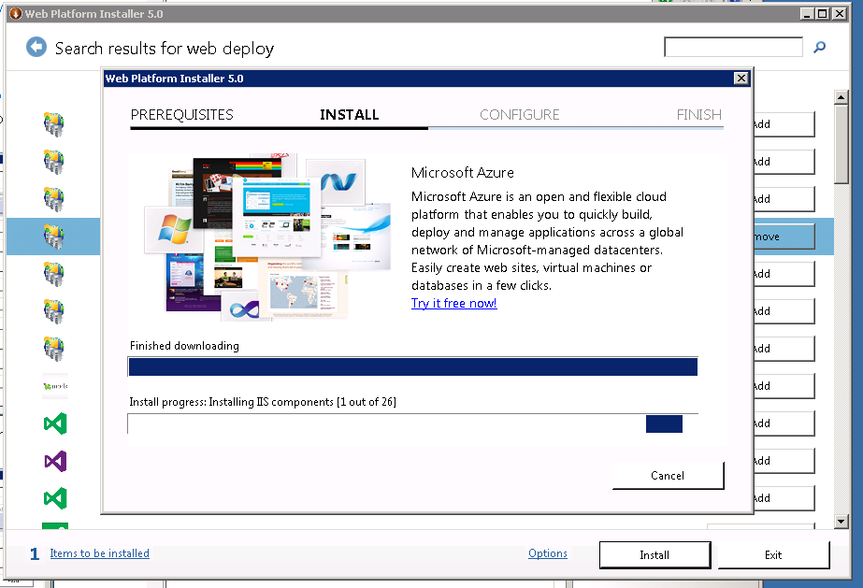

Once installation is complete, figure below will be shown and you have successfully installed Web Deploy 3.5:

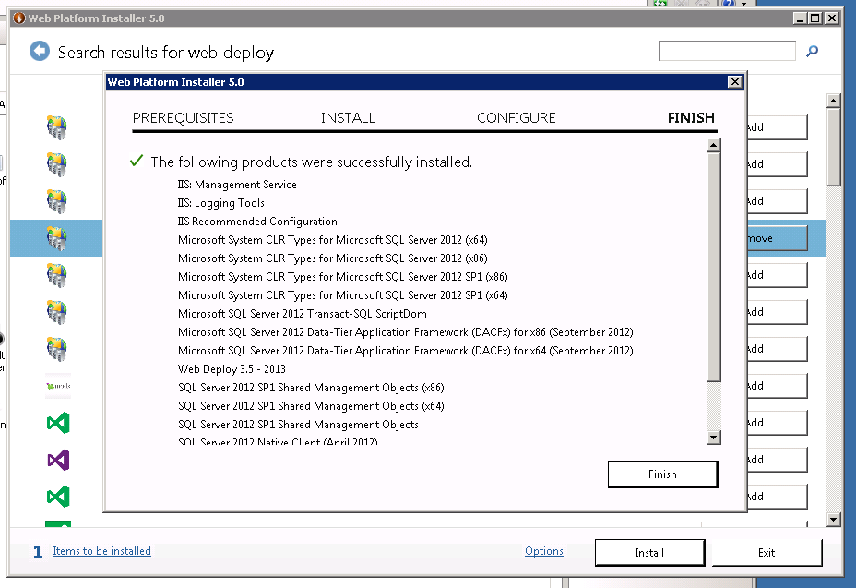

**3.9 SQL Management Studio**

To install SQL Management Studio, you can simply click on the following link and it will take you to the page as shown below: <https://docs.microsoft.com/en-us/sql/ssms/download-sql-server-management-studio-ssms>

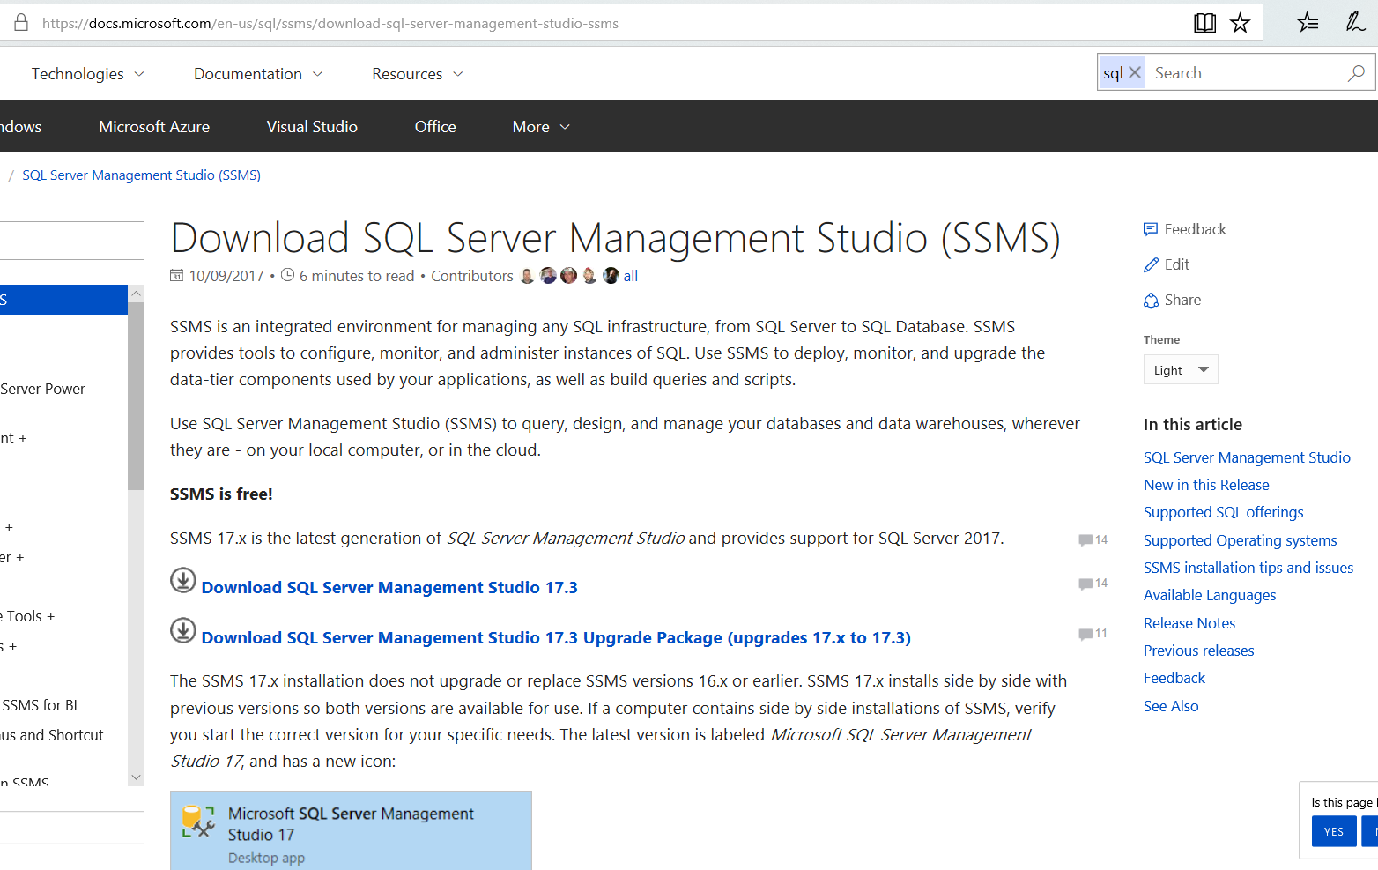

After clicking "Download SQL Server Management Studio 17.3", you will go through the download process as shown below. Simply press "Install":

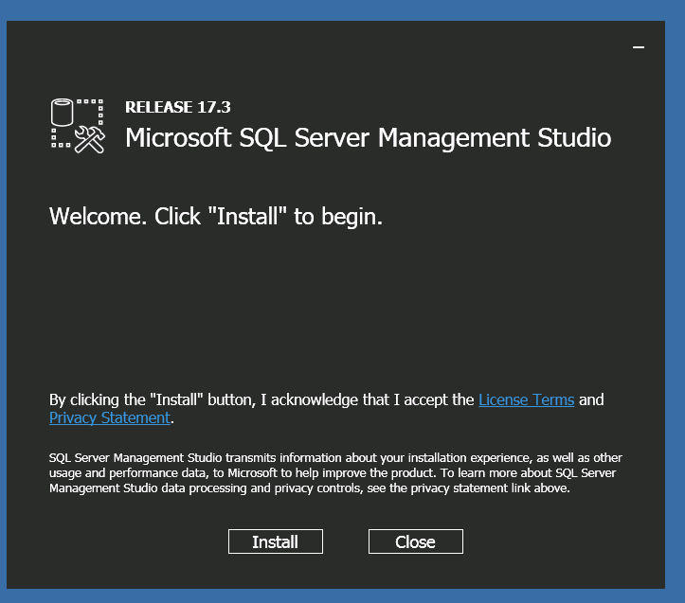

Using SQL Management studio, execute all queries in the SQL folder of the project. This will setup the database.

**4. Generating Salted Password Hash**

To generate a salted password hash, we can use the GetHash function. The simplest way to do so is to use Visual Studio's C# interactive. The first step is to initialize the interactive with project as shown below:

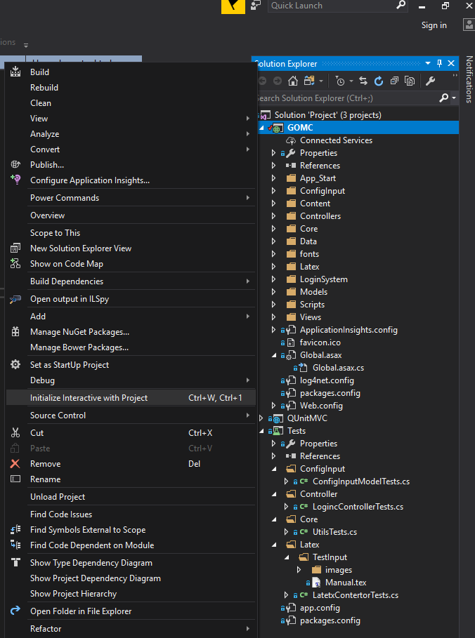

The interactive window will appear and now we can call the GetHash function directly with any password we want. We can use “password” as an example as shown below:

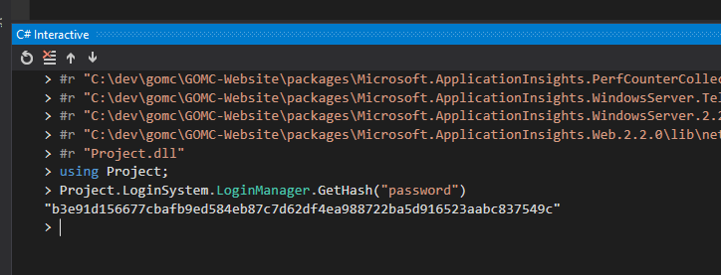

**5. Publishing Website**

To publish a website from Visual Studio from your development machine onto the web server, you use Web Deploy. Visual Studio already has that feature built in where all you do is right click on the project in the solution explorer and click "Publish" as shown below:

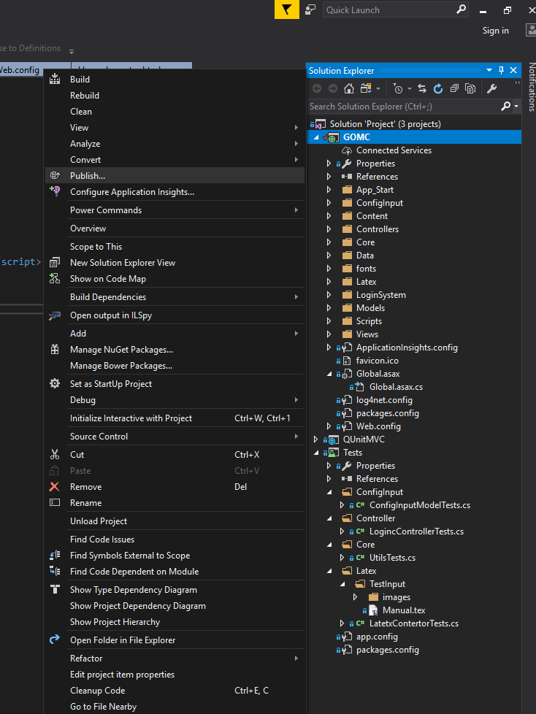

On the "Connection" section, set the server address and credentials as shown below (replace values with the actual values in your server):

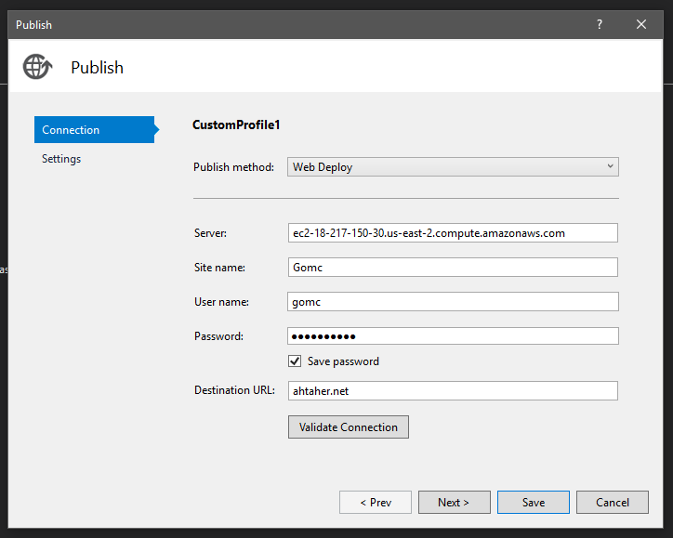

On the "Settings" section, make sure the selected options are checked and then click "Save"

