Sub-monolayer tracking of molecular evolution at buried interfaces
via optical tensor-informed resonant X-ray scattering
Harlan Heilman¹, Emily Biegler¹, Sushil Adhikari¹, Victor Murcia², Tanner Melody¹, Fred Woodall¹, Lars Thompson³, Obaid Alqahtani^{2,4}, Brian A. Collins^{1,2*}
¹Department of Physics and Astronomy, Washington State University, Pullman, Washington 99164, USA
²Department of Materials Science and Engineering, Washington State University, Pullman, Washington 99164, USA
³Australian Synchrotron, ANSTO, Clayton, VIC, Australia
⁴Department of Physics, Prince Satam bin Abdulaziz University, Alkharj 11942, KSA

Phenomena responsible for emerging technologies originate from the depth-evolution of novel molecular states at buried interfaces. Yet quantitatively resolving this buried evolution, especially for molecular orientation, conformation, and chemical state is out of reach in most cases. Resonant scattering has demonstrated sensitivity to these states at a local level but is limited due to a lack of accurate interpretive models. We leverage a machine learning (ML)-optimized optical tensor model to analyze polarized resonant soft X-ray reflectivity (PXR) from molecular thin films. This new analysis establishes the direct and quantitative interpretation of molecular orientation and packing states as a function of depth with sub-monolayer resolution – reaching beyond the diffraction limit. Instead of the expected molecular alignment based on substrate patterning, we discover a gradient evolution of molecular behavior indicative of competing surface versus bulk dynamics at the interface that define the final molecular interfacial states. This insight into buried interfacial formation and final structure opens possibilities in controlling interfacial states in next-generation technologies.
The molecular orientation [1,2], composition [3] and oxidation state [4,5] at the inaccessible interfaces of buried nanoscale assemblies are decisive quantities that dictate material function across physics, chemistry and materials science critical to advanced technologies. For example, in extreme-ultraviolet photoresists the chemical gradient at the edge of the latent image limits the minimum achievable process size for microprocessors. [6,7] In organic electronic devices such as solar cells, LEDs, and transistors, the interfacial molecular orientation governs emergent electronic states that control charge generation, recombination, and transport, respectively, in those devices [1,2]. In bio- and chemical sensing, molecular states at buried interfaces have resulted in novel ionic transport dynamics. [8–10] Controlling these interfaces is, therefore, central to advancing each of these technologies.
Unfortunately, these buried interfaces are inaccessible to most local measurements. Instead, novel interfacial molecular states are thought to be achieved via substrate patterning effects, governed by surface energy. For example, molecular orientation and packing originates from this initial pattern enforced by the substrate, [11–13] similar to atomic epitaxial growth. Painstaking studies have attempted to access the buried molecular state via in-situ measurements at checkpoints during film growth. [14] These studies have revealed density gradients that contradict the patterning hypothesis. However, it is possible these studies merely reveal a snapshot of the exposed molecular layers in a temporary state, which change once buried, rather than the final state of the interface.
Resonant soft X-ray scattering, tuned to the energies of electronic transitions into unoccupied molecular orbitals can reveal the chemical and physical states within these buried structures. [7,15,16]. The scattered intensity is set by two coupled inputs, the structure of the assembly and the energy-dependent index of refraction tensor containing the chemical, electronic, and orientation information. Through forward simulation techniques, both structural and optical parameters are fit to scattering data, but the physiochemical states must be inferred from the optical parameters as a function of energy and polarization.
In reflection geometry (PXR), the structure is one dimensional, resolving depth-dependent information, [15,17–21] but PXR doesn’t provide mapping of optical parameters to the underlying molecular state. In fact, analyzing PXR with more X-ray energies results in more optical parameters, making the analysis unstable. Therefore, analyses commonly retreat to a diagnostic resonance such as the Carbon $1s→π^{*}$, but since this is common to all aromatic compounds, the analysis cannot distinguish chemical species nor their relative orientation unless simplifying assumptions are made. [17,22,23] Worse, a buried interfacial layer is typically required to accurately fit the data which is assumed to be comprised of contaminants or oxidation, [17,18,20,21] obviating interfacial analysis.
Recently, near edge X-ray absorption fine structure (NEXAFS) spectroscopy measurements have been used to construct an Edisonian optical model, enabling the orientation state to be inferred though a secondary analysis of the fit optical parameters although the above limitations remain. [17–19,21,24] Alternative approaches arrive at the optical model from density functional theory (DFT), yet are limited by fundamental computational inaccuracies. [25–27] Recently, we have demonstrated that ML-refined DFT optical models can quantitatively reproduce angle-resolved NEXAFS measurements of polycrystalline thin films with different orientation and crystal phases while retaining individual bond identity and orientation. [28] This optical model could provide a platform for PXR chemical and orientational analysis.
Here we apply this ML-DFT optical model in PXR analysis to directly quantify molecular chemical identity, orientation and density as a function of depth in a molecular thin film. The approach ties resonances together in one physical model of the molecule, to increase chemical and orientational sensitivity while dramatically reducing parameters. This significantly increases in precision of the analysis, resulting in sub-monolayer resolution of molecular chemical and orientational state – well beyond the diffraction limit of the soft X-rays. Analysis of the first buried monolayer of growth reveals, not contaminants, but the deposited molecule at a different orientation and packing state with a continuous depth evolution. This establishes the bulk texture is set not by substrate patterning but by competing surface and intermolecular interactions during growth. The new PXR analysis, therefore, enables direct characterization of buried structures at the molecular level critical to the physics of crystal growth, kinetic deposition, and solvent interaction models that dictate these interfaces across material systems.

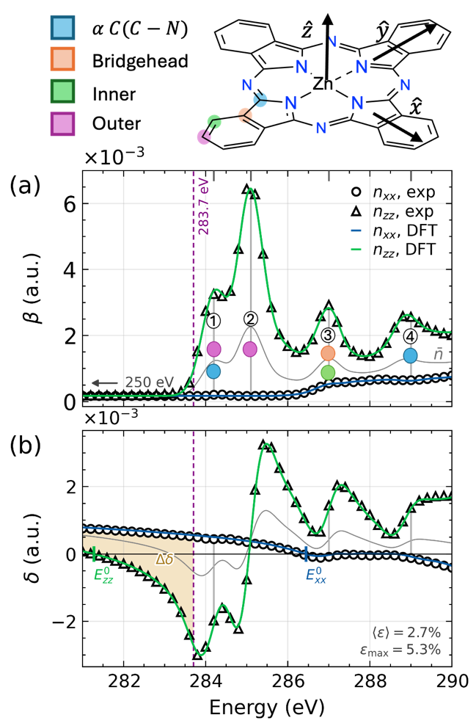
FIG. 1. Resonant optical tensor of ZnPc near the carbon K edge, from DFT (Traces) and angle resolved NEXAFS (points), deviating by $\left\langle ϵ\right\rangle =2.7\%$ and $ϵ_{max}=5.3\%$ at resonance 1. Top, molecular frame and the four inequivalent carbon excitation centers, colored as labeled. (a) $β_{xx},β_{zz}$, and the isotropic average $\overline{β}$ (grey), numbered bars are fine structure resonances targeted for PXR measurement. (b) $δ$ by Kramers-Kronig transformation [29], with shaded $Δδ$ bounded by the zero crossings $E_{xx}^{0} \& E_{zz}^{0}$.
We focus on thin films of Zinc phthalocyanine (ZnPc), a mature molecular platform spanning foundational studies of single-molecule photophysics and quantum optics [30–34], commercial photovoltaics [35,36], thin-film transistors and sensors [37,38], and photomedicines. [39–41] Physical vapor deposition (PVD) yields polycrystalline films with the molecular orientation commonly set by patterning underlayers where CuI and graphene pattern face-on orientation and Si patterning the more stable edge-on herringbone orientation [11–13]. However, film coverage studies have suggested that ZnPc and other MPc films bear more complex microstructural states that evolve from the substrate to the vacuum interface. [14,42–45] Yet this evolution has yet to be confirmed a completed film of ZnPc as deposited on silicon.
On silicon, PVD ZnPc assumes a monoclinic $γ$-ZnPc [13,14] with a strong edge-on texture confirmed by ellipsometry and GIXRD. Angle-resolved (AR) NEXAFS places the film-averaged macrocycle normal ($\hat{z}$ in Fig. 1 schematic) at a polar tilt of $γ={74}^{∘}$ from the substrate surface normal (pre-characterization in SI Sec. 1). From the same AR-NEXAFS, the molecular tensor $n_{ij}\left(E\right)=1-δ_{ij}\left(E\right)+iβ_{ij}\left(E\right)$ follows by projecting $β$ onto the optical axes (Fig 1a, symbols) [46,47], with the molecule-to-film relation given in SI Sec. 2. This pure experimental spectrum measures the product of transition dipole moment (TDM) orientation and molecular orientation, so the two cannot be separated without independent knowledge of the TDM directions. Following our prior work, we compute the DFT simulated NEXAFS spectroscopy. Through our unsupervised ML algorithm, we extract a set of principle TDM clusters associated with each fine structure resonance, [28] enabling refinement of the model to achieve quantitative agreement with experimental NEXAFS (SI sec. 3). The refined TDMs then set $β_{ii}\left(E\right)$ and $δ_{ii}\left(E\right)$ though the Kramers-Kronig (KK) transform and compared in Fig 1. The average quantitative errors between the refined model in reproducing the AR-NEXAFS data is 2.7% with all experimental features reproduced in Fig 1. Thus, the ML-DFT single molecule tensor fully captures the optical interactions emergent in the film, while assigning chemical character and TDMs to spectral features.
The first two TDM clusters orient along $\hat{z}$ and carry the dominant oscillator strength, producing a strong pre-edge birefringence ($Δδ$, Fig. 1b). We exploit this in two modes. First, high-density sampling in energy up to 283.7 eV (just below the first absorption resonance), we trace the extinction of the s-polarized critical angle $θ_{c}^{s}=\sqrt{2δ_{xx}}$, fixing the film averaged orientation at low dose. Maximum q-range reflectivity is then collected at two bookending diagnostic energies, 250 eV where the ZnPc optics are isotropic, and 283.7 eV where dichroism is maximal at minimal absorption, improving sensitivity to thin buried layers and consistent with prior work. [21] Because these components are set by the primary $π^{*}$ transitions common to any $π$-conjugated ring, the pre-edge reports the orientation of the conjugated framework rather than chemical identity. Chemical specificity is provided though PXR measurements at the fine structure resonances which resolve all four inequivalent carbon environments of the macrocycle (labeled in Fig. 1 schematic).
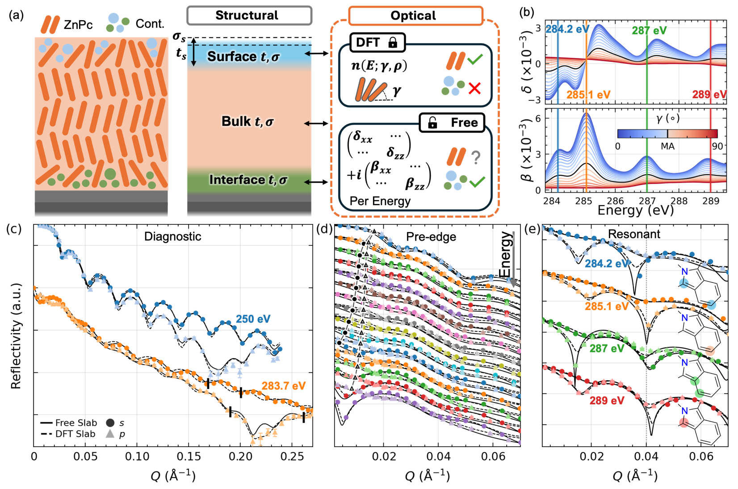
We analyze the PXR data across these energies via forward simulation where the film is modeled in not one but a three-slab structure, each with a thickness $t$ and roughness $σ_{r}$, outlined in Fig. 2a. Three slabs are required for a good fit instead of one to capture the physics occurring at the surface, bulk and buried interface of the film similar to most PXR analyses. [17,21] We then apply two optical models of the slabs to contrast the ML-DFT optical model with that of the traditional analysis. The traditional approach, designated the Free model, fits four uniaxial tensor components per energy per slab (Fig 2a) with 252 parameters across the 21 measured energies. A secondary analysis of varying types must be developed to determine chemical nature, orientation, and density from these parameters. In contrast to this, the ML-DFT model uses the energy and polarization-dependent optical tensor from Fig. 1 (derived in Apx. A) to directly parameterize density $ρ$ and molecular tilt angle $γ$ – only two parameters total per layer. An assumption of this approach is that chemical differences will manifest as poor fits to PXR data at the key energies that describe the molecule’s resonance structure above the absorption edge, in this case, data in Fig. 2d.
FIG. 2. PXR data collected at beamline 11.0.1.2 (SI sec. 4) for each energy measured in this study compared between Free tensor (solid) and DFT (dashed) optical models. (a) Three-layer slab structure diagram (Surface, Bulk, Interface) and optical model diagram comparison between the DFT locked model, and Free tensor model. (b-d) Vertically offset waterfall plots comparing models (traces) with data s-pol (circle/darker) and p-pol (triangle/lighter hue) for each energy domain: (b) diagnostic energies, (c) pre-edge, $δ$-crossing, (d) post-edge, resonant. Traced in (c) is the critical angle for each s-and-p-pol across the pre-edge energies.
Fit quality between the two models differs by energy regime. Across the pre-edge and resonance series of Fig 2 c & d, the DFT model tracks the data with similar or better residuals from the free tensor model. The critical angles traced in Fig 2c, vertical black traces, highlight the underlying birefringence resolved in this regime. The s-polarized edge extinguishes between the 282.7 and 282.9 eV reflectivity profiles indicating that $δ_{xx}$ crosses zero while the p-polarized edge persists across the full series, and ordering requires a polar tilt angle above the magic angle $γ>{54.7}^{∘}$. Of importance, the DFT model in the molecule’s resonance series (Fig 2d), fits equal or better than the Free model with a median model-data deviation of 1.7$σ$ vs 2.2$σ$. For example, the minima at $Q\sim 4/Å$ are in several cases better fit by the DFT model that restricts only ZnPc to be present in the film. This indicates a lack of contamination or oxidation present in the film.
Fig 2b presents the largest divergences between the models, where the characteristics of the 283.7 eV reflectivity profile are the most challenging to reproduce for the either model. At this energy, the DFT model performs worse with a noticeable phase shift between the fringes in the data and model though most of the s-pol profile. Neither model performs well around Brewster’s angle in the p-pol profile, although the DFT model performs better here. This is despite both models arriving at similar slab structures (Tab. SI, SII). In the free model the total thickness of the film $208.5\left(7\right)$ similar to the DFT model $206.47\left(3\right) Å$, both within $2σ$ of variable angle spectroscopic ellipsometry measurements of the same film (Fig S1), yet the DFT model achieves this with >10x sharper parameter uncertainties. Since both models are so similar structurally despite producing different reflectance, we surmise that the cause for the model divergence lies within the differences in refined optical constants and possibly an issue with the three-slab model in properly describing the film structure.
From the DFT model, the orientation and density are read directly, tracing the microstructure evolution though the film. At the silica interface, ZnPc assumes a lower density arrangement with tilt angle $γ=47.24{\left(3\right)}^{∘}$ before reorienting to an edge-on texture after approximately 1 nm. Notably, this is well below the diffraction limit of the soft X-rays used which exhibit $λ/2>2nm$. This progression is consistent with prior work suggesting the existence of a reduced density interfacial layer with distinct crystal phase. [14,44] The film then holds this edge-on configuration at $γ=69.54{\left(5\right)}^{∘}$ though roughly 18 nm of bulk growth at near the tabulated density of $1.53\left(3\right)$ g/cm³, in agreement with the critical angle analysis. At the free surface, the orientation reverts to $γ=52.21{\left(3\right)}^{∘}$, just below the magic angle. Each interfacial layer presents not only a distinctive orientation from the bulk but also a distinct density, indicating novel packing arrangements, and both carry the resonant anisotropy that only orientated ZnPc can produce. Notably, neither boundary layer requires the adventitious hydrocarbon contamination to which such layers are customarily assigned. [17,20,21,48]
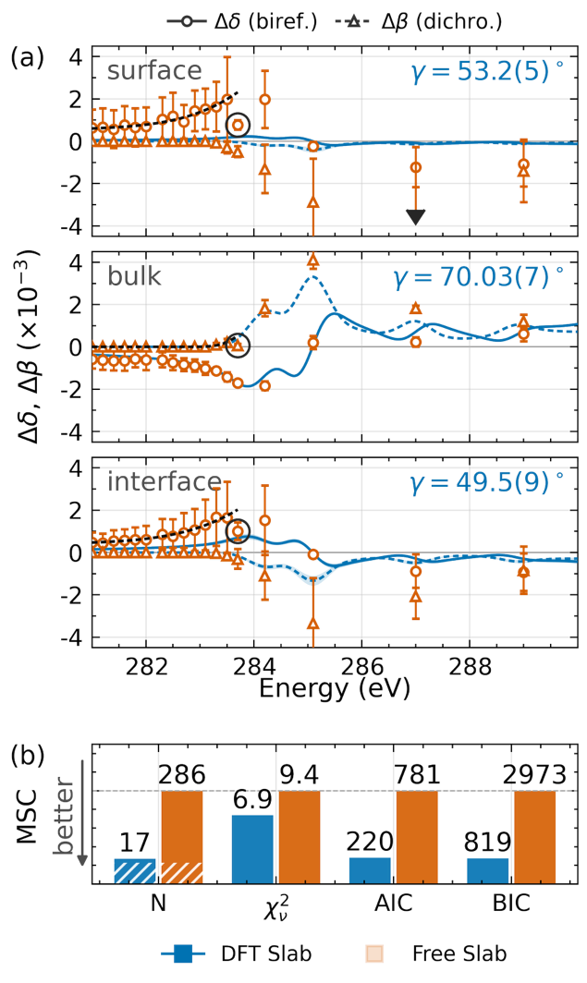
The optical properties of the two models, as shown in Fig 3a (expanded in Fig. S10), agree closely within the bulk, while that of the Free model surface and buried interface carry both larger uncertainties and wider divergence from the DFT model. On average the Free model indicates more extreme birefringence in these interfacial layers yet with uncertainties that largely overlap with the DFT model. In particular, for the energies most sensitive to chemical identity (the highest four energies located at molecular resonances of ZnPc bonds), the Free model parameters’ uncertainty overlap with those of the DFT model. This is further evidence that no contamination or oxidation exists in the surface or buried interfacial layer, but rather the layer depicts a unique molecular configurational state described by the DFT model.
FIG. 3 Layer-resolved optical anisotropy and model selection. (a) Birefringence $Δδ=δ_{xx}-δ_{zz}$ (circles, solid) and dichroism $Δβ=β_{xx}-β_{zz}$ (triangles, dashed) for the surface, bulk, and interfacial ZnPc layers. Green points are Free tensor optical components fit independently per energy. Blue traces follow from the DFT slab model fitting molecular orientation $γ$ and density $ρ$ across energies. (b) Reduced total parameter counts $N$, $χ^{2}$, and the AIC and BIC criteria for the two models where lower values indicate the preferred model. Hashed regions in N represent experimental offset parameters tabulates in SI Sec. 4.4
The comparison of the models highlights several issues with the Free model. For instance, the unphysical dichroism at 287 eV (black arrow pointing off scale in Fig 3a) highlights the fact that there are no constraints against unphysical results. In particular, there is no known way to assure the Free model optical parameters obey KK consistency. [21] The second notable issue is interpreting the Free model optical parameters for orientational or chemical state. In particular, the low energy trends in Fig 3a are interrupted at the diagnostic dataset at 283.7 eV (circled in Fig 3a). Here, analyzing each energy’s optical parameters results in contradicting conclusions regarding the orientation state of the molecules.
In contrast to the Free model, the uncertainties in the DFT model rarely expand beyond the thickness of the line, being on the order of 10x smaller. Fig 3b presents the total number of parameters in the models (N) and three methods of evaluating model selection. The reduced chi square parameter suggests that the DFT model reaches the best agreement with the experiment across the full set of energies. The Bayesian and Akaike information criterion (BIC & AIC) measure the weight of evidence for each model and the expected performance for new measurements, respectively. On predictivity, the free tensor model fails inherently, as data at new energies require fitting four new optical constants per layer. From these results, we conclude that the DFT model achieves the same quality of fit with 17x fewer parameters, while presenting directly interpretable results that are useful to interrogate the surface and buried interfaces.
Although the three-slab structural model enables a good fit and is a well-represented strategy in the literature, it is not physically motivated. Instead, we develop a single-slab gradient model based on the physics of a continuous second order transition from a pinned molecular state due to strong surface energies that evolve toward an energy-minimized state in the bulk, derived in Apx. B. This results in a description physically matched to an evolving growth front during deposition with each deposited layer taking its orientation from those beneath it. The gradient model resolves orientation as a smooth function of depth, parameterized by the bulk state and two exponentials that decay over characteristic lengths $τ$ toward the state at each interface. Besides incorporating the physics at play during deposition, this model also has fewer parameters than the three-slab model.
The graded interface structural model (with DFT optical model) is plotted against the first two in Fig. 4a for the diagnostic PXR profile at 283.7 eV. Notably, the previous erroneous phase shift of the s-pol. fringes is removed in this fit and the Brewster angle is reproduced significantly better than the original two fits. These fit improvements along with the reduced number of parameters enable the lowest goodness of fit at the diagnostic energy than all prior models ($χ_{ν}^{2}=1.4)$, suggesting this model recovers the true orientation and density gradient within the sample more accurately than what the traditional slab picture achieves.
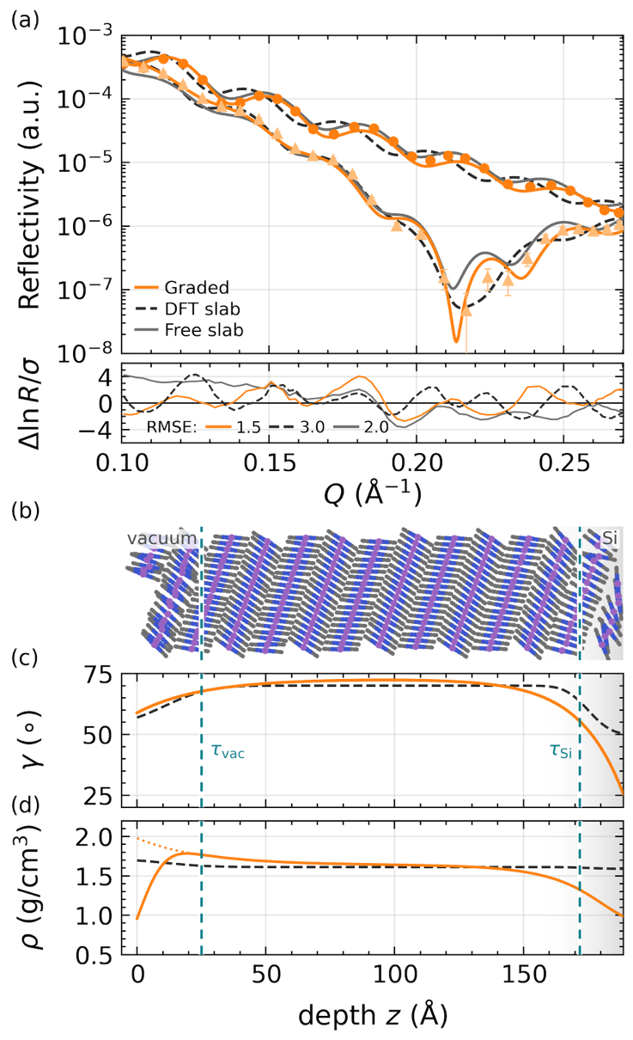
The recovered structure is a single ZnPc layer whose orientation and density vary continuously though the film, plotted in Fig 4b & c. The bulk tilt of $72.9{\left(1\right)}^{∘}$ is consistent with the film averaged orientation from AR-NEXAFS (Fig S5). At the silicon interface the profile descends to a face-on $21{.1\left(1\right)}^{∘}$, lower density layer with characteristic thickness $τ_{Si}=16.1\left(2\right)Å$. Growth characteristics inconsistent with substrate patterning have been previously inferred for both ZnPc and other Pc analogs, yet the interfacial orientation has not been measured to the authors understanding. [14,44,45] At the free surface the orientation relaxes to the magic angle with a possibility of random orientation and a slightly higher density than bulk. These characteristic thicknesses, anchoring orientations and densities are additionally consistent with a second film grown under identical conditions with a different total thickness (Fig S10), a comparison that suggests these parameters may be intrinsic to the growth conditions of the ZnPc system and dictated directly by the free energy potentials at the vacuum and silica interfaces. Fig 4b presents a real space model of the film based on our analysis. It is of note that the entire film is only 13 monolayers thick with the interfacial region affected by the substrate surface energy represented by less than a monolayer. Thus, the continuous variation of tilt and density represents the statistical molecular states at the interface with sub-monolayer resolution. This is impressive give the interface itself is below the diffraction limit of the soft X-rays used with uncertainties ~100x smaller.
FIG. 4 Orientation and density gradient model. (a) s- and p-pol PXR fits near the 283.7 eV Brewster angle for the DFT slab (dashed), free tensor (solid), and orientation gradient (Red) models, with p-polarized residuals shown below on the shared q-axis. (b) A real space illustration constructed directly from the fitted orientation and density profiles to be treated as an illustration (d) density depth profile of the gradient model (red) against the DFT slab fit with characteristic interfacial widths $τ_{Si}$ and $τ_{vac}$ with RMS surface roughness accounted for in the red density trace.
TABLE II. Best fit parameters from the orientation and density gradient model.
Region | $$γ\left(∘\right)$$ | $$ρ(g/{cm^{3}})$$ | $$τ\left(Å\right)$$
Vac | $$58.9(4)$$ | $$1.98(6)$$ | $$25(1)$$
Bulk | $$72.9(4)$$ | $$1.6385(3)$$ | $$N/A$$
Si | $$25.5(8)$$ | $$.87(6)$$ | $$16.9(7)$$
These results are direct evidence against the model of substrate patterning of bulk molecular orientation and provides evidence toward an alternative model that incorporates intermolecular interactions at the growth surface. One explanation for our results is that the orientation a planar molecule adopts during deposition reflects a competition between the substrate adhesion, which favors face-on alignment, and intermolecular $π-π$ cohesion, which favors edge on packing. The gradient then traces the crossover from a low dimensional interfacial coupling to the three-dimensional growth mechanism that sets the bulk texture. We expect that evaluating these effects on interfacial states in molecular systems will enable control of emergent phenomena at these interfaces controlling, for example, charge generation and recombination in organic solar cells and OLED technologies [1,2]or charge and ion transport in transistors or electrochemical devices. [8]
The surface densification noted here, along with an orientation approaching the magic angle indicates a distinct phase from the bulk, where the density may be driven by a phenomenon different from pure orientation and packing, potentially caused by surface tension. In this case, these boundary layers are not the adventurous hydrocarbon contamination to which film-averaged analyses and other PXR studies customarily assign them [21,49] but rather potentially a primordial state before the ZnPc molecules fully crystalize. Moreover, this demonstrates that in studies characterizing structure at in situ checkpoints during deposition [14] do not measure the state expected in a continuously deposited film, since both substrate and surface tension effects pull the state away from the final buried states.
The new PXR analysis provides a depth sensitivity to buried molecular state applied in a broad category of physical conditions, acting as a quantitative validator of crystal growth, kinetic deposition, and solvent interaction models that dictate these interfaces across material systems. The same construction extends to molecules with additional orientational and chemical freedom, to polymers, alloys, and mixed oxidation states. The analysis is, furthermore, applicable to scattering geometries beyond reflectivity, bringing local chemical, electronic, and physical analyses to the inaccessible interfaces that govern function across a multitude of systems.
In summary, we fix the optical response of the film to a first-principles dielectric tensor that is ML-refined to experimental spectroscopy. This transfers the degrees of freedom of a PXR analysis from the optical constants to the structure, collapsing the parameter space of the reconstruction onto the physical state of the film. For ZnPc, the constrained model recovers molecular tilt and density with roughly 17x fewer model parameters (17 against 286, Fig. 3), dramatically increase the precision of the analysis and is preferred by every applied model selection criterion. When extended to a single continuous profile based on deposition physics, the analysis improves further, resolving a buried face-on to edge-on orientation gradient with sub-monolayer depth resolution that a slab picture could not reproduce. This directly resolves the statistics of the final molecular state with depth, in contrast to the checkpoint studies that have so far tracked this growth front that is likely in a temporary state. More broadly, the approach uses the optical properties of the material itself to translate measured PXR intensities to physical states of the material directly, enabling an exquisite view and control to buried interfaces and structures that could lead to novel functionality.
Acknowledgements- This work was supported by the Department of Energy Early Career Research Program under Grant DE-SC0017923. This research used resources of the Advanced Light Source, which is a DOE Office of Science User Facility under contract no. DE-AC02-05CH11231. HH was supported in part by an ALS Doctoral Fellowship in Residence. Funding support for OA was provided by Prince Satam bin Abdulaziz University, Saudi Arabia. Part of this work was carried out on the Soft X-ray Spectroscopy (SXR) beamline of the Australian Synchrotron, part of ANSTO. The authors also acknowledge the National Energy Research Scientific Computing Center (NERSC) provide supercomputer resources to this work for the DFT calculations, and most PXR fits. The authors also acknowledge Dr. Thomas Ferron, Dr. Cheng Wang, and Dr. Kas Andrle form the Advanced Light Source of Lawrence Berkeley National Lab for their support in the data collection, and modeling. Fable 5 from Anthropic was used for minor copy editing and code generation under the ALD computing group’s team.
Data Availability Statement - All data generated and used in this study will be made available upon reasonable request to the corresponding author. The source code for all software used in this analysis is available on GitHub.

[1] J. R. Tumbleston, B. A. Collins, L. Yang, A. C. Stuart, E. Gann, W. Ma, W. You, and H. Ade, The influence of molecular orientation on organic bulk heterojunction solar cells, Nature Photon 8, 385 (2014).
[2] D. Yokoyama, Molecular orientation in small-molecule organic light-emitting diodes, J. Mater. Chem. 21, 19187 (2011).
[3] B. A. Collins, Z. Li, J. R. Tumbleston, E. Gann, C. R. McNeill, and H. Ade, Absolute Measurement of Domain Composition and Nanoscale Size Distribution Explains Performance in PTB7:PC71BM Solar Cells, Advanced Energy Materials 3, 65 (2013).
[4] J. Cabana, B. J. Kwon, and L. Hu, Mechanisms of Degradation and Strategies for the Stabilization of Cathode–Electrolyte Interfaces in Li-Ion Batteries, Acc. Chem. Res. 51, 299 (2018).
[5] L. Wang, Q. Meng, M. Xiao, C. Liu, W. Xing, and J. Zhu, Insights into the Dynamic Surface Reconstruction of Electrocatalysts in Oxygen Evolution Reaction, Renewables 2, 272 (2024).
[6] P. D. Bisschop, Stochastic effects in EUV lithography: random, local CD variability, and printing failures, JM3 16, 041013 (2017).
[7] K. Andrle, Q. Zhang, H. Heilman, T. Ferron, and C. Wang, Nanostructure Characterization via RSoXS: Inverse Scattering with FEM-Based Maxwell Solvers, in Metrology, Inspection, and Process Control XL, Vol. 13981 (SPIE, 2026), p. 139810D.
[8] T. Khan, T. McAfee, T. J. Ferron, A. Alotaibi, and B. A. Collins, Local Chemical Enhancement and Gating of Organic Coordinated Ionic-Electronic Transport (Adv. Mater. 5/2025), Advanced Materials 37, 2570041 (2025).
[9] L. Q. Flagg et al., Resonant X‑ray Diffraction Reveals the Location of Counterions in Doped Organic Mixed Ionic Conductors, Chem. Mater. 35, 3960 (2023).
[10] S. F. Mayer et al., Lumen charge governs gated ion transport in β-barrel nanopores, Nat. Nanotechnol. 21, 116 (2026).
[11] M. Kato, M. Nakaya, Y. Matoba, S. Watanabe, K. Okamoto, J.-P. Bucher, and J. Onoe, Morphological and optical properties of α- and β-phase zinc (∥) phthalocyanine thin films for application to organic photovoltaic cells, J. Chem. Phys. 153, 144704 (2020).
[12] G. O. Ngongang Ndjawa et al., Impact of Molecular Orientation and Spontaneous Interfacial Mixing on the Performance of Organic Solar Cells, Chem. Mater. 27, 5597 (2015).
[13] C. Schünemann, C. Elschner, A. A. Levin, M. Levichkova, K. Leo, and M. Riede, Zinc phthalocyanine — Influence of substrate temperature, film thickness, and kind of substrate on the morphology, Thin Solid Films 519, 3939 (2011).
[14] T. L. Derrien, A. E. Lauritzen, P. Kaienburg, E. Hancox, C. Nicklin, and M. Riede, Interfacial rearrangements and strain evolution in the thin film growth of ZnPc on glass, Phys. Rev. Mater. 6, 033401 (2022).
[15] D. Grabner, H. Heilman, A. Patterson, T. M. Melody, and B. A. Collins, Resonant Soft X-Ray Scattering in Polymer Materials, Annual Review of Materials Research 55, (2025).
[16] K. Andrle et al., Using a FEM-Based Maxwell Solver and CD-RSoXS Measurement for the Analysis of Photoresist Pattern, in Advances in Patterning Materials and Processes XLII, Vol. 13428 (SPIE, 2025), p. 134281G.
[17] T. J. Ferron, J. L. Thelen, K. Bagchi, C. Deng, E. Gann, J. J. de Pablo, M. D. Ediger, D. F. Sunday, and D. M. DeLongchamp, Characterization of the Interfacial Orientation and Molecular Conformation in a Glass-Forming Organic Semiconductor, ACS Appl. Mater. Interfaces 14, 3455 (2022).
[18] C. Wang, T. Araki, B. Watts, S. Harton, T. Koga, S. Basu, and H. Ade, Resonant soft x-ray reflectivity of organic thin films, Journal of Vacuum Science & Technology A: Vacuum, Surfaces, and Films 25, 575 (2007).
[19] H. Yan, C. Wang, A. R. McCarn, and H. Ade, Accurate and Facile Determination of the Index of Refraction of Organic Thin Films Near the Carbon 1 s Absorption Edge, Phys. Rev. Lett. 110, 177401 (2013).
[20] M. Mezger, B. Jérôme, J. B. Kortright, M. Valvidares, E. M. Gullikson, A. Giglia, N. Mahne, and S. Nannarone, Molecular orientation in soft matter thin films studied by resonant soft x-ray reflectivity, Phys. Rev. B 83, 155406 (2011).
[21] T. J. Ferron, M. E. Fiori, M. D. Ediger, D. M. DeLongchamp, and D. F. Sunday, Composition Dictates Molecular Orientation at the Heterointerfaces of Vapor-Deposited Glasses, JACS Au 3, 1931 (2023).
[22] H. Li et al., Pattern-enhanced Resonant Soft X-ray Scattering for Operando monitoring of electrochemical solid-liquid interfaces, Nat Commun (2026).
[23] P. H. Nguyen et al., Resonant Soft X-ray Scattering Reveals the Distribution of Dopants in Semicrystalline Conjugated Polymers, J. Phys. Chem. B 128, 12597 (2024).
[24] J. L. Thelen, C. Bishop, K. Bagchi, D. F. Sunday, E. Gann, S. Mukherjee, L. J. Richter, R. J. Kline, M. D. Ediger, and D. M. DeLongchamp, Molecular Orientation Depth Profiles in Organic Glasses Using Polarized Resonant Soft X-ray Reflectivity, Chem. Mater. 32, 6295 (2020).
[25] L. Pasquali, S. Mukherjee, F. Terzi, A. Giglia, N. Mahne, K. Koshmak, V. Esaulov, C. Toccafondi, M. Canepa, and S. Nannarone, Structural and electronic properties of anisotropic ultrathin organic films from dichroic resonant soft x-ray reflectivity, Phys. Rev. B 89, 045401 (2014).
[26] R. Capelli, E. Da Como, G. Kociok-Köhn, C. Fontanesi, A. Verna, and L. Pasquali, Quantitative resonant soft x-ray reflectivity from an organic semiconductor single crystal, J. Chem. Phys. 150, 094707 (2019).
[27] L. Pasquali, N. Mahne, A. Giglia, A. Verna, L. Sponza, R. Capelli, M. Bonfatti, F. Mezzadri, E. Galligani, and S. Nannarone, Analysis of Resonant Soft X-ray Reflectivity of Anisotropic Layered Materials, Surfaces 4, 18 (2021).
[28] V. Murcia, O. Alqahtani, H. Heilman, and B. A. Collins, Quantitative and Bond-Traceable Resonant X-Ray Optical Tensors of Organic Molecules, arXiv:2509.01734.
[29] B. Watts, Calculation of the Kramers-Kronig transform of X-ray spectra by a piecewise Laurent polynomial method, Opt. Express, OE 22, 23628 (2014).
[30] B. Yang et al., Sub-nanometre resolution in single-molecule photoluminescence imaging, Nat. Photonics 14, 693 (2020).
[31] Y. Zhang et al., Visualizing coherent intermolecular dipole–dipole coupling in real space, Nature 531, 623 (2016).
[32] Y. Luo et al., Electrically Driven Single-Photon Superradiance from Molecular Chains in a Plasmonic Nanocavity, Phys. Rev. Lett. 122, 233901 (2019).
[33] S. Cao, A. Rosławska, B. Doppagne, M. Romeo, M. Féron, F. Chérioux, H. Bulou, F. Scheurer, and G. Schull, Energy funnelling within multichromophore architectures monitored with subnanometre resolution, Nat. Chem. 13, 766 (2021).
[34] B. Doppagne, M. C. Chong, H. Bulou, A. Boeglin, F. Scheurer, and G. Schull, Electrofluorochromism at the single-molecule level, Science 361, 251 (2018).
[35] R. A. Klenkler, A. P. Yuen, and N. M. Bamsey, Photovoltaic Device, US8962994B2 (24 February 2015).
[36] M. Pfeiffer, C. Uhrich, A. Petrich, R. Schüppel, K. Schulze, K. Leo, P. Bäuerle, E. Reinold, and E. Brier, Organic Photoactive Device, US8426727B2 (23 April 2013).
[37] N. T. Boileau, R. Cranston, B. Mirka, O. A. Melville, and B. H. Lessard, Metal phthalocyanine organic thin-film transistors: changes in electrical performance and stability in response to temperature and environment, RSC Adv. 9, 21478 (2019).
[38] Z. J. Comeau, R. R. Cranston, H. R. Lamontagne, C. S. Harris, A. J. Shuhendler, and B. H. Lessard, Surface engineering of zinc phthalocyanine organic thin-film transistors results in part-per-billion sensitivity towards cannabinoid vapor, Commun Chem 5, 178 (2022).
[39] K. Chornovolenko and T. Koczorowski, Phthalocyanines Conjugated with Small Biologically Active Compounds for the Advanced Photodynamic Therapy: A Review, Molecules 30, 3297 (2025).
[40] J. Rak, M. Kabesova, J. Benes, P. Pouckova, and D. Vetvicka, Advances in Liposome-Encapsulated Phthalocyanines for Photodynamic Therapy, Life 13, 305 (2023).
[41] T. Luo, G. T. Nash, Z. Xu, X. Jiang, J. Liu, and W. Lin, Nanoscale Metal–Organic Framework Confines Zinc-Phthalocyanine Photosensitizers for Enhanced Photodynamic Therapy, Journal American Chemical Society 143, 13519 (2021).
[42] J. Yang, S. Yim, and T. S. Jones, Molecular-Orientation-Induced Rapid Roughening and Morphology Transition in Organic Semiconductor Thin-Film Growth, Sci Rep 5, 9441 (2015).
[43] I. Yamamoto, M. Imamura, J. Azuma, and K. Takahashi, Variation in zinc phthalocyanine molecular orientation on SrTiO3(100) surface, Surface Science 726, 122162 (2022).
[44] D. G. de Oteyza, E. Barrena, S. Sellner, J. O. Ossó, and H. Dosch, Structural Rearrangements During the Initial Growth Stages of Organic Thin Films of F16CuPc on SiO2, J. Phys. Chem. B 110, 16618 (2006).
[45] J. O. Ossó, F. Schreiber, M. I. Alonso, M. Garriga, E. Barrena, and H. Dosch, Structure, morphology, and optical properties of thin films of F16CuPc grown on silicon dioxide, Organic Electronics 5, 135 (2004).
[46] J. Stöhr, NEXAFS Spectroscopy (Springer Berlin, Heidelberg, 1992).
[47] B. A. Collins et al., Polarized X-ray scattering reveals non-crystalline orientational ordering in organic films, Nature Mater 11, 536 (2012).
[48] L. Pasquali, S. Mukherjee, F. Terzi, A. Giglia, N. Mahne, K. Koshmak, V. Esaulov, C. Toccafondi, M. Canepa, and S. Nannarone, Structural and electronic properties of anisotropic ultrathin organic films from dichroic resonant soft x-ray reflectivity, Phys. Rev. B 89, 045401 (2014).
[49] K. Fostiropoulos, T. Mete, Z. Li, and I. Lauermann, Temperature-induced molecule assembly effects on the near-edge X-ray absorption fine-structure spectra of Zn-phthalocyanine layers on Si substrates, J Synchrotron Rad 26, 1260 (2019).
[50] P.-G. de Gennes and J. Prost, The Physics of Liquid Crystals, Second ed (Clarendon press, Oxford, 1993).
[51] V. L. Ginzburg and L. D. Landau, On the Theory of Superconductivity, in On Superconductivity and Superfluidity: A Scientific Autobiography (Springer Berlin Heidelberg, Berlin, Heidelberg, 2009), pp. 113–137.
[52] M. Kozlik, S. Paulke, M. Gruenewald, R. Forker, and T. Fritz, Optical Constants of α- and β-Zinc(II)-Phthalocyanine Films, Dataset Papers in Science 2013, 926470 (2013).
[53] C. Schünemann, D. Wynands, K.-J. Eichhorn, M. Stamm, K. Leo, and M. Riede, Evaluation and Control of the Orientation of Small Molecules for Strongly Absorbing Organic Thin Films, J. Phys. Chem. C 117, 11600 (2013).
[54] J. Ilavsky, Nika : software for two-dimensional data reduction, J Appl Crystallogr 45, 324 (2012).
[55] D. Nečas and P. Klapetek, Gwyddion: an open-source software for SPM data analysis, Open Physics 10, 181 (2012).
[56] T. Chikamatsu, Md. Shahiduzzaman, K. Yamamoto, M. Karakawa, T. Kuwabara, K. Takahashi, and T. Taima, Identifying Molecular Orientation in a Bulk Heterojunction Film by Infrared Reflection Absorption Spectroscopy, ACS Omega 3, 5678 (2018).
[57] B. L. Henke, E. M. Gullikson, and J. C. Davis, X-Ray Interactions: Photoabsorption, Scattering, Transmission, and Reflection at E = 50-30,000 eV, Z = 1-92, Atomic Data and Nuclear Data Tables 54, 181 (1993).
[58] CXRO X-Ray Interactions With Matter, https://henke.lbl.gov/optical_constants/.
[59] L. Névot and P. Croce, Caractérisation des surfaces par réflexion rasante de rayons X. Application à l’étude du polissage de quelques verres silicates, Rev. Phys. Appl. (Paris) 15, 761 (1980).
[60] Y. Esashi, M. Tanksalvala, Z. Zhang, N. W. Jenkins, H. C. Kapteyn, and M. M. Murnane, Influence of surface and interface roughness on X-ray and extreme ultraviolet reflectance: A comparative numerical study, OSA Continuum, OSAC 4, 1497 (2021).

End Matter

Appendix A: Optical model parameterization - Molecular order within the film is parameterized by the molecular tilt angle $γ$ of the molecular surface normal from the film surface normal. For uniaxial film, this is the polar cone angle. We begin with the single molecule refined DFT optical model. This construction assumes the single molecule DFT is representative of the electronic states available to a film of the material, ignoring the creation of new multi molecule states, that could be caused by variations to molecular packing or orientation alignment. However, as the clustered DFT model agrees with the experimentally derived optical model, we surmise that these effects are not dominant in this system.
We start with the uniaxial molecular optical tensor${ n}^{m}$ constructed though clustering,
$$\begin{aligned}n^{m}\left(E\right)=\left(\begin{matrix}n_{xx} & 0 & 0 \\ 0 & n_{xx} & 0 \\ 0 & 0 & n_{zz}\end{matrix}\right) \#\left(A1\right)\end{aligned}$$
where $n_{xx}$ is the in plane or ordinary component, and $n_{zz}$ is the out of plane or extraordinary component. The molecule is then tilted by an arbitrary polar angle $γ$ about the $x$ or $y$-axis, the choice being arbitrary, before computing the uniform azimuthal average over $ϕ∈\left[0,2π\right]$, i.e.,
$$\begin{aligned}n^{f}\left(E,γ\right)={〈R^{T}\left(ϕ, γ\right)n^{m}\left(E\right)R(ϕ,γ〉}_{ϕ} \#\left(A2\right)\end{aligned}$$
where $ϕ$ is the dummy azimuthal orientation variable, and $R\left(ϕ,γ\right)$ the product $R_{z}\left(ϕ\right)R_{x/y}\left(γ\right)$. Because the refined molecular tensor is azimuthally symmetric, all off diagonal components vanish by inspection producing a simple analytic relationship for a uniaxial film. When combined with the density scale factor discussed previously, the ZnPc optical tensor is described by the reduced set of analytical functions
$$\begin{aligned}n_{xx}^{f}\left(E;γ,ρ\right)=\frac{ρ}{2}\left(n_{xx}^{m}\left(1+\cos^{2}{γ}\right)+n_{zz}\sin^{2}{γ}\right)\#\left(A3\right) \\ n_{zz}^{f}\left(E;γ,ρ\right)={ρ(n}_{xx}^{m}\sin^{2}{γ+n_{zz}^{m}\cos^{2}{γ)}}\#(A4)\end{aligned}$$
To validate these results, we find the isotropic condition is $γ=\arcsin{\sqrt{2/3}}≈{54.7}^{∘}$the so-called magic angle, in agreement with Stöhr. [46]
Appendix B: Orientation gradient theoretical foundation - We formulate our gradient model from a Ginzberg-Landau framework of second order phase transitions, where we treat the molecular orientation and density as order parameters (not to be confused with nematic order parameters $S\left(γ\right)$ or $P(γ)$). [50,51] This sets that molecular orientation and density within the film of thickness $L$ to follow from a second order phase transition along the one dimensional depth axis $z$. Here we take the order parameters as the deviation in the density $Δρ\left(z\right)=ρ\left(z\right)-ρ_{b}$ and orientation $Δγ\left(z\right)=γ\left(z\right)-γ_{b}(z)$ from the bulk. The total free energy of the film is described by the functional
$$\begin{aligned}F\left[Δρ,Δγ\right]=\int_{0}^{L}{f\left(Δρ,Δγ\right)+\frac{1}{2}c_{ρ}{\left({Δρ}^{'}\right)}^{2}+\frac{1}{2}c_{γ}{\left({Δγ}^{'}\right)}^{2}dz} \\ +F_{v}\left[Δρ\left(0\right),Δγ\left(0\right)\right]+F_{Si}\left[Δρ\left(L\right),Δγ\left(L\right)\right]\#\left(B1\right)\end{aligned}$$
Here $f(Δρ,Δγ)$ is the local bulk free energy density, and the terms proportional to $c_{ρ}$ and $c_{γ}$ are the gradient energy penalties that oppose abrupt variations within the film. The interface terms $F_{v}$ and $F_{Si}$ account for the anchoring potentials at the interface boundaries. Expanding $f\left(Δρ,Δγ\right)$ to quadradic order about the bulk minimum,
$$\begin{aligned}f\left(Δρ,Δγ\right)≈f_{0}+\frac{1}{2}a_{γ}{Δγ}^{2}+\frac{1}{2}a_{ρ}{Δρ}^{2}+bΔρΔγ.\#\left(B2\right)\end{aligned}$$
where $a_{ρ}$ and $a_{γ}$ are the stability coefficients of the bulk phase, and $b$ the bilinear coupling term between the density and orientation fields.
Minimizing the total variation $δF=0$ and integrating the gradient terms by parts yields a system of coupled second-order differential equations for the film interior,
$$\begin{aligned}c_{ρ}{Δρ}^{''}=a_{ρ}Δρ+bΔγ \#\left(B3\right)\end{aligned} \\ \begin{aligned}c_{γ}{Δγ}^{''}=a_{γ}Δγ+bΔρ \#\left(B4\right)\end{aligned}$$
with boundaries dictated by the surface free energies. To leading order in the interface fields $h$, the boundary variation yields Robin boundary conditions, where the gradient of the order parameter is propagational to the surface field, i.e.
$$\begin{aligned}c_{ρ}Δρ^{'}\left(0\right)=-h_{ρ}^{v} &&c_{ρ}Δρ^{'}\left(L\right)=h_{ρ}^{Si}\#\left(B5\right)\end{aligned}$$
and with similar form for $Δγ$. In the limit of strong anchoring, the surface fields $h$ are much stronger than the bulk stiffness coefficients $c/τ$, the system enters the Dirchlet regime. Here each interface potentials set the order parameters to fixed interfacial values, $Δρ\left(0\right)={Δρ}_{v}$ and $Δρ\left(L\right)={Δρ}_{Si}$. Within this regime the interfaces impose an orientational state regardless of the bulk interaction, a feasible state given the known different growth modes for ZnPc films at the substrate and surface. [14,42]
This system of equations may be decoupled into a normal modes problem, under the coordinate transform $\tilde{Δρ}=\sqrt{c_{ρ}}Δρ$ and similar transform for $Δγ$. Given that the bulk represents the stable minimum, the general solution is restricted to the linear combination of exponentials decaying from the boundaries with correlation lengths $τ_{±}$ derived from the eigenvalues of the coupled system. When the orientation and density coupling is nonzero, these correlation lengths are shared between the order parameters. As each interface bears its unique interactions that dictate this coherence length, we assume that each interface is dominated by a single mode. The interface gradient model used in the main text satisfies these conditions,
$$\begin{aligned}Δρ\left(z\right)=Δρ_{v}\exp\left(-z/τ_{vac}\right)+Δρ_{Si}\exp\left(-\left(L-z\right)/τ_{Si}\right)\#\left(B6\right)\end{aligned} \\ \begin{aligned}Δγ\left(z\right)=Δγ_{v}\exp\left(-z/τ_{vac}\right)+Δγ_{Si}\exp\left(-\left(L-z\right)/τ_{Si}\right) \#\left(B7\right)\end{aligned}$$
While this model is congruent with the continuous reorientation under an evolving growth front, it remains an empirical approximation of the underlying interfacial physics. A more rigorous determination of the anchoring potentials would require a detailed investigation of the boundary conditions, specifically whether the system is governed by Dirichlet or Robin boundaries as this determines the relationship between exponential amplitudes and the interfacial potentials. Furthermore, this model assumes a continuous structural relaxation; however, it is possible that the molecular realignment across the interface occurs under a different mechanism than described here requiring a different theoretical basis. These challenges may be resolved in future work that integrates multiple techniques together with PXR to understand these surface interactions.

Supporting Information
Harlan Heilman¹, Emily Biegler¹, Sushil Adhikari¹, Victor Murcia², Tanner Melody¹, Fred Woodall¹, Lars Thompson³, Obaid Alqahtani^{2,4}, Brian A. Collins^{1,2*}
¹Department of Physics and Astronomy, Washington State University, Pullman, Washington 99164, USA
²Department of Materials Science and Engineering, Washington State University, Pullman, Washington 99164, USA
³Australian Synchrotron, ANSTO, Clayton, VIC, Australia
⁴Department of Physics, Prince Satam bin Abdulaziz University, Alkharj 11942, KSA

Film Growth and Pre-characterization
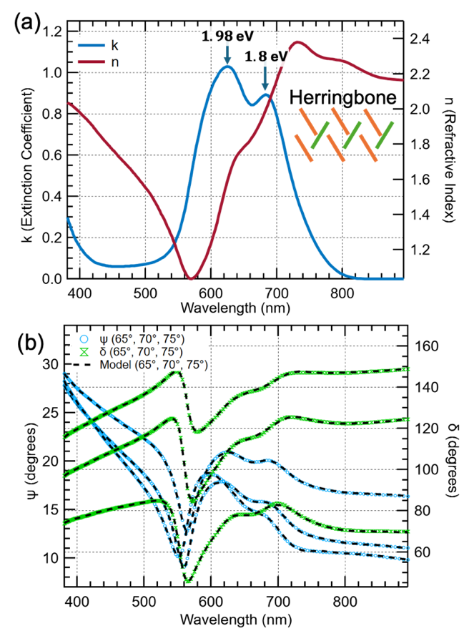
Small molecule ZnPc (C32H16N8Zn sourced from Alpha Chem) with purity $≥99.5\%$ was further purified in the physical vapor deposition (PVD) chamber (base pressure $<1×{10}^{-7}$ Torr) by gradually heating, approaching CuPc sublimation temperature over approximately an hour until no further off gassing of contaminants were detected by the quartz crystal monitor (QCM). Thin films (~200 nm measured by QCM) of ZnPc were deposited at $.2 Å/s$ on high conductivity polished Si wafers (University Wafers). Wafers were cleaved 1 cm x 3 cm and cleaned via sonication in deionized water, acetone and isopropyl alcohols before a 30 min UV ozone bake. ZnPc was either deposited directly onto these wafers to create the herringbone crystal structure, or onto a thin Copper Iodide (CuI, 3nm) patterning layer producing a face on brick-stone polymorph. Substrate temperature was either set to the ambient room temperature (24 C), by liquid nitrogen cooling (-50 C), or by thermal substrate heating (100 C). For brick-stone samples, CuI and ZnPc depositions were performed sequentially under the same vacuum, with 20 min between depositions to return to the base pressure. Films for PXR were stored under an inert N2 atmosphere and transported to the ALS under vacuum. Auxiliary pre characterization measurements were performed on separate films from the same batch to avoid surface contamination and oxidation prior to PXR.
FIG. S1 VASE for ZnPc films deposited at room temperature. (a) Fit results for each incidence. (b) Optical constants derived from the VASE fit, highlighted is the Q-band splitting at 625 nm (1.98 eV) and 690 nm (1.80 eV) indicative of herringbone phase ZnPc packing motifs.

Variable angle spectroscopic ellipsometry
Variable angle spectroscopic ellipsometry (VASE) (Fig S1) was performed using a J.A. Woollam alpha-SE to pre characterize layer thickness and molecular orientation. Data was collected at three incidences (${65}^{∘}, {70}^{∘}, { \& 75}^{∘}$) targeting a sample from the same PVD batch and measured using vendor supplied CompleteEase software.
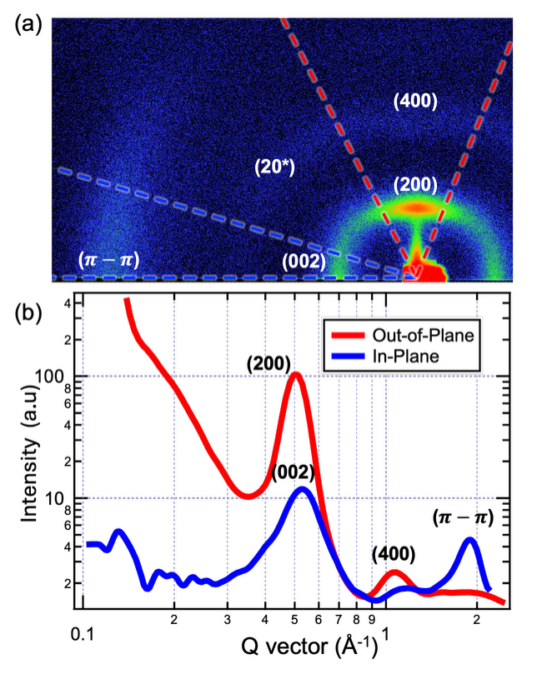
The extinction coefficient exhibits a split Q band at 1.98 and 1.80 eV characteristic of Davydov coupling between the translationally inequivalent molecules of the herringbone packed motif. That the higher energy peak is more intense, suggests the edge on herringbone ($α$ family) polymorph previously reported for as-deposited ZnPc in both UV-Vis and ellipsometry derived optical constants. [52,53] ZnPc layer thickness is recorded as $t_{ZnPc}=21.4(5)$ nm with a MSE of 1.433, consistent with the QCM report during deposition.
FIG. S2 (a) GIWAXS image of ZnPc deposited on native-oxide silicon substrate. (b) 1D reduction showing the out-of-plane (200) peak at 0.50 $Å^{-1}$ (12.6 $Å$), it’s broadened second order (400) near $1Å^{-1}$, the in-plane (002) peak at 0.53 $Å^{-1}$ (11.8 $Å$) as well as a mixed index $π-π$ stacking peak at 1.89 $Å^{-1}$ (3.3 $Å$). Weak arks near $±{45}^{∘}$ from the substrate normal, makers (20*) in (a), are tentatively assigned to a mixed-index reflection but are too broad azimuthally for a definitive index.

Grazing incidence wide angle X-ray scattering
Grazing incidence wide angle x-ray scattering (GIWAXS) measurements (Fig S2) were performed at Washington State University on a Xenocs Xeuss 3.0 with a focused Cu X-ray source, under vacuum at 72 mm sample-detector distance with incident angle set to 0.2 degrees. 1D reduction of GIWAXS images was done using NIKA software. [54]
The GIWAXS texture corroborates the polymorph and orientation assignments assigned though ellipsometric optical constants. The out-of-plane (200) reflection at $d=12.6 Å$ together with the in-plane (002) and $π-π$ stacking reflections place the film in agreement with edge-on textured ZnPc on weakly interacting oxides. [14,53] The (200) spacing matches the relaxed $γ$-ZnPc (herringbone / $α-$II family) value of 12.67 $Å$ rather than the strained early growth spacing observed in the initial layers of growth. [14]

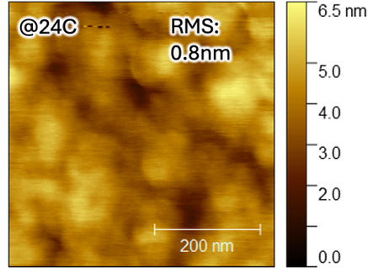
Atomic force microscopy
FIG. S3 AFM height map of ZnPc sample from the same batch used for PXR measurement. RMS roughness measured as 0.8 nm.
Atomic force microscopy (AFM) height maps were acquired on a Bruker Dimension Icon in tapping mode with a TESPA-V2 SAMPLE probe. Scans where processed using Gwyddion [55] to extract root-mean-square (RMS) roughness values. Film morphologies and RMS roughness values were used to pre-characterize film surface roughness and morphology PXR measurements (Fig S3).

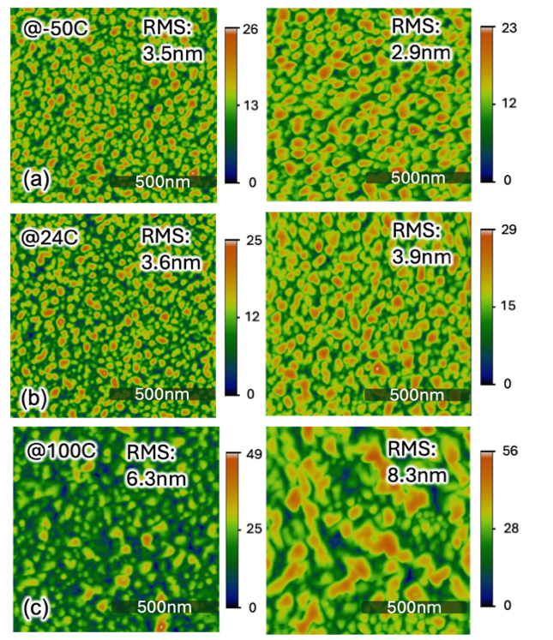
Effect or growth parameters for Copper (II) Iodide patterned films
FIG. S4 AFM height map of ZnPc under different deposition conditions. (a-c) ZnPc deposited on a 3 nm CuI patterning layer as a function of deposition rate (left .15 $Å/s$, right $.5 Å/s$) and substrate temperature (a) -50 C, room temperature (b) 24 C, and (c) 100 C.
A film series was prepared for ZnPc grown on a 3 nm CuI patterning layer to identify deposition conditions to make suitable PXR samples. Samples were grown to a target of 20 nm as measured via QCM and validated though spectroscopic ellipsometry. AFM height maps were performed for the series and displayed below.
The surface texture for these films shows dense, laterally uniform grains with significant RMS roughness across the series. Increasing temperature leads to the formation of larger grains with more dispersity amongst their size. At 100C the morphology is most dependent on deposition rate, with the higher rate resulting in elongated domains and a larger RMS roughness. Across all conditions, film heights vary by more than the approximate layer thickness (> 20 nm) suggesting that ZnPc does not form fully wetted and continuous layers when deposited on CuI, in agreement with prior work in device applications. [56] As such we surmise that when deposited on CuI, layers grow under the Volmer-Weber (island) process, developing towsers of ZnPc as opposed to continuous layer formation. PXR was attempted but could not be reduced to a reliable specular dataset due to the dominant off specular signal, consistent with incomplete surface coverage

NEXAFS Spectroscopy
NEXAFS spectroscopies were collected at the Soft X-ray Spectroscopy (SXR) beamline of the Australian Synchrotron, part of ANSTO in total electron yield mode on Si wafers. Samples were prepared under similar conditions as for PXR measurements yet were collected via a separate batch. Spectra were collected at five sample alignments with respect to the incident electric field polarization vector with respect to the surface normal (${20}^{∘}, {40}^{∘}, {55}^{∘}, {70}^{∘}, \& {90}^{∘}$). NEXAFS was collected over the energy range of 270-350 eV and normalized to the energy dependent intensity fluctuation and optical loss via a direct photodiode measurement, and Au mesh drain current. Mass absorption was computed via normalization in the pre and post edge regions to the bare atom mass absorption of ZnPc as extracted from the CXRO Henke atomic scattering factors. [57]
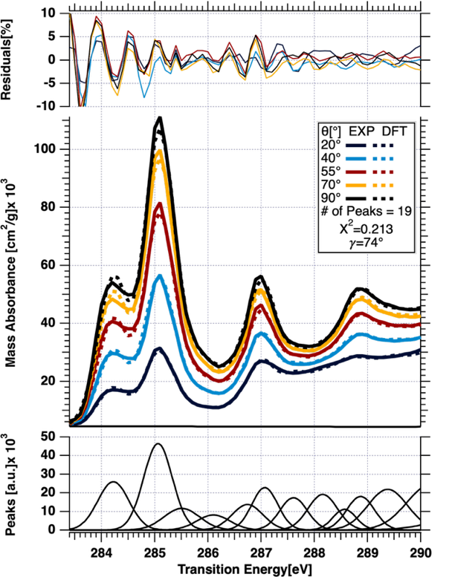
Molecular tilt angle was extracted via the DFT cluster and refinement process. As the final step of the refinement process, the molecular polar tilt angle $γ$ is fit using the TDM cluster orientations prescribed by DFT providing a measure of the molecular orientation. This fit produces a reduces $χ^{2}$ goodness of fit statistic of .213 indicating very good agreement between the model and experimental data. The molecular tilt angle of ${74}^{∘}$ agrees with all other characterizations of the ZnPc face on herringbone polymorph described in this study and is taken as the coarse-grained molecular orientation within the films measured under PXR.
FIG. S5 Comparison of refined clustered optical model with experimental NEXAFS spectroscopy. From the clustering approach, we find the molecular tilt angle of ${74}^{∘}$.

Optical Tensor Construction
The optical tensor is defined under the convention $n\left(E\right)=1-δ\left(E\right)+iβ\left(E\right)$. From experimental NEXAFS the imaginary component is computed directly form the mass absorption spectra
$$\begin{aligned}β\left(E\right)={μρ}/{2k} \#\left(S1\right)\end{aligned}$$
The NEXAFS spectra is scaled to agree with the bare atom mass absorption as tabulated by the CXRO with a density of one. [58] This constructs an index of refraction specific volume that we use to evaluate the index of refraction for a given material density. The real part of the refractive index $δ\left(E\right)$ is computed via the Kramers-Kronig calculation using the KKcalc package. [29]
The experimental tensor components are constructed following the established empirical method. [21,47] From clustering, we know that the primary $π^{*}$ TDM cluster rests at ${.01}^{∘}$ from the molecular normal, that we will use to indicate the molecular normal. We then compute the NEXAFS derived dichroism across the carbon edge by taking the average difference spectra between all pairs of incident angles as a function of energy. This constructs an experimental dichroism that is used to augment the isotropic $β\left(E\right)$ measured at the magic angle to recover the refractive tensor components from the molecular reference frame, i.e.,
$$\begin{aligned}β_{zz}\left(E\right)=β_{iso}\left(E\right)+A\left(θ\right)Δβ\left(E\right) \#\left(S2\right) \\ β_{xx}\left(E\right)=β_{iso}(E)-B\left(θ\right)Δβ\left(E\right) \#(S3)\end{aligned}$$
The coefficients $A(θ)$ and $B\left(θ\right)$ are defined to match the condition in Stöhr, modified to accommodate the off axis TDM polar angle $θ$ associated with the of the primary transition.
$$\begin{aligned}A\left(θ\right)=\left(3\cos^{2}{θ}-1\right){β_{iso}\left(E_{π}\right)}/{Δβ\left(E_{π}\right)}\#\left(S4\right) \\ B\left(θ\right)={{\left(1-{\cos^{2}{θ}}/2\right)β}_{iso}\left(E_{π}\right)}/{Δβ\left(E_{π}\right)} \#(S5)\end{aligned}$$
The DFT tensor is instead defined using the directly calculated tensor components for each TDM cluster, resulting in the comparison of Fig 1, requiring no auxiliary analyses.

DFT Methods
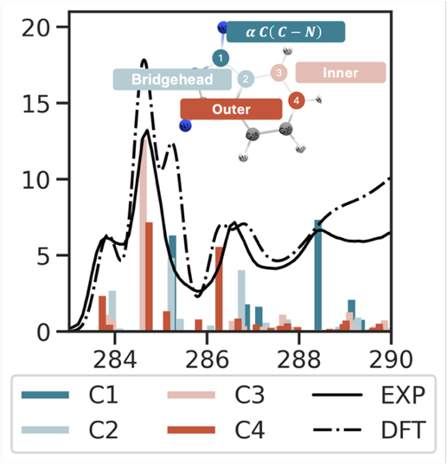
A time independent transition potential calculation using the StoBe library was performed on a single molecule of ZnPc. A HCH approach sets the manifold of transition energies, along with each TDM and oscillator strength, while the $ΔKS$method is used to fix the absolute energy associated with each transition. For details see our previous work. [28] The molecular geometry was extracted from a crystallographic structure file (.cif) as it produced results with a higher initial agreement to experiment compared to thermodynamically relaxed structures, or those relaxed from molecular force fields.
FIG. S6 Raw pre clustered DFT results compared with experimental magic angle NEXAFS spectroscopy collected at ANSTO SXR beamline.
Using this structure, we chose the four carbon atoms labeled in Si 1 as the excitation centers, performing the DFT calculation for each. Calculations using the entire outer wing of the molecule where tried, along with those simulating a half of the molecular carbons. Both produced similar results, while further expanding the dimensionality. Here we demonstrate that a reduced set of excitation reproduces the entire set of transitions possible for molecular ZnPc, and though clustering provides an optical model that is useful for scattering analysis.

Clustering and Refinement
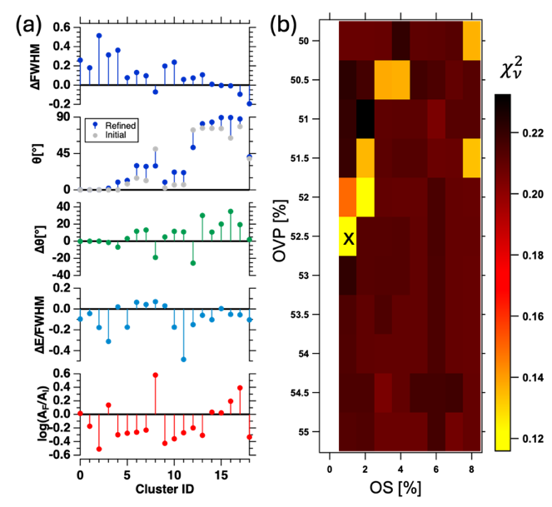
Clustering and refinement were performed using the Igor Pro implementation of the hierarchical agglomerative clustering to extract a set of TDM clusters as the initial building blocks for the optical model. Oscillator strength threshold and Overlap percentage hyperparameters were explored using an evenly spaced support via
FIG. S7 Clustering and refinement analysis. (a) Change in parameters though the refinement process for the chosen set of hyper parameters. (b) OVP % and OS % hyper parameter optimization map
$$OS∈\left[0, 10\right] \& OVP∈\left[25,75\right]$$
Hyperparameter pairs were evaluated by reduced chi square to experimental NEXAFS and well-behaved parameter pairs where secondarily evaluated by their difference form the original DFT, ensuring the preservation of the DFT calculated information. Here we chose the best fit clustering parameters of $OS=.25$ and $OVP=52.5$. In general, we find good clustering and convergence for all $OVP∈\left[55,50\right]$, with significantly worse performance outside of these bounds. Moreover, we find that $OS∈\left[.1,8\right]$ performed similarly, yet parameter agreement with originating DFT degrades rapid for larger $OS$, while the refinement never converse for $OS<.1$.

PXR Experimental and Analysis Methods

PXR Collection
PXR measurements were performed at advanced light source beamline 11.0.1.2 following the standard procedures established by Ferron et. al. Using the scatter slits and higher order suppressor optical elements, the direct beam intensity was attenuated to a reasonable level for direct measurement on the photodiode detector. In this configuration, the beam was aligned using the in-chamber photodiode detector via the following. A knife edge experiment is used to align the sample z-motor position. Then from this z position, the sample theta motor is offset to 1-2 degrees. The detector theta motor is then scanned over a 4-degree window around the corresponding 2theta position. By recursively performing sample-z-and-theta alignment scans the sample can be aligned to the center of the goniometer axis of rotation to within .01 deg. Note that motor issues, beam drift, and tilt along the sample plate, the axis alignment must be recalibrated during extended runs, especially after changing polarization or substantially changing beamline energy.
Experimental data was collected starting in the s-pol configuration, beginning at 250 eV and working to the resonant energies realigning the axis of rotation after every 10 energies. Between polarizations, the alignment was recalibrated after waiting a subsequent amount of time for the new heat load to affect the optics. Measurements were performed over a 12-hour shift with an energy calibration performed using the transmission NEXAFS of polystyrene, at the start and end of the shift showing no energy drift throughout the experiment duration.

PXR Reduction
PXR measurements are reduced from 2D images by first locating the specular reflected beam on the area detector and integrating the intensity within a suitable region. A background signal is removed from this intensity using a region of the detector far from the specular beam spot. This background region is collected along the same row as the beam spot to account for systematic CCD readout noise. The measured reflectance is then computed from the specular reflected intensity by dividing by the incident $I_{0}$ intensity collected at the start of each energy scan.
High dynamic range sensitivity was achieved by slicing the measurement q-range into subsets with overlapping points where the reflected intensity could be well captured on the two orders of magnitude of dynamic range allotted by the CCD detector. This is done by using the higher order suppressor optical element and increasing the exposure time. Using the overlapping points, an effective $I_{0}$ intensity can be determined for each subset used in the calculation of reflectance for long q-range scans.

Error Approximations
Each frame of a reflectivity profile is inherently a photon counting measurement. The raw intensity in each detector pixel follows a poissonian distribution to first approximation, giving a per-pixel error equal to $\sqrt{N}$. Systematic noise is also present, originating from the dark current, readout noise, and stray light. Readout noise is reduced by first trimming a 10-pixel border around the images and then performing a row-by-row subtraction using the average counts from the first 10 pixels in every row of the detector image. This flattens the thermal background caused by the readout process. The stray light and dark current can then be modeled and accounted for using the dark region of the detector as described above. Non-poissonian noise is characterized using a Fano factor defined as the ratio of the observed variance in $I_{0}$ and effective $I_{0}$ measurements to the hypothesized poissonian variance at the same intensity level. This effectively scales the raw poissonian noise in each q subset.
The final source of error comes in the discrimination between specular and off specular reflectance. Thin film surface scattering and roughness effects smear the reflected beam over a finite width of pixels. This effect becomes more pronounced at higher q-values. To account for this error a q-dependent uncertainty envelope is applied to the propagated uncertainties from data reductions producing a higher uncertainty in the higher q regions of spectra.

PXR Analysis Methods
Our fitting methodology has been largely updated from the procedures outlined in Ferron et. al. [21] The model was constructed containing three layers of ZnPc (Surface, Bulk, Interface), on top of a thin SiO2 native oxide layer, followed by the Si substrate. Each ZnPc layer is modeled using a uniaxial optical tensor whose derivation is described in the methods above. The reflection and transmission coefficients for the stack are computed for each energy and scattering vector via the 4x4 transfer matrix formalism where boundary condition matching at each of the five interfaces sets the reflection and transmission coefficients for each layer, while interfacial roughness manifests as an exponential attenuation to account for the off specular diffuse scattering from a faceted interface. Here we model interfacial roughness in the Nèvot-Croce (NC) sense as is standard for reflectivity analyses. [59,60] This sets the parameterization of the physical model structure as thickness and roughness for the surface, bulk, and interface layers of ZnPc, along the native SiO2 layer for a combined eight parameters to set the full structure.
The optical constants for each layer are set depending on the optical model and differ between the free tensor and DFT parameterization. Consistent across both are the non-resonant material slabs for the vacuum and silicon fronting media, along with the silicon dioxide layer. Each are set with tabulated bare atom optical constants, parameterized by the energy independent material density that we allow to vary subtly from the tabulated values to accommodate differences in stoichiometry, but fixed to a feasible region of (2, 2.8) g/cm³. The optics for free tensor ZnPc are parameterized as birefringence, dichroism, isotropic $δ_{iso}$, and isotropic $β_{iso}$ each constrained to a reasonable range dictated by the original optical model and following the choices by Ferron et. al. resulting in 252 optical tensor components for the present work. The DFT optics are set energy independently via a molecular orientation and density per layer, along with an energy offset term common across all layers and accounting for the energy calibration differences between instruments resulting in just seven parameters to describe the three ZnPc layers. Thus, the free tensor parameterization uses 266 (8+2+252) parameters to describe the material, while the DFT model uses just 17 (8+2+7) to describe the same structure, over an order of magnitude in reduced complexity.
Notably, our free tensor parameterization differs from Ferron et. al. [21] in the removal of a dichroic ratio as it prerequisites the creation of the energy dependent optical tensor along with evaluating the energy dependent ratio between dichroism and birefringence. This is feasible for measurements using few energies that are far from inflection points in this ratio, yet an energy mismatch between NEXAFS experiment and PXR collection strictly breaks any naive implementation, requiring an additionally fitted energy independent energy shift that is challenging to implement robustly. This constraint is also applied per energy offering no guarantee of Kramers-Kronig or anisotropic consistency across the manifold of fitted optical constants, while only minimally reducing parameter space complexity. As a result, in our comparisons, we take the full tensor complexity for our Free tensor model.
The reflectivity model calculating PXR from the material stack is augmented to include several experimental correction terms that account for beam and motor drifts, along with instrument miscalibration during the measurement. This includes a normalization correction scale factor and an angle of incidence offset applied to each energy and polarization, following the analysis of Ferron et. al. [21] Combined this adds in four correction terms per energy (84 in this work) accounting for a majority of the fitted parameters in our DFT constrained optical model. This brings the total model parameters to 101 for the DFT model and 350 for the Free tensor model.
For those seeking to follow this analysis, experimental correction parameters can often be critical to producing a good fit. However, it is important to note that without proper bounds on a per energy basis, experiment correction parameters easily become cross corelated with both the structure and optics leading to non-physical fit results. We recommend only adding these offset parameters if the first fringe is challenging to reproduce using physically realistic structural and optical parameters. Reasonable bounds on the normalization correction term are (.8, 1.2) with exceptions for datasets with visible outliers in the $I_{0}$ measurement points. Angle of incidence may vary more widely from zero, and manual observations of the data should be used to set a feasibility region of this parameter. Here we use bounds of (-.1, .1) due to the measurable alignment drift across energies. Additionally, as ALS 11.0.1.2 and other future PXR capable instruments constantly improve their configurations, these ranges should be discussed with the beamline scientist for the instrument for the latest insights.

Fit Results
TABLE SI Best fit structural properties of the ZnPc film as analyzed though the lenses of the free optical tensor model.
Layer | $$t \left(Å\right)$$ | $$σ_{r} \left(Å\right)$$
Surf | $$8.8\left(4\right)$$ | $$7.21\left(28\right)$$
Bulk | $$174.4\left(4\right)$$ | $$10.43\left(31\right)$$
Int. | $$14.48\left(24\right)$$ | $$8.39\left(15\right)$$
TABLE SII Best fit structural properties of the ZnPc film as analyzed though the lenses of the free optical tensor model.
 | $$t \left(Å\right)$$ |  |  | $$σ_{r} \left(Å\right)$$ |  | $$γ\left(∘\right)$$ |  | $$ρ(g/{cm^{3})}$$
Surf. |  | $$8.9335\left(4\right)$$ | $$7.0560\left(11\right)$$ |  | $$52.208(7)$$ |  | $$1.8(3)$$
Bulk |  | $$179.951\left(3\right)$$ | $$13.1363\left(2\right)$$ |  | $$69.54(1)$$ |  | $$1.6385(3)$$
Int. |  | $$10.7048\left(2\right)$$ | $$7.8924\left(5\right)$$ |  | $$47.241(9)$$ |  | $$1.0(6)$$
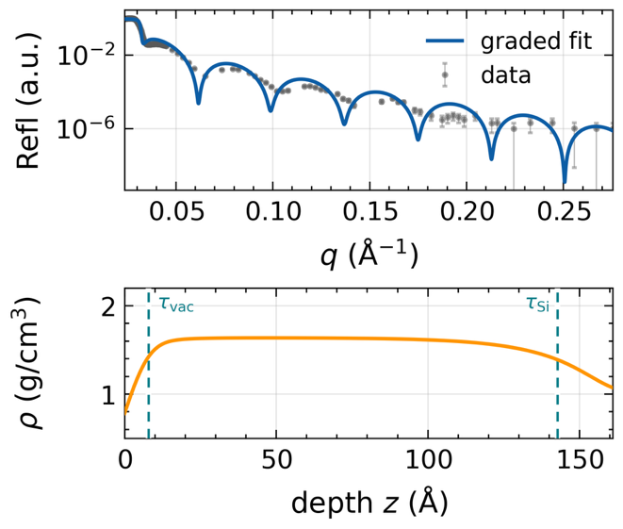
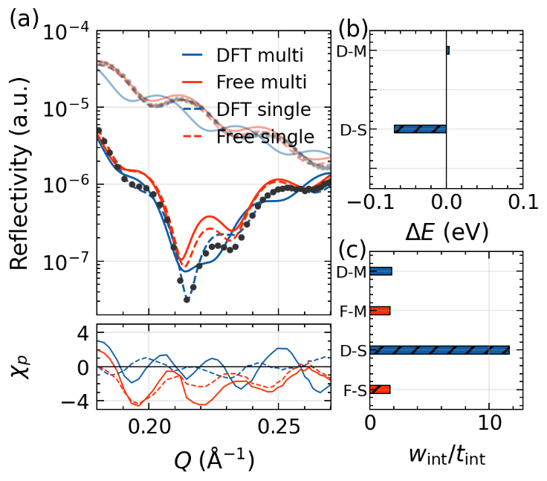
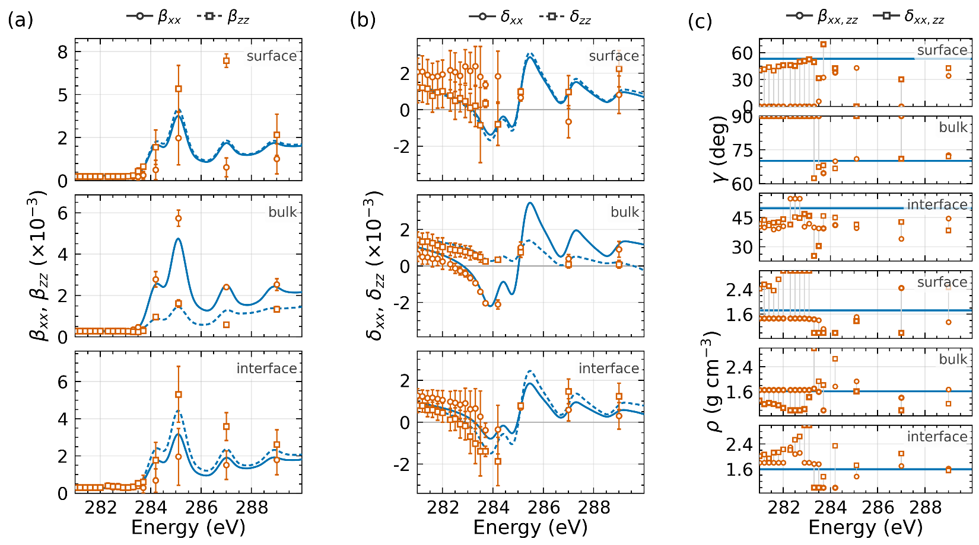
FIG. S10 Non resonant XRR measured on a similarly prepared sample with thickness 15 nm measured by QCM and grown under otherwise identical conditions. Data was measured at Washington State University on a Xenocs Xeuss 3.0 with a focused Cu X-ray source. Reflectivity was refit using the fixed $τ_{Si}$, $τ_{vac}$, & $ρ_{bulk}$ of Table I, with refined total thickness, surface roughness, $ρ_{v} \& ρ_{Si}$ to vary. A single non resonant energy is incapable of independently determinizing all parameters for the film and is only presented here to further support the gradient model.
FIG. S9 Comparison of single energy PXR fits at the diagnostic energy (283.7 eV) against the multi energy refinement. (a) Direct fit comparison and residuals showcasing that the DFT single energy can out-perform other fit strategies within Brewster’s angle. (b) Energy offset parameter results used in the fits compared between the DFT multi energy (D-M) and single energy (D-S) fits indicating that the single energy fit must take an extreme -.1 eV offset, to a non-absorbing energy. (c) Interfacial width $w=\sqrt{2π}σ_{r}$ of the interface layer showcasing that the D-S fit is >10x the total thickness of this buried layer.
FIG. S8 Comparison in final best fit optical constants revealed though the free tensor and dft models. (a) Imaginary tensor components $β$, (b) real tensor components $δ$. The extracted orientation and density are compared in (c) and (d) where the directly refined orientation from the DFT model (traces) is compared with the per energy orientation computed from a secondary refinement to the full tensor. The density is determined by the magnitude of the trace of the optical tensor and showcases a much lower inter energy variance. The orientation that sets dichroism and birefringence varies much strongly between energies and amongst q-ranges.8

