Starting Tables
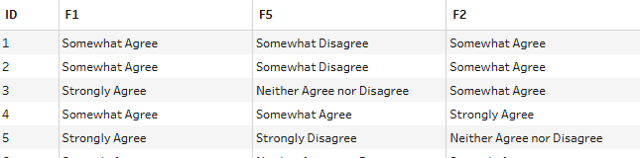 | … | 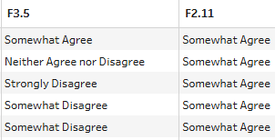

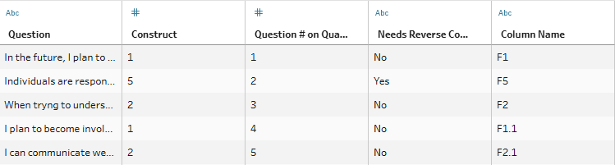

Step | Data Description
1
2
3
4
5

Ending Table
