Table | Data Description
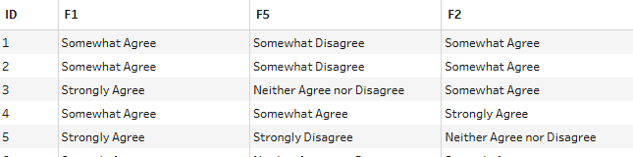  Note: Starting with the health survey data | NA
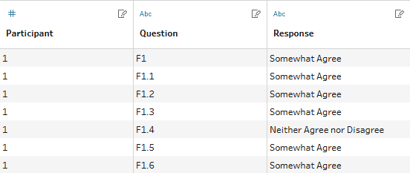
Note: One row per question
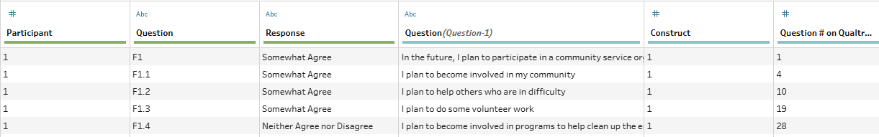
Note: Combine health survey and recoding tables
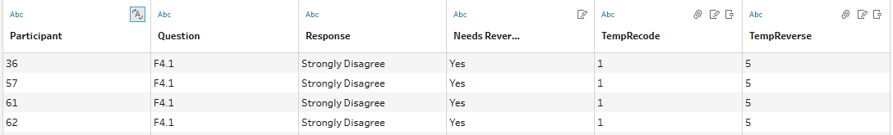
Note: Recoding values: Regular coding – Strongly Disagree = 1 … Strongly Agree = 5; Reverse coding – Strongly Disagree = 5 … Strongly Agree = 1
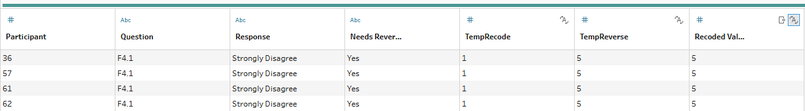
Hint: Use IF
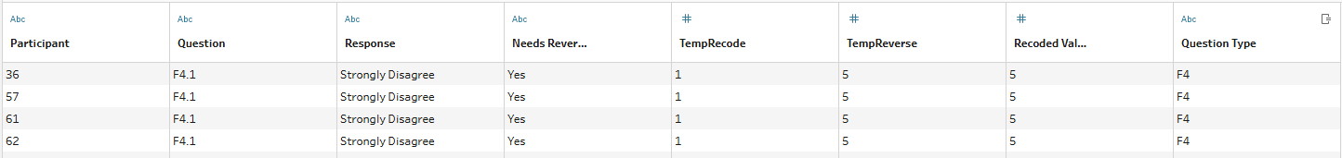
Note: Create Question Type variable
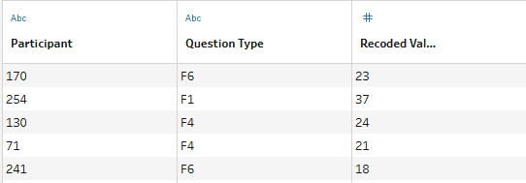
Note: Find total score per question type per participant
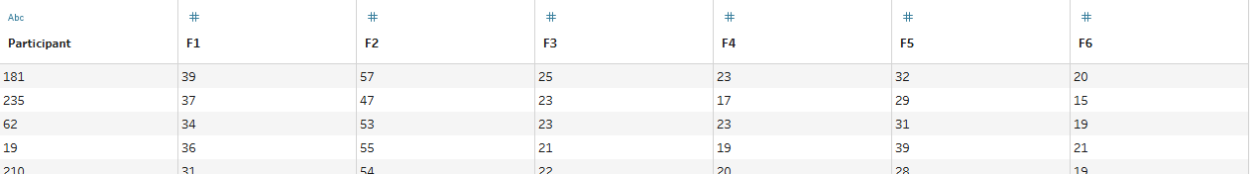
Note: Split questions into columns

