Consider the following tables obtained from the American Community Survey 2017.

|  |  |  |
| --- | --- | --- |
| Table: Uninsured | Table: Population | Table: Name |

Use the above tables to fill in the appropriate value for each cell missing information.

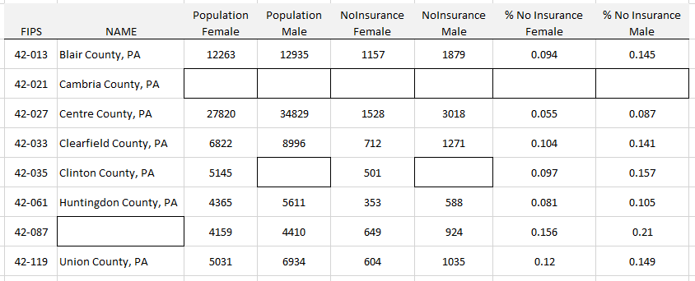

Next, let us consider an algorithm that would be necessary in order to create the above table. Reconsider each step that you used in filling in the missing cells. In the table below, provide clear instructions for each data processing step so that another person could replicate your process.

Title: Data Processing Document for ACS 2017 Join Date: ______________________  
Author: __________________________________

|  |  |
| --- | --- |
| **Step 1:** |  |
| **Step 2:** |  |
| **Step 3:** |  |
| **Step 4:** |  |
| **Step 5:** |  |
| **Step 6:** |  |
| **Step 7:** |  |
| **Step 8:** |  |