**Hospital (Emergency Room) Deserts Across Iowa**

|  |
| --- |
| Wiki: **Medical deserts in the United States** [ [Link](https://en.wikipedia.org/wiki/Medical_deserts_in_the_United_States) ]  The [United States](https://en.wikipedia.org/wiki/United_States) has many regions which have been described as [medical deserts](https://en.wikipedia.org/wiki/Medical_desert), with those locations featuring inadequate access to one or more kinds of medical services. [[1]](https://en.wikipedia.org/wiki/Medical_deserts_in_the_United_States#cite_note-1) An estimated thirty million Americans, many in [rural regions](https://en.wikipedia.org/wiki/Rural_area) of the country, live at least a sixty-minute drive from a [hospital](https://en.wikipedia.org/wiki/Hospital) with trauma care services. |

The goal of this problem is to understand hospital (or emergency room) deserts across the state of Iowa. Two data sources will be used for this investigation – data from the Centers for Medicare & Medicaid Services web portal and the US Zip Codes Database.

Dataset #1: Hospital Information

Source: <https://data.cms.gov/provider-data/dataset/xubh-q36u>

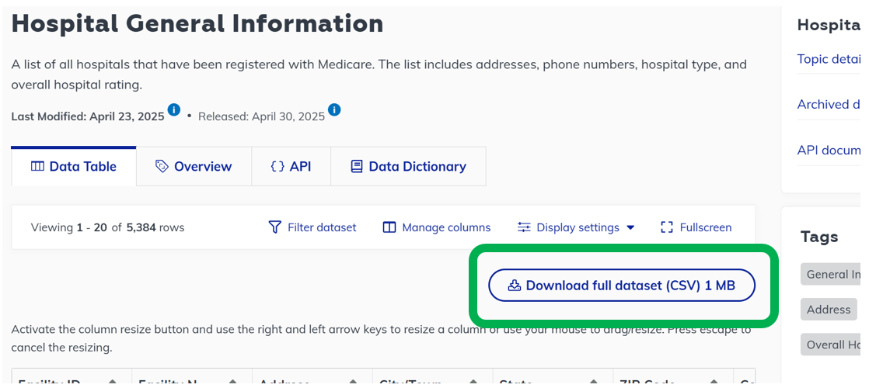

*Action*: Open this file in Tableau Prep. Apply the following filters to reduce the hospitals to only those in Iowa that provide emergency room care.

* FILTER to State = IA
* FILTER to Hospital Type = Acute Care Hospitals OR Hospital Type = Critical Access Hospitals
* FILTER to Emergency Services = Yes

*Deep (Data) Thoughts:*

* Make note of the number of hospitals in Iowa that provide emergency room care
* Consider a SELECT action to minimize columns as a JOIN is forthcoming

Dataset #2: Zipcode Information

Source: https://simplemaps.com/data/us-zips

Download and unzip the Zipcode file. Open this file in Tableau Prep. The following variables are most relevant for our investigation.

* zip: five-digit zipcode
* lat: latitude of the centroid location of this zipcode
* lng: longitude of the centroid location of this zipcode
* city: Name of the city for that zipcode
* state_id: State abbreviation for that zipcode

*Action*: Apply a filter on the Zipcode data to include only zip codes where state_id = IA.

*Deep (Data) Thoughts:*

* Make note of the number of unique zip codes that are present for that state of Iowa.
* Consider a SELECT action to minimize columns as a JOIN is forthcoming

*Action*: Using a JOIN, create a new table that has a latitude and longitude measurement for each hospital. Zipcode will be the key used to complete the JOIN.

Note: For our investigation here, the hospital location can be approximated by the centroid location of their associated zip code. If more exact geo-location is desired, one can use Geoapify.com (<https://www.geoapify.com/tools/geocoding-online/>) will allows one to obtain the geo-locations for a bulk set of addresses. A *.CSV file can be uploaded directly which is convenient.

*Deep (Data) Thoughts:*

* Verify that the number of records in the joined table make sense.

*Action*: If you have not already done so, create a table that includes zip, lat, lng, city, state_id from the Zipcode data file. Using another JOIN, create a table that has all hospital locations crossed with all zipcodes/cities in IA.

*Deep (Data) Thoughts:*

* Again, verify that the number of records in the joined table make sense.

*Action*: The data after completing the outer JOIN, each record should include a latitude and longitude measurement for a particular hospital and a latitude and longitude measurement for a particular city. Using Haversine formula, compute the distance (in miles) between the hospital and the city for each record. An example MUTATE action is provided here.

*Deep (Data) Thoughts:*

* Using Google Maps, verify that your application of Haversine formula is correct.

*Action*: Next, create a new variable called ProximityRank. This WINDOW calculation will be used to rank the distances from smallest to largest between a hospital and all cities across Iowa. An example MUTATE action is provided here.

*Deep (Data) Thoughts:*

* Verify that your ProximityRank WINDOW function is correct.

**Final Thoughts…**

1. Apply the FILTER action ProximityRank = 1. What information is gained by considering this list of records? Briefly explain.
2. Consider only records where ProximityRank = 1. Identify the record (or city) that has the maximum distance. What information is gained by considering this record? Briefly explain.
3. Make a custom Google Map of all hospital locations across Iowa. Identify the city that has the maximum distance when ProximityRank = 1 on this map. Where is this city located?

[Link: CUSTOM MAP](https://www.google.com/maps/d/edit?mid=1Qnt9ZdtHcWxsCoLqimaicioKoDP0fdY&usp=sharing)  
  
1. Do you believe Iowa suffers from healthcare deserts? Briefly discuss.
2. Finally, for our accident-prone friends - hospital for 50010 😊

