**Time Spent – Gender Divide**

Article Source: <https://www.nbcnews.com/data-graphics/men-do-housework-women-still-do-more-rcna216748>

Data Source: <https://www.bls.gov/tus/>

|  |
| --- |
| Wiki: **Medical deserts in the United States** [ [Link](https://en.wikipedia.org/wiki/Medical_deserts_in_the_United_States) ]  The [United States](https://en.wikipedia.org/wiki/United_States) has many regions which have been described as [medical deserts](https://en.wikipedia.org/wiki/Medical_desert), with those locations featuring inadequate access to one or more kinds of medical services. [[1]](https://en.wikipedia.org/wiki/Medical_deserts_in_the_United_States#cite_note-1) An estimated thirty million Americans, many in [rural regions](https://en.wikipedia.org/wiki/Rural_area) of the country, live at least a sixty-minute drive from a [hospital](https://en.wikipedia.org/wiki/Hospital) with trauma care services. |

The goal of this problem is to understand hospital (or emergency room) deserts across the state of Iowa. Two data sources will be used for this investigation – data from the Centers for Medicare & Medicaid Services web portal and the US Zip Codes Database.

Dataset #1: Hospital Information

Source: <https://data.cms.gov/provider-data/dataset/xubh-q36u>

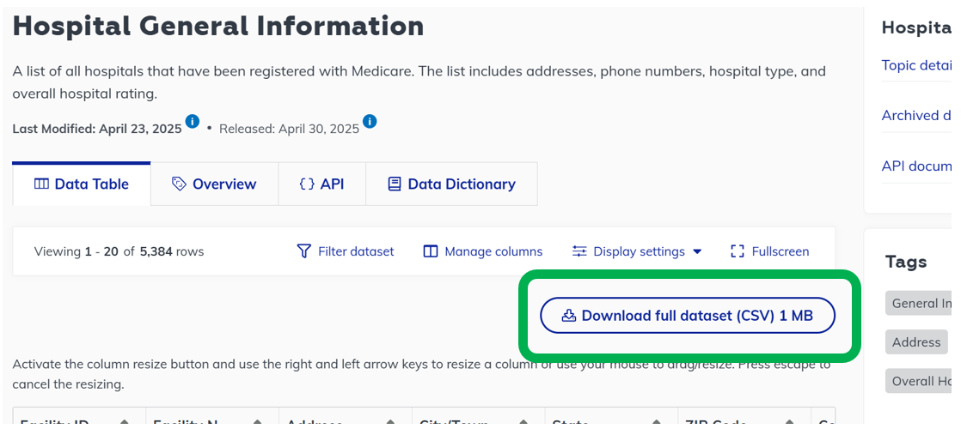

*Action*: Open this file in Tableau Prep. Apply the following filters to reduce the hospitals to only those in Iowa that provide emergency room care.

* FILTER to State = IA
* FILTER to Hospital Type = Acute Care Hospitals OR Hospital Type = Critical Access Hospitals
* FILTER to Emergency Services = Yes

*Deep (Data) Thoughts:*

* Make note of the number of hospitals in Iowa that provide emergency room care
* Consider a SELECT action to minimize columns as a JOIN is forthcoming

Dataset #2: Hospital Location

The Hospital Location file will need to be created. This file will contain the latitude and longitude measurements for each hospital under consideration. Geo-locations for a bulk set of addresses can be obtained using Geoapify.com ( <https://www.geoapify.com/tools/geocoding-online/> ).

|  |  |
| --- | --- |
| **Step 1**: Using the Hospital Information file, create a Hospital_Addresses.csv file as shown here. |  |
| **Step 2:** Upload the Hospital_Addresses.csv file to geoapify.com. This app will generate latitude and longitude outcomes for each hospital. |  |
| **Step 3**: Download the file created by geoapify.com. This file, named Hospital_Addresses_with_Lat_Long.csv, will be joined with the Hospital Information data. |  |

*Action*: Using a JOIN, create a new table that has a latitude and longitude measurement for each hospital. A LEFT JOIN is needed where Table A is the hospital information file and Table B is the Hospital Addresses with Lat and Long returned from geoapify.com. Table A should be retained.

*Deep (Data) Thoughts:*

* Verify that the number of records in the joined table make sense.

Dataset #3: Zipcode Information

Source: https://simplemaps.com/data/us-zips

Download and unzip the Zipcode file. Open this file in Tableau Prep. The following variables are most relevant for our investigation.

* zip: five-digit zipcode
* lat: latitude of the centroid location of this zipcode
* lng: longitude of the centroid location of this zipcode
* city: Name of the city for that zipcode
* state_id: State abbreviation for that zipcode

*Action*: Apply a filter on the Zipcode data to include only zip codes where state_id = IA.

*Deep (Data) Thoughts:*

* Make note of the number of unique zip codes that are present for that state of Iowa.
* Consider a SELECT action to minimize columns as a JOIN is forthcoming

*Action*: If you have not already done so, create a table that includes zip, lat, lng, city, state_id from the Zipcode data file that will be used for a JOIN with the Hospitals file that includes Lat and Long for each hospital. Using a CARTESIAN JOIN, create a table that has all hospital locations crossed with all zipcodes/cities in IA.

*Action*: After completing the cartesian JOIN, each record should include a latitude and longitude measurement for a particular hospital and a latitude and longitude measurement for a particular city. Using Haversine formula, compute the distance (in miles) between the hospital and the city for each record. The MUTATE action is provided here and the formulas can be copied directly into Prep.

|  |  |
| --- | --- |
| Create Calculated Filed in Prep | Copy/Paste Haversine Formula |
|  | 3959*ACOS(  SIN(RADIANS([Hospital_Latitude]))*  SIN(RADIANS([City_Latitude]))  +  COS(RADIANS([Hospital_Latitude]))*  COS(RADIANS([City_Latitude]))*  COS(RADIANS([Hospital_Longitude]) -  RADIANS([City_Longitude])  )  ) |

*Deep (Data) Thoughts:*

* Using Google Maps, verify that your application of Haversine formula is correct.

*Action*: Next, create a new variable called ProximityRank. This WINDOW calculation will be used to rank the distances from smallest to largest between a hospital and all cities across Iowa. An example MUTATE action is provided here.

*Deep (Data) Thoughts:*

* Verify that your ProximityRank function has been correctly implemented.

***Final Deep Thoughts*…**

1. Apply a FILTER action for ProximityRank = 1. What information is gained by considering this list of records? Briefly explain.
2. Consider only records where ProximityRank = 1. Identify the record (or city) that has the maximum distance. What information is gained by considering this record? Briefly explain.
3. [Optional] Make a custom Google Map of all hospital locations across Iowa. Identify the city that has the maximum distance when ProximityRank = 1 on your custom map. Where is this city located?

[Link: CUSTOM MAP](https://www.google.com/maps/d/edit?mid=1Qnt9ZdtHcWxsCoLqimaicioKoDP0fdY&usp=sharing)  
  
1. Do you believe Iowa suffers from healthcare / emergency room deserts? Briefly discuss.
2. Finally, for our accident-prone friends - hospital for Ames, IA 😊

