Mack Parker
Project 2: Proposal
Description and Scope
I decided to find a design contest on 99 designs and the one I chose was to redesign a website for a bus company selling tickets for their routes. They sell different types of routes and have special deals on them. The website is a bit old looking and they want a more modern design. The name of the website is iLikeBus.com.
99 designs contest link: https://99designs.com/web-design/contests/help-apex-bus-inc-website-design-89157/brief
Existing website: http://www.apexbus.com
Significance
The purpose of the new website is to make it more clean and modern. I want to make the current website less crowded and prehistoric looking. I want the website to be visually appealing to the user. I think the older website has good colors, it uses blue, yellow and white. To me those invoke very trusting emotions. Those colors are the same ones that Best Buy uses and make me think of wanting to buy from them and you’re getting a great deal just come to mind when I see their logo.
The current website just doesn’t have a lot of design to it. When the width is changed or is made smaller to the size of a table or phone there are no reactive styles to make the website adapt to the device size. When the width gets smaller the website gets a horizontal scroll so it just has the same design as it did when it was in desktop mode. Although they do use the yellow and blue, that’s only on a few elements, there is a lot of blank white space, so I would like to add more color to the website to make it less bland looking.
Equipment Needs and Resources
Before I even start coding I’ll make a mockup in figma of the page. I’ll save a pdf and a .fig file in a projects file in the project 2 repository.
First off, for the navigation I want it to be fixed so it scrolls with the user as they go down the page. I want the logo to be a design of a bus, I will use adobe illustrator to make the design. I’ll have three different tabs for all the pages.
The pages will be Home, Charter a bus, and an about us page.
The home page will have a big hero image that spans the whole width of the view port, and it will have a hook to get the user's attention. I’ll also have some kind of form that will have a shortcut to search for tickets that the user can purchase. Underneath the hero there will be directory buttons to manage a current trip and for help. There will be a button that leads to a map to look at routes on the map. There will be a section where it uses custom bootstrap cards with special deals on current tickets. Then last there will be a carousel section to see past user reviews that will rotate and have a star system.
The second page will be the Charter a Bus page, where the user uses a form to choose from a drop down of cities where they can rent a bus to come to their location and pick them up. They will also select the date they would like to be picked up, I would like to use a little javascript to show the current date for convenience. The body of the page will be a gallery which shows all the different types of buses the user can charter. This page will use one photo specifically for a hero image of people in the interior of a bus. Additionally, it will use five different photos for the different types of buses.
The third page will be an about us page, which will have a short description of the bus company and then two different sections of accordions with helpful information and an faq section with common questions.
I’d like to use a colorway with different shades of blue so it will use a monochromatic color scheme, and will have a white background. The current website did not have a logo so that will be one of the first things I’d like to create, then make the mockup for reference while I am coding, and then I will start coding once I’m done with the mockup.
The fonts that I used were Montserrat for headers and titles. For paragraphs I used Poppins cause I thought it would catch the user’s eye. I am using bootstrap icons for symbols for socials and buttons. I mainly use the bootstrap framework, and a javascript function to show the current date.

Steps for completion
- 1 hour - Find a contest on 99design I find interesting enough to make a website
- 1 Hour - Choose images on Unsplash
- 1 Hour - Make logo
- 4 Hours - Make a mockup of the website for reference and for brainstorming
- 1 Hour - Come up with colorway and create variables for colors and fonts
- 3 HoursStart coding the homepage first beginning with the navigation, then body, and finally footer
- 3 Hours - Code the Charter a bus page, and work on the gallery layout
- 2 Hours - Code the About us page
- 4 Hours - Start working on SCSS styles for each page
- 30 minutes - Organize files into folders and make necessary files for SCSS files and import them into the main SCSS file
- 2 Hours - Double check each page and look for errors an bugs and make sure all the photos have appropriate alt titles

Persona
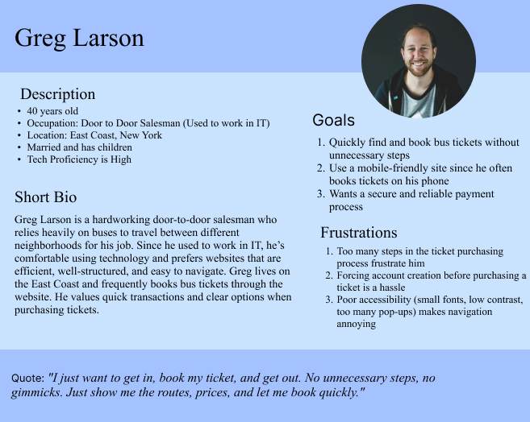

Styles
