**Description and Scope**

**Gabor’s Custom Water Features**

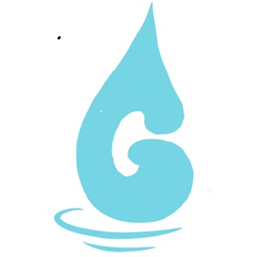Logo created by Kenny Gabor

This website is meant to be a place that will allow the artist and the user to be able to collaborate on a water feature that is personal and original. Each water feature is environmentally conscious, safe products. Many of the water features are solar powered and use small amounts of water that result in a beautiful but sustainable feature.

This site allows the user to submit one or more inspirational photo(s) that give the artist an idea of what the customer would like to see, they are able to provide inspirational pieces and collaborate on the water feature. The artist will create a custom fountain that embodies his version of their inspiration. This page has a design concept (attached) and will have a have a home page, an about us that has an accordion for FAQ’s, a page that will show previous water features created and sold, an inventory page of already created features, a page that will accept jpegs and text to describe the requested custom water feature (this could turn into an email address that you could send attachments, and be able to accept a payment, and lastly a Contact Us page . This page is meant to be a simple beginning page for an artist to begin their business of creating custom water features themselves and should not

require a lot of difficult coding to maintain the page. The drop-down menu’s will be the same color and format on each page that have links to go back to the home page and the contact us page.

**Significance**

This site is meant to provide a means of selling original environmentally thoughtful fountains and art pieces with minimal website maintenance. A one stop collaborative space for both artist and user. An easy-to-use page that doesn’t need many instructions but provides a collaborative environment for custom orders and creations. It should work well and reflect the artist’s easy style; we want to represent him well to potential customers.

**Equipment Needs and Resources**

1. Adobe XD
2. Laptop
3. Domain
4. Visual Studio Code
5. Images
6. Payment Resources (to accept credit cards for purchases)
7. Price list
8. Product Descriptions

**Timeline**

3 hours proposal

3 hours prototype

7 hours coding

2.5 hours for HTML content

2 hours for grid and layout

2.5 hours to set up buttons and responsiveness, clean it up

3 hours user interviews

3 hours editing and improving site according to feedback

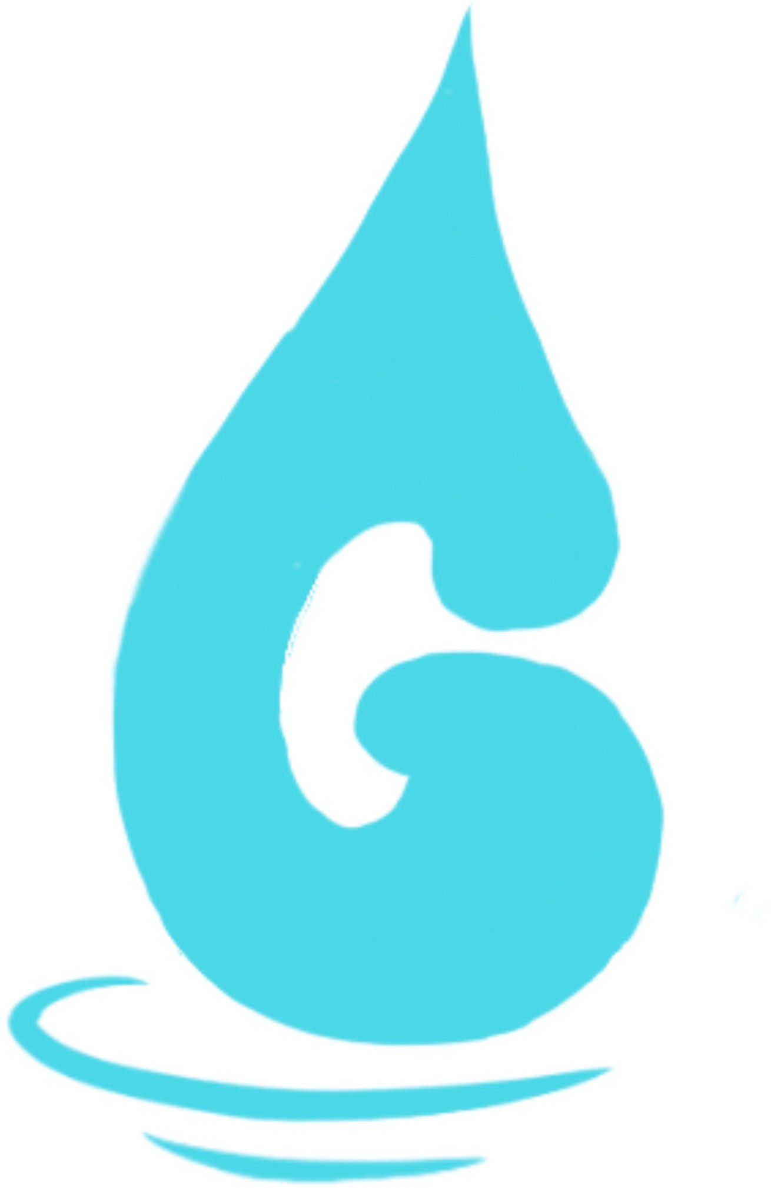

#C0AB95

#E8DACD #76D4E5 #9FA48E

Logo created by Kenny Gabor

**Gabors Water Features**

Helvetica 16

**Column Headings**

Helvetica 13

Text and descriptions

Helvetica 11

