# Intrduction
The Multiset I am going to design is a player inventory that stores the string item names and their count value (if the all the item appear multiple times there count will increase by 1 and I will implementing this using the HashTable. Each unique will be the key and the value will count the number of times that key appears. This structure would be fast for inserting, removing and even for looking up the items.
Example: "potion": 3
potion is the key and 3 is the value/count i.e. the number of potions he has in the inventory. Adding 1 more potions will increase the value to 4 and so on.
# Design Philosophy
Efficiency: The operations such as adding or removing items will occur in O(1) time complexity because of the hash table structure.
Simplicity: This focuses on the game-relevant operations (add, remove, count, contains).
Extensibility: The design allows adding future operations like random removal.
Readability: Clear method semantics, consistent handling of edge cases and well-defined invariants ensure that developers or other game-system modules can safely interact with the Multiset.
Clients and Users:
Client: Game module such as inventory management of games.
User: Players those are playing the game and interact with inventories through the game mechanics.

# Core Operations
* Add(item, count)
Concept: Adds count copies of item to the player inventory.
Average Time Complexity: O(1)
Edge Cases: Adding items more than available space will handle the error(e.g., returning “bag is full”).
HashTable support: Key lookup ,inseration or remove using pseudo-random probing that ensures the fast access.

* Remove(item, count)
Concept: Removes the count by 1 everytime if remove occures and if reaches 0 removes the Key.
Average Time Complexity: O(1)
Edge Cases: Removing the non-existent item returns 0 and also removal of more than present items in the Multiset counts to 0.
HashTable Support: Efficient lookup and update, with slot marked empty upon deletion.
* Count(item)
Concept: Returns the count of individual item in the inventory.
Average Time Complexity: O(1)
Edge Cases: False for missing keys/item.

* totalCount()
Concept: Returns the total number of items in the inventoy by summing up all the counts of every item.
Time Complexity: O(1)
Edge Case: At the starting totalCount would be 0.

* distinctSize()
Concept: Counts up all the unique items in the inventory.
Time Complexity: O(1)
Edge Case: At the starting totalCount would be 0.

# Set Operations

* UnionWith (Other)
Game Analogy: This comibines the two players inventories or merge loot drops.
Operation: For each Key in other, increment the count in current Multiset by other's count.
Conceptual Comlexity: O(other.distinctSize)
Edge Cases: pseudo-random handles the collisions during insertion and adding items more than available space will handle the error by returning "bag is full".

# Extension Feature

* Remove_item(item)
Purpose: Removes a specified item from the inventory completely, setting its count to 0 and deleting its key from the table.
New Methods: Public method remove_item(item).
Looks up the item in the hash table Sets its count to 0 and deletes the key.
Time Complexity: O(1)
Gameplay Value: Supports game mechanics where an enemy can steal a specific item from the player. By removing the item completely from the inventory.
pseudocode block for remove_item(item)
function remove_item(item){
if(table.contains(item){
table(item.count) = 0;
delete table(item);
}
}
# UML DIAGRAM
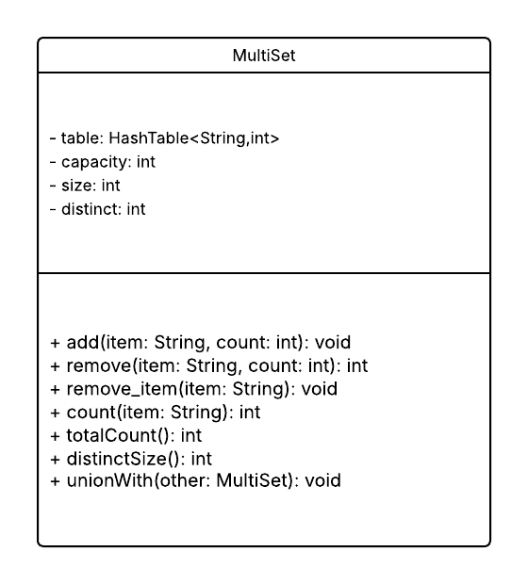
# Trade-off Analysis
Data Structure | Advantages | Disadvantages | Core functions
HashTable | Fast average-case O(1) for add/remove/lookup | No ordering | Insert avg O(1), remove O(1), lookup O(1)
AVLTree | Sorted order | More complex rotations | Lookup O(log n), Insert O(log n), Remove O(log n)

Why not AVLTree?
AVLTree guarantees sorted traversal and predictable O(log n) operations but it adds complexity (rotations, balance factors) and higher memory overhead. For a player inventory, fast average-case operations are more important than sorted order, so HashTable is the better fit.

