**Part 1 - Build a VPC**

For each step below, provide a screenshot that shows the network resource has been created according to specification along with a description of what the resource does (what is its role). You may add whatever additional notes you would like. **The screenshot and description of each network component is required**. Any other notes you leave behind may make this project more useful in the future. Getting a good screenshot can be done by clicking on the resource and showing configurations in the details menu.

1. Create a VPC.
   * Tag it with "YOURLASTNAME-VPC"
   * Specify a /24 private IP address range
2. Create a subnet
   * Tag it with "YOURLASTNAME-Subnet"
   * Specify a /28 private IP address range
   * Attach it to your VPC
3. Create an internet gateway
   * Tag it with "YOURLASTNAME-gw"
   * Attach it to your VPC
4. Create a route table
   * Tag it with "YOURLASTNAME-routetable"
   * Attach it to your VPC
   * Associate it with your subnet
   * Add a routing table rule that sends traffic to all destinations to your internet gateway
5. Create a security group
   * Tag it with "YOURLASTNAME-sg"
   * Allow SSH for a set of trusted networks including:
     + Your home / where you usually connect to your instances from
     + Wright State (addresses starting with 130.108)
     + Instances within the VPC
   * Attach it to your VPC
   * Image should include your Inbound rules
6. (If necessary, else skip) Create a key pair

**Part 2 - EC2 instances**

1. Create a new instance. Give a write up of the following information:
   * AMI selected
     + default username of the instance type selected
   * Instance type selected
2. Attach the instance to your VPC. As discussed there are different pathways to doing this. Say how you did it.
3. Determine whether a Public IPv4 address will be auto-assigned to the instance. Justify your choice to do so (or not do so)
   * **NOTE** - in the next few steps, you will be required to request an Elastic IP address and associate it to the instance. Factor that in to your discussion here.
4. Attach a volume to your instance. As discussed there are different pathways to doing this. Say how you did it.
5. Tag your instance with a "Name" of "YOURLASTNAME-instance". Say how you did it.
6. Associate your security group, "YOURLASTNAME-sg" to your instance. Say how you did it.
7. Reserve an Elastic IP address. Tag it with "YOURLASTNAME-EIP". Associate the Elastic IP with your instance. Say how you did it.
8. Create a screenshot your instance details and add it to your project write up. Example below: [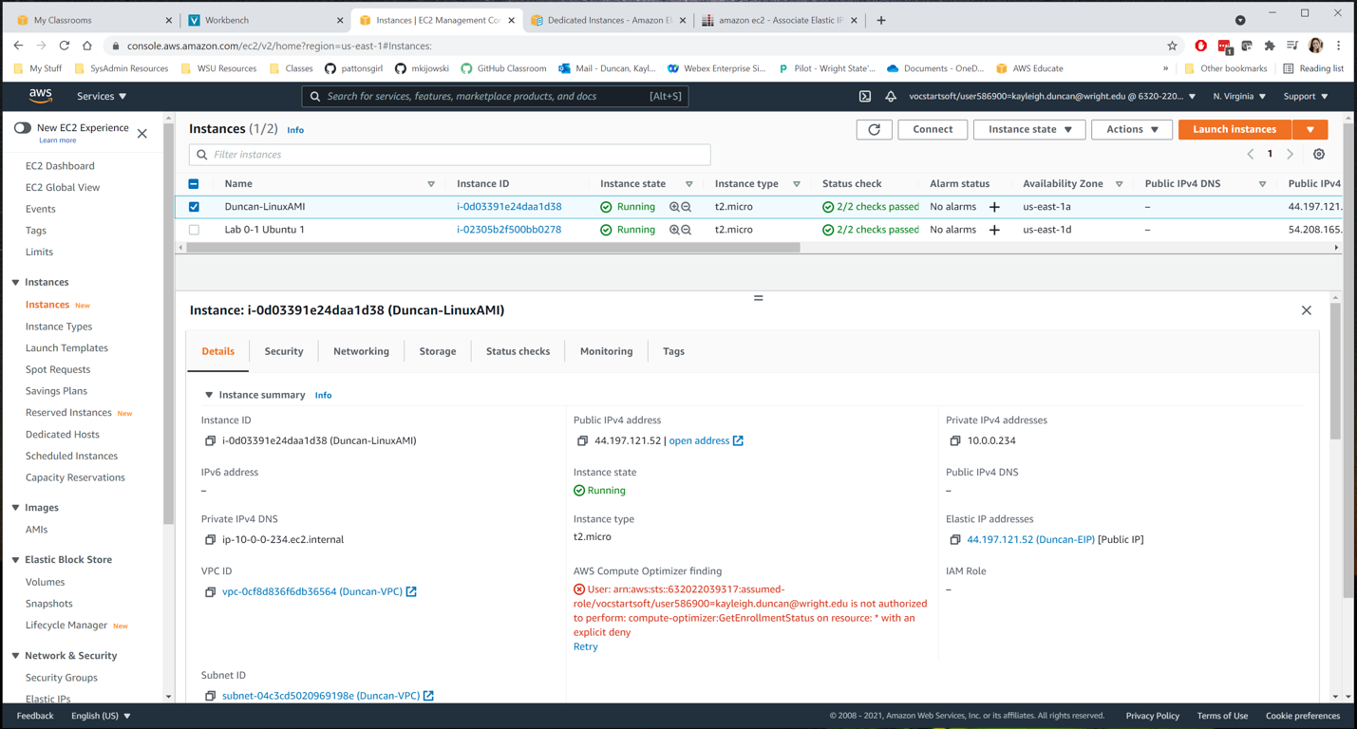](https://github.com/pattonsgirl/Fall2022-CEG3120/blob/main/Projects/Project2/sample.png)
9. ssh in to your instance. Change the hostname to "YOURLASTNAME-AMI" where AMI is some version of the AMI you chose. Say how you did it.
   * It is wise to copy config files you are about to change to filename.old For /etc/hostname, for example, I would first copy the current hostname file to /etc/hostname.old
   * You should not change permissions on any files you are modifying. They are system config files. You may need to access them with administrative privileges.
   * Here is a helpful resource: <https://www.tecmint.com/set-hostname-permanently-in-linux/> I did not modify /etc/hosts on mine - do so or not as you wish.
10. Create a screenshot your ssh connection to your instance and add it to your project write up - make sure it shows your new hostname.

**Submission**

1. Commit and push your changes to your repository. Verify that these changes show in your course repository, <https://github.com/WSU-kduncan/ceg3120-YOURGITHUBNAME>
   * Your repo should contain:
   * images folder (optional depending on how you implement screenshots)
   * README.md
2. In Pilot, paste the link to your project folder. Sample link: <https://github.com/WSU-kduncan/ceg3120-YOURGITHUBUSERNAME/blob/main/Projects/Project2>
3. You may delete all created resources once done to save monies. No really, trash it - especially the instance and disassociate and release the elastic IP