

**Team Inventory**

**Team**

REMI-HPCStochPy

**Prepared For**

Dr. Eric Logfren

**Team Members**

Michael McNaughton

Gerald Hoff

Ryan Charit

**Michael J McNaughton**

**Major:** Computer Science

**Hometown:** Stanwood, WA

**Education**

Stanwood High School

Washington State University

* Computer Architecture
* Automata Theory
* Database Systems
* Intro to Parallel Computing
* Intro to Data Mining
* Software Engineering
* Design and Analysis of Algorithms
* Programming Language Design

**Skills**

* Basic Knowledge of Python, Haskell, C++, C#, C, and Linux
* Experience with SQL, designed a database schema and basic operations for it

**Other Interests**

* The Arts, both creative and performative
* Foreign Languages
* Games of all types

**Gerald Hoff**

**Major:** Computer Science

**Hometown:** White Salmon, WA

**Education**

Columbia High School

Washington State University

* Computer Architecture
* Automata Theory
* Parallel Computing
* Data Science
* Big Data
* Software Engineering
* Data Structures



**Skills**

* Python, C/C++, Java, R, Linux
* dplyr, javaFX, MPI, OpenMP, CUDA

**Other Interests**

* Strategy Games
* Magic the gathering
* Biking
* Reading

**Ryan Charit**

**Major:** Computer Science

**Hometown:** Moscow, ID

**Education**

Moscow High School

Washington State University

* Data Structures
* Computer Architecture
* Automata Theory
* Design and Analysis of Algorithms
* Database Systems
* Software Engineering
* Systems Programming
* Technical and Professional Writing

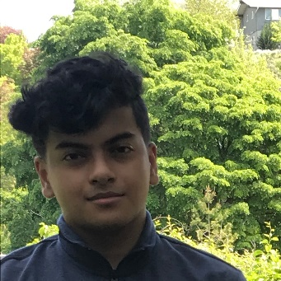

**Skills**

* Python (basic), C (better), C++ (better), Linux, SQL (design and implementation)
* Qt GUI (basic), PostgreSQL

**Other Interests**

* Playing video games
* Watching movies and TV shows
* Listening to music
* Failing programming interviews