NOTICE IN COMPLIANCE WITH PUBLISHER POLICY: This is a formatted, post-print manuscript version of:

Richard Smith, Kirstin Miller. "Ecocity Mapping Using GIS: Introducing a Planning Method for Assessing and Improving Neighborhood Vitality." Progress in Community Health Partnerships: Research, Education, and Action 7.1 (2013): 95-106. *Project MUSE*. Web. 6 Dec. 2013. DOI: 10.2139/ssrn.2100547

Archived with author permission.

**Ecocity Mapping Using GIS: Introducing a Planning Method for Assessing and Improving Neighborhood Vitality**

**Richard J. Smith**

**Abstract**    
**Background**: Assessing neighborhood vitality is important to understand how to improve quality of life and health outcomes. The ecocity model recognizes that cities are part of natural systems and favors walkable neighborhoods. This article introduces ecocity mapping, an innovative planning method, to the public health literature on community engagement by describing a pilot project with a new affordable housing development in Oakland, California between 2007 and 2009. While ecocity mapping began as a paper technology, advances in Geographic Information Systems (GIS) moved it forward.

**Objectives**: This article describes how Ecocity Builders used GIS to conduct ecocity mapping to: 1) assess vitality of neighborhoods and urban centers to prioritize community health intervention pilot sites, and 2) create scenario maps for use in community health planning.

**Methods**: From fall 2007 to summer 2008, Ecocity Builders assessed neighborhood vitality using walking distance from 1) parks, 2) schools, 3) rapid transit stops, 4) grocery stores, and 5) retail outlets. In 2008, ecocity maps were shared with residents to create a neighborhood health and sustainability plan. In 2009, Ecocity Builders developed scenario maps to show how changes to the built environment would improve air quality by reducing greenhouse gas emissions from vehicles, while increasing access to basic services and natural amenities.

**Conclusions**: Community organizing with GIS, was more useful than GIS alone for final site selection. GIS was useful in mapping scenarios after residents shared local neighborhood knowledge and ideas for change. Residents were interested in long-term environmental planning provided they could meet immediate needs.

**Keywords:** Curriculum, data management, health sciences librarianship, research, research data management

Since the 19th century Settlement House movement, improving community quality of life has been of interest to social work and other professionals (1). The Settlement Houses in the United Kingdom and United States created maps as part of a community assessment to display poverty levels and environmental conditions to advocate for change. Today professionals in community-based organizations are “mapping” on computers with Geographic Information Systems (GIS) (1–3). The relationship of community-based organizations to academic and local government institutions has evolved with different approaches such as conflict organizing for social change (4–6) or the popular education approach that creates alternative educational institutions to raise consciousness and empower oppressed communities (7–9). There is a rich literature in public health on community-engaged research and community based participatory action research (CBPR) that intersects with the community organizing tradition to discuss ethical issues of insider-outsider knowledge and the competing demands between social movements and research integrity (10–12). Some literature advocates research in service to the community (13), but others share how from the perspective of the community-based organization, the academy's research mission may seem irrelevant (14). However, others stress the importance of campus-community partnerships initiated by community-based organizations for technical expertise, training, and social change (15–17). The term *e-science* has been described as a new research methodology, fueled by networked capabilities and vast amounts of data requiring new strategies for research support,1 whereas *e-research* is a broader term encompassing all domains of research which are also challenged by conducting “research in computationally enhanced and networked environments.”3 In this growing era of data-intensive research, opportunities exist for health sciences librarians to develop unique and valuable services.

The Dilemma of GIS and Public Participation

Using GIS presents risks and opportunities for community-based partnerships. A GIS allows places to be analyzed with attribute data such as poverty levels, housing values, air quality, and other environmental indicators. The Public Participation GIS (PPGIS) literature warns of ethical and practical dilemmas of using GIS to engage the public to organizational and neighborhood problems (18–21). Competing ethical demands include balancing government transparency, individual privacy, security, and fiscal stewardship (21). Another theme is the dilemma of disempowerment from needing experts to operate a GIS versus the potential of GIS to empower citizens with timely and accurate access to information (18; 20). While first wave GIS in the 1990s required elite professional expertise to operate desktop software, second wave GIS is web-based and gives lay-persons access to information. Third wave GIS is mobile and allows scenario planning and interaction with users (19). For example, in Missouri non-profit organizations used GIS to solve immediate problems related to employment training, high school retention, substance abuse, and child abuse or neglect (22). In Western New York, GIS has been used by a community/campus partnership for perinatal health planning (23). Related literature includes GIS and Society (GISoc), Participatory GIS (PGIS), and Critical GIS, which provides critiques on the role of technical experts, local knowledge, and the potential of technology for social change (21). One example of the risk of GIS is how it may be used for the development of projects that increase property values that in turn displace low-income residents or minorities (18). On the other hand, successful community-based organizations can use GIS to empower residents through access to data to make more informed short and long-range decisions.

GIS Based Ecocity Mapping to Build Ecocities

This article contributes to interdisciplinary literature about use of GIS for planning by community-based organizations. Ecocity Builders, a nonprofit eco-urban think tank and activist organization founded in 1992, developed ecocity mapping, a planning tool that can utilize GIS to assess neighborhood vitality (24). Richard Register, founder and president of Ecocity Builders, developed the ecocity model of urban development (25), which recognizes that cities and their human inhabitants are an integral part and sub-system of Earth's natural systems. Register defines vitality as "Access by Proximity": a condition such that people meet their daily needs within walking distance (26). He refers to urban, dense areas with diverse land use and natural spaces as vital or vitality centers (26), but Downton uses the term urban fractals (27). For purposes of the pilot project described in this paper, vitality centers are also referred to as sustainable urban villages. Assessing vitality is important because in order for existing cities to transition to sustainable ecocities, cities will need to invest in dense centers and repurpose abandoned land for natural habitat and food production (28–31). Community health partnerships may find ecocity mapping a useful tool for planning a variety of changes to the built environment that improve health outcomes.

Objectives

This article describes ecocity mapping, a planning method using GIS to: 1) assess vitality of neighborhoods and urban centers to prioritize intervention pilot sites and 2) create scenario maps for use in community planning. This article assesses the use of ecocity mapping and provides recommendations for replication in other communities. See Figure 1 for a conceptual overview of the process.

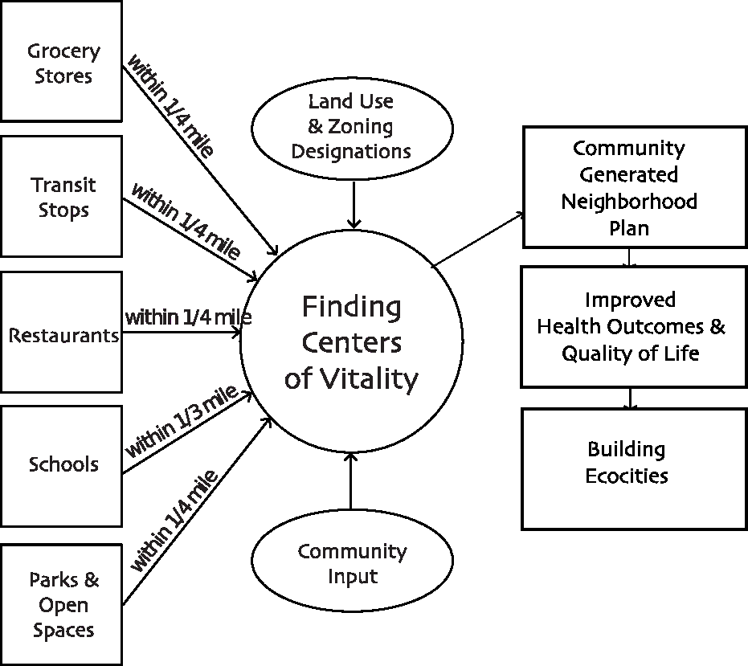

**Figure 1:** The ecocity mapping process balances set land use patterns, actual vitality and the voice of the community to identify and improve sustainable urban villages.

Method

Ecocity Mapping was developed in the 1980s by Richard Register (25; 26), inspired by architect Paolo Soleri (32) and landscape architect Ian McHarg (33). They shared a belief that people need walkable access to natural environments to thrive. McHarg developed suitability analysis, a planning method that involved overlaying transparent maps to determine the optimal location of built infrastructure such as parkways. In the analysis phase, hazardous areas were scored negative, while biodiverse and picturesque areas were given positive scores. Other GIS techniques that inform ecocity mapping include "location allocation" (34), a process of finding the best place for a building or intervention and "optimization" (35), the process of finding the cheapest route to travel.

Ecocity mapping communicates visually both how a neighborhood or metropolitan area looks today and in the future, after changing the built environment to improve access to parks, transit stops, schools, grocery stores, services, and other amenities. Ecocity mapping, as initially outlined by Register in *Ecocity Berkeley* (25), has seven steps listed in Table 1. Ecocity Builders followed Register’s steps as closely as possible, but used GIS instead of transparent paper maps.

For this project, Ecocity Builders used ArcGIS 9.3 software (Environmental Systems Research Institute (ESRI), Redlands, CA). The shapefile is the vector file format in ArcGIS that represents places as points, lines, and polygons and assigns various labels and values. Ecocity Builders built a GIS using map layers containing information about the natural and built environment. See Table 1 for a list of data sources for each step. While all steps are important, some require additional explanation and emphasis. The next paragraph will describe steps one through three in detail, so that they may be replicated by a proficient user of ArcGIS. Step seven will also be discussed in the next section in the context of a case study. These steps have most direct relevance to community health partnerships. Space constraints prohibit full descriptions of other steps, but they are in the final report (36).

**Table 1**: Ecocity Mapping Steps As Implemented in Sustainable Urban Villages Pilot.

|  |  |  |  |
| --- | --- | --- | --- |
| **Step** | **Description** | **Pilot in Oakland, CA** | **Data Sources** |
| Step 1 | Produce a local natural-history map to understand how the built environment relates to the landscape and water systems. | Water features, elevation, earthquake fault lines, fill, solar access, & historic cultural features. | Geographic Information Science Center (GISC) at the University of California, Berkeley; City of Oakland, CA. |
| Step 2 | Identify walkable vitality centers. | Walkable centers defined as residencies within:   1) 1/3 mile from schools;  2) 1/2 mile from parks;   3) 1/4 mile from rapid transit;  4) 1/4 mile from restaurants; 5) 1/4 mile from grocery stores. | GISC; City of Oakland, CA for school and park data; Metropolitan Transportation Commission for transit data, Yellow Pages for retail data. |
| Step 3 | Redraw the perimeter of vitality centers in relation to nature corridors and agricultural areas. | Many underground creeks pass beneath commercial centers in Oakland, CA. | GISC; City of Oakland, CA; Metropolitan Transportation Commission, Yellow Pages. |
| Step 4 | Show where streets end in a "T" and the location of railroad right-of-ways. | Pine Street ends at Cannery Lofts. The Amtrak line bounds the development to the west. | GISC; City of Oakland, CA; Metropolitan Transportation Commission, Yellow Pages. |
| Step 5 | Prepare sample vertical cross sections of buildings to highlight scenic views. | Buildings on the east side of Pine St. look out to the San Francisco Bay. | Renderings based on photos collected on-site. |
| Step 6 | Provide a map legend. | Each type of community asset (e.g. Cultural, Food Systems & Security) had a unique color and icon. | All data, including notes taken by community organizers during one on one meetings. |
| Step 7 | Add scenario maps. | Prospective reduction of greenhouse gas emissions from new food coop, urban farm & greenway. | GISC, City of Oakland, Metropolitan Transportation Commission data and US Census data for population. |

For step one, creating a natural history map, Ecocity Builders recruited Berkeley students, including the first author, in spring of 2006 to assemble map layers with water features, elevation, earthquake fault lines, fill, solar access, and historic cultural features.

For step two, Ecocity Builders worked with the Berkeley students for a draft vitality model in 2006 and then refined the model in 2007 through summer 2008 after obtaining funding. The first author continued with the new GIS team recruited by Ecocity Builders. This new GIS team determined that sufficient vitality can be estimated for locations within walking distance of the five following amenities as specified in the second column of Table 1. Schools were included because they are the top destination for non-work-related trips (37). Grocery stores were included because only 48% of food assistance recipients own a car and 27% are over five miles from the nearest grocery (38). In general, the literature suggests that having shopping within one fourth mile reduces automobile use (37; 39–41). Ideally, one would verify the accuracy of retail locations personally using a GPS (18; 19), but this was cost prohibitive given the large number of establishments in the city.

For the next part of step two, the GIS team loaded in each of the five layers on top of the natural history map and base map. Next, the GIS team converted the vector shapefiles to raster grids. The raster format used a checkerboard grid with 20 feet square such that each cell could take a user assigned value. Using the Euclidean distance command, the GIS team gave each cell the distance in feet from the nearest point to each amenity. Next, using the raster reclassify command, the GIS team gave each cell a value of one if it was within the distance specified in the previous paragraph (e.g. cells that are a one half mile buffer around each park = 1) and zero otherwise. After each of the five layers were reclassified, the GIS team added them together so that every cell within the city received a score of one to five. The map was color coded and labeled for display.

For step three, the GIS team centered the areas of high vitality along existing features in the following way. First, areas with all five amenities within walking distance were converted to polygon shapefiles. The GIS team intersected these polygons with the parcels zoned as neighborhood commercial/retail. This step selected appropriately zoned sections of the city if they had current vitality. The GIS team used a polygon to point command to identify the new center of this polygon. See Figure 2 for an overview of steps two and three. In an early version, the GIS team adjusted the boundaries of centers along lakes and buried creeks, but Figure 2 shows a simpler presentation.

For community organizing and advocacy purposes, the GIS team created maps that highlighted places that needed improvement such as poor bayshore or food access (i.e. food deserts). The GIS team selected raster cells that had only four of the five amenities. Separate maps were created to show each layer individually. Ecocity Builders used these maps to advocate for investment in a neighborhood food cooperative, for example. See Figure 3 for a centers map of Oakland, CA. The next section will discuss a case study applying ecocity mapping.

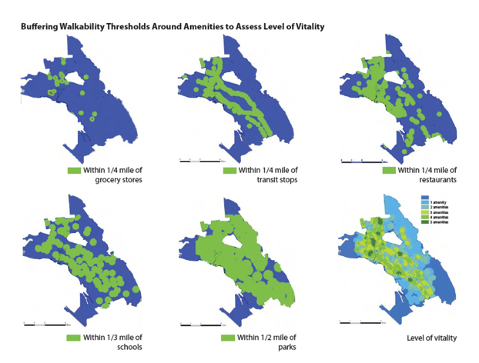

**Figure 2 (contd. on pp.10):** Ecocity mapping steps two and three--finding centers.

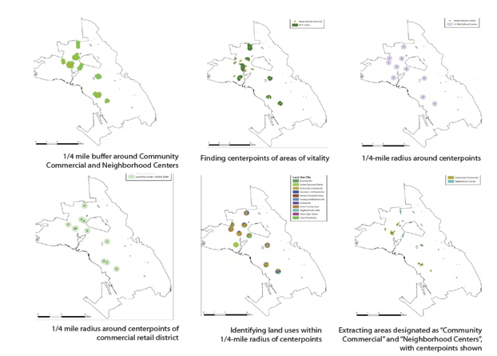

**Figure 2 (contd. from pp. 9):** Ecocity mapping steps two and three--finding centers.

Summary of Sustainable Urban Villages (SUV) Pilot Project

The sustainable urban villages (SUV) pilot in West Oakland, California is novel in that it was conceived by and initiated by a community-based nonprofit organization, Ecocity Builders. Therefore, the project did not involve academic research or community-based participatory research but it is arguably a community-engaged approach to improve quality of life (42). Rather than highlighting the role of a university, it is more appropriate to speak of how Ecocity Builders engaged two academic institutions for support. First, as noted in the previous section, in the spring of 2006 Ecocity Builders recruited GIS interns from the University of California, Berkeley. The project otherwise had no formal relationship with the university. Second, the Western Institute for Social Research (WISR) provided community-organizing interns as part of a formal agreement. WISR is an alternative educational institution offering degrees in psychology, education, community development and social change (43).

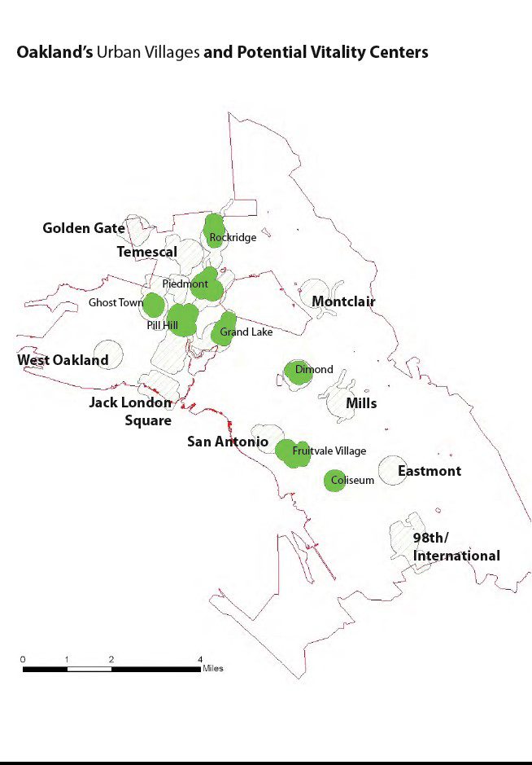

**Figure 3**: Potential pilot sites for Oakland sustainable urban villages.

Community organizing support also came from the City of Oakland Crime Services. In the summer of 2007, Ecocity Builders and WISR applied for and in late fall of 2007 obtained funding from the Climate Protection Grant Program of the Bay Area Air Quality Management District (BAAQMD) (44). The purpose of this program was to reduce greenhouse gas emissions related to climate change, improve air quality, and support activities that have co-benefits to the community. See Figure 4 for a timeline of major partners (above the line) and activities (below the line) involved in the SUV project team.

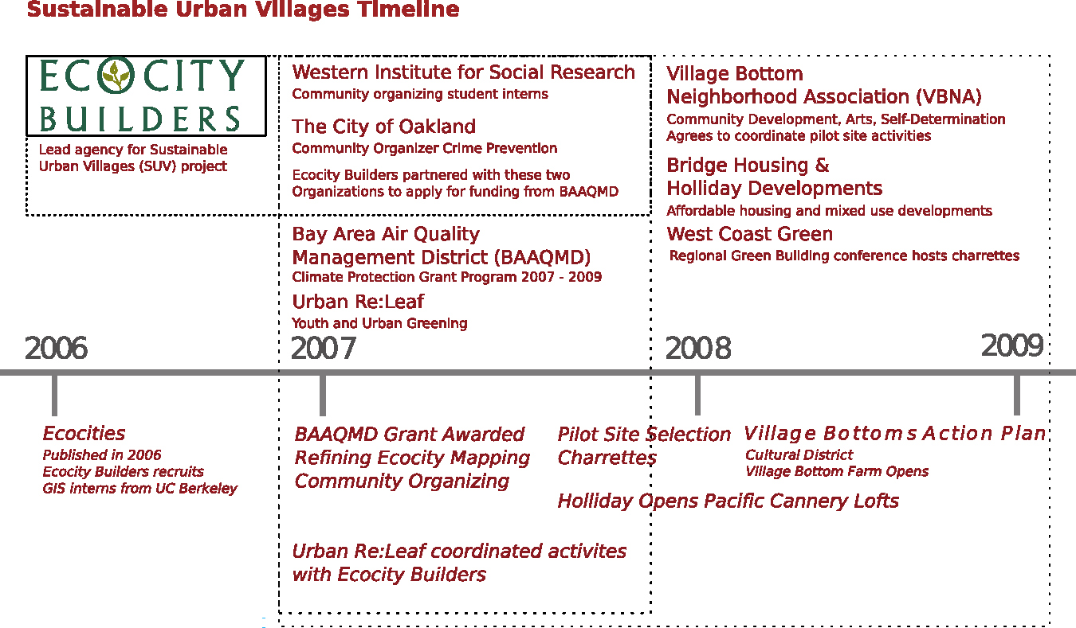

**Figure 4**: Timeline of community-based partnerships for pilot site from 2006 to 2009.

Phase One: Community Organizing and GIS for Pilot Site Section

Although Ecocity Builders has over 20 years experience in popular education and community engagement in Berkeley, California, it had not yet worked extensively in neighboring Oakland. Therefore, Ecocity Builders was an outsider to many neighborhoods in Oakland and had to establish trust with residents and organizations in the community (11). For this reason, in 2007 Ecocity Builders partnered with community organizers from the City of Oakland and the WISR in order to coordinate one-on-one organizing sessions with organizations in neighborhoods that could partner on the SUV project. African- American organizers emphasized the importance of Caucasian professionals and other outsiders understanding the history of oppression and exclusion experienced by communities of color in Oakland (45; 46).

In 2008 during the first year of implementation, Ecocity Builders met with community organizers to share the results of the GIS vitality analysis and discuss five initial potential urban village pilot sites. Two were in East Oakland, which is predominantly Latino, and three were in West Oakland, which is majority African-American with some African and Asian immigrants. The City of Oakland and Ecocity Builders were comfortable working with any neighborhood. WISR had strong ties to West Oakland because of an existing pool of students and alumni. Consequently, in late summer of 2008 the SUV project team agreed to choose West Oakland as a pilot. In order to identify a specific neighborhood for a pilot, the SUV team needed more detailed data on West Oakland. Ecocity Builders and WISR met one-on-one with 43 other community based organizations, including one, Urban Releaf, a community greening initiative, which had also received a climate protection grant from BAAQMD. Urban Releaf and Ecocity Builders organized high school students to conduct a subjective inventory of community assets in West Oakland. The Village Bottom Neighborhood Association (VBNA) emerged from the one-on-ones as a formal partner because they had an interest in self-determination, preserving African-American heritage and environmental justice, and had been working with residents to start social enterprises.

Phase 2: The SUV Pilot Planning Process

The Village Bottoms neighborhood, along Pine Street, formed the western edge of the Prescott neighborhood of West Oakland, about a ten-minute walk from the West Oakland transit station. Because this neighborhood is next to the Port of Oakland, it did not have four of five amenities within walking distance in the initial vitality analysis. However, during community organizing and outreach that occurred in 2008, the SUV team determined that VBNA had a mature community engagement process, an emerging vision for a sustainable neighborhood, and a demonstrated need for access to services and nature. They also convinced local recyclers to reduce business activities that compromised air quality.

The south end of Pine Street included the vacant Phoenix Iron Works, which needed environmental remediation. The north end of Pine ended at Central Station (47), a green development at the historic terminus of the Transatlantic Railroad. This mixed income, mixed use development contained the Ironhorse, a low-income housing tax credit project with 99 units of green affordable housing, which were available to families at or below 50% of area median income (48). The developer, Bridge Housing, Inc. (49) was a non-profit with a for-profit affiliate, Holiday Developments, which handled the market-rate portions. Retail spaces were built in the adjacent Pacific Cannery Lofts, a market rate property (50). VBNA partnered with Bridge Housing and Holiday Developments in 2008 to lease the retail spaces and provided leads for potential residents of the new Central Station development. Finally, VBNA and Bridge Housing had completed an oral history of the neighborhood so that they could preserve local culture despite anticipated gentrification by new Central Station residents.

While SUV collaborators recognized the importance of dense affordable housing to increase use of transit, walking and biking, and, in turn, improve air quality, they needed input from both existing and new residents to identify ways to preserve the local culture. To engage local residents, in the summer of 2008 and 2009 community leaders from VBNA and Ecocity Builders brought a vanload of residents to West Coast Green, a regional green building conference, to have a design charrette facilitated by national experts with support from the Home Depot Foundation. A charette is a form of community participation in which citizens and experts join at a roundtable to solve a community design problem. Ecocity Builders and VBNA secured volunteer professional architects, landscape architects and planners to compile the drawings and notes from each table for inclusion in the neighborhood plan. Each table had a facilitator, resident, non-profit leader, business leader, planner, and architect. Participants first came to agreement on the values and vision that residents had for their community. Then participants brainstormed strategies for change, while the volunteer architects sketched ideas generated. In 2008, Ecocity Builders and VBNA also conducted series of charettes with residents on weekday evenings at the Central Station development.

The vision statement generated from residents for the Village Bottom Action Plan completed in the summer of 2009 was to: 1) "activate Pine Street as a retail and cultural destination"; 2) "increase self-determination, self-reliance and ecological resiliency"; and 3) "prevent displacement through equitable partnerships, land ownership and 'bottom-up' planning."(36). The main theme of the plan was to create a living testimony to African-American culture as a tourist destination, in the same way various Chinatowns are for the Chinese-American culture and the Castro is for the lesbian, gay, bisexual, and transgendered (LGBT) culture in San Francisco. The creation of landmarks would create a regional identity to preserve social sustainability. Highlights include:

* Village Bottom Farms: This 3000 sq. ft., closed-loop urban agriculture site plan includes a raised bed garden, greenhouse, herb box, fish tanks, and compost bins.
* Community Retail: An antiques shop, the Soul Food Coop, and the Black Dot Café would provide jobs and meet some needs to reduce vehicle miles traveled to improve air quality.
* African-American Heritage Museum: Use the vacant Ironworks facility to expand the farm and build a cultural center featuring a quilt museum, tropical plant conservatory, and a vegetated buffer will filter air coming from the East Bay with bamboo, native trees, and an orchard.
* New Greenways: To reduce vehicle miles traveled to improve air quality, two new greenway parks would provide improved pedestrian and bike access to the transit station and Shoreway Park.

To show how Pine Street would look completion, architects drew vertical cross sections as recommended by step five of the ecocity mapping process.

Evaluation of Environmental Impact

The only evaluation activity required by the funding agency, BAAQMD, was to assess each intervention in terms of its impact on greenhouse gas (GHG) as expressed in carbon dioxide equivalents (CO2) (44). Because ecocity mapping was a planning tool and not the intervention, estimates were prospective in nature. In the summer of 2009, the GIS team developed scenario maps, ecocity mapping step seven, and used formulas provided by BAAQMD and population data from the US Census to estimate the changes in GHG (See Figure 5). The Village Bottom Farm estimate came from the known ability of vegetables to absorb carbon from the atmosphere for a potential savings of 21 metric tons/CO2/year. The Soul Food Co-op could save as much as 34 metric tons/CO2/year. The greenway could reduce a potential 91 metric tons/carbon dioxide/year. While the project would have benefited from a formal evaluation, none of the partner organizations had the resources to conduct one.

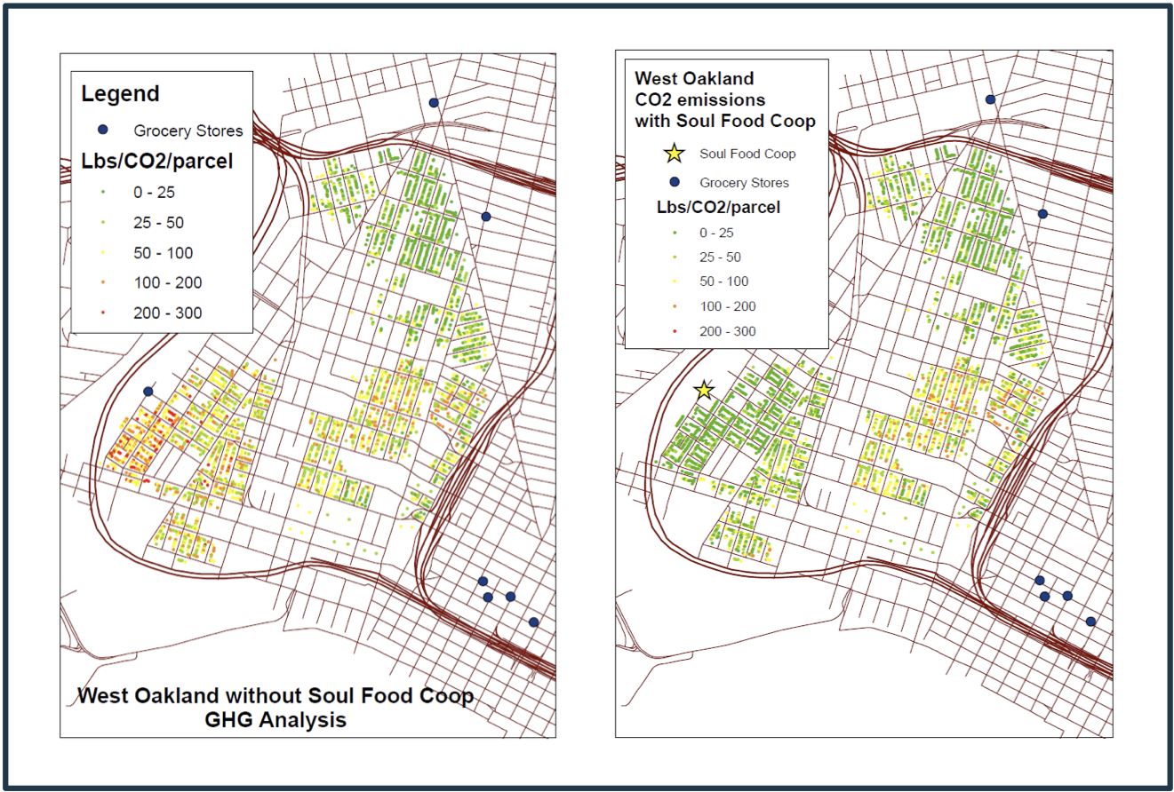

**Figure 5**: Ecocity mapping step seven--scenario maps of air quality impacts.

Conclusions and Lessons Learned

The community-based plan, partly informed by ecocity mapping and analysis, identified ways low- and moderate-income housing residents could derive health benefits from street-level retail with healthy food, community gardens, and improved pedestrian access to transit and local parks. Several lessons emerged from this process that will be discussed one by one.

Problems and Potential for GIS

Primarily, using GIS for ecocity mapping was useful for an initial city-wide vitality analysis of existing vitality, instead of relying on outdated zoning maps. Neighborhood residents were able to verify and complement more complex assessments of vitality that included up to 23 or more variables, not just the five that Ecocity Builders used to assess vitality for the city. In the SUV pilot, organizational relationships and capacity eventually became more important than numeric measures of vitality. GIS was more useful for neighborhood level scenario maps to demonstrate the benefits of walkable environments on air quality.

Ecocity Builders learned it needed to take advantage of third wave PPGIS (19) technologies and put GIS into the hands of residents. Ecocity Builders has since partnered with Ushahidi and ESRI to develop an ecocitizen crowdmap platform that residents can use to post photos and information to crowd-source an asset map. The data points can then be brought over into an online GIS environment for more detailed analysis and comparison against local data and information about the bio-geo-physical and social-cultural conditions of the area.

Neighborhood Priorities vs. Institutional Priorities

A second lesson from this project is that because of the great recession of 2008, basic human needs and then foreclosures became unexpected foci. While residents were concerned about air quality and quality of life, they were also concerned about gentrification, jobs, safety, and retail opportunities. Consistent with lessons from literature (18; 22), community organizers reported that the short-term needs and issues of race, power and community capacity overshadowed institutional needs for long-term environmental planning (17; 46). By partnering with a neighborhood association that had a current track record of delivering opportunity, the SUV project was able to be perceived as legitimate among residents.

Community idea generation

Community engagement was an excellent source of idea generation for the Village Bottom Action Plan. For example, residents suggested improving pedestrian and bike access to the Shoreway Park and the transit station. For the Village Bottoms, local history was an asset to help define a vision for planning that represented the community. This was the inspiration for the cultural center.

In summary, ecocity mapping helps identify areas with existing vitality and also helps determine ways to increase vitality. This may not only improve air quality but also physical activity, which can improve other health outcomes related to obesity and cardiovascular health. While article describes expert first wave PPGIS, interventions will be greatly improved by use of mobile third wave PPGIS. With proper attention to privacy and research ethics, users may input data about community assets and health risks in real time via a mobile device. While the ecocity mapping approach used for the SUV Project was developed as a planning tool, it should be of interest to community-based health researchers who target interventions based on the built environment.

Acknowledgements

Funding for this intervention was provided by the Bay Area Air Quality Management District (BAAQMD), Kaiser Permanente, Foundation for Sustainability and Innovation, LiveEdge, Miller Company Landscape Architects, California Waste Solutions, It's a Grind Coffee House, and Pacific Coast Brewing Company. Collaborators included Ecocity Builders, Western Institute of Social Research, the City of Oakland, Urban Re-Leaf, the Village Bottoms Community Development Corporation, Village Bottoms Neighborhood Association (VBNA), Prescott Joseph Center for Community Enhancement, and Oakland Technology Exchange West. The GIS team included students and alumni of the University of California, Berkeley: David Ried, Stephanie Hsia, Jason Hayter and David Schecter. This manuscript benefited from comments made by Albert Acker, Joanne Smith-Darden and anonymous reviewers.

References

1. Kemp SP. Recentring Environment in Social Work Practice: Necessity, Opportunity, Challenge. [Internet]. British Journal of Social Work 2011 Sep;41(6):1198–1210.[cited 2012 Feb 13] Available from: <http://bjsw.oxfordjournals.org/content/41/6/1198.short>
2. Glass G. Geographic Information Systems for the People. [Internet]. Progress in Community Health Partnerships: Research, Education, and Action 2008; 2(1):3–4.[cited 2012 Mar 8] Available from: http://muse.jhu.edu/journals/progress_in_community_health_paatnerships_research_education_and_action/v002/2.1glass.html
3. Hillier A. Why social work needs mapping. [Internet]. Journal of Social Work Education 2007 Apr;43(2):205–222.[cited 2012 Feb 13] Available from: <http://dx.doi.org/10.5175/JSWE.2007.200500524>
4. Alinsky S. Reveille for Radicals. New York: Vintage; 1946.
5. Alinsky S. Rules for Radicals. New York: Vintage; 1971.
6. Warren MR. Dry bones rattling: community building to revitalize American democracy. Princeton, N.J: Princeton University Press; 2001.
7. Freire P. Pedagogy of the Oppressed. New York: Continuum; 1970.
8. Horton M, Freire P. We Make the Road by Walking: Conversations on Education and Social Change. Philadelphia: Temple University Press.; 1990.
9. Boggs GL, Kurashige S. The Next American Revolution Sustainable Activism for the Twenty-First Century [Internet]. Berkeley: University of California Press; 2011.[cited 2012 Jul 25]
10. Cordner A, Ciplet D, Brown P, Morello-Frosch R. Reflexive Research Ethics for Environmental Health and Justice: Academics and Movement Building. [Internet]. Social Movement Studies 2012;11(2):161–176.[cited 2012 Jul 25] Available from: http://www.tandfonline.com/doi/abs/10.1080/14742837.2012.664898
11. Minkler M. Ethical Challenges for the “Outside” Researcher in Community-Based Participatory Research. [Internet]. Health Educ Behav 2004 Dec;31(6):684–697.[cited 2012 Mar 8] Available from: http://heb.sagepub.com/content/31/6/684
12. Mulligan M, Nadarajah Y. Working on the sustainability of local communities with a “community-engaged” research methodology. [Internet]. Local Environment 2008;13(2):81–94.[cited 2012 Jul 25] Available from: http://www.tandfonline.com/doi/abs/10.1080/13549830701581911
13. Nyden P. Academic Incentives for Faculty Participation in Community-based Participatory Research. [Internet]. Journal of General Internal Medicine 2003;18(7):576–585.[cited 2012 Jul 25] Available from: http://onlinelibrary.wiley.com/doi/10.1046/j.1525-1497.2003.20350.x/abstract
14. Stoecker R. Are academics irrelevant? Approaches and roles for scholars in community based participatory research. In: Minkler M, Wallerstein N, editors. Community-based participatory research for health. San Francisco, CA: Jossey-Bass; 2008 p. 107–120.
15. CCPH Board of Directors. Principles of Good Community-Campus Partnerships [Internet]. 2006;[cited 2012 Mar 8] Available from: http://depts.washington.edu/ccph/principles.html#principles
16. Tandon SD, Phillips K, Bordeaux B, Bone L, Brown PB, Cagney K, Gary T, Kim M, Levine DM, Price E. A vision for progress in community health partnerships. Progress in Community Health Partnerships: Research, Education, and Action 2007;1(1):11–30.
17. Freudenberg N, Pastor M, Israel B. Strengthening Community Capacity to Participate in Making Decisions to Reduce Disproportionate Environmental Exposures. [Internet]. American Journal of Public Health 2011 Dec;101(S1):S123–S130.[cited 2012 Jul 28] Available from: http://ajph.aphapublications.org/doi/full/10.2105/AJPH.2011.300265
18. Barndt M. A model for evaluating public participation GIS. Community participation and geographic information systems 2002;346–356.
19. Ganapati S. Public Participation Geographic Information Systems: A Literature Survey. [Internet]. Comparative E-Government 2010;449–466.[cited 2012 Jul 25] Available from: http://www.springerlink.com/index/V64455J834641L44.pdf
20. Obermeyer NJ. PPGIS: the evolution of public participation GIS. In: Unpublished UCGIS white paper. 1998 p. 1–5.
21. Sieber R. Public participation geographic information systems: A literature review and framework. [Internet]. Annals of the Association of American Geographers 2006;96(3):491–507.[cited 2012 Jul 25] Available from: http://www.tandfonline.com/doi/abs/10.1111/j.1467-8306.2006.00702.x
22. Bishop SW. Building Programmatic Capacity at the Grassroots Level: The Reactions of Local Nonprofit Organizations to Public Participation Geographic Information Systems. [Internet]. Nonprofit and Voluntary Sector Quarterly 2010 Dec;39(6):991–1013.[cited 2012 Jul 23] Available from: http://nvs.sagepub.com/content/39/6/991
23. Caley LM, Shiode N, Shelton JA. Community/Campus Partnership: Tailoring Geographic Information Systems for Perinatal Health Planning. [Internet]. Progress in Community Health Partnerships: Research, Education, and Action 2008;2(1):23–29.[cited 2012 Mar 8] Available from: http://muse.jhu.edu/journals/progress_in_community_health_partnerships_research_education_and_action/v002/2.1caley.html
24. Ecocity Builders. Ecocity Builders [Internet]. 2012;[cited 2008 Jul 23] Available from: http://www.ecocitybuilders.org/
25. Register R. Ecocity Berkeley: Building Cities for a Healthy Future. Berkeley, CA: North Atlantic Books; 1987.
26. Register R. Ecocities: rebuilding cities in balance with nature. New Society Publishers; 2006.
27. Downton PF. Ecopolis Architecture and Cities for a Changing Climate [Internet]. 2009.[cited 2012 Aug 19] Available from: http://www.springerlink.com/content/978-1-4020-8495-9/#section=118456&page=1
28. Kenworthy JR. The eco-city: ten key transport and planning dimensions for sustainable city development. [Internet]. Environment and Urbanization 2006 Apr;18(1):67–85.[cited 2010 Mar 27] Available from: <http://eau.sagepub.com/cgi/content/abstract/18/1/67>
29. Rees W, Wackernagel M. Urban ecological footprints: why cities cannot be sustainable—and why they are a key to sustainability. Urban Ecology 2008;537–555.
30. Rees WE. Cities as Dissipative Structures: Global Change and the Vulnerability of Urban Civilization. In: Weinstein MP, Turner RE, editors. Sustainability science: the emerging paradigm and the urban environment. Springer New York; 2011
31. Wang R, Zhou T, Hu D, Li F, Liu J. Cultivating eco-sustainability: Social–economic–natural complex ecosystem case studies in China. [Internet]. Ecological Complexity 2011 Dec;8(4):273–283.[cited 2012 Aug 19] Available from: <http://www.sciencedirect.com/science/article/pii/S1476945X11000304>
32. Soleri P. Arcology: The city in the image of man. Cambridge, MA: The MIT Press; 1974.
33. McHarg IL. Design with nature. Garden City, NY: The Natural History Press; 1969.
34. Beaumont JR. Location-allocation problems in a plane a review of some models. Socio-economic planning sciences 1981;15(5):217–229.
35. Church RL. Geographical information systems and location science. Computers and Operations Research 2002;29(6):541–562.
36. Ecocity Builders. Ecocity Mapping for Urban Villages [Internet]. Oakland, CA: 2009.[cited 2012 Mar 7] Available from: <http://www.scribd.com/doc/44265860/BAAQMD-Final-Report-July1>
37. Hu PS, Reuscher TR. Summary of Travel Trends 2001 National Household Travel Survey. ORNL; 2004.
38. Rose D, Richards R. Food store access and household fruit and vegetable use among participants in the US Food Stamp Program. Public Health Nutrition 2007;7(08):1081–1088.
39. Cao X, Mokhtarian PL, Handy SL. Examining the Impacts of Residential Self-Selection on Travel Behaviour: A Focus on Empirical Findings. Transport Reviews 2009 May;29(3):359–395.
40. Shay E, Khattak AJ. Automobiles, Trips, and Neighborhood Type: Comparing Environmental Measures. Transportation Research Record 2007;2010(-1):73–82.
41. Boer R, Zheng Y, Overton A, Ridgeway GK, Cohen DA. Neighborhood design and walking trips in ten US metropolitan areas. American journal of preventive medicine 2007;32(4):298–304.
42. Cromley E, Kleinman LC, Ramos MA, Arniella G, Viswanathan N, Garel M, Horowitz CR. A Community-Engaged Approach to Select Geographic Areas for Interventions to Reduce Health Disparities. [Internet]. Progress in Community Health Partnerships: Research, Education, and Action 2011;5(3):299–305.[cited 2012 Mar 8] Available from: <http://muse.jhu.edu/journals/progress_in_community_health_partnerships_research_education_and_action/v005/5.3.cromley.html>
43. Western Institute for Social Research. Western Institute for Social Research [Internet]. 2009;[cited 2012 Mar 9] Available from: http://www.wisr.edu/
44. Bay Area Air Quality Management District. Climate Protection Grant Program Guidelines [Internet]. 2007;Available from: <http://www.baaqmd.gov/Divisions/Strategic-Incentives/Climate-Protection-Grant-Program.aspx>
45. Wilson SM (Sacoby M, Wilson OR, Heaney CD, Cooper J. Use of EPA Collaborative Problem-Solving Model to Obtain Environmental Justice in North Carolina [Internet]. Progress in Community Health Partnerships: Research, Education, and Action 2007;1(4):327–337.[cited 2012 Mar 8] Available from: <http://muse.jhu.edu/journals/progress_in_community_health_partnerships_research_education_and_action/v001/1.4wilson.html>
46. Wilson OR, Bumpass NG, Wilson OM, Snipes MH. The West End Revitalization Association (WERA)’s Right to Basic Amenities Movement: Voice and Language of Ownership and Management of Public Health Solutions in Mebane, North Carolina [Internet]. Progress in Community Health Partnerships: Research, Education, and Action 2008;2(3):237–243.[cited 2012 Mar 8] Available from: <http://muse.jhu.edu/journals/progress_in_community_health_partnerships_research_education_and_action/v002/2.3.wilson.html>
47. Holliday Development, H.F.H., Ltd. Central Station [Internet]. [date unknown];[cited 2012 Mar 8] Available from: <http://www.welcomeaboard.com/pages/home.html>
48. BRIDGE Housing. Ironhorse at Central Station [Internet]. 2008;[cited 2012 Mar 8] Available from: <http://www.bridgehousing.com/Ironhorse>
49. BRIDGE Housing. BRIDGE Home [Internet]. 2008;[cited 2012 Mar 8] Available from: <http://www.bridgehousing.com/Home>
50. PCL Associates, LLC. Pacific Cannery Lofts San Francisco Bay Area Real Estate For Sale [Internet]. 2007;[cited 2012 Mar 8] Available from: <http://www.pacificcannerylofts.com/>