Creating Learning Objects in powerpoint
Step-by-step
- Download the media into powerpoint
  - Use the Tool to select a VMC portfolio and then to download that portfolio into a powerpoint 2007. Power point 07 has an XML base. You can resave later into earlier versions of powerpoint. The Mac version, keynote will also work as it has the same XML base.
  - Open the newly created powerpoint, rename and save.
  - Choose View Tab from tab menu bar.
    - Select Slide Master from Presentation Views. The most common template, or master, was chosen for this tool, i.e., Title with text that appears to the right of the downloaded photos. If this master is not already highlighted on the left side, choose it. This master will not show the actual text. (It will say “Click to edit Master ….) Title and text are filled in from the fields found in the Virtual Motor City collection when you go back to Normal view.
    - You can change the text size and font on this master. You might also want to move the location and size of the text box and/or the title box.
    - Grab the edge of the box to move or change size.
    - To change size to type of text, Highlight text and then choose Home Tab, where you will use Font tools to make changes.
  - To see your changes, choose View Tab from menu bar and then from Presentation Views click on Normal. If the changes you made still need editing, repeat Step 3.
  - To change background of slide, choose Design Tab. Choose Background Styles. (Do not use Themes)
  - Save your work.
Tip: Once you have the slide in a style that you like, all other slides using the same Master will also change. If not use the Slide Sorter from View, select all the slides, go the Home Tab and choose Reset from Slides section.

- Review learning object components
  - Introduction
  - Learning objective(s)
  - Explanation, description, background,
  - Examples
  - Relationship to other relevant concepts
  - Practice
  - Assessment
  - Summary
- Combine media, text and learning strategies for each component of the learning object. See the following example:
Introduction (advance organizer)  Overview, why is it important to learn; How could it be applied to real life; how is it relevant …; connected … | 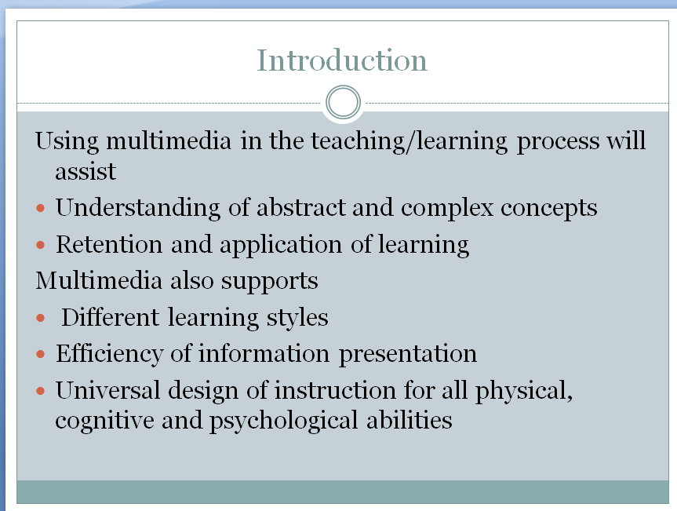
Learning Objectives  What will students be able to do after the lesson? Use verbs that are measurable and applicable to the type of learning desired. Is it knowledge to be gained (identify criteria)? Or will the students do something with that knowledge (apply criteria)? Or will they subject their learning to a parsing and comparison with other learning (analyze photos)? | 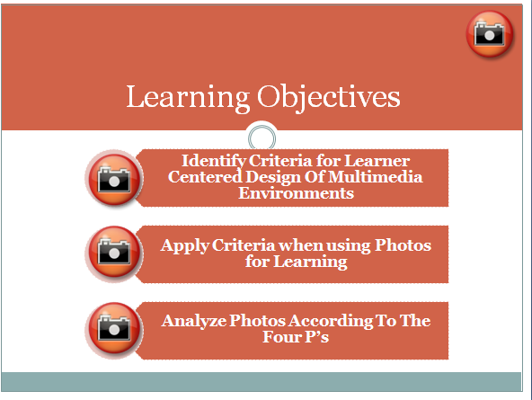
Explanation, description, background  Are you presenting a process? A concept? Something concrete? Abstract? | 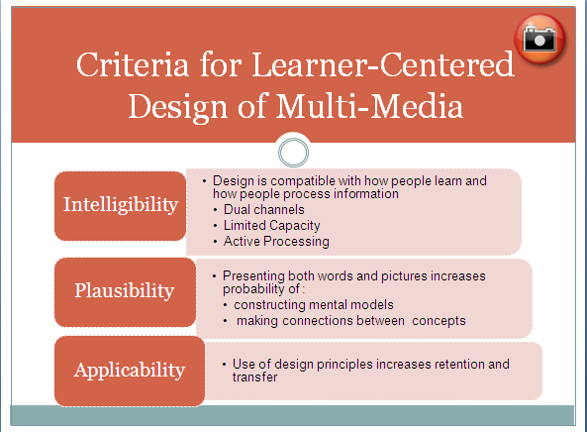
Examples  Some complete, some incomplete; highlight the distinctiveness, emphasize what is defined. | 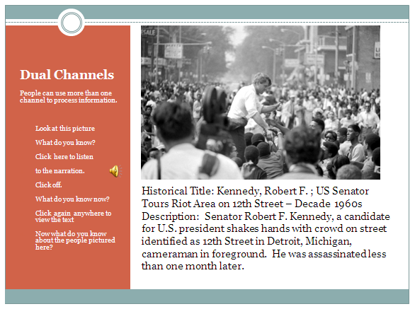
Relationship to other relevant concepts  How does the object fit into the content area, the discipline, a concept map? To what is it connected; part of? Is it a sub category or supra? | 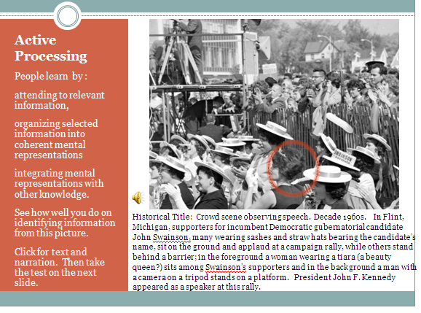
Practice  Hands-on engagement with learning object. Doing. Reflecting. | 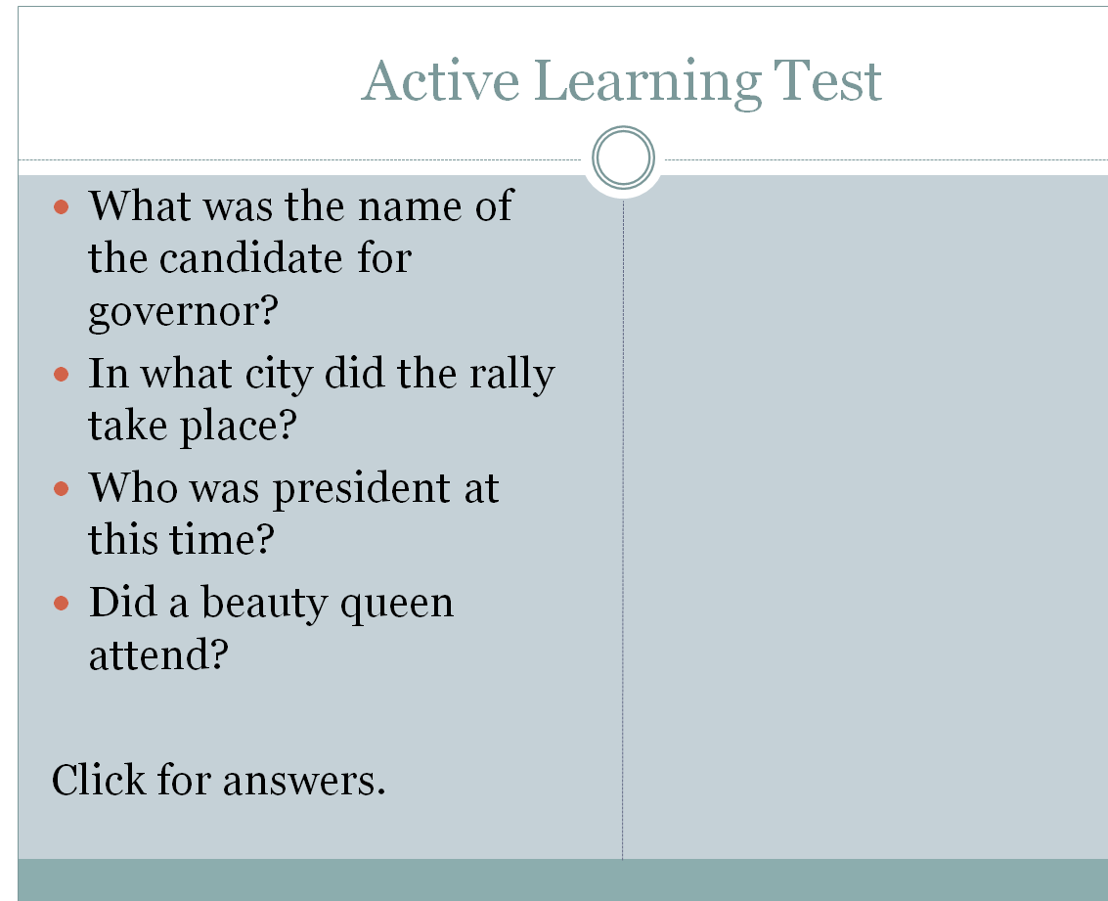
Assessment  Align with learning objectives above. If you want application, then create new examples and new content. | 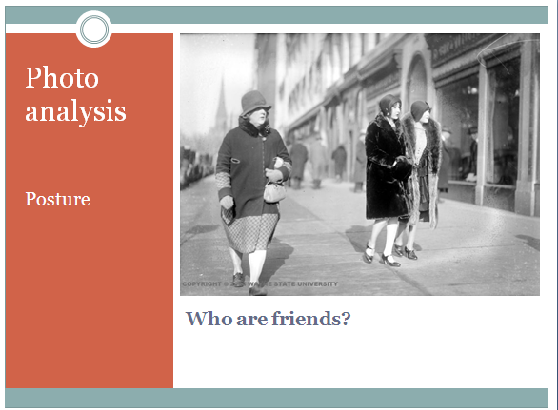
Summary  What was learned. | 