**RefStats Tool Documentation**

# Table of Contents

Table of Contents

About

Button / Transcation Definitions

How to Use

Selecting Location

Recording Transactions

Managing Transactions

Manually Adding Transactions

Edit Transaction

Contact

# Button / Transaction Definitions



**Defined:** Involves the logistical use of the library, campus or the website. Includes questions on policies and procedures.

**Examples:**

* Where is a department located?
* How late are you open today?
* What is the URL for the library homepage?
* Do you have vending machines in this building?
* How does course reserves work?



**Defined:** Involves the knowledge, use or instruction of one or more information sources (catalog, library homepage, print books, databases, etc.) and lasts less than 3 minutes.

**Examples:**

* Do you own this book?
* How do I cite a web page using APA style?
* Where should I go to find resources relating to social work?



**Defined:** Involves the knowledge, use or instruction of one or more information sources (catalog, library homepage, print books, databases, etc.) and lasts more than 3 minutes.

**Examples:**

* I need 5 literary criticism articles.
* Can you help me locate this specific inventory for PTSD?
* I need help finding historical images of a particular building.



**Defined:** Pertaining to general circulation functions

**Examples:**

* General inquiries about Circulation policies and procedures
* Check in/out materials from the general stacks
* Collect Library fines
* Creating/updating patron records



**Defined:** Pertaining to Reserve items

**Examples:**

* General inquiries about Reserve materials
* Check in/out items from Reserves collection
* Process request for items to be on Reserve



**Defined:** Pertaining to ILL / MEL items

**Examples:**

* General inquiries about ILL / MEL materials
* Check in/out ILL / MEL materials
* Assist with requesting ILL / MEL materials



**Defined:** Pertaining to public printing, copying, scanning services

**Examples:**

* General inquiries about printing/copying/scanning services
* Assist with printing/copying/scanning process
* Submit a maintenance request



**Defined:** Pertaining to public computing services

**Examples:**

* General inquiries about public computing
* Assist with WSU related applications (i.e. Academica, Blackboard)
* Assist with Microsoft Office applications or other specialty software applications



**Defined:** Pertaining to personal mobile devices

**Examples:**

* General inquiries about personal mobile devices
* Assist with accessing/configuring mobile device with WSU wireless



**Defined:** Pertaining to assisting Library System staff

**Examples:**

* Assist with inquiries regarding desktop support for Library System staff
* Submit a maintenance request



**Defined:** Pertaining to assisting Library System staff

**Examples:**

* Assist with inquiries regarding classroom technology
* Assist with inquiries regarding lecture capture technology
* Submit a maintenance request

# How to Use

## Selecting Location

Select the reference desk location from where you will be recording reference statistics. When selected, the Please Select Your Location button will show a drop down menu listing the appropriate libraries.



# 

After selected, the screen will notify you that your reference location been set.

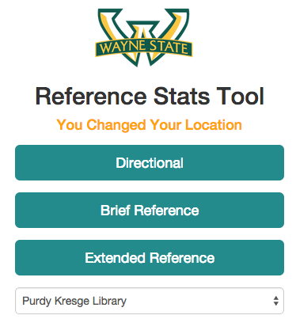

Now that you’ve set your location, you can begin using the Reference Stats Tool. **Please note: some locations (e.g. Neef and Med) will reveal buttons and user groups buttons applicable to that location.**

## Recording Transactions

After a reference transaction has occurred, click the appropriate button to record the type of transaction.

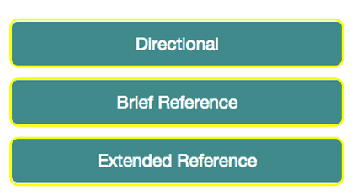

After you click the button, the transaction will logged by RefStats, and a confirmation message will display at the top:

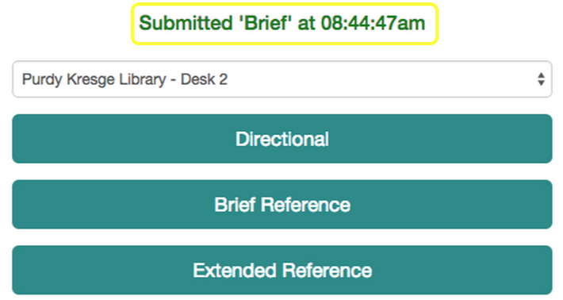

You can edit this transaction immediately - perhaps you made a mistake and clicked the wrong button - by clicking the “Submitted” message, which will take you to the edit screen. For more information on editing this transaction, click here.

You can also see that the transaction was updated in Today’s Stats, displayed at the bottom of the screen. The statistics are colored coded according to transaction type.

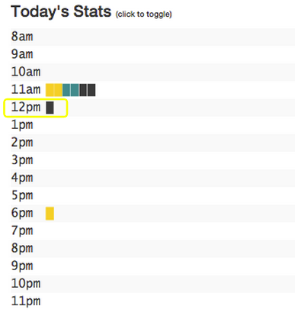

## Managing Transactions

To manage recorded reference transactions, click the “Edit Transactions” button just below the main recording buttons:

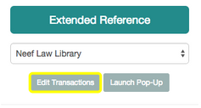

*Figure: Edit Transactions button*

On the next screen, you will be presented with a table showing reference statistics for your **currently selected** location from the main screen. **Note**: the tool is designed to be in a small, narrow window, this editing area is not. It is recommended that you make the window bigger to more efficiently edit transactions.

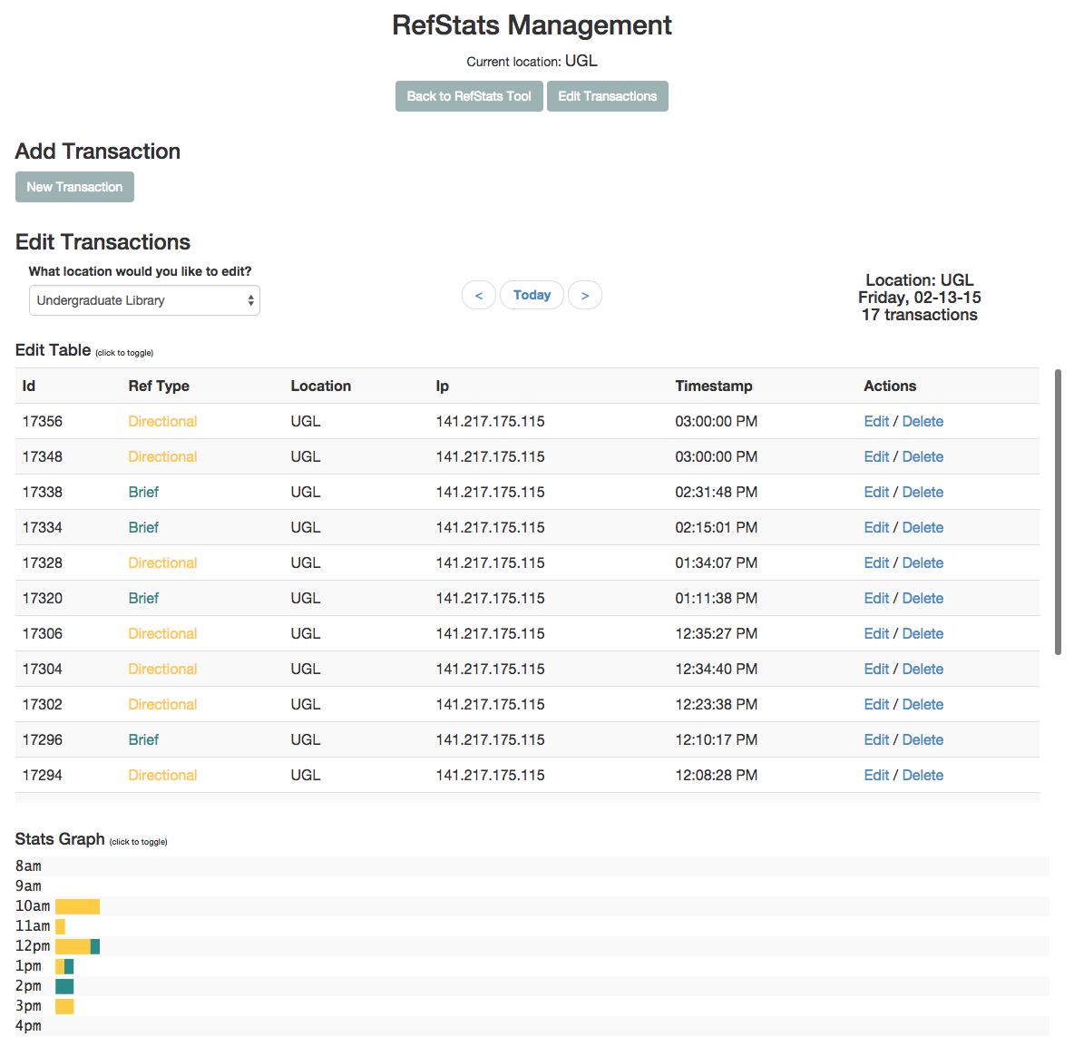

*Edit Transactions main screen*

When you begin editing, your location will be set to your location from the main page. You can also view / edit transactions from other locations by using the “What location would you like to edit?” menu as shown here:

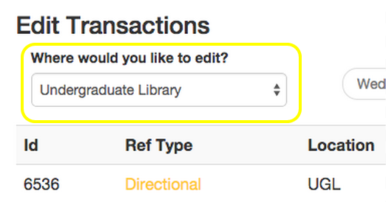

*Figure: “Where would you like to edit” menu*

**Note:** Changing your location from this menu is temporary - returning to the main screen will revert back to the location selected for reporting stats (creating new transactions will default to your currently selected location as well). This is by design, to discourage viewing stats from another location, but then forgetting you changed locations, and errantly recording transactions for the wrong location. **Selecting your location on the main screen is the preferred and most enduring method to set your location.**

From this screen you are able to create new transactions, edit and delete previously recorded transactions, cycle through different days, and at the bottom, see transactions for the currently selected day.

## Manually Adding Transactions

To create a new transaction, click the “New Transaction” button at the top. This will bring up the following window:

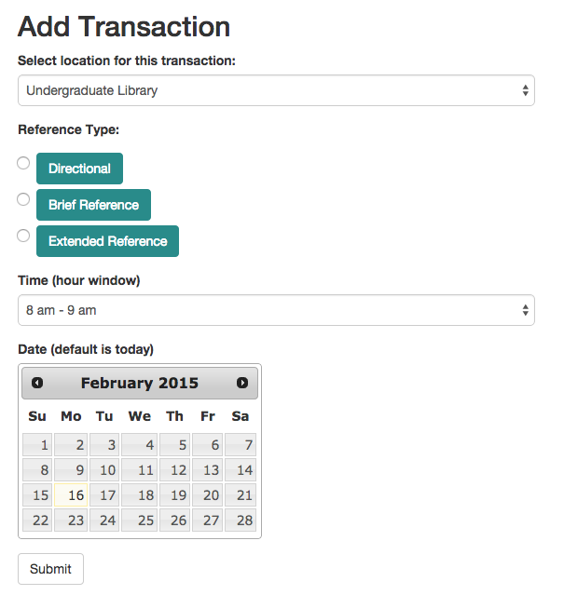

From here you are able to add a new transaction, reference type, hour, and date.

If you need to revise a previously recorded transaction, you can click “Edit” from the table, under the “Actions” column:

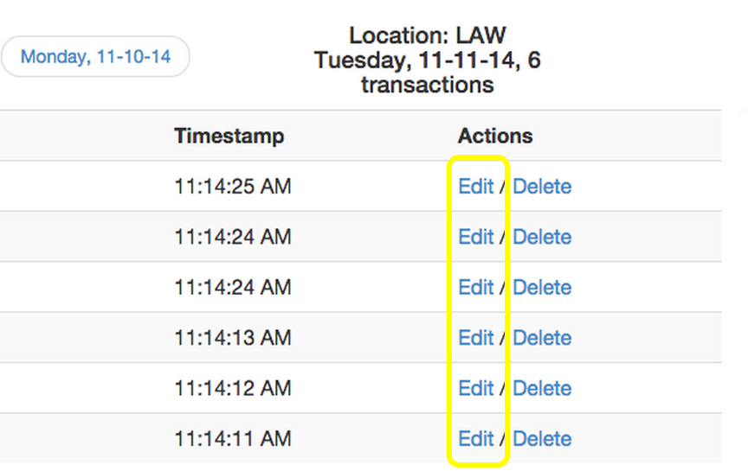

*Figure: Click “Edit” to edit transaction*

## Edit Transaction

This will bring up the following “Edit Transaction” window:

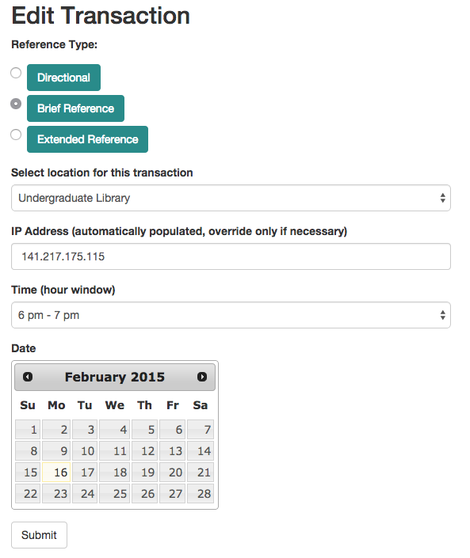

*Figure: Edit Single Transactions window*

From this window, you are able to change the reference type, the location of the transactions, the IP of the computer where the transaction took place (not recommended to change), time, and date. **Note**: when editing a transaction, you may only select the hour window for which the transaction was recorded, not the minutes or seconds.

If you need to delete a transaction, simply click “Delete”. **Note:** Deleting a transaction from the transactions table is immediate, and irreversible. But remember, you can add them again if need be!

# Contact

For additional help please contact:

|  |  |  |
| --- | --- | --- |
| Katrina Rouan | 313-577-5296 | [dv5445@wayne.edu](https://mail.google.com/mail/?view=cm&fs=1&tf=1&to=dv5445@wayne.edu) |
| Matthew Wisotsky | 313-993-7641 | [aj3401@wayne.edu](mailto:aj3401@wayne.edu) |
| Rod Fiori | 313-577-6109 | [ab5395@wayne.edu](mailto:ab5395@wayne.edu) |
| Cole Hudson | 313-577-2659 | [fi1806@wayne.edu](https://mail.google.com/mail/?view=cm&fs=1&tf=1&to=fi1806@wayne.edu) |
| Graham Hukill | 313-577-5951 | [ej2929@wayne.edu](https://mail.google.com/mail/?view=cm&fs=1&tf=1&to=ej2929@wayne.edu) |
| Library Webmaster |  | [libwebmaster@wayne.edu](https://mail.google.com/mail/?view=cm&fs=1&tf=1&to=libwebmaster@wayne.edu) |