VCCS [requires CST]
Requirement Report
Author: <Author name>
Revision: 0.1

NA
NA | Date: March 09, 2026

Revision History
Revision | Date | Reason For Changes | Author
1.0 | Jan 02, 1990 | <Release> | <Author Name>
0.1 | Jan 01, 1990 | <Initial draft> | <Author Name>
Table of Contents
Microsoft Word users please click here and press F9 to create Table of Contents.
OpenOffice.org users please remove this text and select Insert Table of Content from menu.
Table of Figures
Microsoft Word users please click here and press F9 to create Table of Contents.
OpenOffice.org users please remove this text and select Insert Table of Content from menu.
Executive Summary
This section previews the main points of a report. The executive summary contains enough information for a reader to get familiarized with what is discussed in the full report without having to read it.

Introduction

Purpose
<This document provides requirements with their properties including requirement id, requirement name, requirement text and the dependencies.>

Scope
<Provide a short description of the system being specified and its purpose, including relevant benefits, objectives, and goals.>

Overview
<Describe what the document contains and explain how the document is organized>

Report Requirements

RR Report Requirements
HEADER

RR.1 Traceability Tables
The report shall include traceability tables linking requirements to allocated components and verification methods.
Documentation:
Traceability supports assessment of requirement implementation status and compliance with systems engineering practices.
Comment:
Traceability supports assessment of requirement implementation status and compliance with systems engineering practices.
Verify Method:
Inspection

RR.2 On-Demand Generation
The report shall be capable of being generated on demand to support monthly reporting and preparation for major technical reviews.
Documentation:
Program management requires recurring and ad-hoc reporting for leadership visibility and review readiness.
Comment:
Program management requires recurring and ad-hoc reporting for leadership visibility and review readiness.
Verify Method:
Demonstration

RR.3 Word-Compatible Output
The report shall support export to Microsoft Word format suitable for contractual documentation and review packages.
Documentation:
Program review artifacts and contract deliverables are typically compiled and delivered in Word documents.
Comment:
Program review artifacts and contract deliverables are typically compiled and delivered in Word documents.
Verify Method:
Demonstration

RR.4 Automated Model Extraction
The report generation process shall automatically extract information from the system model without manual data entry.
Documentation:
Automated extraction reduces effort and ensures consistency between the model and review artifacts.
Comment:
Automated extraction reduces effort and ensures consistency between the model and review artifacts.
Verify Method:
Demonstration

RR.5 Plain Language Terminology
The report shall present information using plain-language terminology understandable to non-SysML stakeholders (e.g., component, implements, verification method).
Documentation:
Many report consumers have limited familiarity with SysML constructs; terminology must support comprehension by mixed technical audiences.
Comment:
Many report consumers have limited familiarity with SysML constructs; terminology must support comprehension by mixed technical audiences.
Verify Method:
Inspection

RR.6 Requirement Scope Filtering
The report shall allow filtering to include only system-level and subsystem-level requirements while excluding deprecated or derived requirements.
Documentation:
Stakeholders require focused reporting to avoid overwhelming leadership with irrelevant or obsolete requirements.
Comment:
Stakeholders require focused reporting to avoid overwhelming leadership with irrelevant or obsolete requirements.
Verify Method:
Test

RR.7 Traceability Gap Identification
The report shall identify requirements lacking allocation to components or lacking verification coverage.
Documentation:
Stakeholders need rapid visibility of gaps before technical reviews and program management meetings.
Comment:
Stakeholders need rapid visibility of gaps before technical reviews and program management meetings.
Verify Method:
Test

RR.8 Requirements Traceability Summary
The reporting solution shall generate a structured report summarizing system and subsystem requirements, their allocated components, and associated verification information extracted from the system model.
Documentation:
Stakeholders require a consolidated view of requirements traceability to assess design progress and coverage during project reviews.
Comment:
Stakeholders require a consolidated view of requirements traceability to assess design progress and coverage during project reviews.
Verify Method:
Inspection

Appendix A: Diagram

Report Requirements
NA
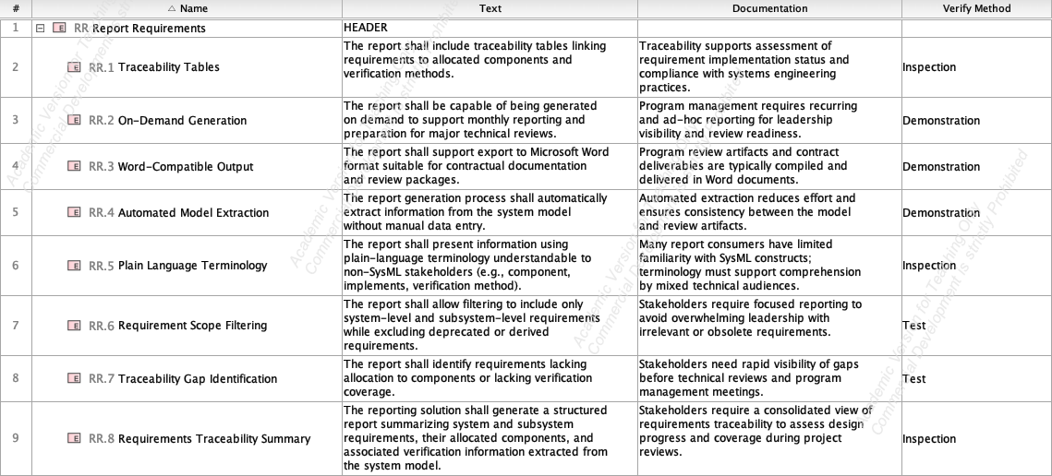
- Report Requirements

