DNRC Water Right Query System Help Guide

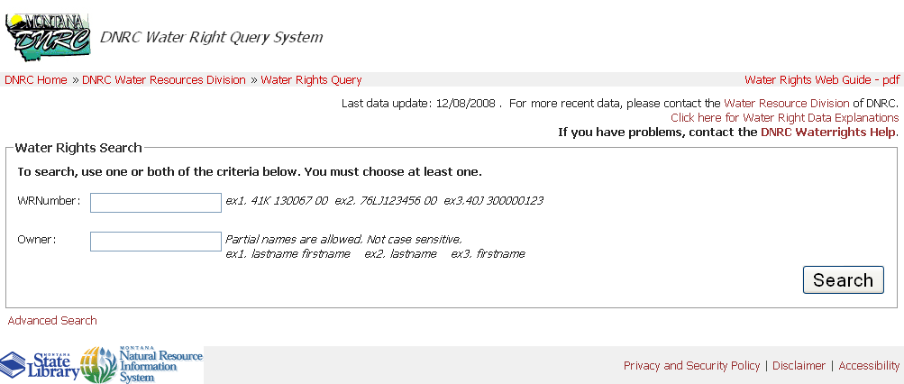

Table of Contents

Introduction 2
Sources of Water Right Data 2
Types and Format of Water Right Information 2

Instructions For Using the Water Right Query System 3
Advanced Search Steps 4
Viewing the Report 5

Link URLs                                                               5

Introduction
The Montana Department of Natural Resources and Conservation (DNRC) and the Natural Resource Information System (NRIS) of the Montana State Library are pleased to present the Montana Water Rights Query System. This Internet tool provides on-line access to the DNRC Water Rights Database.

The Upper Clark Fork River Basin Steering Committee, through their requests for resource data played an important role in stimulating the development of the original Water Rights Query System.

As the Upper Clark Fork project matured a decision was made to develop this tool, not just for the Upper Clark Fork river basin, but also for the entire state. The DNRC and NRIS have jointly developed and maintained the Water Rights Query System and in 2008 improved the query tools to make the application more useful to Montana water users and researchers. The improvements added several query criteria and a slightly different user interface.

Sources of Water Right Data
The DNRC Water Right database is accessible through two different Internet applications. The NRIS Digital Atlas of Montana () and the DNRC Water Right Query System (); both provide access to the same formats of water right information but use different methods to query that data.

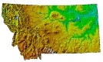
Digital Atlas of Montana
The NRIS Digital Atlas of Montana is an application that allows a user to find water rights and many other types of data through several geographic query tools. The result of the Digital Atlas geographic query is an Interactive Mapping Tool (iii) where the user can view the data in an interactive map display, toggle the data layers, download reports in a text file format or GIS shape file of the displayed data.

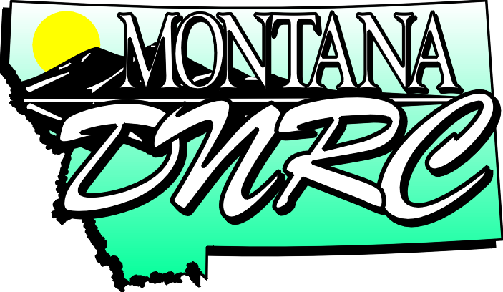
Water Right Query System
The DNRC Water Right Query System is an easy to use gateway to find reports of water rights organized by various criteria. A user can generate abstracts of water rights and view scanned historical documents in the water right files. The Water Rights Query System also provides links to the same Interactive Mapping Tool (iii) that the Digital Atlas uses except through the Water Right Query System only one water right will be viewed at a time.

Types and Format of Water Right Information
Both applications offer the water right information in the following formats:

Water Right Indexes
There are several water right indexes to choose from. Each index presents a different selection of water right data. The indexes are shown in a table that includes a link to a summarized water right abstract, a link to the scanned file documents, a link to the NRIS Interactive Mapping Tool that shows only the record selected and a link to download the entire index in a text file that can be imported into a spreadsheet or database program. The index data is sometimes shown with acronyms or abbreviations, for these a Description of the Index Data () may be useful.

NRIS Interactive Mapping Tool ()
Is a web based GIS application that allows the user to view and manipulate the water right data in an interactive map layout along with other map layers provided by NRIS. The application can display the water right data over several background images such as USGS topographic maps and aerial photos. The application also has the ability to format the map in a printable version with a data legend, scale and other map details.

Scanned File Documents
In all of the indexes under the “Doc Image” column is a link to that water right’s scanned file documents. The scanned documents include the original claim file, ownership updates, adjudication documents and permit applications.

GIS Shape Files
Shape files are generated from the centroid of the Point of Diversion or Place of Use legal land description from the water right database. The points are only as accurate as the legal land description in the water right. A Point of Diversion description of a quarter, quarter, quarter section will produce a point in the center of that ten acre area. A point of use description with an entire section will produce a point in the center of that square mile.

Instructions For Using the Water Right Query System
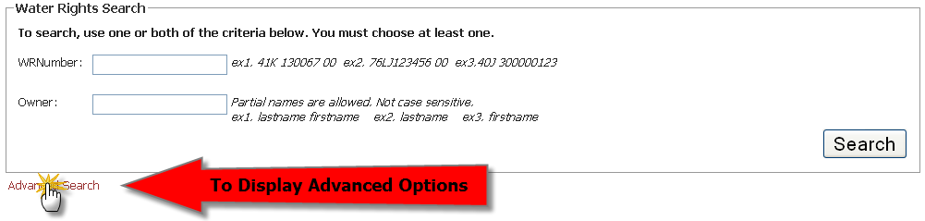
The Water Right Query System has an Advanced Search and a Simple Search option. The Simple Search is presented initially and allows the user to enter either a water right number or an owner name. To expand the page to the Advanced Search options, click on the Advanced Search link at the bottom left of the page.

Advanced Search Steps
- Select an index type. Each index includes slightly different information. If an index type is not selected the search will use the default index.

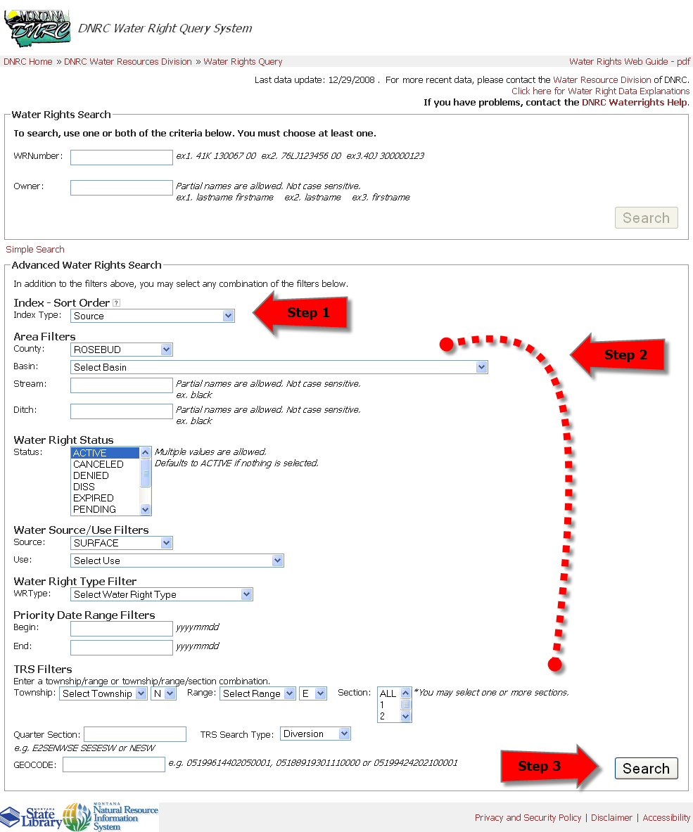
- Enter the search criteria or filters. A combination of any of these can be used to narrow the search: County, Basin, Stream, Ditch, Water Right Status, Source, Use, Water Right Type, Priority Dates, Legal Land Description and Geocode.

Note: Several of the Filters are designed to include anything that closely matches what is entered in the text box. For example if a Stream named “Rock Creek” is search for any variation of “Rock Creek” will be returned with the report.

- When all the search criteria are selected, press the Enter key on the keyboard or click on the Search button at the bottom right of the web page.

Viewing the Report
A report will then be generated based on the entered search criteria and the index type. There may be several pages of the report not shown; if there are, the links to the rest of the report will be at the bottom of the page.

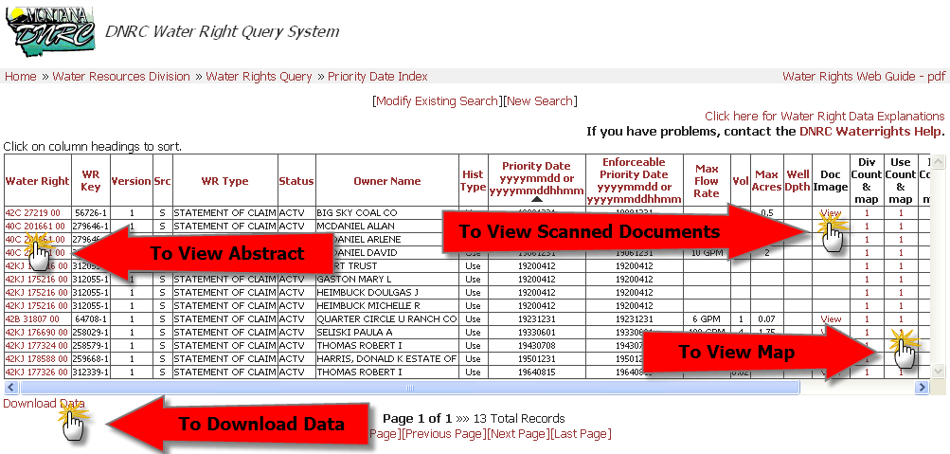
For a short abstract of a the water rights that appears on the report, click on the Water Right number in the first column.

To view scanned documents that are in the water right file click on the View link associated with the water right under the Doc Image column.

To download a text file of all the data in the report to use for analysis or manipulation on other software click on the Download Data link at the bottom left of the web page.

To view a map of the selected water right in the Interactive Mapping Tool (iii), click on the number below the Div Count & Map or the Use Count & Map columns.

Link URLs

http://maps2.nris.mt.gov/mapper/
http://nris.mt.gov/dnrc/waterrights/ iii http://maps2.nris.mt.gov/mapper/mapperhelp/mapimageguide.html
http://nris.mt.gov/dnrc/waterrights/wrkeydocfeb05.htm
http://maps2.nris.mt.gov/mapper/mapperhelp/mapimageguide.html

