|  |  |
| --- | --- |
|  | **Level Design   Document** |
|  | UFCF7M-30-2 Game Level Design |
|  | *William Whitehouse 19019239* |

Contents

Change Log 2

Copyright Notice 2

Overview 3

Quick Summary / X-Statement 3

Game Concept 3

Objective Summary 5

Location 5

Metrics 5

Level Atmosphere & Mood 5

High-Level Design Devices 6

Player Activities & Actions 6

Equation 6

Rhetoric 7

Level Rules (Sieve) 7

Pillars 7

Level Design 8

Level Flow Diagram 8

Level Bubble Diagram 9

Detailed Level Bubble Diagram 9

Regions 9

Maps & Elevations 9

Game Design 10

Systems 10

Lighting 10

Physics 10

Particles 10

Heads Up Display (HUD) / User Interface (UI) 11

Cinematics 11

Entities 13

# Change Log

|  |  |  |
| --- | --- | --- |
| Version No. | Date | Significant Changes |
| 1.3 | 22/12/2020 | Added Equation, Copyright Notice, and pillars. Reformatted Onion Diagram |
| 1.2 | 21/12/2020 | Rewritten Game Concept, fixed and replaced Onion Diagram and fixed Objective Summary to match new game concept. |
| 1.1 | 11/12/2020 | Added introduction paragraph to Level Flow Diagram. |
| 1.0 | 08/12/2020 | Initial document creation |

# Copyright Notice

This document and its contents are copyright of William Whitehouse - All rights reserved.

Any redistribution or reproduction of part of or all the contents in any form is prohibited other than the following:

* You may print, download or store a local copy for your personal and non-commercial use only.
* You may copy the contents to individual third parties for their personal use, but only if you acknowledge the document as the source of the material

# Overview

## Quick Summary / X-Statement

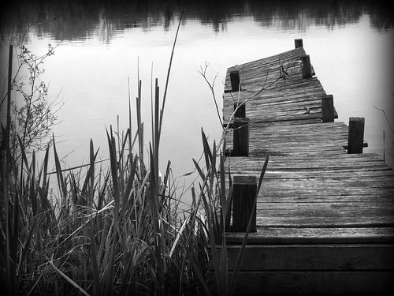The player must find missing persons but gets trapped in the other side. Then the player must escape the island before being captured by the monster who dwells there.

## Game Concept

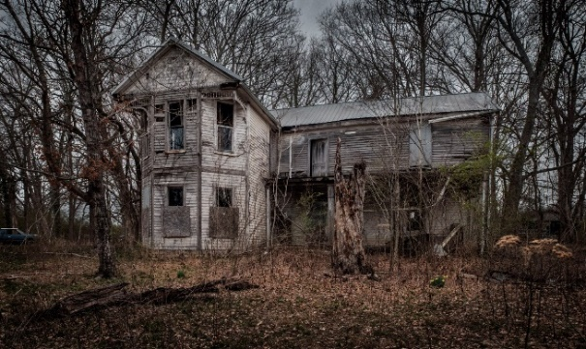A mainland police office, the player, arrives on a damp and dull isolated Scottish island by boat. They dock the boat at a small, very poorly maintained dock, they are only one other boat docked there. The mainland police officer is there to investigate disappearances, they are directed to the old police station to get up to speed on the current investigation. The player gets some information about the disappearances and uncovers that they occur on the other side of the island in an old forest.

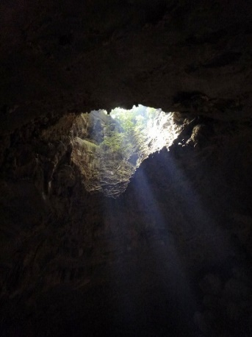Player heads towards the forest following dim torch light to explore (they also have a flashlight with them they can use), once they’ve entered the forest the player stumbles upon an old, seemingly abandoned cabin. The cabin is locked. The player has the choice to knock on the door, but nobody will answer. The player can look through the cabin windows to see inside they can see a ladder heading into the ground in the far corner of the cabin with a faint light emanating from it. Player searches the nearby area around cabin to find items that could open the door, there will be multiple ways for the player to achieve this. For example, an old rusty key found around back of the cabin, a bent crowbar under a pile of leaves, a woodcutter’s axe sticking out from a log. The player walks into the cabin and they can now descend the ladder. While going down the ladders break, and the player falls down a small cavern hits the bottom. The ladder falls with them; there is no way back up.

The player is in a cave system, the cave walls are covered in some light foliage and some chains handing from the cave roof and resting on the floor (these are physics objects they can interact with). While moving forward through the caves he encounters a dead human body. He doesn’t look like one of the disappearances, but the body is old and has been there for a while. The body is holding a strange cube stone-like artefact. The player picks the artefact up.

At the end of the cave system the player finds a large circular stone structure. In front of this structure is a plinth with a cube shaped hole in the top. The player inserts the artefact into the plinth, and it locks in place. The stone structure rotates (similar to a [stargate that has been dialled](https://www.youtube.com/watch?v=sFSEV9hDAx0)) and also locks in place. After taking the artefact the structure creates a portal/gateway in the centre and opens to the other side. The player walks through.

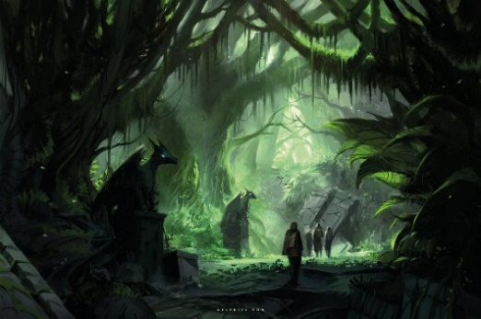The player emerges into a cave system closely related to the one they were just in. It’s an alien realm, known as the other side and it almost mirrors the real world. The physics and gravity are different in this realm, the player can do higher/longer jumps and is “floatier” while in the air. The player comes across another artefact and picks it up, when they do so, this time it burns their hand and an engraving is burnt onto the players hand. They have now unlocked the double jump powerup. The player must complete some platforming challenges, with the use of their new powerup, to reach the top of the cave and exit. On the way up however, the player missteps and a large boulder falls from a significant height making a loud crash as it hits the ground and blocking and significantly destroying the gateway back to the real world. A short time afterwards a loud growl can be heard from a distant creature/ monster, this creature sounds like nothing from the real world.

The player must now escape from the island as quickly as possible before being captured and killed by the monster. They must run and complete platforming challenges as the world is slowly collapsing around them and a void appears below them (missing a platform and landing in the void will result in the players death). The player is under a time constraint before being captured by the monster.

The player navigates all previous areas of the level but this time in the other realm. All the trees are overgrown and moving as if everything had a mind of its own, patterns and symbols (almost like graffiti) are written and etched into the sides of the trees and buildings. Strange plants and foliage surround them and will remind the player of a distant alien world.

The atmosphere will change throughout the escape. The sky and sun will get redder as time goes on to indicate the lack of time remaining. It will get duller and the players view distance will decrease as a dark and thick fog will start invading the island.

If the player makes it back to the village, they will be able to see their boat docked. They must enter the boat and the victory cutscene will start to play. This cutscene is the player slowly rowing away from the island back to the mainland, they can see a large shadow of the monster covering the island and growling again. The next levels could consist of the player trying to find a way back to the real world.

If the player doesn’t make it back to the boat within the time constraint the defeat cutscene will play. This cutscene consists of the monster plucking the player off the ground and holding him up to his eyes (this is very high up in the air). His eyes are shut initially but they will suddenly open and stare at the player. The screen will turn to black and the monster will growl one final time before the level finishes.

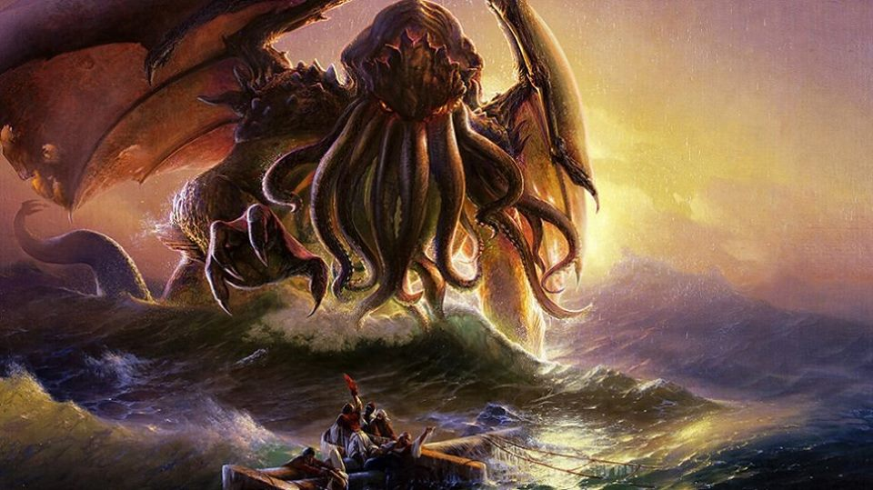

## Objective Summary

* Try to find missing persons by exploring forest.
* Player stumbles onto an old cabin and must get inside.
* While exploring the cabin they go down the ladders and gets stuck in a cave system, they must find a way out.
* Player finds an artefact and an old portal, using the artefact as the key the portal will open and the player can step through to the other side.
* Try and exit the cave system from in the other side.
* Player picks up an artefact that unlocks a double jump powerup.
* Player must complete platforming challenges (using the double jump) to escape the cave, they accidently awaken the monster.
* The player must race to their boat under a time constraint. If they make it, they beat the level, if not they lose. A cutscene plays either way.

## Location

* Isolated Scottish island – Small village, with some unfriendly people
* Dull, overgrown forest – This forest holds the old cabin the player must break into
* The caves – Claustrophobic caves with seemingly no escape
* The other side – A strange realm almost mirroring the real world, odd plants and wildlife. Something seems off, the sky is darker and is home to the monster.

## Metrics

* Timing – The player has at least three and a maximum of four minutes from starting the level to escape.
* Visual Themes:
  + Old and poorly maintained buildings and docks
  + Overgrown forest
  + Claustrophobic caves
  + Strange alien world – The other side

## Level Atmosphere & Mood

It’s a dark and dull winter afternoon on the island, it’s just been raining so the pavement is wet, and the soil is very muddy and sludgy. The sky is very cloudy indicating it could rain again very soon. The trees are slowly dripping rainwater and the forest is very damp and muddy.

# High-Level Design Devices

## Player Activities & Actions

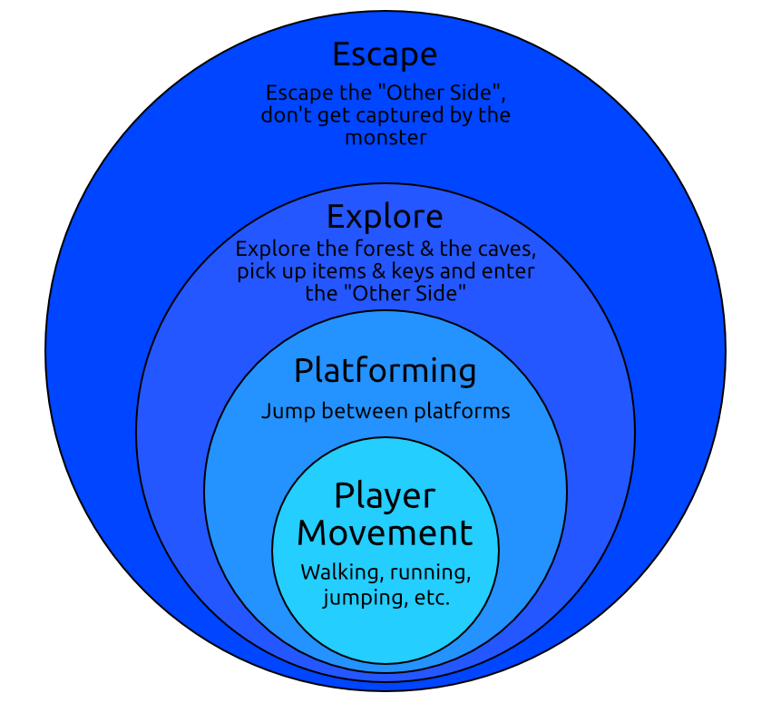

Figure 1 - Player Activities Onion Diagram

The player is capable of many different actions throughout the level. The onion diagram shows the different levels of importance each action represents and how each action depends on the previous. The actions in the outer layers are dependent on actions in the inner layers. For example, platforming isn’t possible without the player movement.

## Equation

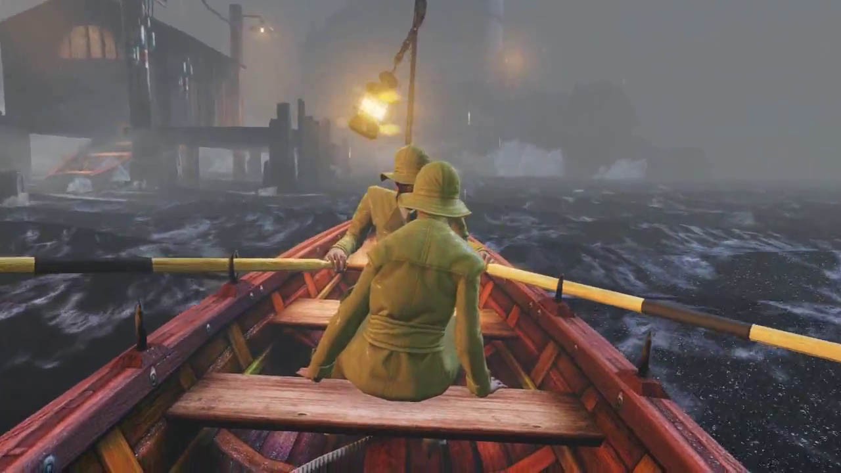

+

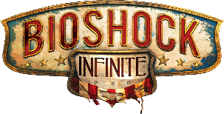

**Bioshock Infinite Opening**

Player arrives at an isolated island and gets transported to a different, unusual place.

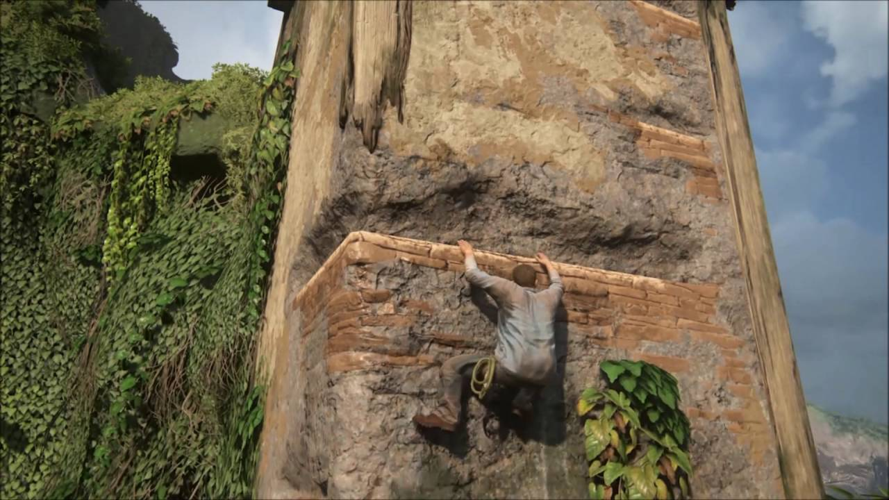

**Uncharted 4 Platforming**

Player must jump platforms and complete platforming / parkour challenges



Figure 2 - Equation

## Rhetoric

// TODO – Does the level have a meaning, a subtext or are you trying to show something or change people

## Level Rules (Sieve)

Below are a set of rules the level must follow. If the level does not follow all these rules, it must be discarded. This is for the level to follow the same narrative and feel as if it belongs with the other levels included in the final game and with different regions of the level itself.

|  |  |
| --- | --- |
| * The player has at least three and a maximum of four minutes from starting the level to escape. * Escaping the other side must be a challenge. The player must find three objects in order to escape. * The player must be able to use different items to break into the cabin. These items must be spread out enough to give the illusion that the player stumbled across an unintended item. | * The level must contain an amount of physics objects the player can interact with. * Cutscenes must not be longer than 10 seconds at a time in order to keep the player engaged. * The player should have safe points around the level where they will not be in danger – Where the player could save & quit the game or where they will be reset to if they die. |

## Pillars

// TODO

**Game Level Design**

// TODO

Figure 3 - Pillars

// TODO

# Level Design

## Level Flow Diagram

Below (figure 2) is a level flow diagram, this is a visual representation of the path the player will take through the level. At the end there is a split path, this the level outcomes. The victory outcome is when the player beats the level and escapes the island. The defeat outcome is when the player dies or gets captured by the monster.

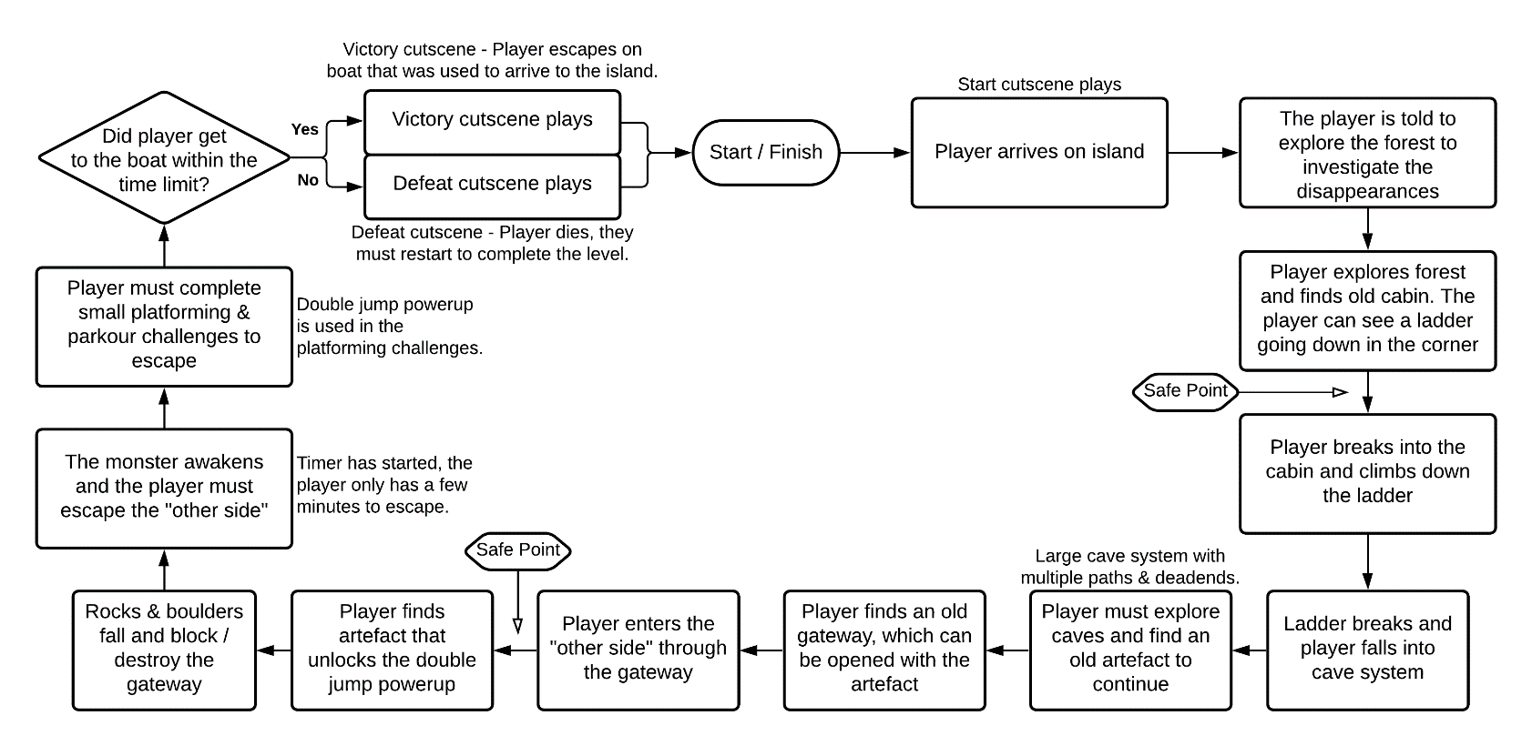

Figure 4 - Level Flow Diagram

## Level Bubble Diagram

## Detailed Level Bubble Diagram

## Regions

## Maps & Elevations

# Game Design

## Lighting

There will be some basic atmospheric lighting throughout the level. The island is dull and set in the late evening, meaning the lighting will be dull and contain no bright lights. A guiding light pattern will be used to guide the player through the start of the level. This will be done by torch light; small torches will be placed along the path leading the player to the abandoned cabin.

The caves will include some dim torches throughout that guide the player to the portal, this is another example of the guiding light level design pattern.

Bright lights will be used when opening the portal to the other side. The portal itself will emit a bright light; this is to indicate to the player there is something interesting about the portal and indicate to the player that they must enter.

Towards the end of the level (when the player is escaping the other side) the lighting will change and react to the time remaining. As time is running out the global lighting will get darker and the player will not be able to see as much, to accompany this, a fog will start appearing in the distance and start getting closer. This will negatively affect the players vision and they must try and escape while in this state.

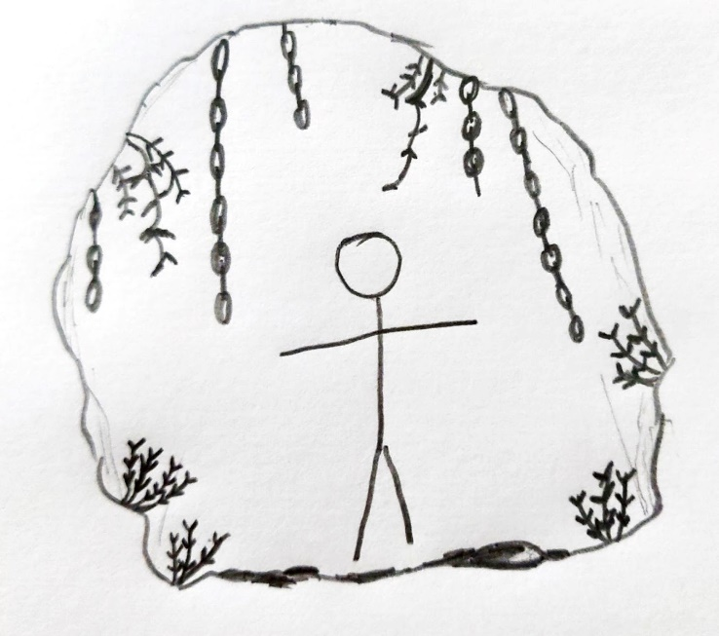

Player

Chains

Foliage

Figure 5 - Physics Objects in Cave

## Physics

There will be a few physics objects throughout the level that the player can interact with.

In the cave region of the level the player will come across foliage on the walls and ground. And chains hanging from the cave roof. These can be moved and interacted with as they will be using rigidbody physics. Figure 5 shows how the chains and foliage will be laid out through the cave.

There will be small rocks and pebbles throughout the cave system and the other side realm. These can be moved and pushed by the player and are fully interactable.

## Particles

There will be multiple particle systems throughout the level.

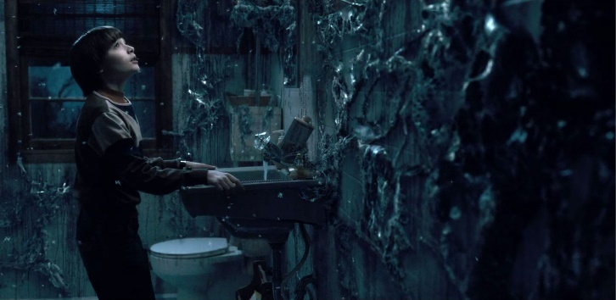

Figure 6 - Stranger Things "Upside Down"

The torches that guide the player will have a fire and smoke effect.

The other side will have a global dust-like particle system, this will look similar to the Stranger Things upside down which is shown in figure 6 on the right.

## User Interface (UI)

### Heads Up Display (HUD)

The level will include a minimal HUD only showing information the player will need throughout the level. Figure 5 is a diagram of the HUD. In the top-left will be a current objective text telling the player what they need to do next. It will not contain a large description of the objective and will update automatically at different points around the level. The bottom-right will contain the inventory bar, this is where any items the player picks up will be displayed, there is a maximum of 5 items that the player can carry. The player can switch between which item is currently active by using the 1 to 5 number keys on their keyboard each corresponding to each slot.

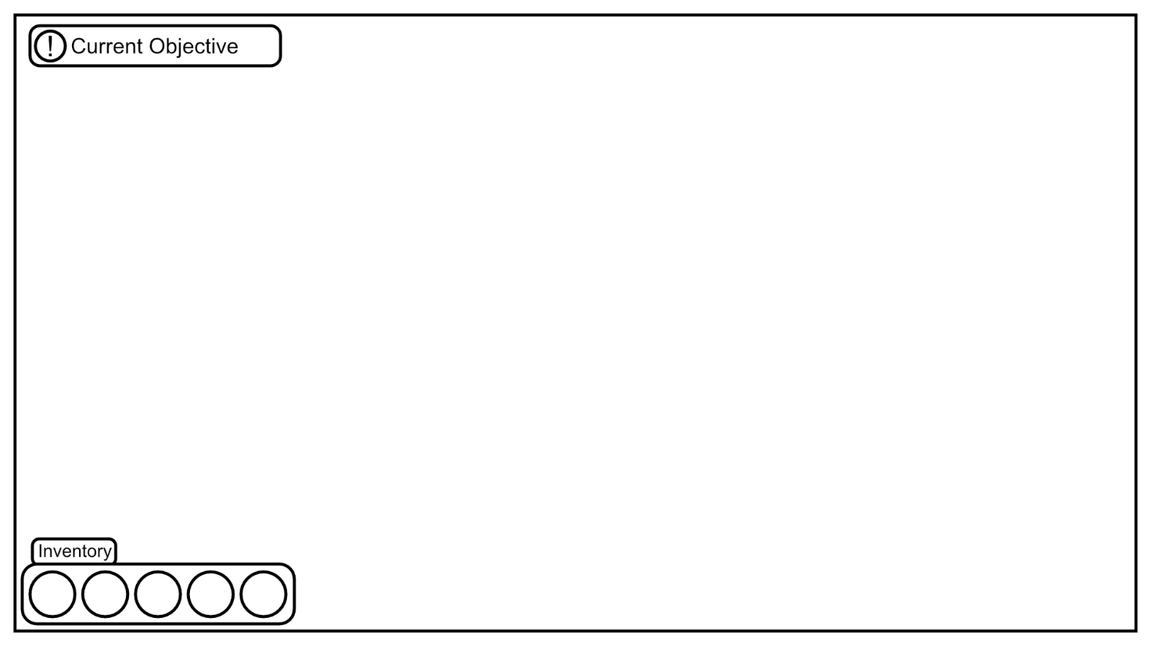

Figure 7 - In-Game HUD Layout

### Pause Menu

The pause menu will appear when the player clicks the pause key (most commonly the ‘ESC’ key). Pressing this key will also pause the game and stop it from progressing any further. Figure 8 shows the pause menu layout. There is a blur to hide the HUD and the game behind the menu.

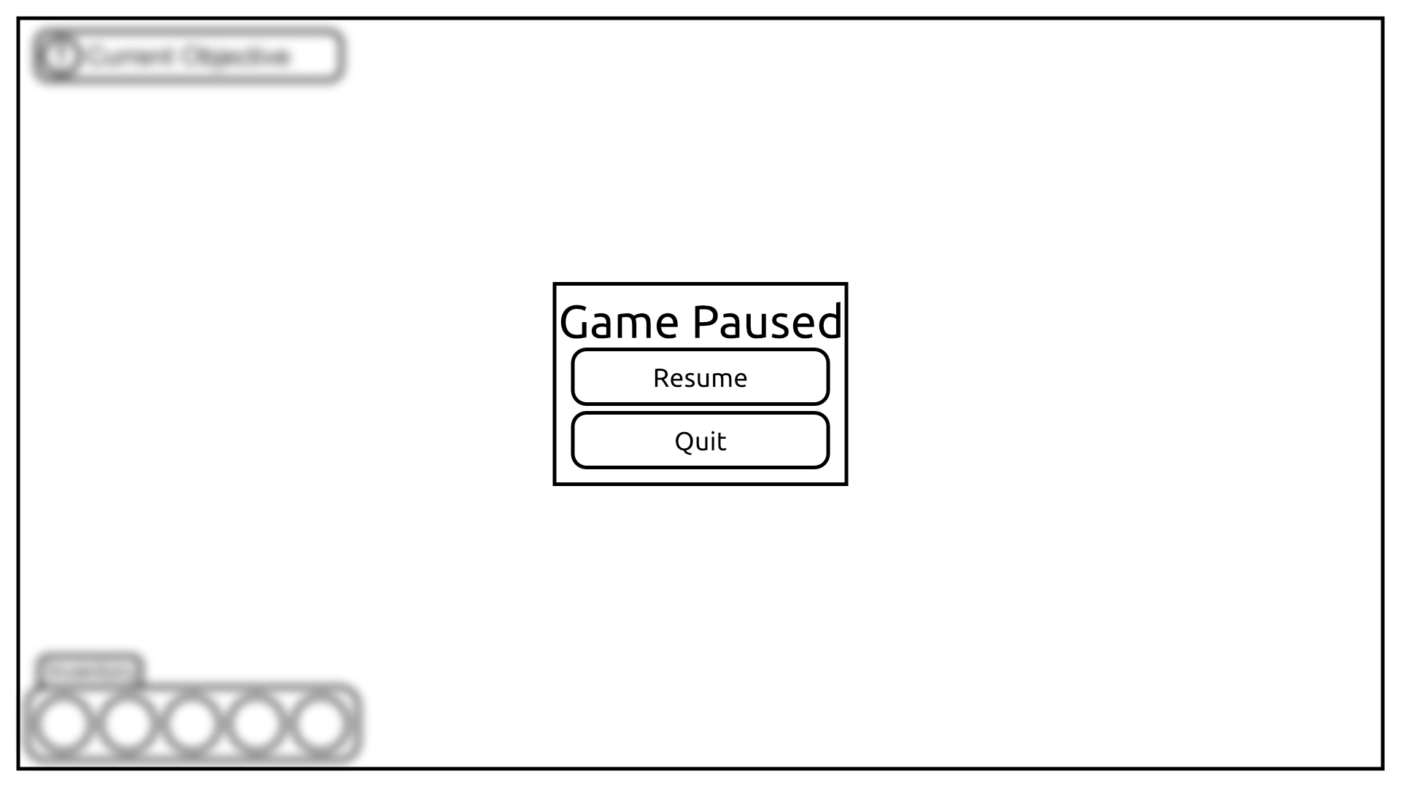

Figure 8 - Pause Menu Layout

## Cinematics

There will be multiple cinematics throughout the level to break up gameplay and to share important story details or moments with the player.

#### Opening Cinematic

The player takes control of the character as soon as they are on the docks, but before this moment a small cutscene showing a boat approaching the docks. This is the beginning of the story and shows the player that the character they are playing as has just arrived on the island.

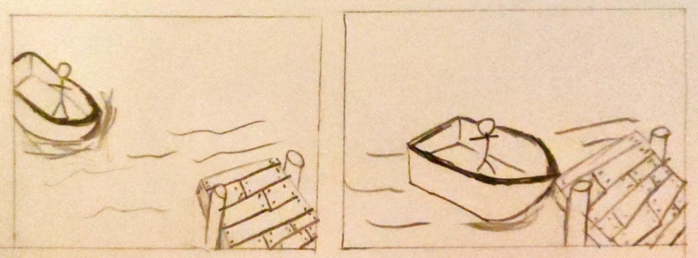

Figure 9 - Boat Approaching Dock Cinematic

This cinematic is very simple, it is just one shot of the boat slowly approaching the docks. Once this is complete the player takes control of the character who is now standing on the edge of the docks.

#### Ending Cinematic

There are two ending cinematics, a victory and defeat one. Whichever one gets displayed depends on if the player escapes the other side and gets back to the village.

## Entities