Working with Git and GitHub

Installing git

Click on https://git-scm.com/book/en/v2/Getting-Started-Installing-Git to download and install Git for Mac and Linux
Click on https://git-scm.com/download/win to download and install Git for Windows.

Configure name and email:
git config --global user.name "Your Name"
git config --global user.email "your@email.com"

Working with existing folders
pwd
#print working directory

cd “directory-name”
#change directory, moves to the folder you want to commit changes, fill in the directory name you want to go to, include it in quotes if you have spaces in your url

make a new directory, must change directory to start making changes to the new directory
mkdir new-directory-name

initialize a repository once you are in the desired folder
git init

check status of files in staging area, if changes made but unsaved, files will be red
files with no changes will be green
git status

list files in folder as git views them
ls

adds changes to staging area
git add file name

or add multiple files to staging area
git add file name file name file name file name

or add all files in project folder to staging area
git add .

To commit files from staging area
git commit -m “Commit message”

**If you forget to add a message tag (-m) to the first commit or if you need a bigger editing space for your message, bash will open up the default editor (Vim) so you can write a multi-line message.

Write your message
hit ‘i’ to insert
hit escape ‘Esc’ to leave edit mode
then type ‘:wp’
w writes the file
q quits the program

New repository in Github:

To create a new GitHub repository, navigate to github.com and press the plus symbol in the top-right corner, then select the 'New repository' option, as shown in the screenshot here:
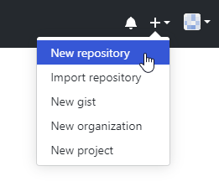
You can also navigate to the GitHub page for creating new repositories by visiting this link: https://github.com/new
On that page, we first need to specify a Repository name and an optional Description.
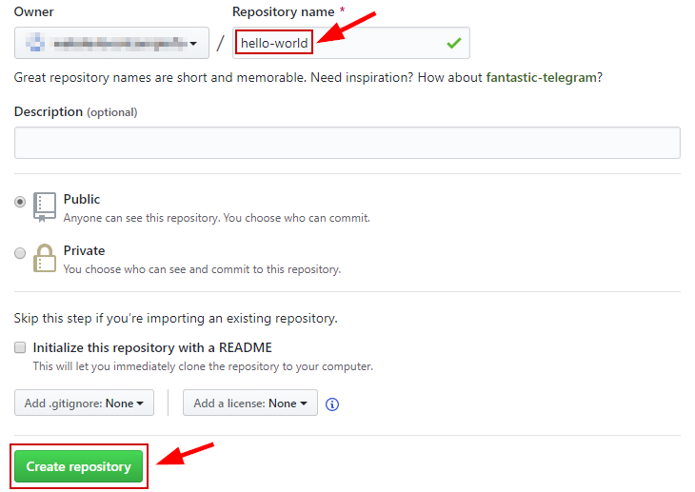
After the last step, you will be forwarded to the starting page of your new GitHub repository that looks like this:

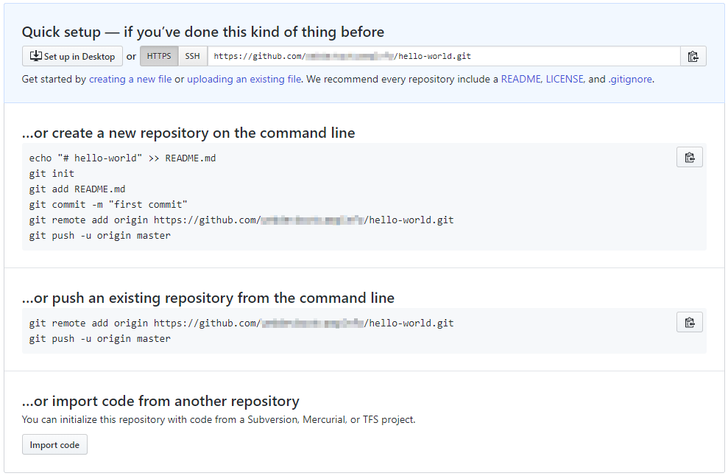

The git remote add origin command will associate our local repository with the remote GitHub repository that we just created.

The git push command will then push our local Git repository code to the remote GitHub repository. When pushing to your remote repository for the first time, add “-u” to set the upstream so that local repository knows there is an upstream repository to push to. “-u” only necessary for first push from local to new (empty) remote repository.
(origin is the standard name for the main remote repository)

git remote add origin https://github.com/<your-username>/<your-repo-name>.git
git push -u origin master

if there are new changes to your local repository that you want to push into remote (github)
git add .
git commit -m “commit message”
git push

Optimal assignment workflow

Github- fork original repository (Github GUI)
Github into local- clone your forked version into local repository
change directory into your the top level directory you want to store your projects in (your folder)
bash: cd “path to directory”
#where you want to store your projects

git clone “url from remote repository github”

Work on your files as usual.

To begin committing changes:
git status
#see what changes you’ve made

git add (file names)
#adds files to staging area

git commit
#commits changes to files

git push origin master
# git push origin is default name given to remote repository that was cloned from, master is name of the branch you want to push

Branching:
Used to work on a new feature without interfering with your main code.

To create a new branch:
git branch name of branch

To change to a different branch:
git checkout name of branch

To BOTH create a new branch and immediately start working in it:
git checkout -b name of branch

To delete branch:
git branch -d name of branch

To view available branches and to see which branch you’re working on:
git branch

Merge:
Merge is a way to combine different branches back together.

Please use this resource and others to better understand merging strategies.
https://www.atlassian.com/git/tutorials/using-branches/git-merge

references:
https://git-scm.com/doc
https://www.notion.so/Introduction-to-Git-ac396a0697704709a12b6a0e545db049
https://www.notion.so/Introduction-to-GitHub-202af6f64bbd4299b15f238dcd09d2a7
https://medium.com/faun/beginners-guide-to-version-control-using-git-and-github-8bf44b421140
https://www.atlassian.com/git/tutorials/using-branches

