Life Expectancy AI: A County-Level Decision Support System
Synthesis Paper – MS-CISBA Capstone
Oluwademilade Oluwafemi
Definitions of the Four Areas & Access to the Capstone
Software Systems (SS)
Definition: The design, development, and deployment of applications that solve real-world problems through structured, interactive solutions.
In this project:
- Built a Streamlit web application (Python) that allows users to explore county health data.
- Integrated a machine learning model (backend) with sliders, dropdowns, and live visualisations (frontend).
- Created a complete decision-support tool that runs locally and can be deployed to the cloud.
Data Analytics (DA)
Definition: Using data, statistical methods, and predictive modelling to support decision-making.
In this project:
- Trained a linear regression model to predict life expectancy from four factors:
  - Median household income
  - % Some college (education)
  - % Adult obesity
  - % Adult smoking
- Achieved MAE = 1.69 years and R² = 0.627 strong performance for public health data.
- Enabled “what-if” scenario analysis, users can change any factor and see the predicted change in life expectancy.
Data Management (DM)
Definition: Acquiring, cleaning, transforming, and integrating data so it is ready for analysis.
In this project:
- Acquired the County Health Rankings 2025 dataset (Excel, multiple sheets).
- Handled messy multirow headers and mixed data types.
- Standardized FIPS codes (5-digit zero-padded strings) to merge two sheets.
- Removed state-level rows (FIPS ending in 000) and missing values.
- Produced a clean CSV file (health_life_exp.csv) with ~3,000 counties.
Cybersecurity & Networking (CN)
Definition: Protecting data integrity, ensuring ethical use, and planning for secure system deployment.
In this project:
- Used only authoritative public data.
- Added a clear disclaimer on the dashboard: predictions are for planning, not medical advice.
- Acknowledged risks: misinterpretation of predictions, data integrity, and access control.
- Future deployment would include HTTPS, user authentication, role-based access, and encrypted storage.
How to Access This Capstone
The complete project is available in my WTAMU-CIDM6395 GitHub repository:
https://github.com/WTAMU-CIDM6395/CAPSTONE-Oluwademilade-Oluwafemi
To run the prototype:
- Clone the repository.
- Navigate to LifeExpectancyAI/.
- Install requirements: pip install -r requirements.txt
- Run the dashboard: streamlit run app.py
The repository also contains cleaned data, data loader script, model training code, and this paper.
Why This Capstone Is Necessary for the MS-CISBA Degree
The MS-CISBA program requires students to synthesise four core areas. This capstone proves that synthesis is not theoretical it is essential to build a working system:
- Without DM → the model would train on garbage.
- Without BA → the dashboard would be a static map with no intelligence.
- Without SS → the model would be invisible to users.
- Without CN → the tool could be misused or misunderstood.
By integrating all four, this project demonstrates the kind of holistic thinking that defines a CISBA graduate who can go from raw data to secure, interactive decision support.
Process Understanding & Integration
The project follows a clear pipeline that connects the four areas in sequence:
Data Management → Data Analytics → Software Systems → Cybersecurity
Step-by-Step Integration
- Data Management
  - Loaded Additional Measure Data and Select Measure Data sheets with header=1.
  - Extracted columns: FIPS, Life Expectancy, Median Household Income, % Adults with Obesity, % Adults Reporting Currently Smoking, % Some College.
  - Converted FIPS to 5-digit strings, removed state rows, dropped nulls.
  - Merged on FIPS → clean CSV.
- Data Analytics
  - Split data into training (80%) and test (20%).
  - Trained a linear regression model.
  - Evaluated: MAE = 1.69 years, R² = 0.627.
  - Interpreted coefficients:
    - Higher income & education → higher life expectancy
    - Higher obesity & smoking → lower life expectancy
- Software Systems
  - Built a Streamlit dashboard with:
    - County selector
    - Actual vs. predicted display
    - Interactive sliders for income, education, obesity, smoking
    - Correlation bar chart
    - Top/bottom county tables
  - The dashboard calls the trained model in real time.
- Cybersecurity & Networking
  - Embedded a disclaimer: “Predictions are for educational and planning purposes only.”
  - Discussed future security measures: HTTPS, authentication, audit logs.
  - Ensured that no personally identifiable information is stored or transmitted.
Why Integration Is Necessary
If any area were missing, the project would fail:
Missing Area | Result
Only SS | A pretty dashboard with hard-coded numbers – no prediction.
Only DA | A model that only a programmer can use – no user interface.
Only DM | A clean CSV file that nobody can explore interactively.
Only CN | A secure empty shell – no data, no model, no value.

Portfolio Evolutions and Learning Progression
Throughout the MS-CISBA program, several prior projects (the “Evolutions”) directly prepared me for this capstone.
Software Systems Evolutions
- Foundation 2 & 3 – Built small web applications and API integrations.
  - Applied here: Structuring the Streamlit app, handling user input, and separating backend logic.
Data Analytics Evolutions
- Foundation 1 – Discover – Explored datasets and articulated trade-offs.
- Regression modelling assignments – Learned to evaluate MAE, R², and interpret coefficients.
  - Applied here: Choosing linear regression for interpretability instead of a black-box model.
Data Management Evolutions
- Foundation 4 – Deliver – Cleaned messy CSV files, merged on keys, documented data pipelines.
  - Applied here: Handling the County Health Rankings Excel file, standardising FIPS, and removing state rows.
Cybersecurity & Networking Evolutions
- Vulnerability assessment labs – Learned about data integrity, access control, and ethical disclaimers.
  - Applied here: Adding the dashboard disclaimer, planning for HTTPS and authentication in a future version.
Feasibility and Synthetic Understanding
Feasibility Demonstrated
The prototype works. It is not a theoretical design; it is running code that produces real predictions.
Screenshot Example :
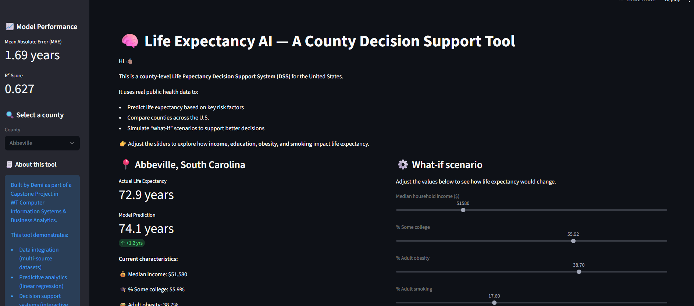
Figure 1: Dashboard showing Abbeville County, SC – actual life expectancy 72.9 years, model prediction 74.1 years.
Synthetic Understanding
Synthesis means that the whole is greater than the sum of its parts. This project achieves that:
- DM provides clean data.
- DA extracts knowledge from the data (coefficients, predictions).
- SS makes that knowledge accessible to any user.
- CN ensures the knowledge is used responsibly.
A user does not need to know SQL, Python, or regression theory. They select a county and move sliders. That is synthesis in action.
Fully Realized Future Version
A scaled-up version of this system would:
- Pull real-time data from CDC WONDER or similar APIs.
- Add more predictors (healthcare access, environmental factors, food environment).
- Include explainable AI (SHAP values) to show why a specific county’s prediction is high or low.
- Deploy on a secure cloud server with HTTPS, OAuth login, and role-based access (public health officials vs. public viewers).
- Add geographic maps for intuitive exploration.
All these enhancements are natural extensions of the same four pillars, they do not require reinventing the project.
Conclusion and Future Vision
Summary of Achievements
- Built an interactive life expectancy predictor for all U.S. counties.
- Achieved solid predictive performance (MAE 1.69 years) using only four public-health variables.
- Demonstrated full integration of Software Systems, Data Analytics, Data Management, and Cybersecurity.
- Provided clear documentation and a runnable prototype in a GitHub repository.
Future Vision
“What if every county health department had a tool like this?” In the future, this system could be used by:
- Local public health officials to identify high-risk counties and test intervention strategies.
- Researchers to quickly explore correlations and generate hypotheses.
- Educators teach students about social determinants of health.
With additional funding and engineering, the system could become a national public health decision-support platform helping to reduce life expectancy disparities, one county at a time. Building this capstone taught me that synthesis is not an abstract requirement; it is the only way to build a system that is both powerful and usable. I am proud to present this work as the culmination of my CISBA journey.

