Course: WDD 430 Assignment: W02 Group Project Group Members: Alejandro Camacho Doblado.
Summary of Meeting (planning) Content
I reviewed the "Handcrafted Haven" project description and clarified the technical requirements (Next.js/Node.js Stack) and functional requirements (Profiles, Products, Reviews). I decided to use Figma for design prototyping and GitHub Boards for task management. I will handle the entire project myself, taking full responsibility for the repository setup, deployment, design, and user stories.
Project Repo URL: https://github.com/WTHACD/WDD-430/tree/main/handcrafted-haven
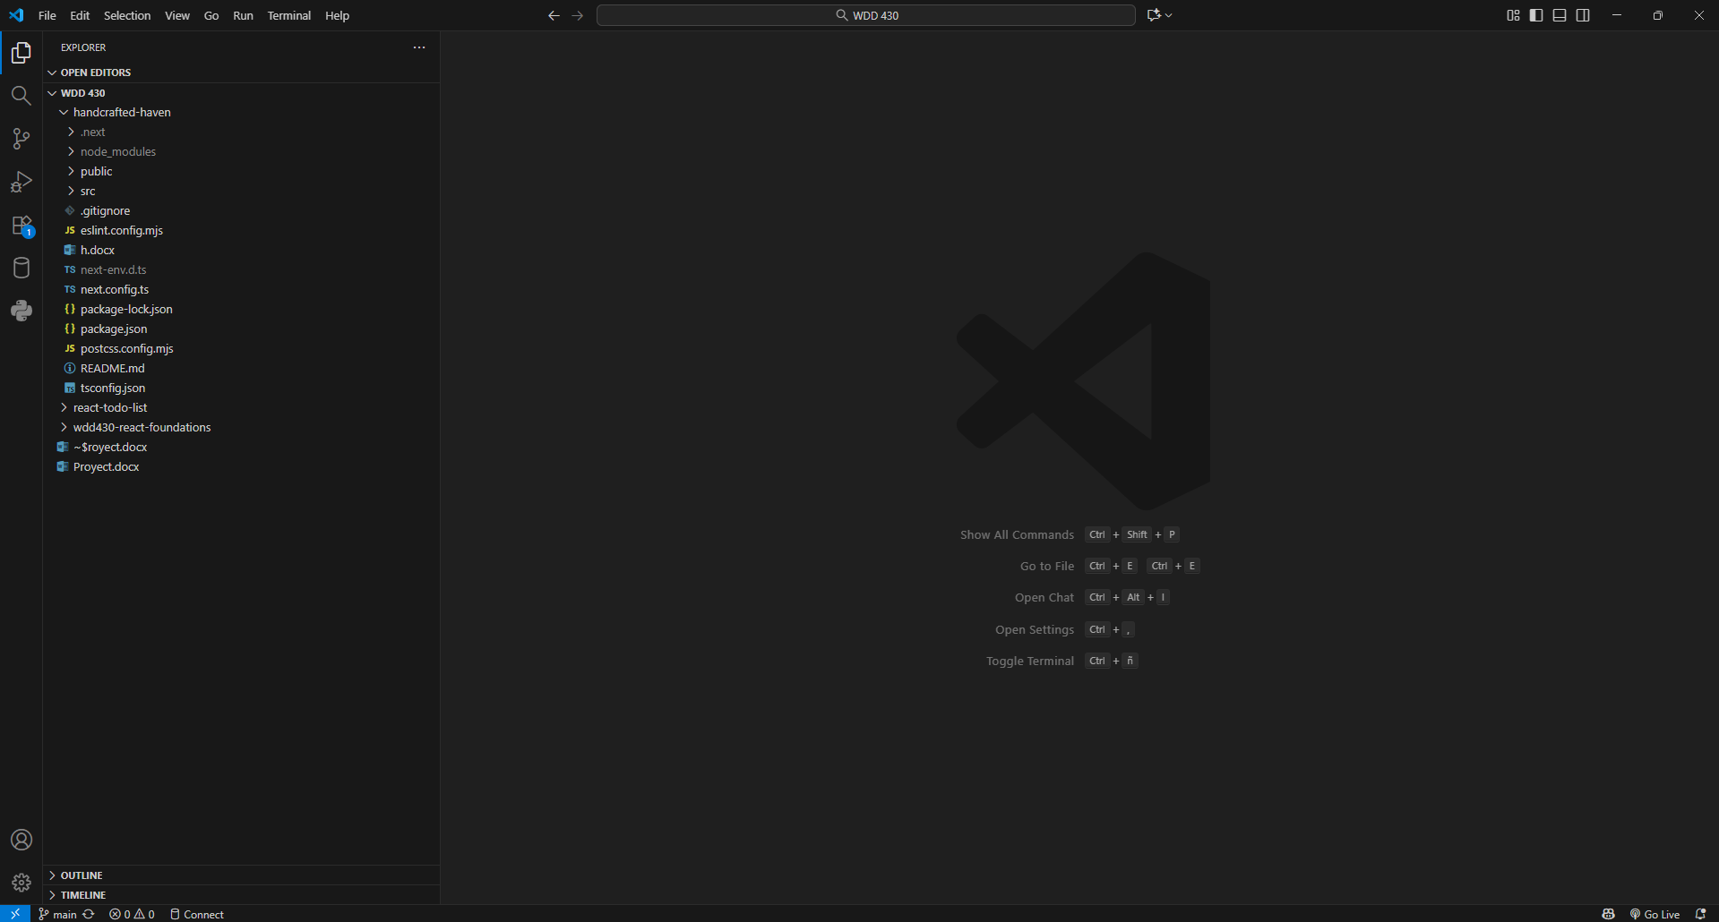
Project Review
1. Purpose:
The project has a threefold purpose:
Product: Build "Handcrafted Haven," a web application (marketplace) connecting artisans (sellers) with consumers seeking handmade products.
Technical Skills: Develop a comprehensive full-stack application using Next.js, Node.js, a database, and cloud deployment on Vercel.
Soft Skills: Foster team collaboration and peer teaching, aligning with the course outcomes and the BYU-Idaho learning model.
Requirements:
Functional:
-Authentication: Required for seller profiles.
-Seller Profiles: Sellers must be able to create profiles, share stories, and display products.
-Product Listings: Sellers must be able to add items with descriptions, prices, and images.
-Catalog: Users must be able to browse and filter products (by category, price, etc.).
-Reviews & Ratings: Any user can leave a rating and a written review for a product.
Technical (Stack):
-Front-End: Next.js (HTML, CSS, JavaScript).
-Back-End: Node.js and a database.
-Management: Git/GitHub and GitHub Boards.
-Deployment: Vercel.
-Standards & Design:
-Responsive Design: Seamless experience on mobile, tablet, and desktop.
-Accessibility: Must comply with WCAG 2.1, Level AA.
-Web Standards: Valid code, performance optimization, SEO, and usability.
-Branding: Consistent visual identity (colors, typography) and intuitive navigation.

Limitations (Scope):
-The technology stack is strictly defined.
-The project focuses on profiles, the catalog, and reviews. Complex e-commerce features (like a full shopping cart or payment processing) are not explicitly listed in the initial functional requirements and may be out of scope for this specific phase unless added later.
-Strict adherence to WCAG 2.1 AA will dictate specific design choices regarding color contrast and keyboard navigation.
2. Design Planning
This is an initial plan. It is recommended to use Figma to visualize this.

Concept/Theme: "Organic & Trustworthy." The design should feel warm, clean, and professional to highlight the quality of the craftsmanship.
Color Scheme (WCAG AA Friendly):
Primary (Actions): Forest Green (#3A5A40)
Secondary (Accents): Terracotta (#C97C5D)
Background: Off-White (#FBFBFB)
Main Text: Dark Charcoal (#333333)
Secondary Text/Borders: Soft Gray (#A9A9A9)

Typography:
Headings: Merriweather (A serif font conveying elegance and tradition).
Body: Inter (A modern sans-serif for high readability in descriptions and UI).

General Layout:
Navigation: A clean, sticky header with the Logo, Main Links (Explore, Artisans), Search Bar, and Profile/Login access.
Product Grid: Use of CSS Grid or Flexbox to display product "cards" responsively (e.g., 1 column mobile, 2 tablet, 4 desktop).
Graphical Elements:
Buttons: Softly rounded borders. Primary buttons use Forest Green for clear Calls to Action (CTA).
Cards: Subtle shadow, ample whitespace, and clear hierarchy (Image > Title > Artisan Name > Price).

3. User Stories / Work Items

- (Feature) User Authentication Setup:
Description: Implement the signup and login system for users and sellers.

- (Feature) Data Model - Seller:
Description: Define and create the database schema for the seller profile (name, bio, profile photo, link to products).

- (Feature) Seller Profile Page (Public):
Description: Build the front-end page (Next.js) that displays a specific seller's information and their product gallery.

- (Feature) Data Model - Product:
Description: Define and create the database schema for products (title, description, price, images, category, seller reference).

- (Feature) Seller Dashboard - Add/Edit Product:
Description: Create the form (protected by authentication) allowing a seller to create, read, update, and delete their own product listings.

- (Feature) Catalog Page (Browse):
Description: Build the main landing page that displays all products using a responsive grid layout.

- (Task) Implement Catalog Filters:
Description: Add front-end controls (and back-end/API logic) to filter products by category and price range.

- (Feature) Data Model - Review:
Description: Define the database schema for reviews (product reference, 1-5 star rating, review text, user name).

- (Feature) Review Component (Display & Submit):
Description: Create the component on the product detail page that displays existing reviews and includes a form for users to submit new ones.

- (Task) Initial Project Setup (CI/CD):
Description: Initialize the GitHub repository, set up the Next.js project and Node.js server, and connect to Vercel for automatic deployment.
4. Design and Styling Evidence
Typography:
Headings: Merriweather
Body: Inter
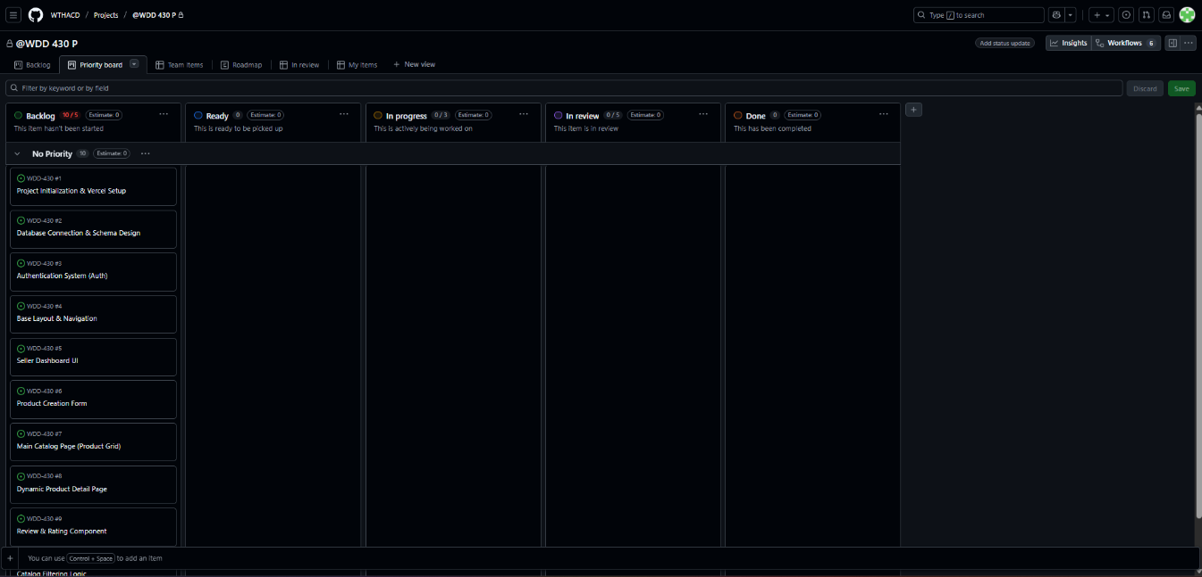
Color Palette (WCAG AA Approved):
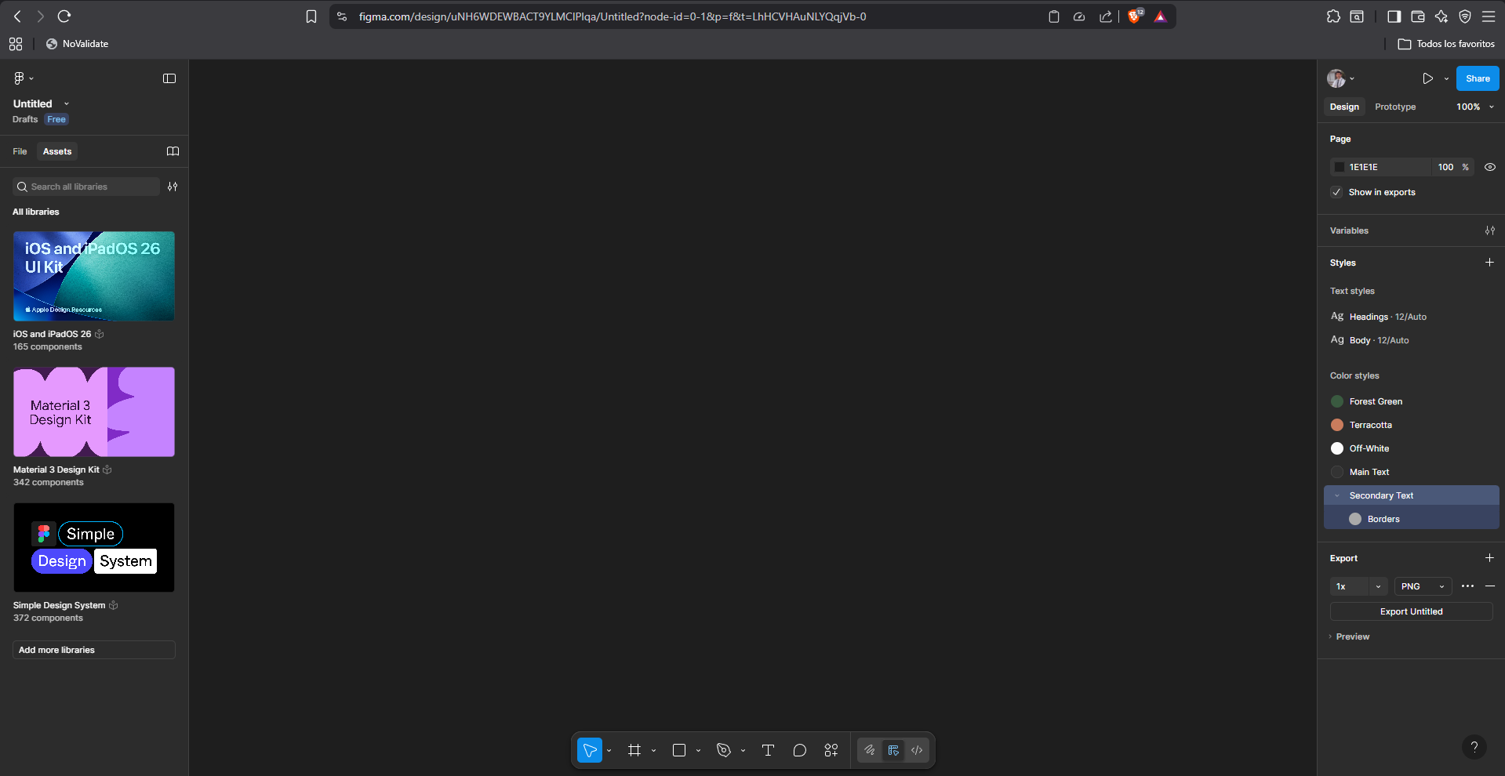
5. User Stories and Work Items
https://github.com/users/WTHACD/projects/1/views/2

