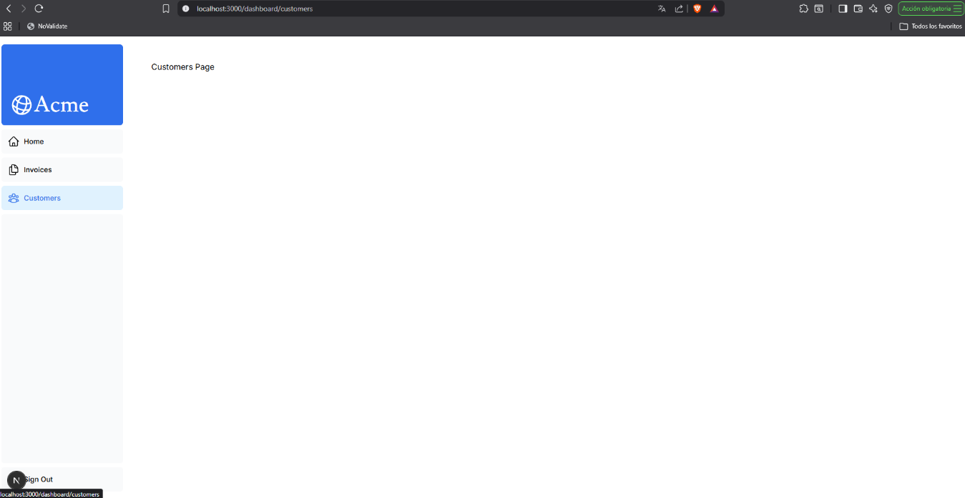
https://github.com/WTHACD/WDD-430/tree/master/wdd430-react-foundations/nextjs-dashboard

