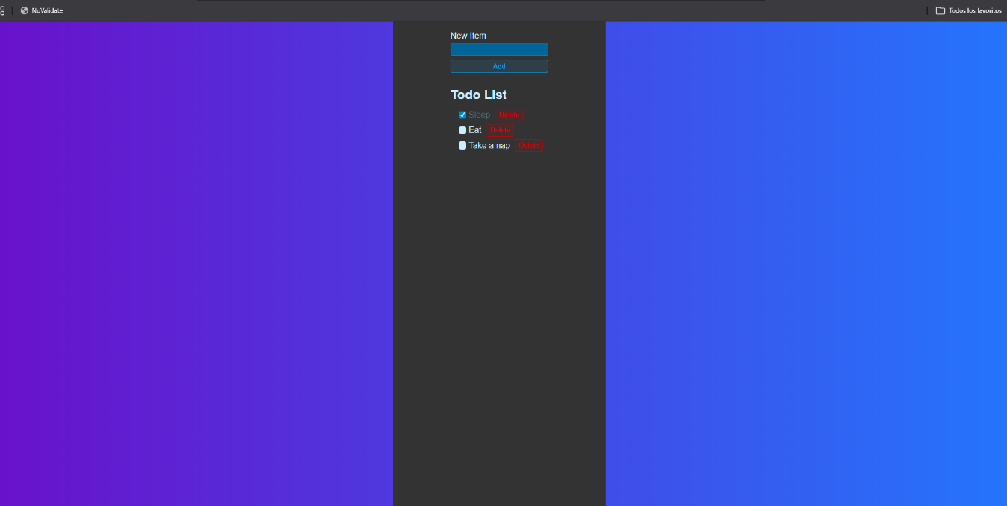
https://github.com/WTHACD/WDD-430/tree/master/react-todo-list

