Oscar Martinez
Professor Murray E. Jennex
CIDM-6340-70
8/12/25
Recovery Plan Assignment
1. What Did You Do
First, I began by looking at the Nmap scan results from Assignment 1, but I was unsatisfied that I didn’t have a device map, so I reinstalled Nmap and Python to make Zenmap work. I did a new intense scan to identify all my devices on my network. This included recording their IP addresses, hostnames, operating systems, open ports, and detected services. The results were put into an inventory table and network topology map for reference.
Next, I used Assignment 3 to get my ShieldsUp results. Where I made scans before on the “Common Ports” and “All Service Ports” test, and captured the results in a pdf file.
Then, I looked at the results, but the host discovery scan didn’t give me much to talk about, so I decided to do a more comprehensive on Nessus Essentials. From the dashboard, I created a new scan and selected the “Basic Network Scan”. I entered the local subnet 192.168.1.0/24 as the target range to ensure all devices on my home network were scanned. I started the scan and allowed it to run until it completed. Once finished, I saw the detailed results page, which had much more useful information, and so I exported the full report in to a pdf.
Finally, I categorized each device by its role in my environment and how important it is for recovery. The priority was decided by work necessity, connectivity needs, and personal usage. Using the new Nessus scans, I identified vulnerabilities on each device, focusing on those with medium, high, or critical severity. I determined backup requirements for each device based on its role and critical information stored. I documented a password backup list, noting only the roles of credentials needed for recovery.
2. What Are the Results
Figure 1 – Topology of Network Devices
This figure is a topology of my Zenmap generated device map, and it shows all detected devices from the Nmap scan, displaying their hostnames, IP addresses, connection paths, open port status, and network latency from the scanning host.
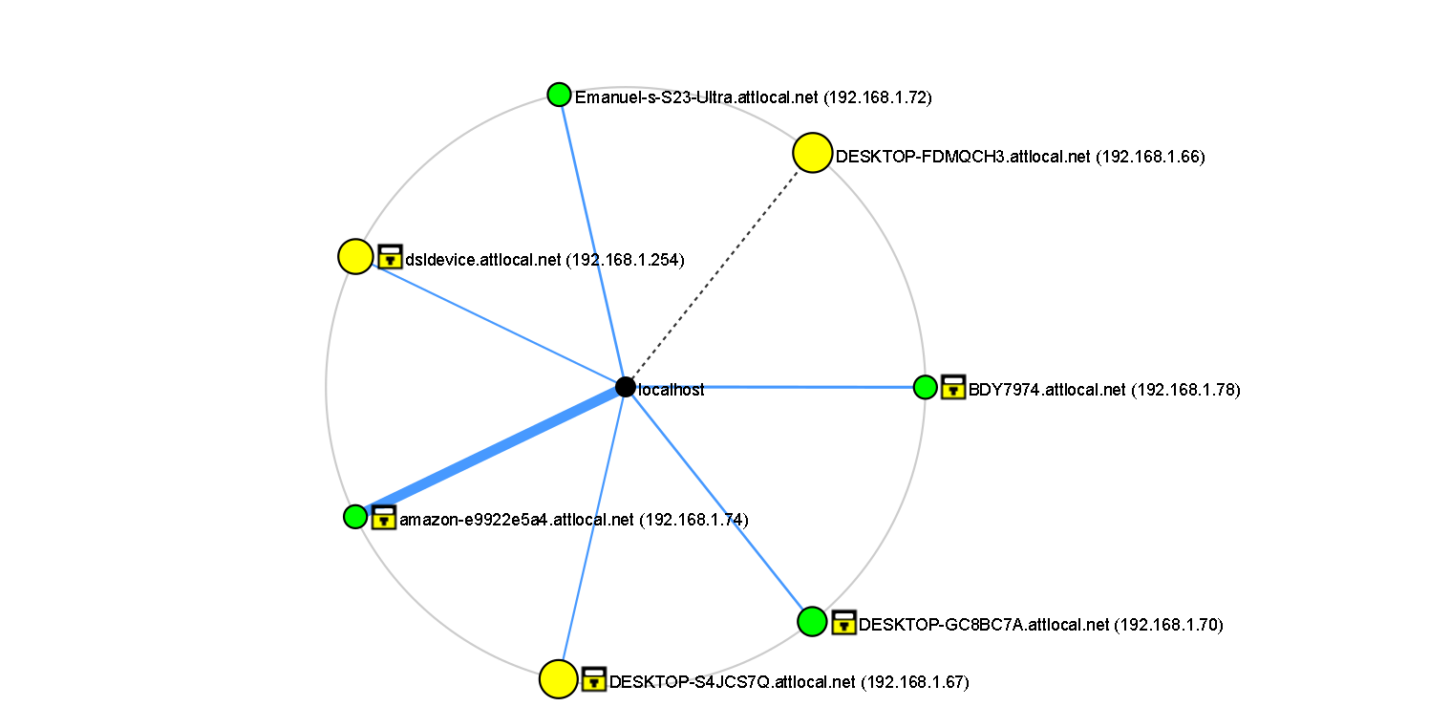
Figure 1 Full network topology view based on Zenmap results
The map provides a visual representation of my network and device relationships. By showing connection paths and open ports, it helps identify potential security risks, and plan recovery steps in case of an attack.

Table 1 – Inventory of Network Devices
This table lists all detected devices from the Nmap scan, showing their IP addresses, device types, operating systems or firmware versions, open ports, and their role within my network.
Device Name / IP | Device Type | OS / Firmware | Open Ports | Role in Organization
DESKTOP-FDMQCH3 (192.168.1.66) | Personal Desktop | Windows 10 | 135, 139, 445, 3306, 3389, 5357 | Personal and school projects, gaming, possible local game hosting
DESKTOP-S4JCS7Q (192.168.1.67) | Gaming PC | Windows 10 | 135, 139, 445, 5357, 8000 | Gaming and entertainment
DESKTOP-GC8BC7A (192.168.1.70) | General-use PC | Windows 10 | 5357 | Gaming and entertainment
Emanuel-s-S23-Ultra (192.168.1.72) | Mobile Device | Android | None | Personal phone
amazon-e9922e5a4 (192.168.1.74) | IoT Device | Unknown | None | Entertainment device
BDY7974 (192.168.1.78) | Work Laptop | Windows 11 | None | Work-related tasks
dsldevice (192.168.1.254) | Router / Gateway | Linux/OpenWrt | 53, 80, 443 | Network connectivity, DNS, firewall
Table 1 Full network device inventory based on Nmap results.
The inventory is essential for understanding the network’s assets. By identifying each device, its services, and its role, we can determine the potential impact of ransomware on the device. This inventory also helps with which devices are essential to recover first and which can wait until later in the restoration process.
Table 2 – Prioritized Recovery List
This table categorizes devices into critical, vital, and non-critical priority levels for recovery.
Priority Level | Device Name / IP | Role | Reason for Priority
Critical | BDY7974 (192.168.1.78) | Work laptop | Required for remote work and job-related tasks
Critical | dsldevice (192.168.1.254) | Router / Gateway | Restores internet connectivity for all devices
Vital | DESKTOP-FDMQCH3 (192.168.1.66) | Personal desktop | Hosts personal and school projects and gaming environment
Vital | DESKTOP-S4JCS7Q (192.168.1.67) | Gaming PC | Important for entertainment and personal use
Non-critical | DESKTOP-GC8BC7A (192.168.1.70) | Gaming laptop | Casual use for entertainment
Non-critical | Emanuel-s-S23-Ultra (192.168.1.72) | Mobile device | Can reconnect easily; data mostly cloud-based
Non-critical | amazon-e9922e5a4 (192.168.1.74) | IoT device | Entertainment only
Table 2 Device recovery priority ranking based on role and necessity
Prioritization ensures that the most important devices are available first for work and network functionality. The work laptop and router are critical due to their role in remote work and internet connectivity. Vital devices hold important but less time-sensitive data, while non-critical devices can be restored later without much impact, although, my family members will probably freak out.
Table 3 – Backup Requirements
This table identifies which devices require backups, what data needs to be backed up, how often, and where it should be stored.
Server Name / IP | Type of Data | Backup Frequency | Backup Storage Location | Restore Priority
BDY7974 (192.168.1.78) | Work files, project data | Daily or before major updates | Encrypted shared drive or secure cloud | Critical
DESKTOP-FDMQCH3 (192.168.1.66) | Personal projects, local game saves/configs | Weekly | External drive or NAS server | Vital
DESKTOP-S4JCS7Q (192.168.1.67) | Game saves/configs not stored in cloud services | Weekly or as needed | External drive or NAS server | Vital
dsldevice (192.168.1.254) | Router/firewall/DNS configs | After major changes | Offline file or printed copy | Critical
Table 3 Backup frequency, data type, and restore priority for each key device.
Placing backup requirements secures essential data that can be restored quickly in the event of a ransomware attack. Different devices have different backup needs, work and network systems require frequent backups, while gaming or personal PCs can be backed up less often. Backup locations are chosen based on security and accessibility during recovery.
Table 4 – Devices/Components Needing Updates
This table lists vulnerabilities detected by Nessus and supported by ShieldsUp where relevant, their descriptions, severity levels, and recommended fixes.
Device Name / IP | Vulnerability ID | Description | Risk Level | Recommended Action
DESKTOP-FDMQCH3 (192.168.1.66) | 42873 | SSL Medium Strength Cipher Suites Supported (SWEET32) | High | Disable weak ciphers in SSL/TLS settings
DESKTOP-FDMQCH3 (192.168.1.66) | 104743 | TLS Version 1.0 Protocol Detection | Medium | Disable TLS 1.0
DESKTOP-FDMQCH3 (192.168.1.66) | 157288 | TLS Version 1.1 Deprecated Protocol | Medium | Disable TLS 1.1
DESKTOP-FDMQCH3 (192.168.1.66) | 57608 | SMB Signing not required | Medium | Enable SMB signing
DESKTOP-S4JCS7Q (192.168.1.67) | 172186 / 201198 / 170113 | Multiple vulnerabilities in Apache 2.4.x (< 2.4.60) | Critical | Update Apache to latest version
DESKTOP-S4JCS7Q (192.168.1.67) | 201084 / 181288 / 171079 | Multiple vulnerabilities in OpenSSL 1.1.1 (< 1.1.1za) | Critical | Update OpenSSL to latest version
DESKTOP-S4JCS7Q (192.168.1.67) | 57608 | SMB Signing not required | Medium | Enable SMB signing
Emanuel-s-S23-Ultra (192.168.1.72) | 10114 | ICMP Timestamp Request Remote Date Disclosure | Low | Disable ICMP timestamp replies
amazon-e9922e5a4 (192.168.1.74) | 10114 | ICMP Timestamp Request Remote Date Disclosure | Low | Disable ICMP timestamp replies
dsldevice (192.168.1.254) | 51192 | SSL Certificate Cannot Be Trusted | Medium | Replace with valid certificate
dsldevice (192.168.1.254) | 57582 | SSL Self-Signed Certificate | Medium | Replace with CA-signed certificate
dsldevice (192.168.1.254) | 15901 | SSL Certificate Expiry | Medium | Renew certificate before expiry
Table 4 Security vulnerabilities and recommended mitigation actions.
Vulnerabilities can be exploited by ransomware to enter or spread within a network. Addressing high and critical vulnerabilities, such as outdated Apache or OpenSSL components. Medium and low vulnerabilities, like certificate issues or SMB signing, should also be resolved to harden the network and lessen attack endpoints.
Table 5 – Passwords to Back Up (By Role)
This table lists the roles of passwords that must be backed up for recovery purposes, without revealing actual credentials.
System / Device | Role Description | Reason Needed for Recovery
BDY7974 (192.168.1.78) | Windows login / work VPN credentials | To restore access to work systems
DESKTOP-FDMQCH3 (192.168.1.66) | Windows login credentials | Restore personal desktop environment
DESKTOP-S4JCS7Q (192.168.1.67) | Windows login credentials | Restore gaming PC environment
dsldevice (192.168.1.254) | Router admin credentials | Restore internet and network settings
Table 5 Password roles required for full recovery after an incident.
In the event of a ransomware attack, password loss can prevent access to critical systems. Keeping a secure offline record of these credentials ensures that devices and services can be restored without delays. The focus is on administrative and access credentials for devices central to network recovery.
3. What Did You Learn
This exercise showed me that even a home network can contain multiple vulnerabilities that ransomware could exploit. My Nessus scan revealed outdated software, weak SSL/TLS configurations, and missing security settings on systems as ordinary as a gaming PC. While ShieldsUp confirmed no direct external exposure, internal weaknesses could still be used if ransomware entered one of my devices.
I also learned the value of prioritizing devices by their role. In my case, the router and work laptop are most important because without them, I lose connectivity and the ability to work and risk putting my organization in jeopardy. Personal desktops and gaming systems are still important but take lower priority in recovery. This supports the need for regular backups of data and secure offline storage of passwords, and constant patching for all devices to prevent malware taking advantage of a vulnerability.
From now on, I can use these tools as part of a security routine or after major network changes to catch vulnerabilities early, track patch status, and ensure minimal external exposure. For an organization, this is a proactive method of risk reduction, regulatory compliance, and better protection of sensitive data. Constant scanning provides insights for IT teams, supports remediation, and builds logs of network health valuable for both audits and incident response.

