Weekly Box Office Mojo 2024 Analysis
Oscar Martinez
West Texas A&M University
CIDM6355: Data Mining Methods
Dr. Jingyi Tian
12/05/2025

Data and Context
The analysis will be over the domestic weekly box-office data for 2024, collected from Box Office Mojo using a custom Python script. The raw dataset contains 3618 rows & 16 columns, representing the weekly performance of films showing each week during the year. Films remain in theaters for multiple weeks, so the dataset has repeated entries with the same titles.

My business question will be “Can a film’s opening-week gross be used to predict how many theaters it should open in?”. Opening week is strategically important because studios negotiate with theaters to see how many screenings they can have before a film opens. Finding the relationship between gross and theater count can help exhibitors and distributors plan accordingly because these decisions influence momentum, revenue potential and expected demand.

Cleaning the model so that each movie only appears once, so that only opening-week records show up will have us use the field “New This Week” to filter it out. Leaving us with 522 entries total. Planning to use regression, I only kept two variables, “Gross” & “Theaters”. Because six rows had missing theater counts, I removed them with our final dataset only containing 516 unique records, representing a single opening week with no repeated entries.

Methods & Approach
As explained earlier, I used filtering to only keep rows where “New This Week” == “true”, reducing the dataset from 3618 to 522 rows. I also only kept the variables “Gross” & “Theaters” for the regression model. Next, I cleaned the dataset by making the strings remove commas and dollar signs. I also converted the value types from strings to numeric values. Six rows were missing theater counts so I removed them because they made up less than 1% of the dataset. Leaving us with a final dataset of 516 records & 2 columns.

The regression set up will use the “Gross” as Predictor (X), “Theater” as Target (y), a Train/test split of 75% train, and 25% test, StandardScaler applied to Gross, Linear Regression from scikit-learn for the model, and Metrics, measuring R², MAE, and RMSE.

Results

A. Analytical Outputs
Opening-Week gross had a mean of $6.70 million, standard deviation of $24.84 million, minimum of $196 dollars, median of $155,156, and a max of $298,575,919. Opening-Week theater count with a mean of 842, standard deviation of 1,227, minimum of 1, median of 124, and a max of 4,575 (See Appendix A). Both distributions might be skewed because of limited movie releases and wide-releases.

B. Regression Performance
My model’s regression performance had a R square of 0.435, meaning there is a 43.5% of the variation in opening-week theater count giving us a moderate predictive strength. Mean Absolute Error (MAE) of 795.66 & Root Mean Squared Error (RMSE) of 959.53, both in number of theaters, reflecting a large variance between small releases and wide-releases. The model seems to underpredict wide-releases making it consistent with nonlinear patterns in data.

C. Visualizations
Figure 1 – Scatter Plot: Opening Gross vs Opening Theaters
The plot uses log (Gross) on the x-axis to reduce skew. There is an upward trend indicating high grossing films open in more theaters. It is nonlinear and has more variance at high values. A cluster near the origin possibly meaning that those are the limited releases. This probably a good reason why this linear model isn’t good for extreme values.
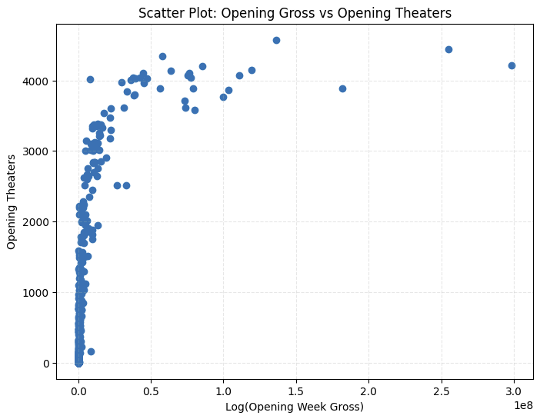
Figure 2 – Scatter Plot: Opening Gross vs Opening Theaters
The red dashed line is the perfect prediction, but most points are below the line, meaning the model is underpredicting wide-releases. The predictions cluster around 750 theaters probably because the model only uses gross as the predictor. This shows the moderate R squared and high error values.
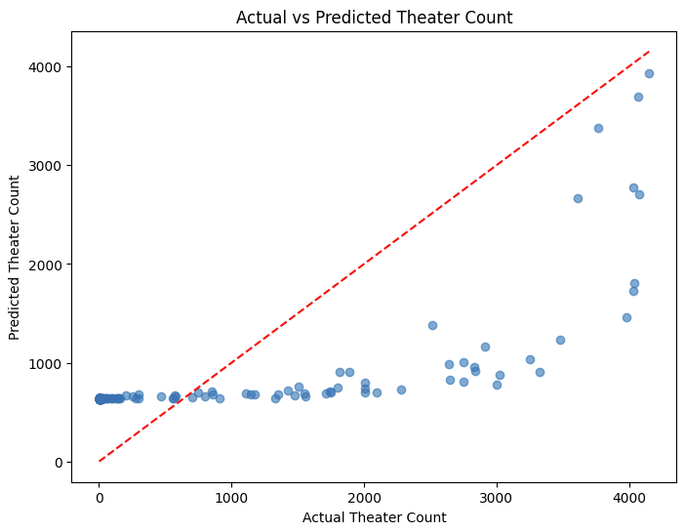

Recommendations & Risks

A. Actionable Insights
Exhibitors can give a baseline for screen allocation. With films predicted to have more demand will have more screens. Any final decisions should also consider genre, audience, and competition. Distributors can compare predicted vs. actual theater counts to look for potential over/under booking. In a future model, marketing budget, franchise indicators, or historical performance can make better planning.

B. Limitations
My model only uses one predictor being Gross and its relationship with theater count is nonlinear. There is a need for more features because a simple linear regression can’t accurately predict theaters needed at opening.

B. Ethical & Fairness Considerations
Large studios already have an advantage in screenings making revenue-based prediction models reinforced industry dominance. Indie and niche films will be undervalued in the predictions if the model is used explicitly. We must still use our own judgment and guidance for programming decisions and model outputs.

Conclusion
Opening-week gross revenue gives us insight but it is incomplete for predicting how many theaters a film will need to be open in the first week. The model has a lot of the variance (R² = 0.435) but can’t see the complexity of other external variables can have in the success of a film so that to make screening decisions. While it is okay for a baseline analytical tool, future models incorporating additional predictors and nonlinear techniques may improve accuracy. This project demonstrates foundational data mining skills including collecting, cleaning, exploratory analysis, modeling, and evaluation.
References
Box Office Mojo. (2024). Weekly domestic box office. IMDb. https://www.boxofficemojo.com/weekly/
Python Software Foundation. (2024). Python 3.12 documentation. https://docs.python.org/3/
The Pandas Development Team. (2024). Pandas documentation. https://pandas.pydata.org/
Scikit-learn Developers. (2024). Scikit-learn user guide. https://scikit-learn.org/
Matplotlib Developers. (2024). Matplotlib documentation. https://matplotlib.org/
Richardson, L. (2024). Beautiful Soup documentation. https://www.crummy.com/software/BeautifulSoup/

Appendix

Appendix A – Summary Statistics
Based on the summary statistics below, the right-skew is extreme in both Gross & theaters. Gross ranged from $196 to $298.6M, median $155K. Theater counts ranged from 1 to 4575, median 124.

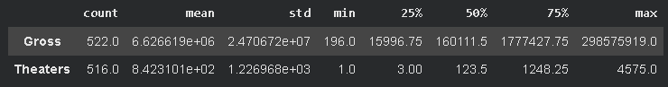
Appendix B – Code
https://colab.research.google.com/drive/1AHNoN06vBvKlzPq696gLKJLJEwnSrfyY?usp=sharing

