Lab 1.2 – Forms and Multimedia Elements in HTML

- Download the lab folder, Lab1.2_Student, and open it with VS code.
- Open the HTML file named Lab1.2.html

Result
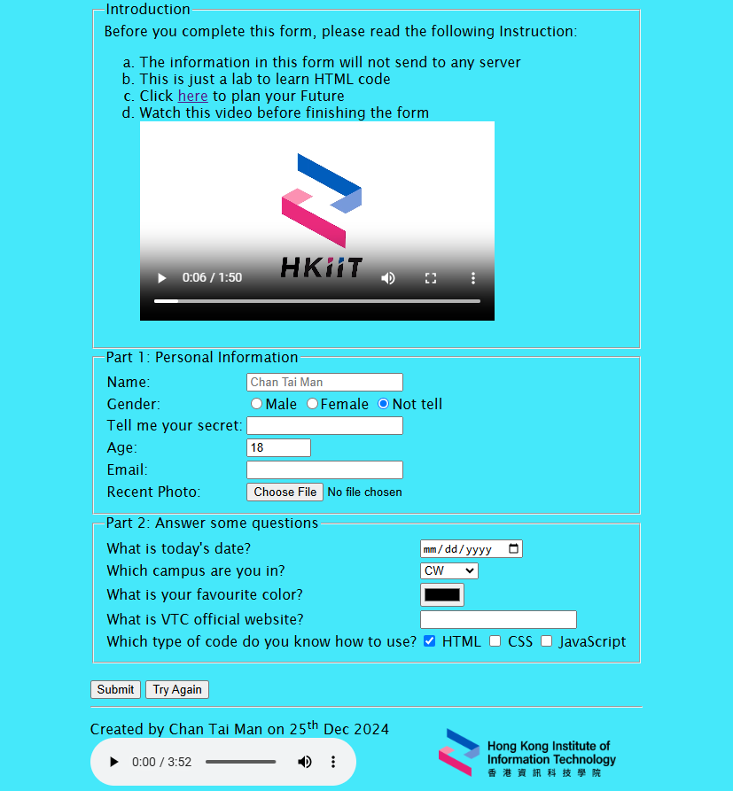

Table Layout
- The webpage has two parts. The first part is the form, and the second form is the footnote. The following is the layout structure of the webpage.
Form
Footnote | HKIIT logo

- Use EMMET magic word table>tr*2>td*2 to create a table inside the provided <div> tag and modify the table to become similar to step 1.
* You may set <table border="1"> to show the border line.
<div>
<table border="0">
<tr>
<td colspan="2">
…
</td>
</tr>
<tr>
<td></td>
<td></td>
</tr>
</table>
</div>

Forms
- Add a <form> tag inside the merged cell in the first row of the created table.
<td colspan="2">
<form>
</form>
</td>

Fieldset and Legend
- Use EMMET magic word (fieldset>legend)*3 to create three form sections, and name the section "Introduction", "Part 1: Personal Information", and "Part 2: Answer some questions".
<form>
<fieldset>
<legend>Introduction</legend>
</fieldset>
…
<fieldset>
<legend>Part 2: Answer some questions</legend>
</fieldset>
</form>

Forms - Introduction
- Use EMMET magic word ol[type="a"]>li*4 in the first fieldset and add the following instructions to the fieldset.
  - The information in this form will not send to any server
  - This is just a lab to learn HTML code
  - Click here to plan your Future
  - Watch this video before finishing the form
<fieldset>
<legend>Introduction</legend>
Before you complete this form, please read the following Instruction:
<ol type="a">
<li> The information … </li>
…
<li> Watch this… </li>
</ol>
</fieldset>
- Markup the word "here" as a hyperlink using <a> tag and modify the link able to open a new tab when clicking the link.
<li>
Click <a href=" https://hkiit.edu.hk/" target="_blank">here</a> to plan your Future
</li>
- Add the video clip "hkiit.mp4" in the video folder under the fourth instruction item.
<li>
Watch…
<br>
<video controls width="400">
<source src="./video/hkiit.mp4">
</video>
</li>

Forms - Part 1
- In the second fieldset, use EMMET magic word table[align=" left"]>tr*6>td*2 to create a hidden table for layout purposes.

- Follow the below table to set the question and corresponding input type
Question | Input type | Special Requirement
Name: | text | Use "Chan Tai Man" as an input example  Required input
Gender: | radio | Male / Female / Not tell  (Set "Not tell" as the default selection.)
Tell me your secret: | password | --
Age: | number | 0 to 100, and the default value is 18
Email: | email | --
Recent Photo: | file | --

- Here is a sample to set the question and the input
<fieldset>
<legend>Part 1: Personal Information</legend>
<table align="left">
<tr>
<td>Name:</td>
<td><input type="text" placeholder="Chan Tai Man" required></td>
</tr>
<tr>
<td>Gender:</td>
<td>
<input type="radio" name="gender" value="M">Male
<input type="radio" name="gender" value="F">Female
<input type="radio" name="gender" value="NT" checked>Not tell
</td>
</tr>
<tr>
<td>Tell me your secret:</td>
<td></td>
</tr>
…
</table>
</fieldset>

Forms - Part 2
- In the third fieldset, use EMMET magic word table[align="left"]>tr*5>td*2 to create a hidden table for layout purposes.

- Follow the below table to set the question and corresponding input type
Question | Input type | Special Requirement
What is today's date? | date | --
Which campus are you in? | select + option  (dropdown list) | CW / KT / LWL / ST / TM / TY  (Set your campus as the default selection)
What is your favourite color? | color | --
What is VTC official website? | url | --
Which type of code do you know how to use? | checkbox | HTML / CSS / JavaScript

- Here is a sample to set the checkbox and dropdown list
<fieldset>
<table align="left">
…
<tr>
<td> Which campus are you in? </td>
<td>
<select>
<optgroup label="Campus">
<option selected>CW</option>
<option>KT</option>
<option>LWL</option>
<option>ST</option>
<option>TM</option>
<option>TY</option>
</optgroup>
</select></td>
</tr>
…
<tr>
<td>Which type of code do you know how to use?</td>
<td>
<input type="checkbox" name="code1" value="html" checked="checked" /> HTML
<input type="checkbox" name="code1" value="css" /> CSS
<input type="checkbox" name="code3" value="js" /> JavaScript
</td>
</tr>
</table>
</fieldset>

Ruler
- Create a Horizontal Rule after the Part 2 fieldset using the <hr> tag.

Submit and Reset Button
- Add the following tags to create the submission and reset buttons.
<br>
<input type="submit">
<input type="reset" value="Try Again">
<hr>
</form>

Footnote
- Add the footnote "Created by (Your name) on (date)" in the leftmost cell in the second row of the webpage table.
- Add the Background Music control panel with autoplay function under the footnote where the music file bgm.mp3 is in the provided audio folder.
<td>Created by Chan Tai Man on 25<sup>th</sup> Dec 2024
<br>
<audio controls autoplay>
<source src="./audio/bgm.mp3">
</audio>
<!--autoplay was muted in Chrome browser-->
</td>

Add Logo
- Add our HKIIT logo to the rightmost cell in the second row of the webpage table.
- Set the height and width of the image as 100 and 200 pixels respectively.
<td>
<img src="./img/hkiit_logo.png" width="200">
</td>

Extra information about <div> tag

At this moment div tag may not be related to your learning progress. BUT, The <div> tag is an empty element with no specific content or meaning. Instead, it is used as a container to group other components, such as text, images, or other HTML elements, and apply styles or functionality to them as a single unit.

