Stroke Risk Prediction — Model Analysis Report
Generated by Stroke Risk Prediction ML Pipeline

1. Model Performance Summary
All models trained with class_weight='balanced' to handle the 95/5 stroke imbalance.
Primary evaluation metric: Recall (minimise missed stroke cases). Secondary: F1-score and ROC-AUC. Accuracy is de-prioritised due to class imbalance.
Model | Accuracy | Precision | Recall | F1 | ROC-AUC
Naive Bayes | 0.189 | 0.056 | 0.987 | 0.106 | 0.789
Logistic Regression | 0.731 | 0.13 | 0.787 | 0.223 | 0.839
SVM | 0.759 | 0.119 | 0.613 | 0.2 | 0.776
Decision Tree | 0.928 | 0.17 | 0.12 | 0.141 | 0.545
Voting Ensemble | 0.948 | 0.381 | 0.107 | 0.167 | 0.841
Gradient Boosting | 0.948 | 0.25 | 0.027 | 0.048 | 0.824
AdaBoost | 0.951 | 0.0 | 0.0 | 0.0 | 0.828
Random Forest | 0.949 | 0.0 | 0.0 | 0.0 | 0.801
KNN | 0.947 | 0.0 | 0.0 | 0.0 | 0.612

2. Classification Reports

Logistic Regression
precision recall f1-score support
No Stroke 0.99 0.73 0.84 1458
Stroke 0.13 0.79 0.22 75
accuracy 0.73 1533
macro avg 0.56 0.76 0.53 1533
weighted avg 0.94 0.73 0.81 1533

Decision Tree
precision recall f1-score support
No Stroke 0.96 0.97 0.96 1458
Stroke 0.17 0.12 0.14 75
accuracy 0.93 1533
macro avg 0.56 0.54 0.55 1533
weighted avg 0.92 0.93 0.92 1533

Random Forest
precision recall f1-score support
No Stroke 0.95 1.00 0.97 1458
Stroke 0.00 0.00 0.00 75
accuracy 0.95 1533
macro avg 0.48 0.50 0.49 1533
weighted avg 0.90 0.95 0.93 1533

Gradient Boosting
precision recall f1-score support
No Stroke 0.95 1.00 0.97 1458
Stroke 0.25 0.03 0.05 75
accuracy 0.95 1533
macro avg 0.60 0.51 0.51 1533
weighted avg 0.92 0.95 0.93 1533

AdaBoost
precision recall f1-score support
No Stroke 0.95 1.00 0.97 1458
Stroke 0.00 0.00 0.00 75
accuracy 0.95 1533
macro avg 0.48 0.50 0.49 1533
weighted avg 0.90 0.95 0.93 1533

SVM
precision recall f1-score support
No Stroke 0.97 0.77 0.86 1458
Stroke 0.12 0.61 0.20 75
accuracy 0.76 1533
macro avg 0.55 0.69 0.53 1533
weighted avg 0.93 0.76 0.83 1533

KNN
precision recall f1-score support
No Stroke 0.95 1.00 0.97 1458
Stroke 0.00 0.00 0.00 75
accuracy 0.95 1533
macro avg 0.48 0.50 0.49 1533
weighted avg 0.90 0.95 0.92 1533

Naive Bayes
precision recall f1-score support
No Stroke 1.00 0.15 0.26 1458
Stroke 0.06 0.99 0.11 75
accuracy 0.19 1533
macro avg 0.53 0.57 0.18 1533
weighted avg 0.95 0.19 0.25 1533

Voting Ensemble
precision recall f1-score support
No Stroke 0.96 0.99 0.97 1458
Stroke 0.38 0.11 0.17 75
accuracy 0.95 1533
macro avg 0.67 0.55 0.57 1533
weighted avg 0.93 0.95 0.93 1533

3. Model Comparison Charts

Metrics Comparison
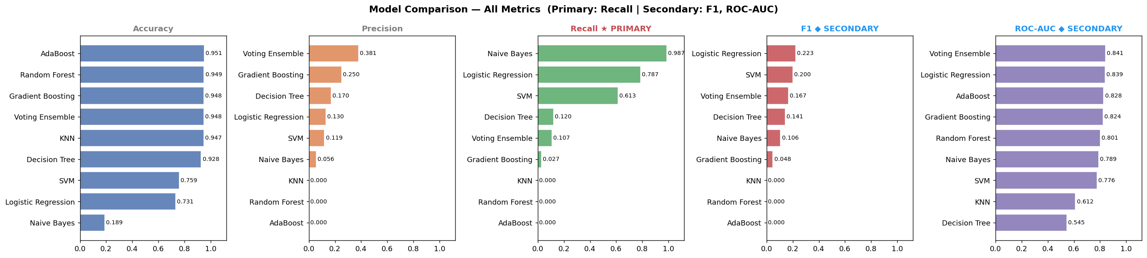

ROC Curves
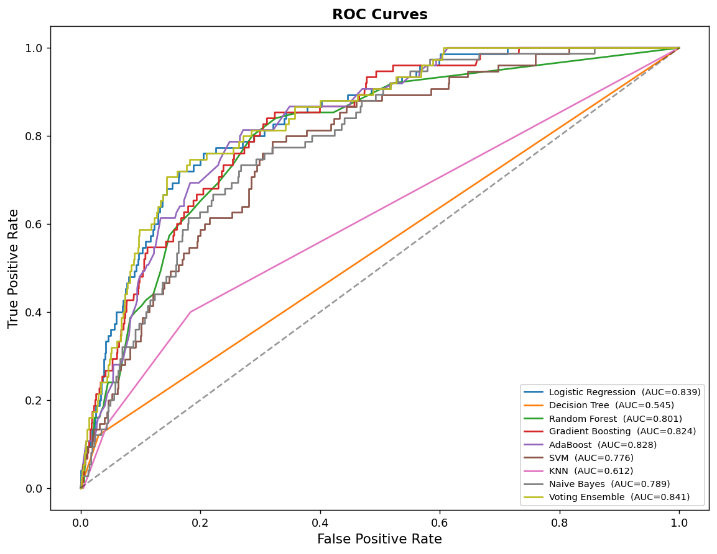

Precision-Recall Curves
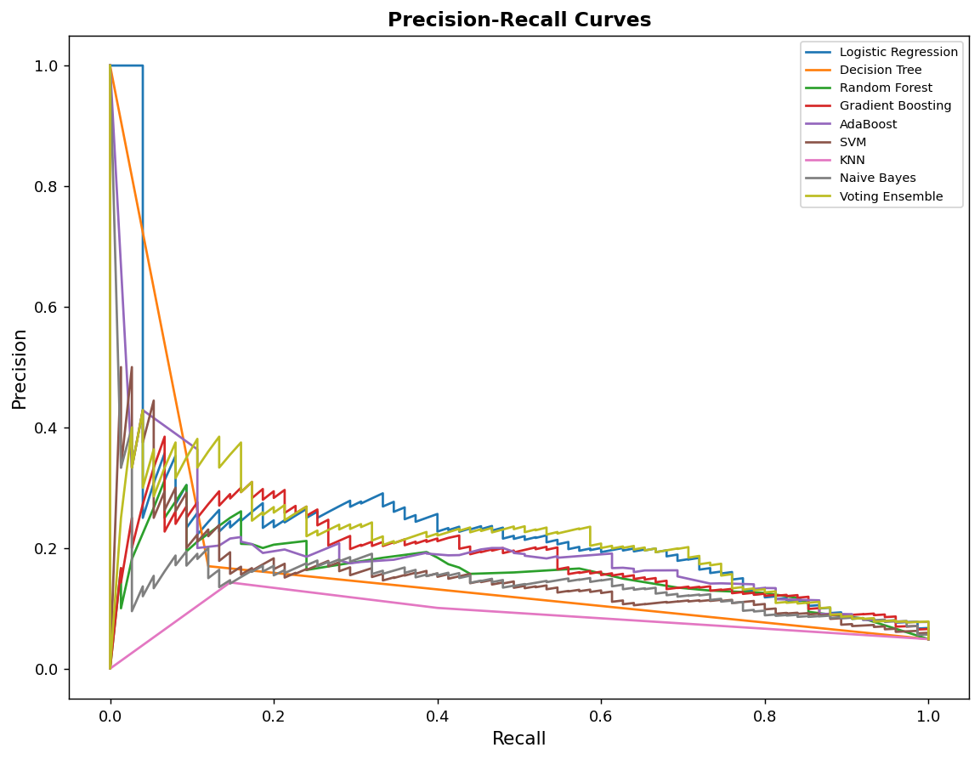

Confusion Matrices
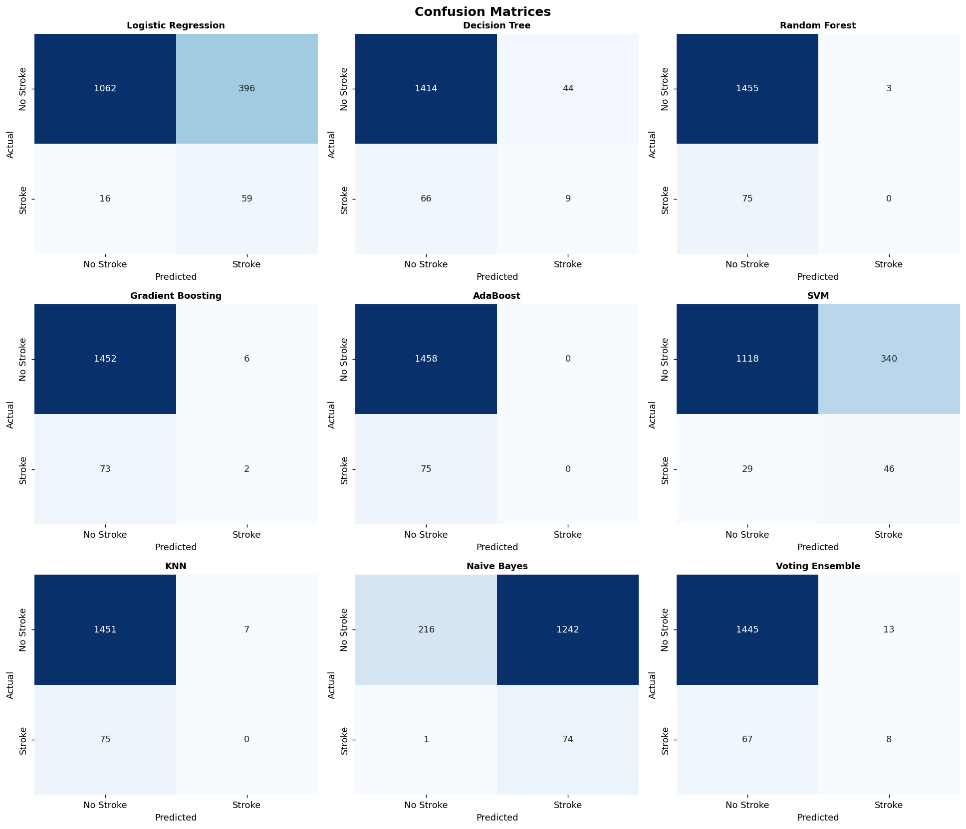

Feature Importance (Random Forest)
