Stroke Risk Prediction — Model Analysis Report
Generated by Stroke Risk Prediction ML Pipeline

1. Model Performance Summary
All models trained with class_weight='balanced' to handle the 95/5 stroke imbalance.
Model | Accuracy | Precision | Recall | F1 | ROC-AUC
Voting Ensemble | 0.948 | 0.381 | 0.107 | 0.167 | 0.841
Logistic Regression | 0.731 | 0.13 | 0.787 | 0.223 | 0.839
AdaBoost | 0.951 | 0.0 | 0.0 | 0.0 | 0.828
Gradient Boosting | 0.948 | 0.25 | 0.027 | 0.048 | 0.824
Random Forest | 0.949 | 0.0 | 0.0 | 0.0 | 0.801
Naive Bayes | 0.189 | 0.056 | 0.987 | 0.106 | 0.789
SVM | 0.759 | 0.119 | 0.613 | 0.2 | 0.776
KNN | 0.947 | 0.0 | 0.0 | 0.0 | 0.612
Decision Tree | 0.928 | 0.17 | 0.12 | 0.141 | 0.545

2. Classification Reports

Logistic Regression
precision recall f1-score support
No Stroke 0.99 0.73 0.84 1458
Stroke 0.13 0.79 0.22 75
accuracy 0.73 1533
macro avg 0.56 0.76 0.53 1533
weighted avg 0.94 0.73 0.81 1533

Decision Tree
precision recall f1-score support
No Stroke 0.96 0.97 0.96 1458
Stroke 0.17 0.12 0.14 75
accuracy 0.93 1533
macro avg 0.56 0.54 0.55 1533
weighted avg 0.92 0.93 0.92 1533

Random Forest
precision recall f1-score support
No Stroke 0.95 1.00 0.97 1458
Stroke 0.00 0.00 0.00 75
accuracy 0.95 1533
macro avg 0.48 0.50 0.49 1533
weighted avg 0.90 0.95 0.93 1533

Gradient Boosting
precision recall f1-score support
No Stroke 0.95 1.00 0.97 1458
Stroke 0.25 0.03 0.05 75
accuracy 0.95 1533
macro avg 0.60 0.51 0.51 1533
weighted avg 0.92 0.95 0.93 1533

AdaBoost
precision recall f1-score support
No Stroke 0.95 1.00 0.97 1458
Stroke 0.00 0.00 0.00 75
accuracy 0.95 1533
macro avg 0.48 0.50 0.49 1533
weighted avg 0.90 0.95 0.93 1533

SVM
precision recall f1-score support
No Stroke 0.97 0.77 0.86 1458
Stroke 0.12 0.61 0.20 75
accuracy 0.76 1533
macro avg 0.55 0.69 0.53 1533
weighted avg 0.93 0.76 0.83 1533

KNN
precision recall f1-score support
No Stroke 0.95 1.00 0.97 1458
Stroke 0.00 0.00 0.00 75
accuracy 0.95 1533
macro avg 0.48 0.50 0.49 1533
weighted avg 0.90 0.95 0.92 1533

Naive Bayes
precision recall f1-score support
No Stroke 1.00 0.15 0.26 1458
Stroke 0.06 0.99 0.11 75
accuracy 0.19 1533
macro avg 0.53 0.57 0.18 1533
weighted avg 0.95 0.19 0.25 1533

Voting Ensemble
precision recall f1-score support
No Stroke 0.96 0.99 0.97 1458
Stroke 0.38 0.11 0.17 75
accuracy 0.95 1533
macro avg 0.67 0.55 0.57 1533
weighted avg 0.93 0.95 0.93 1533

3. Model Comparison Charts

Metrics Comparison
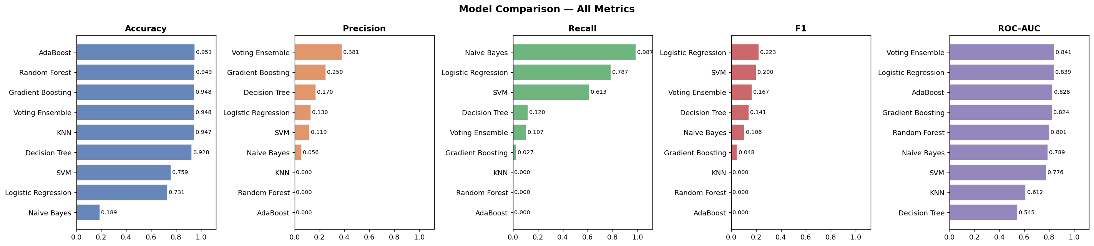

ROC Curves
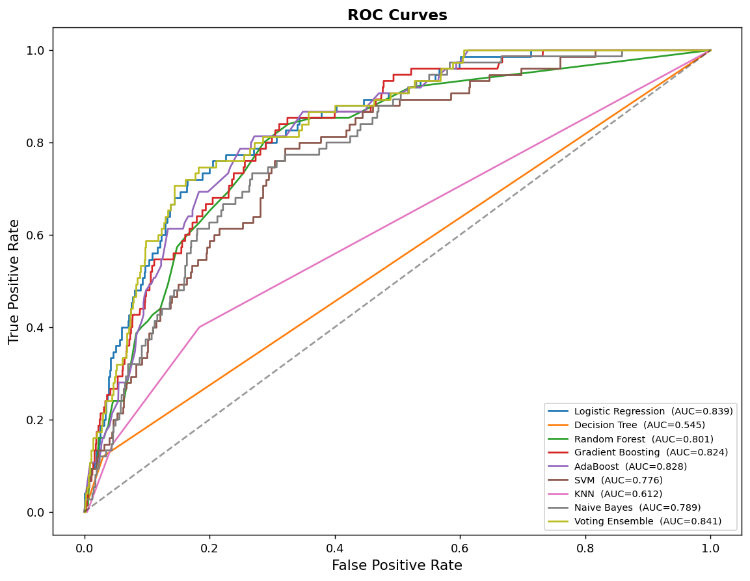

Precision-Recall Curves
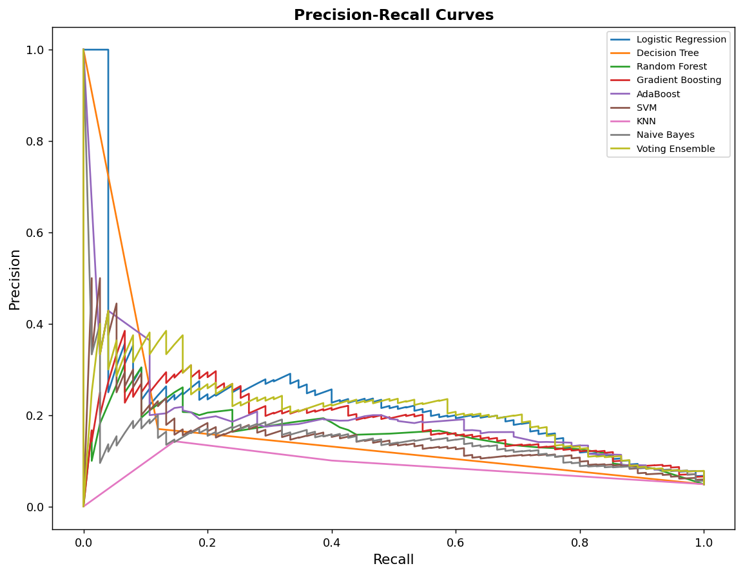

Confusion Matrices
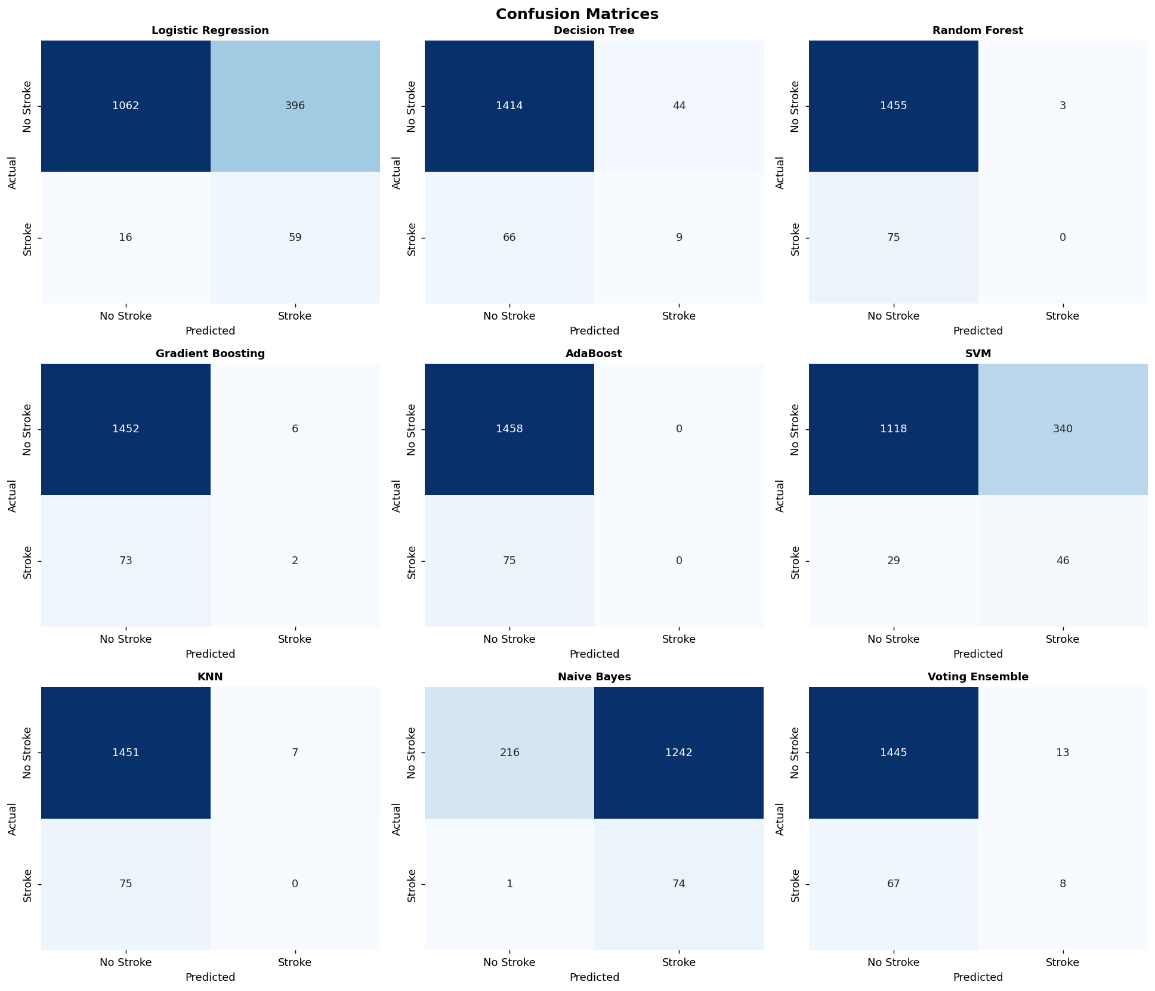

Feature Importance (Random Forest)
