Paper 02, 32 and 40

Similarities, Differences, Ideas we can use, Other papers to read

* **Trap Design for Vibratory Bowl Feeders (Paper 02)**

This paper focuses on the design of vibratory part feeder filters. Usually parts in a feeder are correctly oriented using mechanical filters like wiper blades, grooves, gaps and balconies. In this work they’ve specifically considered design of the two filters: gaps and balconies. They’ve also proposed an algorithm for deciding if a polygonal part will be accepted or rejected by the filter. The analysis is done in 2D and a complete algorithm for automatically synthesizing feeder tracks for any given part still needs to be done.

**Differences:** Part feeders keep rejecting/dropping the part to the bottom of the feeder until it is correctly oriented. In our work we’ll run the process for any given part only once and decide if the part is faulty or not.

For error detection we would need to know the interior information of the given shape

(e.g. location of the holes) but in this paper, they’re only concerned about the orientation of the parts.

**Similarities:** Part feeders use vibration to move the parts and it is a global control input. We also aim to develop layouts which are controlled globally.

Vibratory feeders use both vibration and [gravity](https://en.wikipedia.org/wiki/Gravity) to move material. Gravity is used to determine the direction, either down, or down and to a side, and then vibration is used to move the material.

**Ideas we can use:** I don’t think the ideas of designing gaps or balconies from this paper are very relevant to our work because they are based on the center of mass of the part. In our case, we’d need complete information about the exterior and interior of the given part to detect it correctly. We want to make an obstacle layout which rejects the faulty parts using global control input sequence (e.g. right, down, left and up) and, in this work the part slides past the filter once and it is either allowed to pass to the exit of the feeder or dropped down.



* **Toward a Theory of Geometric Tolerancing (Paper 32)**

This paper involves a lot of geometry of the parts and is primarily aimed at proposing a theory for representing part tolerance information in the computerized geometric modeling systems for automatic tolerance analysis. Tolerancing information is very important for planning part manufacture and tight assembly operations.

This theory still needs to be tested for its effectiveness in industrial applications and assembly planning.



**Similarities:** None

**Differences/Ideas we can use:** Currently, we’re interested in the problem of error detection/ part sorting and this paper deals with the proper representation of the part tolerances so there’s not much similarity between the two projects.

* **Sensor-Based Manipulation Planning as a Game with Nature (Paper 40)**



The robot choses the motor signal and the nature choses the sensor signal.

Planners for two different tasks: Tray tilting and squeeze grasping.

* **Differences:** They are using a sensor for tray orienting and grasping tasks. We want to do sensor-less error detection.
* **Similarities:** None.
* **Ideas we can use:** For our problem of error detection or part sorting we don’t need to do a tree search.

**Other Papers to Read**:

<http://ieeexplore.ieee.org/abstract/document/503878/>

Automated Design of Part Feeders using Genetic Algorithm

K.-F. Bohringer, V. Bhatt, B. R. Donald, and

K. Goldberg. Algorithms for sensorless manipulation

using a vibrating surface. Algorithmica, 26(3), 2000.

R. C. Brost and K. Y. Goldberg. A complete

algorithm for designing planar fixtures using modular

components. IEEE Transactions on Robotics and

Automation, 12(1):31{46, February 1996.

K. Y. Goldberg. Orienting polygonal parts without

sensors. Algorithmica, 10(3):201{225, August 1993.

**Papers read in week 20th – 27th October:**

* **Molecular Shape Sorting Using Molecular Organic Cages**

This paper presents an energy efficient method for separation of chemicals (molecules). In industries, fractional distillation is a common separation process, but it is very costly in terms of energy requirement. The proposed method shows that porous organic molecules can be used for the solid-state separation of other organic molecules.



This idea doesn’t have much in common with our project because they have not proposed any algorithm for automatic sorting or separation of particles/molecules. They’ve simply experimented with two types of organic molecules which can be used to separate a chemical feedstock from its isomer.

* **Shape Sorting of Sand Grains by Wind Action**

This paper provides experimental results which prove that wind transportation favors rounder sand grains. Eolian sand grains are rounder than grains of other sand types. This roundness is attributed to selective sorting by the wind. An example of field evidence of this sorting is the sand dune on the North Carolina coast. The grains of the dune are significantly rounder than the beach sand from which the dune is derived.

The experiments of this paper show that the wind carries round grains faster and farther than it carries the angular grains. The sand used in the experiments was a mixture of very angular and very round grains

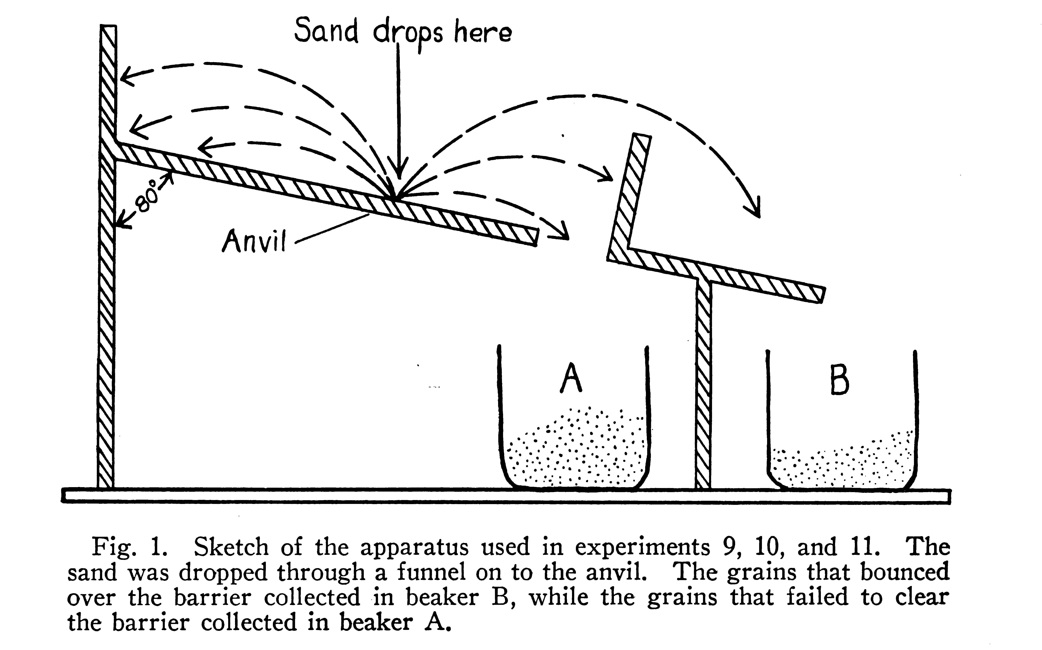

* **A Review of Non-destructive Methods for Quality Evaluation and Sorting of Agricultural Products (Review Paper)**

This paper provides an overview of different methods used for quality evaluation and sorting of agricultural products. These techniques depend on the following properties of the products: density, firmness, vibrational characteristics, X-ray and Gamma-ray transmission ad electrical properties.

**Density**: Density of fruits and vegetables increases with maturity. Defects like frost damage, insect damage or puffiness reduces the density of these products.

**Firmness**: Is a physical property which can be used to evaluate quality. Mature and fully ripe products are firmer as compared to overripe and damaged products.

**Optical reflectance:** has been used to evaluate certain characteristics near the surface of the product for maturity evaluation, color sorting and detection of surface defects.

**Machine Vision**: New algorithms and hardware architectures have been developed for high-speed extraction of features which are related to specific quality factors of the fruits and vegetables.

Although many methods have been developed for quality evaluation, natural variability in structure, composition and other extraneous factors make it difficult to find strong correlation between physical properties and quality factors. However, with the use of computers and fast data processing techniques, researchers have been able to improve the correlation.