|  |  |
| --- | --- |
| **Practicum Case** |  |
| COMP6548  Programming for Penetration Testing |
| **Cyber Security** | **<Case Code>** |
| ***Valid on*** *[Odd/Even/Compact] Semester Year 9999/9999* | **Revision 00** |

## Learning Outcomes

* Socket Network Program for Penetration Testing
* Web Vulnerability with Programming
* Additional tools for Penetration Testing

## Topic

* Server Post-exploitation II

## Subtopics

* Create Keylogger and Mouselogger using Python
* Exfiltrate Log Data through Reverse TCP

## Soal

*Case*

**Keylogger, Mouse Logger and Screenshotter**

You are asked to make a keylogger, mouselogger, and screenshotter program with Python Programming Language, here are some libraries you will need:

1. Pyxhook (for linux only), if you want to use Windows, use python 3.7 and download pyhook on your own.
2. Pynput
3. Autopy

Here are some requirements for the program:

Keylogger:

1. Track every keystroke that user type.
2. Output it to a file (you can use output redirection or open a file with time as filename)



**Figure 1. The Program Executed**

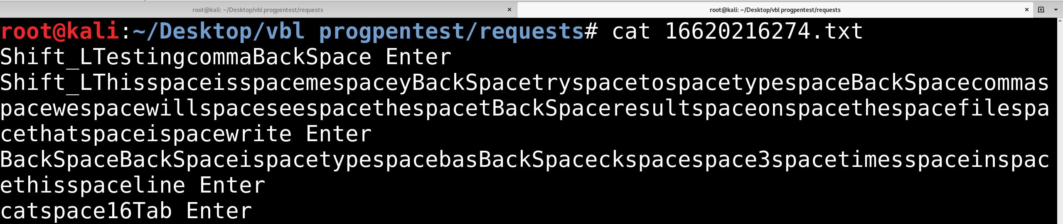

**Figure 2. The Result from the Keylogger**

MouseLogger:

1. Track mouse movement from the user.
2. Track mouse scroll movement from the user.
3. Track user’s mouse click (when clicked and released).

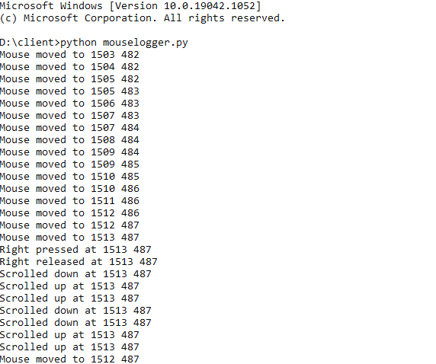

**Figure 3. Mouse Logger Output**

Screenshotter:

1. Screenshot the current display the user use. (this only works on machine that has a display, ubuntu server will not work, you can force it to have virtual screen, but it won’t show anything).
2. Output the file with random hex. (6 characters hex).

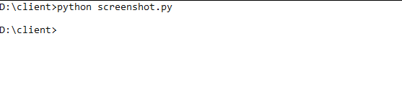

**Figure 4. Command Executed**

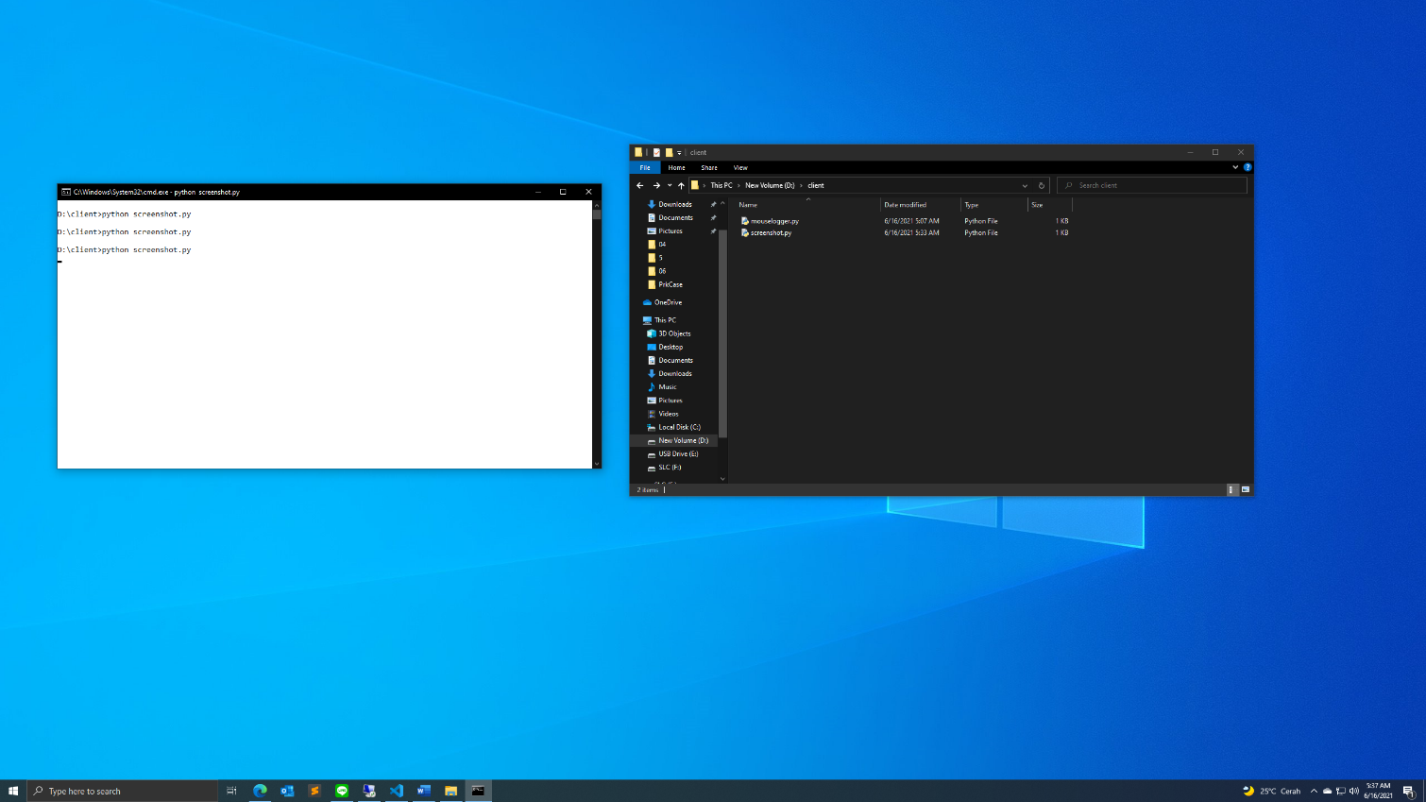

**Figure 5. The Result\***

*to see the image with more clarity, unzip this word file with 7zip (or other program that can unzip a file), and then file a folder called **word**, and then inside it find a folder called “**media**”, and see the “**image6.png**” (You can unzip a word file, ask your assistant if you don’t believe it!)