|  |  |
| --- | --- |
| **Practicum Case** |  |
| COMP6548  Programming for Penetration Testing |
| **Cyber Security** | **<Case Code>** |
| ***Valid on*** *[Odd/Even/Compact] Semester Year 9999/9999* | **Revision 00** |

## Learning Outcomes

* Socket Network Program for Penetration Testing
* Web Vulnerability with Programming
* Additional tools for Penetration Testing

## Topic

* Web Recon and Enumeration

## Subtopics

* Slow Loris DoS Attack
* HTTP Request and Response using Python.
* Brute-Forcing Directory and File Location.
* Generate and Read Directory & Filename Wordlist with Python.

## Soal

*Case*

**DoSer and DirBuster**

Miracle Foundation, one of the charity organization wants you to test their website, there are two things that you need to do, they are:

* Slow Loris Denial of Service attack.

Slow Loris DoS attack is an attack on OSI Layer number 7 (Application Layer) specifically on the HTTP Protocol. The HTTP Protocol consists of Request Line, Request Header and Message Body. Every header will always have CRLF or Carriage Return Line Feed (“\r\n”) and after that after every header has been sent to the server / the endpoint the request will send another CRLF as a sign that from this point onward, the request will send the message body if there is any.

So, the question is what if the one CRLF in the end never sent in the first place? What happened if we keep sending those Headers with CRLF but never send that one CRLF to end the request headers? The server will keep waiting and keep receiving headers that means nothing and the other users that wants to access might have to wait for the request to be handled by the server / the endpoint. Thus, what we are going to do is to make some “users” that will send HTTP Request that constantly sending meaningless headers to the web server.

* Directory Listing with Dirbuster Technique.

As we all know, Dirbuster is a tool that is used for bruteforcing HTTP Requests to find directories and file names on web application / servers.

There are some prerequisites that you need to complete, they are:

* You already have XAMPP installed in your PC.
* You need to have python programming language with **socket** and **requests** **library** installed.

You need to make 2 programs using python to complete these tasks, here are some steps that you need to follow:

1. There is a folder called 08-web in the zip, you need to copy it to your **Document Root** folder (the default folder is in “C:/xampp/htdocs”).
2. Open XAMPP Control Panel.
3. Press “Start” button on a module called “Apache”.
4. Try opening the website on your browser.

**Figure 1. The Website**

1. Try the **Slow Loris** **attack** with **python socket library**. You need to make a program that can make the website incapable of refreshing the page and the Network Usage is pretty high.



**Figure 2. XAMPP Process in Task Manager before Slow Loris Attack**



**Figure 3. XAMPP Process in Task Manager after Slow Loris Attack**

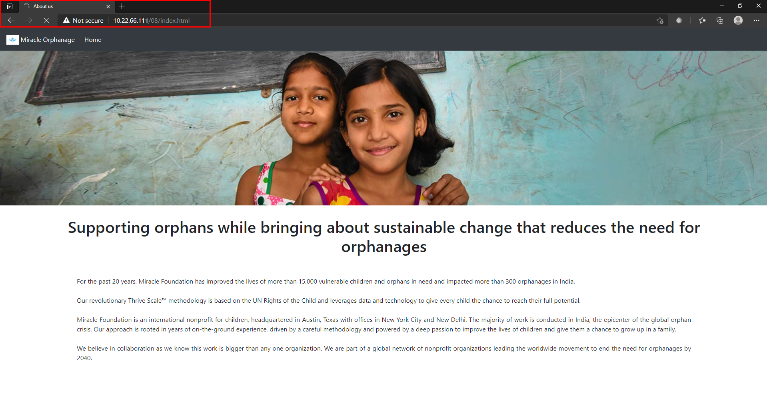

**Figure 4. The Website Incapable of Refreshing the Page**

1. Make a python program to brute force the directory and file inside the web app based on the **HTTP Status Code**.

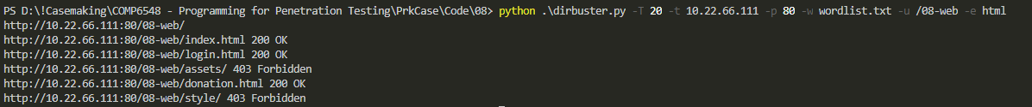

**Figure 5. Dirbuster Result**