|  |  |
| --- | --- |
| **Practicum Case** |  |
| COMP6548  Programming for Penetration Testing |
| **Cyber Security** | **<Case Code>** |
| ***Valid on*** *[Odd/Even/Compact] Semester Year 9999/9999* | **Revision 00** |

## Learning Outcomes

* Socket Network Program for Penetration Testing
* Web Vulnerability with Programming
* Additional tools for Penetration Testing

## Topic

* Python Bot and Automation I

## Subtopics

* Introduction to Web Scraping
* Extract Information from Web Application
* Automate User Action in Web Application

## Soal

*Case*

**Scrapping**

You are asked to scrap a website that is filled with products. You need to make a program using **Python Programming Language** to scrap the website, here are some steps that you need to follow:

1. There is a folder called 09-web in the zip, you need to copy it to your **Document Root** folder (the default folder is in “C:/xampp/htdocs”).
2. Open XAMPP Control Panel.
3. Press “Start” button on a module called “Apache”.
4. Try opening the website on your browser.
5. Open your **phpMyAdmin** on your browser.
6. Create a database called **scrap**.
7. Import the **.sql** file in **helper** folder (**scrap.sql**).
8. Open the website on the browser, it should look like below.

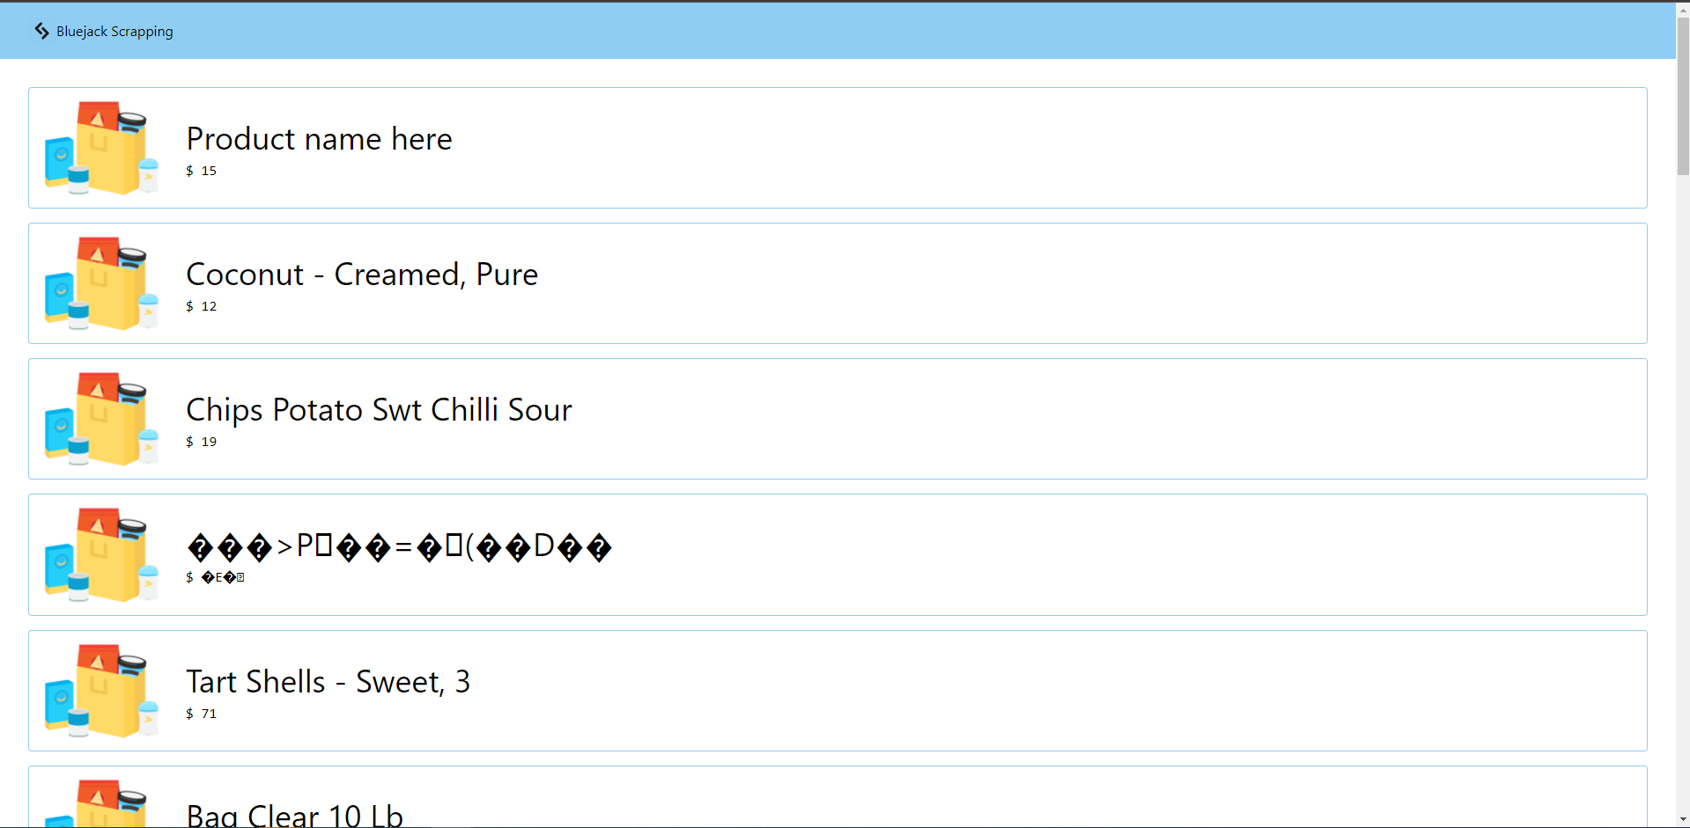

Figure . Website after Configuration

1. Scrap the website, get all product name (except the first one), and all the information from the website. Here are some things that you need to get:
   1. You need to access the website with **normal browser’s header**. You can get it from your browser. The website will automatically reject your request if your header is from **python requests**.
   2. Print the **sum** of all product price.
   3. Print the **total** of products.
   4. Print the **average** of the products.

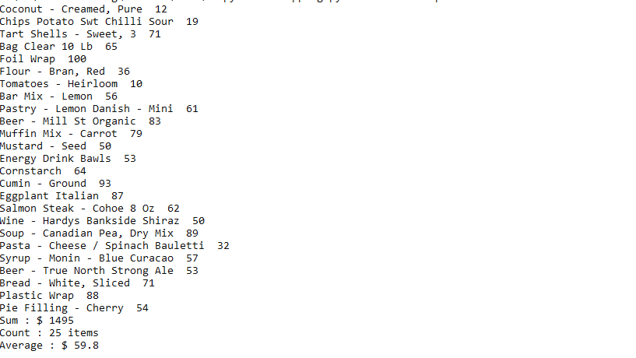

Figure . The Result