|  |  |
| --- | --- |
| **Practicum Case** |  |
| COMP6548  Programming for Penetration Testing |
| **Cyber Security** | **<Case Code>** |
| ***Valid on*** *[Odd/Even/Compact] Semester Year 9999/9999* | **Revision 00** |

## Learning Outcomes

* Socket Network Program for Penetration Testing
* Web Vulnerability with Programming
* Additional tools for Penetration Testing

## Topic

* Python Bot and Automation II

## Subtopics

* Retrieve CSRF Token from Web Response
* Brute-force Web Application Authentication

## Soal

*Case*

**Brute Force Login**

You are a hacker, asked to attack an organization called **Miracle Foundation**, but first you need to get access from the website first, because you are lazy to brute force to the website one by one, you want to make a program to brute force it for you using **Python Programming Language**. Here are some requirements:

1. There is a folder called 10-web in the zip, you need to copy it to your **Document Root** folder (the default folder is in “C:/xampp/htdocs”).
2. Open XAMPP Control Panel.
3. Press “Start” button on a module called “Apache”.
4. Try opening the website on your browser.
5. Open your **phpMyAdmin** on your browser.
6. Create a database called **scrap**.
7. Import the **.sql** file in **10-web** folder (**file.sql**).
8. Open the website on the browser, it should look like below.

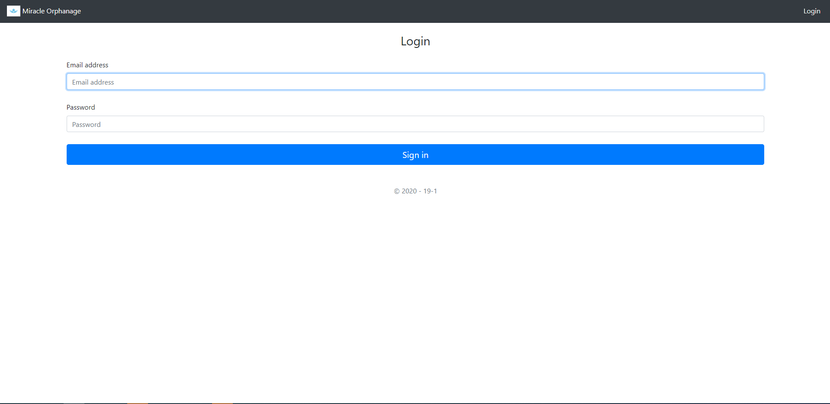

**Figure 1. The Website after Configuration**

1. You need to make a program that can brute force into it (you can add a argument parser, but it is **optional**). Here are the requirements:
   1. The website have a CSRF Token that you need to retrieve.
   2. The website need to you specify email and password to login.
   3. You need to make your own wordlists (email and password).



**Figure 2. The Result of the Program**