A Full-Order Flux Observer with MRAS-Based Speed Estimation for Induction Motor Drives
This paper presents a full-order flux observer (FOO) combined with a model reference adaptive system (MRAS) for induction motor drives. The observer estimates stator and rotor flux linkages using measured stator voltages and currents with feedback correction. A MRAS scheme is employed for rotor speed estimation based on the discrepancy between a reference model and an adjustable model. The stability of the observer is analyzed based on pole placement and Lyapunov principles. Simulation and practical considerations demonstrate that the proposed approach provides reliable performance in medium and high-speed regions.
Electrical parameters tuning, diagnosis, multi observers’ cooperation and control strategy is not in the scope.

1. Core Architecture Overview
The full-order observer + MRAS combination is the industry-standard solution for induction motor control, serving two primary purposes:
- Sensor-less operation: Estimates rotor flux linkage (magnitude and phase) and rotor speed without an encoder
- Sensor-based operation: Provides online parameter self-calibration to compensate for temperature drift and parameter mismatch
The summary focuses on sensor-less operation.
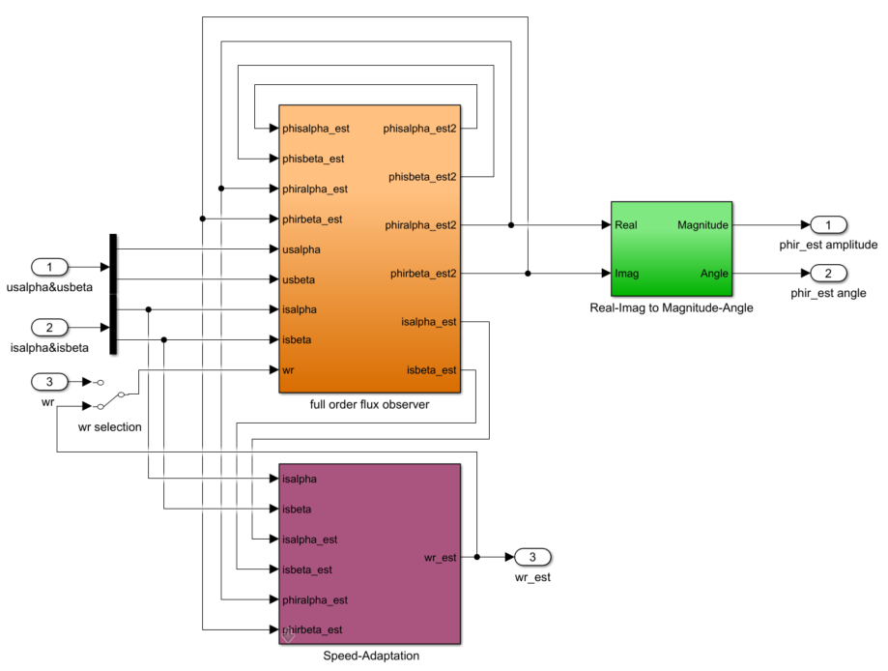

2. Theoretical Foundation

The design is built on a solid theoretical foundation, covering electromagnetic theory of induction motors, full-order state observer design theory, and Lyapunov stability theory. The detailed derivation is as follows:

2.1. Theoretical Foundation 1: Induction Motors

The induction motor model is described in the stationary αβ reference frame. The stator and rotor voltage equations are given as follows:
Stator voltage equations:
$$\begin{aligned}u_{sα}=R_{s}i_{sα}+\frac{dψ_{sα}}{dt} \\ u_{sβ}=R_{s}i_{sβ}+\frac{dψ_{sβ}}{dt}\end{aligned}$$
Rotor voltage equations (assuming the rotor is short-circuited, $u_{rα}=u_{rβ}=0$):
$$\begin{aligned}0=R_{r}i_{rα}+\frac{dψ_{rα}}{dt}-ω_{r}ψ_{rβ} \\ 0=R_{r}i_{rβ}+\frac{dψ_{rβ}}{dt}+ω_{r}ψ_{rα}\end{aligned}$$
Flux-Current Relationship (Inductance Matrix)
$$\begin{aligned}ψ_{sα}=L_{s}i_{sα}+L_{m}i_{rα} \\ ψ_{sβ}=L_{s}i_{sβ}+L_{m}i_{rβ} \\ ψ_{rα}=L_{m}i_{sα}+L_{r}i_{rα} \\ ψ_{rβ}=L_{m}i_{sβ}+L_{r}i_{rβ}\end{aligned}$$
Derivation of the α-axis Rotor Flux Dynamic Equation
Solve for $\frac{dψ_{rα}}{dt}$ from the rotor voltage equation, then eliminate the rotor current $i_{rα}$ and stator current $i_{sα}$ using the flux-current relationship. The final result is:
$$\frac{dψ_{rα}}{dt}=\frac{R_{r}L_{m}}{L_{s}L_{r}-L_{m}^{2}}ψ_{sα}-\frac{R_{r}L_{s}}{L_{s}L_{r}-L_{m}^{2}}ψ_{rα}+ω_{r}ψ_{rβ}$$
It is similar with other axis and has below equations:
$$\frac{dψ_{sα}}{dt}=-\frac{R_{s}L_{r}}{\text{den}}ψ_{sα}+\frac{R_{s}L_{m}}{\text{den}}ψ_{rα}+u_{sα}$$
$$\frac{dψ_{sβ}}{dt}=-\frac{R_{s}L_{r}}{\text{den}}ψ_{sβ}+\frac{R_{s}L_{m}}{\text{den}}ψ_{rβ}+u_{sβ}$$
$$\frac{dψ_{rα}}{dt}=\frac{R_{r}L_{m}}{\text{den}}ψ_{sα}-\frac{R_{r}L_{s}}{\text{den}}ψ_{rα}+ω_{r}ψ_{rβ}$$
$$\frac{dψ_{rβ}}{dt}=\frac{R_{r}L_{m}}{\text{den}}ψ_{sβ}-\frac{R_{r}L_{s}}{\text{den}}ψ_{rβ}-ω_{r}ψ_{rα}$$

2.2. Theoretical Foundation 2: Full-Order State Observer Design
The full-order flux observer belongs to the category of state observers, based on Luenberger observer structure:
Construct an "observer model" with dynamics identical to the "real motor". Drive this model using measurable variables (voltages and currents), and introduce state error feedback ("current error feedback") to make the observer's "state estimates" converge to the "true states (flux linkages)" of the real motor.
- The state equation of the observer takes the form:
$$\overset{˙}{\overset{^}{x}}=A\overset{^}{x}+Bu+K(y-\overset{^}{y})$$Where:
- $\overset{^}{x}=[ψ_{sα},ψ_{sβ},ψ_{rα},ψ_{rβ}]^{T}$: Flux linkage estimates (state vector)
- $A$: State matrix of the motor model (contains coefficients such as $a_{31},a_{33},a_{34}$)
- $B$: Input matrix (corresponds to stator voltages $u_{sα},u_{sβ}$)
- $K$: Feedback gain matrix (contains current error feedback coefficients such as ${k_{1},k_{2},k}_{3},k_{4}$)
- $y-\overset{^}{y}=[Δi_{sα},Δi_{sβ}]^{T}$: Current observation error (feedback signal)

2.3. Theoretical Foundation 3: Lyapunov Stability Theory
To ensure that the "observed flux linkages" converge to the "true flux linkages", we design the feedback gains ${k_{1},k_{2},k}_{3},k_{4}$ using the Lyapunov stability criterion:
- Define observation error: $\overset{\sim }{x}=x-\overset{^}{x}$ (true state minus estimated state)
- Construct Lyapunov function: $V=\frac{1}{2}{\overset{\sim }{x}}^{T}P\overset{\sim }{x}$ (where $P$ is a positive definite matrix)
- Derive error dynamic equation: $\overset{˙}{\overset{\sim }{x}}=(A-KC)\overset{\sim }{x}$ (where $C$ is the output matrix, corresponding to the linear relationship between currents and flux linkages)
- Stability condition: Require $\overset{˙}{V}<0$ (Lyapunov function decreases monotonically), which means all poles of $A-KC$ must lie in the left half of the s-plane. This is achieved by designing k using the pole placement method.
2.4. Theoretical Foundation 4: Numerical Implementation of Discrete Integration
The integration block in your module is a discrete time implementation of integration, based on the Forward Euler method for numerical integration:
The continuous-time integral $ψ_{rα}(t)=\int_{0}^{t}{{\overset{˙}{ψ}}_{rα}}(τ)dτ$ is approximated in a discrete system (with sampling period $T_{s}$) as:
$${\overset{^}{ψ}}_{rα}(k+1)={\overset{^}{ψ}}_{rα}(k)+KT_{s}⋅{\overset{˙}{\overset{^}{ψ}}}_{rα}(k)$$Where $K$ is the integral gain (typically set to 1 in engineering for numerical stability), and $z^{-1}$ is the discrete-time "delay operator", corresponding to the "state at the previous time step".

3. Full-Order Observer (FOO) Core Design

2.1 State Space Model (αβ Stationary Frame)
The FOO is built on the 4-dimensional state-space model of the induction motor, with state variables being the stator and rotor flux linkages in the αβ axes:
$$\overset{˙}{x}=Ax+Bu_{s}$$where:
- State vector: $x={[\begin{matrix}ψ_{sα} & ψ_{sβ} & ψ_{rα} & ψ_{rβ}\end{matrix}]}^{T}$
- State matrix elements (precomputed from motor parameters):
- $a_{11}=-\frac{R_{s}L_{r}}{L_{s}L_{r}-L_{m}^{2}}$
- $a_{13}=\frac{R_{s}L_{m}}{L_{s}L_{r}-L_{m}^{2}}$
- $a_{31}=\frac{R_{r}L_{m}}{L_{s}L_{r}-L_{m}^{2}}$
- $a_{33}=-\frac{R_{r}L_{s}}{L_{s}L_{r}-L_{m}^{2}}$
- Input vector: $u_{s}={[\begin{matrix}u_{sα} & u_{sβ}\end{matrix}]}^{T}$ (measured stator voltages)

2.2 Observer Structure with Current Error Feedback
The FOO adds a current error feedback term to the open-loop model to correct estimation errors:
$$\overset{˙}{\overset{^}{x}}=A\overset{^}{x}+Bu_{s}+K(i_{s}-{\overset{^}{i}}_{s})$$
$$\frac{d{\overset{^}{ψ}}_{sα}}{dt}=a_{11}{\overset{^}{ψ}}_{sα}+a_{13}{\overset{^}{ψ}}_{rα}+u_{sα}+k_{1}(i_{sα}-{\overset{^}{i}}_{sα})$$
$$\frac{d{\overset{^}{ψ}}_{sβ}}{dt}=a_{11}{\overset{^}{ψ}}_{sβ}+a_{13}{\overset{^}{ψ}}_{rβ}+u_{sβ}+k_{1}(i_{sβ}-{\overset{^}{i}}_{sβ})$$
$$\frac{d{\overset{^}{ψ}}_{rα}}{dt}=a_{31}{\overset{^}{ψ}}_{sα}+a_{33}{\overset{^}{ψ}}_{rα}+ω_{r}{\overset{^}{ψ}}_{rβ}+k_{3}(i_{sα}-{\overset{^}{i}}_{sα})-k_{4}(i_{sβ}-{\overset{^}{i}}_{sβ})$$
$$\frac{d{\overset{^}{ψ}}_{rβ}}{dt}=a_{31}{\overset{^}{ψ}}_{sβ}+a_{33}{\overset{^}{ψ}}_{rβ}-ω_{r}{\overset{^}{ψ}}_{rα}+k_{3}(i_{sβ}-{\overset{^}{i}}_{sβ})+k_{4}(i_{sα}-{\overset{^}{i}}_{sα})$$
where:
- $K$ is the feedback gain matrix designed via pole placement
- ${\overset{^}{i}}_{s}=\frac{L_{r}{\overset{^}{ψ}}_{s}-L_{m}{\overset{^}{ψ}}_{r}}{L_{s}L_{r}-L_{m}^{2}}$ (estimated stator current from flux linkages)
- Stator flux feedback gain (k1):
$$k_{1}=R_{s}(K^{2}-1)$$
- Rotor flux direct feedback gain (k3):
$$k_{3}=\frac{R_{r}L_{s}+K^{2}R_{s}L_{r}-KR_{s}L_{r}-KR_{r}L_{s}}{L_{m}}$$
- Rotor flux cross feedback gain (k4):
$$k_{4}=\frac{(K-1)⋅\text{den}}{L_{m}}⋅ω_{r}$$Where:
- $K$: Observer pole placement design parameter
- $ω_{r}$: Rotor electrical angular velocity (rad/s)
The implementation is as below:
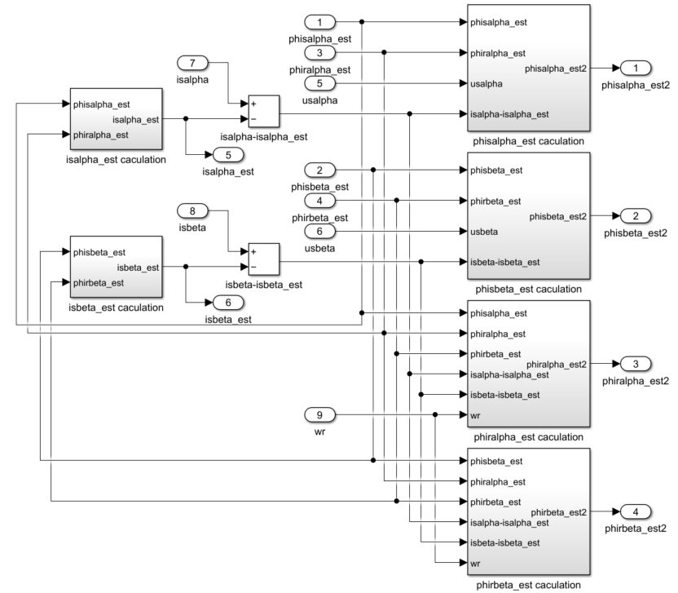

2.3 Pole Placement Strategy
The observer gain matrix K is designed using pole placement to ensure that the observer dynamics are faster than the motor dynamics. The observer poles are selected to be several times the dominant motor pole, providing a trade-off between convergence speed and robustness. In practice, the observer bandwidth is typically chosen to be 3–6 times the electrical bandwidth of the motor
Pole Placement Target | Application Scenario | Key Tradeoff
3× motor bandwidth | Low-speed operation, parameter-sensitive environments | Prioritizes stability and robustness over convergence speed
6× motor bandwidth | High-speed operation, dynamic load changes | Prioritizes fast convergence and dynamic response

4. MRAS Integration for Speed Estimation
MRAS is integrated with the FOO to estimate unknown states (speed) or correct parameter drift, following the "reference model vs adjustable model" framework. Its core logic is to "use the output error of two models to drive the adaptive law and inversely deduce the unknown rotor speed", eliminating the need for physical speed sensors (e.g., encoders) to achieve sensor-less speed estimation.

4.1 Model Definitions (As Per Commercial Driver Implementation)
Reference Model (RM): Voltage model (physically measured, no unknown parameters)
${\overset{^}{ψ}}_{s}^{\text{ref}}=∫(u_{s}-R_{s}i_{s})dt$
Provides the "ground truth" flux reference
Only depends on measured stator voltages and currents
Adjustable Model (AM): Current model (contains unknown parameters/states)
$$\frac{d{\overset{^}{ψ}}_{r}^{\text{adj}}}{dt}=-\frac{1}{{\overset{^}{T}}_{r}}{\overset{^}{ψ}}_{r}^{\text{adj}}+\frac{L_{m}}{{\overset{^}{T}}_{r}}i_{s}+{\overset{^}{ω}}_{r}×{\overset{^}{ψ}}_{r}^{\text{adj}}$$
Contains adjustable parameters: ${\overset{^}{ω}}_{r}$ (rotor speed) and ${\overset{^}{T}}_{r}=\frac{L_{r}}{R_{r}}$ (rotor time constant)
Output is adjusted via adaptive laws to match the reference model
The output of the adjustable model is the "observed stator flux linkage", which directly reuses the output of the full-order observer (${\overset{^}{ψ}}_{sα},{\overset{^}{ψ}}_{sβ}$). Its dynamics depend on the unknown speed estimate ${\overset{^}{ω}}_{r}$.
Adaptation Law (AL): Adjusts the unknown parameters in real time according to the "error between the reference model and the adjustable model" to make the error approach zero.
The flux output of the adjustable model is derived from the observer's rotor flux linkage and measured current, while the observer's rotor flux linkage calculation depends on ${\overset{^}{ω}}_{r}$. Therefore, the output of the adjustable model is directly related to ${\overset{^}{ω}}_{r}$ — the deviation between ${\overset{^}{ω}}_{r}$ and the true $ω_{r}$ will directly lead to the error between ${\overset{^}{ψ}}_{s}$ and $ψ_{s}^{\text{ref}}$.

4.2. Theoretical Design of the Adaptation Law
The adaptation law is the "core algorithm" of the speed adaptation module. Its design must satisfy "error convergence + system stability". The design uses the most commonly used "PI-type adaptation law" in engineering, with its theoretical basis being Popov hyperstability theory.

4.2.1. Error Signal Construction
To ensure that the error is in the same direction as the speed deviation, the "cross product of flux linkage error and observed flux linkage" is constructed as the input to the adaptation law. Actually, this is the critical design with proof:
$$ε=ψ_{sα}^{\text{ref}}⋅{\overset{^}{ψ}}_{sβ}-ψ_{sβ}^{\text{ref}}⋅{\overset{^}{ψ}}_{sα}$$Physical meaning:
- When ${\overset{^}{ω}}_{r}<ω_{r}$ (speed estimate is too low), the flux change rate of the adjustable model is lower than that of the reference model, ${\overset{^}{ψ}}_{s}<ψ_{s}^{\text{ref}}$, and the cross product $ε>0$, driving the adaptation law to increase ${\overset{^}{ω}}_{r}$
- When ${\overset{^}{ω}}_{r}>ω_{r}$ (speed estimate is too high), $ε<0$, driving the adaptation law to decrease ${\overset{^}{ω}}_{r}$
- When $ε=0$, the speed estimate is completely accurate, ${\overset{^}{ω}}_{r}=ω_{r}$
At low speeds, the signal-to-noise ratio of current measurement is much higher than that of voltage-integrated flux linkage, and current errors are more reliable, which can avoid divergence of speed estimation.
Therefore, the "error source switching" theory is introduced:
- Switching logic: When ${\overset{^}{ω}}_{r}≤5$, switch the error signal from "flux error cross product" to "current error cross product"
$$ε=Δi_{sα}⋅{\overset{^}{ψ}}_{sβ}-Δi_{sβ}⋅{\overset{^}{ψ}}_{sα}$$
This is not the scope of the paper.

4.2.2. PI Adaptation Law Formula
The proportional (P) term ensures response speed, and the integral (I) term eliminates steady-state error:
$${\overset{^}{ω}}_{r}=K_{p}⋅ε+K_{i}∫εdt$$Gain tuning theory: $K_{p}$ and $K_{i}$ should be designed according to the motor's rotor time constant $T_{r}$ and flux bandwidth to ensure that the closed-loop poles of the adaptation law match the observer poles (to avoid system oscillation). Typically, $K_{i}=K_{p}/(5T_{r})$.

4.2.3. Collaborative Theory of the Two Modules: Closed-Loop Convergence Logic
The full-order flux observer and the speed adaptation module do not work independently, but form a closed-loop collaboration of "observation-estimation-correction". Its theoretical core is "double closed-loop convergence":
- First closed loop (flux observation closed loop): The full-order observer takes the ${\overset{^}{ω}}_{r}$ output by the speed adaptation module as input, corrects the coupling term in the rotor flux equation, and outputs accurate ${\overset{^}{ψ}}_{r}$ and ${\overset{^}{ψ}}_{s}$ through current error feedback.
- Second closed loop (speed estimation closed loop): The speed adaptation module takes the ${\overset{^}{ψ}}_{s}$ output by the observer as the input of the adjustable model, compares it with the $ψ_{s}^{\text{ref}}$ of the reference model to generate an error, and drives the adaptation law to output a more accurate ${\overset{^}{ω}}_{r}$.
- Collaborative convergence theory: The convergence of the entire system is guaranteed by Lyapunov stability theory. Construct a global Lyapunov function:
$$V=\frac{1}{2}Δψ_{r}^{2}+\frac{1}{2}Δi_{s}^{2}+\frac{1}{2}(ω_{r}-{\overset{^}{ω}}_{r})^{2}$$It can be proven that when the observer gain $K$ and the adaptation law gains $K_{p}/K_{i}$ meet the design conditions, $\overset{˙}{V}<0$, and eventually $Δψ_{r}→0$, $Δi_{s}→0$, and ${\overset{^}{ω}}_{r}→ω_{r}$, achieving simultaneous accurate estimation of flux linkage and speed.

5. Stability Criteria & Parameter Design

5.1 Full-Order Observer (FOO) Lyapunov Stability Criterion
The stability of the observer can be analyzed using Lyapunov theory. By selecting the observer gain such that the eigenvalues of (A − KC) lie in the left half-plane, the estimation error is expected to converge asymptotically.
- Define observation errors:
$$Δψ_{sα}=ψ_{sα}-{\overset{^}{ψ}}_{sα},Δψ_{rα}=ψ_{rα}-{\overset{^}{ψ}}_{rα} \\ Δi_{sα}=i_{sα}-{\overset{^}{i}}_{sα}=\frac{L_{r}}{\text{den}}Δψ_{sα}-\frac{L_{m}}{\text{den}}Δψ_{rα}$$
- Error dynamic equation:
Subtract the observer equation from the real motor equation:
$$\frac{d}{dt}[\begin{aligned}Δψ_{sα} \\ Δψ_{rα}\end{aligned}]=[\begin{matrix}a_{11}-k_{1}c_{1} & a_{13}-k_{1}c_{2} \\ a_{31}-k_{3}c_{1} & a_{33}-k_{3}c_{2}\end{matrix}][\begin{aligned}Δψ_{sα} \\ Δψ_{rα}\end{aligned}]=A_{e}\overset{\sim }{x}$$Where $c_{1}=L_{r}/\text{den}$, $c_{2}=-L_{m}/\text{den}$
- Construct Lyapunov function:
Choose a simple quadratic Lyapunov function (energy function):
$$V=\frac{1}{2}Δψ_{sα}^{2}+\frac{1}{2}Δψ_{rα}^{2}$$This function is always positive ($V>0$) except when all errors are zero ($V=0$).
- Stability condition:
For the system to be stable, the derivative of the Lyapunov function must be strictly negative ($\overset{˙}{V}<0$) for all non-zero errors:
$$\overset{˙}{V}=Δψ_{sα}\frac{dΔψ_{sα}}{dt}+Δψ_{rα}\frac{dΔψ_{rα}}{dt}={\overset{\sim }{x}}^{T}A_{e}\overset{\sim }{x}<0$$
- Physical interpretation:
- $\overset{˙}{V}<0$ means the "energy of the error system" is always decreasing
- Eventually, the energy will reach zero, meaning all errors converge to zero
- This condition is equivalent to all eigenvalues (poles) of the error matrix $A_{e}$ lying in the left half of the s-plane

5.2. MRAS Popov Stability Criterion

The MRAS system has a nonlinear feedback loop (the cross product error is a nonlinear function of the flux linkages). Standard Lyapunov stability is difficult to apply directly to nonlinear systems. Popov's theorem gives a much simpler condition for stability
The system is globally asymptotically stable if:
- The forward path (the motor + observer) is strictly positive real (SPR)
- The feedback path (the adaptation law) satisfies the Popov integral inequality:
$$\int_{0}^{t}{ε(τ)}\frac{d{\overset{^}{ω}}_{r}}{dτ}dτ≥-r^{2}$$
where r is a finite constant.
Proof that PI adaptation law satisfies Popov's condition
Substitute ${\overset{^}{ω}}_{r}=K_{p}ε+K_{i}∫εdt$ into the integral:
$$\int_{0}^{t}{ε}⋅\frac{d}{dτ}(K_{p}ε+K_{i}∫εdτ)dτ=K_{p}\int_{0}^{t}{ε\overset{˙}{ε}}dτ+K_{i}\int_{0}^{t}{ε^{2}}dτ \\ =\frac{K_{p}}{2}ε^{2}(t)-\frac{K_{p}}{2}ε^{2}(0)+K_{i}\int_{0}^{t}{ε^{2}}dτ$$
Since $K_{i}>0$, the integral term is always non-negative. Therefore:
$$\int_{0}^{t}{ε}{\overset{˙}{\overset{^}{ω}}}_{r}dτ≥-\frac{K_{p}}{2}ε^{2}(0)=-r^{2}$$This exactly satisfies the Popov integral inequality, proving that the PI adaptation law guarantees global stability.

5.3. Global Lyapunov Stability for the Combined System
The global Lyapunov function you mentioned:
$$V=\frac{1}{2}Δψ_{r}^{2}+\frac{1}{2}Δi_{s}^{2}+\frac{1}{2}(ω_{r}-{\overset{^}{ω}}_{r})^{2}$$combines three energy terms:
- Flux estimation error energy
- Current estimation error energy
- Speed estimation error energy
When both the observer gains ($k_{1},k_{3}$) and the adaptation law gains ($K_{p},K_{i}$) are properly designed, the derivative of this global Lyapunov function is strictly negative:
$$\overset{˙}{V}=Δψ_{r}\overset{˙}{Δψ_{r}}+Δi_{s}\overset{˙}{Δi_{s}}+(ω_{r}-{\overset{^}{ω}}_{r})(-{\overset{˙}{\overset{^}{ω}}}_{r})<0$$This proves that all three errors will simultaneously converge to zero, ensuring the entire system is globally stable.

5.4. Full-Order Observer Gains
The motor parameters:$R_{s}=1.087Ω,L_{s}=0.148\text{H},R_{r}=0.788Ω,L_{r}=0.148\text{H},L_{m}=0.14\text{H}$
Step 1: Calculate Motor Parameters and Core Matrices
Using the motor parameters you provided:$R_{s}=1.087,Ω,L_{s}=0.148,\text{H},R_{r}=0.788,Ω,L_{r}=0.148,\text{H},L_{m}=0.14,\text{H}$
- Common denominator term:
$$\text{den}=L_{s}L_{r}-L_{m}^{2}=0.148×0.148-{0.14}^{2}=0.002304$$
- State Matrix $A$:
$$A=[\begin{matrix}a_{11} & 0 & a_{13} & 0 \\ 0 & a_{11} & 0 & a_{13} \\ a_{31} & 0 & a_{33} & ω_{r} \\ 0 & a_{31} & -ω_{r} & a_{33}\end{matrix}]$$Where:
- $a_{11}=-\frac{R_{s}L_{r}}{\text{den}}≈-69.86$
- $a_{13}=\frac{R_{s}L_{m}}{\text{den}}≈66.07$
- $a_{31}=\frac{R_{r}L_{m}}{\text{den}}≈47.88$
- $a_{33}=-\frac{R_{r}L_{s}}{\text{den}}≈-50.62$
- $ω_{r}$: Rotor electrical angular velocity (provided by the speed estimation module)
- Output Matrix $C$:
$$C=[\begin{matrix}c_{1} & 0 & c_{2} & 0 \\ 0 & c_{1} & 0 & c_{2}\end{matrix}]$$Where:
- $c_{1}=\frac{L_{r}}{\text{den}}≈64.24$
- $c_{2}=-\frac{L_{m}}{\text{den}}≈-60.76$
Step 2: Specify Desired Poles (Based on System Bandwidth)
To ensure fast and oscillation-free convergence of observation errors, select real poles in the left half of the s-plane (engineering rule of thumb: the absolute value of the pole real part should be 3-5 times the motor bandwidth).
Given the rotor time constant:
$$T_{r}=\frac{L_{r}}{R_{r}}≈0.1878,\text{s}$$Motor bandwidth:
$$ω_{\text{bw}}=\frac{1}{T_{r}}≈5.325,\text{rad/s}$$Desired poles:
$$\text{Desired poles}=[-31.95,-31.95,-31.95,-31.95]$$
Step 3: Solve for Feedback Gain Matrix $K$ Using Pole Placement
Use Matlab's place function (standard pole placement tool) to solve for $K$ by inputting $A$, $C$, and the desired poles:
matlab
% Define motor parameters
Rs = 1.087; Ls = 0.148; Lr = 0.148; Lm = 0.14; Rr = 0.788;
den = Ls*Lr - Lm^2;
% Calculate state matrix coefficients
a11 = -Rs*Lr/den;
a13 = Rs*Lm/den;
a31 = Rr*Lm/den;
a33 = -Rr*Ls/den;
% Define state matrix A (use wr=0 for pole placement, as it is time-varying)
A = [a11, 0, a13, 0;
0, a11, 0, a13;
a31, 0, a33, 0;
0, a31, 0, a33];
% Define output matrix C
c1 = Lr/den;
c2 = -Lm/den;
C = [c1, 0, c2, 0;
0, c1, 0, c2];
% Specify desired poles
poles = [-$31.95$, -$31.95$, -$31.95$, -$31.95$];
% Solve for feedback gain matrix K
K = place(A', C', poles)';
% Extract gains
k1 = K(1, 1); % Stator flux current error feedback gain
k3 = K(3, 1); % Rotor flux current error feedback gain
Step 4: Lyapunov Stability Verification
Construct a quadratic Lyapunov function:
$$V=\frac{1}{2}{\overset{\sim }{x}}^{T}P\overset{\sim }{x}$$Solve the Lyapunov equation:
$$A_{e}^{T}P+PA_{e}=-I$$where $A_{e}=A-KC$ is the error state matrix, and $I$ is the identity matrix.
If a positive definite matrix $P$ exists (all eigenvalues are positive), the system is stable, and the designed $k_{1}$ and $k_{3}$ are valid.

Step 5: Engineering Simplification and Parameter Relationship
For practical implementation, you can use the simplified closed-form formula derived from the decoupling property of the error dynamics:
$$k_{1}=R_{s}(K^{2}-1) \\ k_{3}=\frac{R_{r}L_{s}+K^{2}R_{s}L_{r}-KR_{s}L_{r}-KR_{r}L_{s}}{L_{m}}$$
Where $K$ is the single pole placement design parameter:
For $K=6$:
$$k_{1}=1.087×(36-1)=38.045 \\ k_{3}=\frac{0.788×0.148+36×1.087×0.148-6×1.087×0.148-6×0.788×0.148}{0.14}≈30.31$$

5.5. MRAS Adaptation Law Gains $K_{p}$ and $K_{i}$
The MRAS gains are designed to match the observer bandwidth, ensuring the two loops work together without oscillation.
Step 1: Calculate the rotor time constant
$$T_{r}=\frac{L_{r}}{R_{r}}$$For the example motor: $T_{r}=0.148/0.788≈0.188$ s
Step 2: Calculate $K_{p}$
$$K_{p}=\frac{K⋅L_{m}}{T_{r}⋅L_{s}}$$For the example motor with $K=3$:
$$K_{p}=\frac{3×0.14}{0.188×0.148}≈15.1$$
Step 3: Calculate $K_{i}$
The standard rule of thumb (proven to ensure stability) is:
$$K_{i}=\frac{K_{p}}{5T_{r}}$$For the example motor:
$$K_{i}=\frac{15.1}{5×0.188}≈16.1$$

6. Test
Below graph shows the comparison between speed from encoder and speed from estimation.
The yellow line: Speed from encoder
The blue line: Speed from estimation
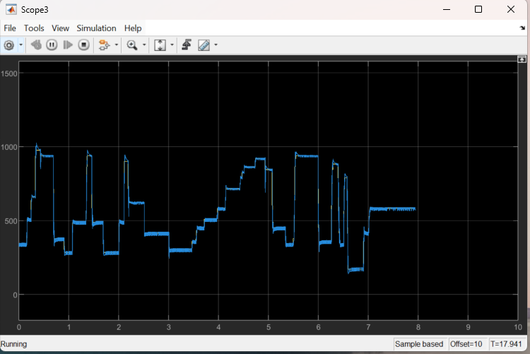

7. Summary
The full-order observer with MRAS integration provides a robust, high-performance solution for induction motor control:
- The FOO uses pole placement to ensure stable, fast convergence of flux estimates
- MRAS extends the FOO capability to estimate speed (sensorless) or calibrate parameters (sensored/sensorless)
- The design balances dynamic response for different operating conditions
- Key physical quantities (back EMF, slip, speed) are implicitly embedded in the observer and MRAS structure
- Smooth strategy switching and phase synchronization enable seamless operation across the full speed range

