Horn telescope cradle assembly
  - Construction guide • 2021 design
Build a wooden cradle to support the horn and can assembly. The cradle attaches to the telescope stand with two bolts.

Materials
Quantity | Material and dimensions
2 | 2 × 2 lumber, 20 inches long
2 | 2 × 2 lumber, 9 5/8 inches long
1 | 2 × 2 lumber, 6 11/16 inches long
3 | 2 × 2 lumber, 9 inches long
1 | 1/4-inch plywood, 7 × 8 inches
About 10 | 2 1/2-inch construction screws
As needed | 1-inch or 1 1/4-inch screws for the plywood
2 | 3 1/2-inch-long 1/4-20 bolts
2 | 1/4-20 wing nuts
The eight lumber pieces can be cut from one 8-foot length of 2 × 2 lumber.

Assembly
1. Assemble the 20-inch, 6 11/16-inch, and 9 5/8-inch pieces into the rectangular frame shown below. Use 2 1/2-inch screws.
2. Attach two 9-inch pieces below the corners at one end of the frame. Attach the third below the crossbar midpoint.
3. Attach the plywood to the bottom of these three extensions. It supports the can and the amplifier cable.
4. Drill 5/16-inch holes for the 1/4-20 bolts that connect the cradle to the stand.

Cradle views
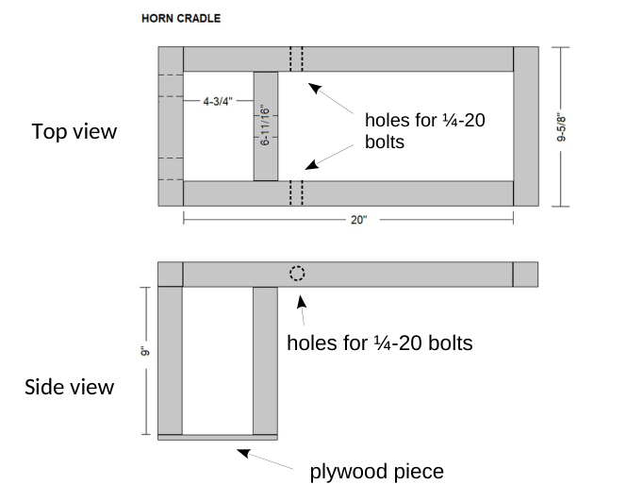
After assembling the horn, attach the amplifier to the can. Choose a hole or slot in the plywood for cable support.
