The Doppler Effect
Astronomy Activity

Isn’t the Universe always the same?
You can spend your life enjoying astronomy and looking into the night sky. Throughout 1000’s of years of recorded history before the telescope, the sky was mostly a mystery, but its consistent presence was a comfort. Yes, the whole “sky dome” rotated once a day, and there were 7 objects that “wandered” among the stars on that dome. They were the Sun, the Moon, Mercury, Venus, Mars, Jupiter, and Saturn- the original Planets of Antiquity. Other than that, the stars and the Milky Way were static, non-moving objects fixed in the sky. The ancient people would recognize the stars and constellations that we see today.
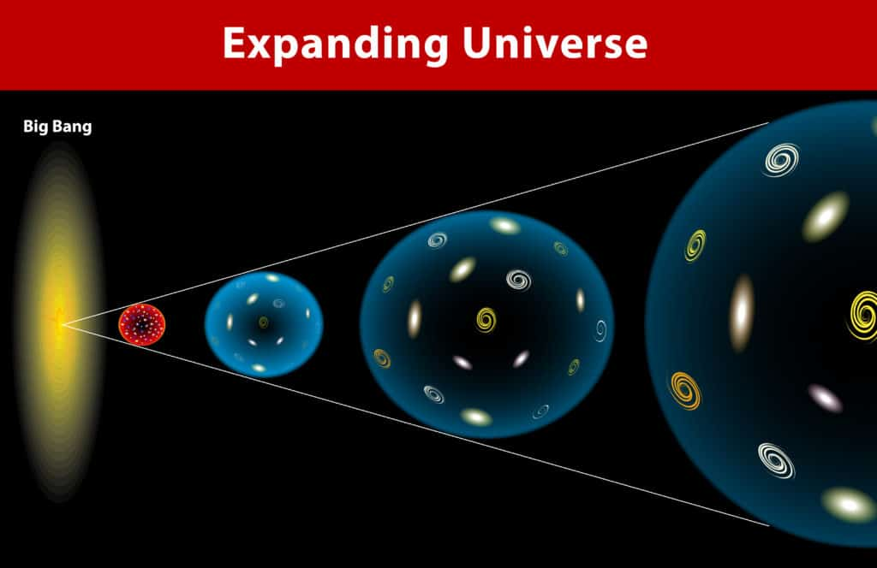
However, even if you are new to astronomy, you may have heard about the Big Bang Theory, or that the Universe is expanding.
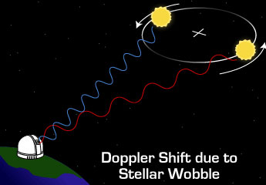
Maybe you heard that we are discovering exoplanets orbiting other stars, even though we can’t see them,
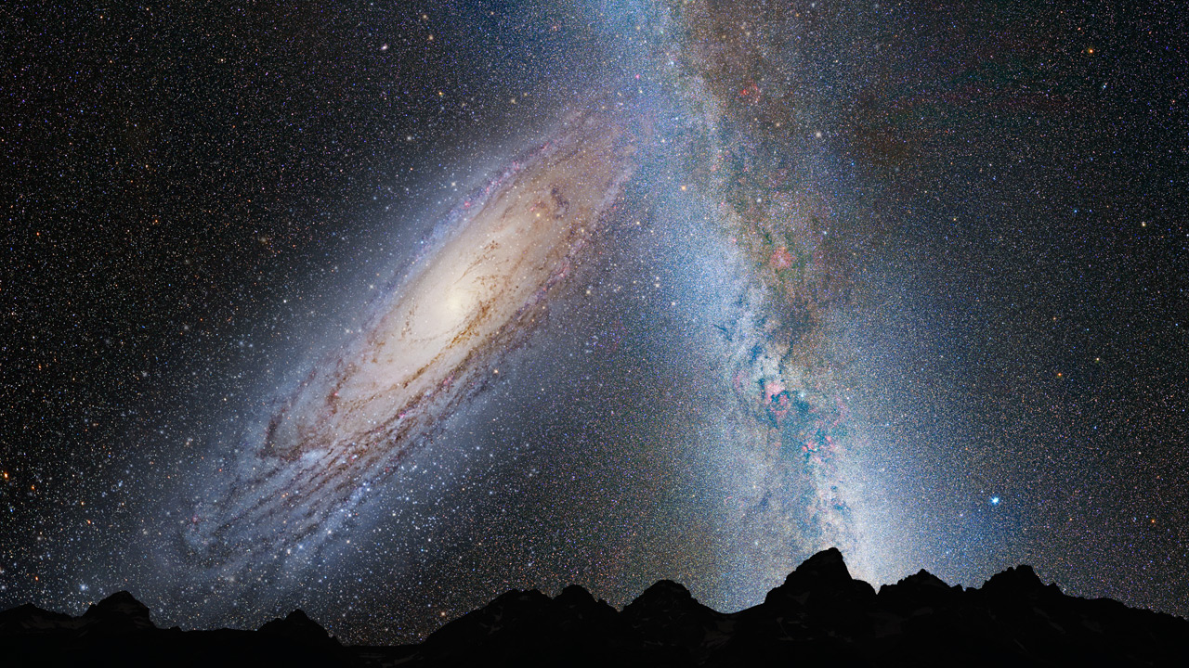
or that our galactic neighbor, the Andromeda Galaxy, is on a collision course with our Milky Way (If you haven’t heard of these astronomical curiosities, then click away!)
All these new, exciting discoveries have “motion” in their nature. How do we know all this if the Universe appears static?...The Doppler Effect.

The Doppler Effect
Most of us have experienced the Doppler effect. We have heard an approaching ambulance with siren blaring (and hopefully pulled off the side of the road to let it pass!). There should be two things you notice; one is that the siren gets louder as it approaches, then quieter when it is leaving you. The other thing is that when the ambulance passes you, you notice a shift in the pitch (frequency) of the sound. The pitch drops to a lower frequency.
The Doppler effect is a wave phenomena. whether it is sound waves or electro-magnetic waves. Since the speed of sound is much slower, a passing ambulance is travelling at enough of a percentage of the speed of sound to easily hear the difference. Seeing shifts in the color spectrum of stars is very subtle because the speed of stars is still far from speed of light. Sensitive instruments are needed to measure these shifts.
Redshift, Blueshift….what does it all mean? Watch this video...Doppler Effect Video.

Time for some math!
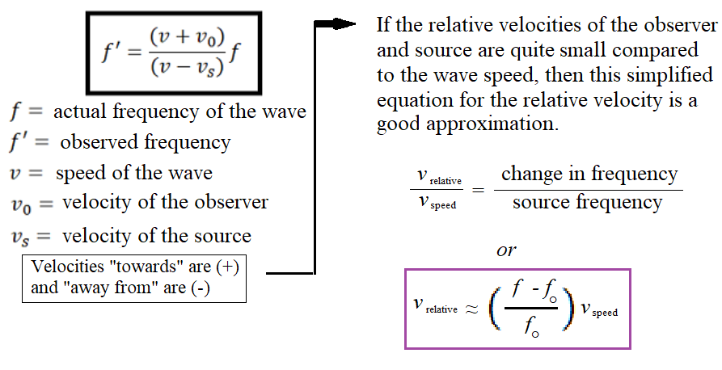
If we start off with slow speeds relative to the wave, then the equation turns into a simple ratio. It will be the change in frequency to the original frequency compared to the speed of the object to the speed of the wave.
Example:
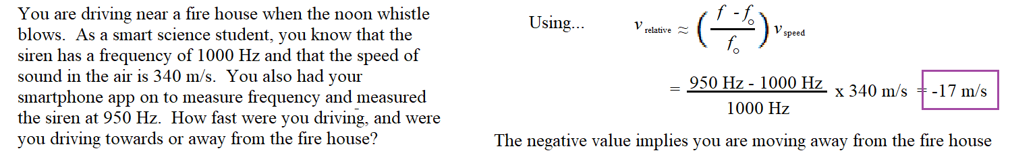

Try this!
The Andromeda Galaxy is heading towards us! How do we know that? Early 20th century astronomers noted the Andromeda Nebula had a blueshift, before they knew it was a whole other galaxy! If you eventually use the DSPIRA Radio Horn Telescope, you will end up using the Doppler equation in some of your analysis.
The following spectrum was generated from data using the DSPIRA spectrometer, but the DSPIRA horn scope was too small to get a clear spectrum of the data. Instead, the 40-ft radio dish at Green Bank Observatory was used to look at a section of the Andromeda Galaxy.
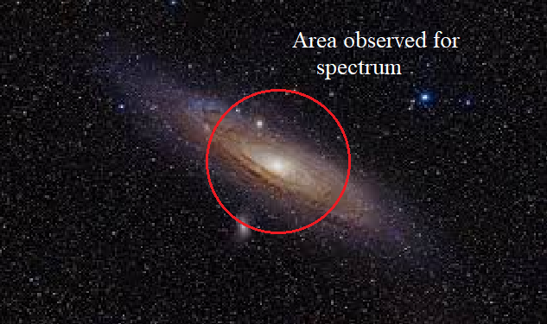
Imagine this galaxy like a spinning frisbee coming at you. Let’s say that the frisbee is coming at you at 20 MPH. However, it is spinning, and for simple math sake, let's say the outside of the frisbee is spinning at 2 MPH. So the frisbee as a whole is coming at you at 20 MPH, but the right side of the frisbee is coming at you at (20 + 2) 22 MPH, and the left side is coming at you at (20 - 2) 18 MPH. So, if you could measure the speed of all parts of the overall frisbee, you should get a range from 18 - 22 MPH with the average of 20 MPH. Well, looking at the middle section of the Andromeda will have the same effect. One side will have the galaxy speed plus the spinning speed, and the other side will have the galaxy speed minus the spinning speed. That is why the spectrum you are about to see is a wide “bump”
What is being measured in Neutral Hydrogen (click for more info as to why it is so important to Galactic astronomers) Neutral Hydrogen has a very precise frequency that is known from observations of hydrogen in any lab. The Frequency of Neutral Hydrogen is 1420.406 Mhz
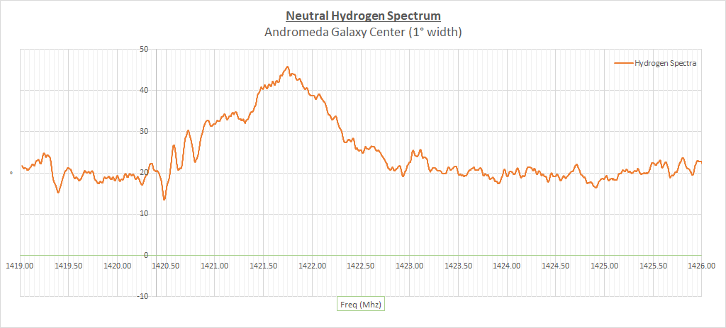

What To Do?
- Determine the frequency of the middle of the “bump” seen in the spectrum above.
Central Frequency = _______________________________ MHz
- Just to make sure you read the info above, what is the frequency of neutral hydrogen?
Neutral Hydrogen = _______________________________ MHz
- You will also need the speed of light in a vacuum. Find it and write it down here.
Speed of Light in a vacuum _________________________ km/s
(note the units here, you may need to convert from the number you found)
- Use the equation from the last page and show your work to determine the speed of the Andromeda Galaxy (follow the example, if you need to)

- Try to find the speed of the Andromeda Galaxy towards EARTH on the internet. Make sure it includes the Sun’s motion as well, and not just the Andromeda’s speed towards the Milky Way. If all is done right, you should have 2 numbers that are close. In a few sentences, how did you do? (This value has proven to be difficult to find online, so cite your sources as well.)
Speed of Earth Towards Andromeda Galaxy ______km/s Cited Source:________

